## Read this specification and understand the purpose of the system and how it works.

1. Please list as much as possible inaccuracies, deficiencies or contradictions in specification, and questions you might have to the specification (do not write out grammatical, syntactic or other language mistakes).

**FRS - Survey**

**Purpose of the Module**

Survey is web application which is used to conduct questionnaires among users and to generate questionnaire reports (questionnaire results in text and graphical format). The application consists of Administration area used by admin to configure the system and User area intend for users.

**User stories**

Story 1 (admin story).

1. Admin opens “Maintain Questionnaires” page in admin area. On this page admin creates questionnaire with several questions having several choices each.
2. Admin opens “Conduct Questionnaires” page. On this page admin chooses created questionnaire and clicks button “Run”.
3. On “Run Questionnaire” page admin chooses invitation mode “Send one-time invitation”. In “Randomization” section he chooses “Number of users” and inputs value “100”. Then he selects several customers and populates “Url parameters” section.
4. Admin clicks “Send” button. Invitations to participate in questionnaire are sent to users.

Story 2 (questionnaire participant user story).

1. User opens his mailbox and sees questionnaire invitation.
2. User opens link in it and goes to questionnaire page.
3. User answers questionnaire.

Story 3 (admin story).

1. Admin opens “Conduct Questionnaires” page. On this page he selects earlier created questionnaire and pushes button “View report”.
2. On “View report” page admin selects report parameters and clicks “View report” button to look report in chart or text mode.
3. Admin returns to “Conduct Questionnaires” page. On this page admin chooses questionnaire and clicks button “Publish”. Now all users related to questionnaire customers can view questionnaire report (in user area).

**Use Cases**



**Usage Information**

Questionnaires are created by Administrator. Each questionnaire may contain one or more questions. Each question consists of question text and one or more choices. Choices are presented to Users as radio buttons.

Administrator invites Users to fill questionnaire by sending emails. Emails are based on templates. Emails should contain special unique links (URLs) to questionnaire pages in Survey system (these links are automatically generated by the system).

Administrator chooses which customers (groups of users) to include in the questionnaire, so that the questionnaire can be run towards one customer, a selection of customers or all customers.

Administrator can specify the percentage or absolute number of Users that should be invited to fill a questionnaire. Users are selected on random basis.

Users fill questionnaires by following the URLs sent to them by Administrator. Each URL contains encrypted and Base64-encoded user ID and questionnaire ID so that a user can be identified on the server and a correct questionnaire page can be loaded.

Administrator can stop run questionnaire by inactivating of run period. Each User may fill each particular questionnaire only once for each run period. Administrator can invite users only during run period. Users cannot participate in questionnaire after the end of current period (when invitation was sent) or in case if period was inactivated.

Administrator can view reports for each questionnaire. Reports display questionnaire results in text (numeric) and graphical format.

Administrator can publish questionnaire reports to users. If questionnaire is made only for one or a selection of customers, then only the Users who belong to those customers are allowed to see it.

**Data Storage**

The following diagram shows the database structure for the Survey module.



**User Interface**

**Admin Area**

Admin area should include an intermediary navigation page with 3 links: **Maintain Questionnaires**, **Conduct Questionnaires** and **Email template**.

**Maintain Questionnaires page**

This page is used to create, edit, and delete questionnaires, and to modify their contents.



1. List of questionnaires
2. Button to add a new questionnaire (displays the Create/Edit questionnaire window)
3. Button to edit the selected questionnaire (displays the Create/Edit questionnaire window). Note that after the questionnaire has been run, it cannot be modified.
4. Button to delete the selected questionnaire. Any questionnaire can be deleted, so, be careful.
5. List of questions
6. Button to create a new question (displays the Question text editor window)
7. Button to edit the selected question (displays the Question text editor window)
8. Button to delete the selected question
9. Buttons to change the order of the selected question in the list. The list of questions should also support drag-and-drop to perform this operation.
10. List of choices
11. Button to create a new choice for the selected question (displays the Choice text editor window)
12. Button to edit the selected choice (displays the Choice text editor window)
13. Button to delete the selected choice
14. Buttons to change the order of the selected choice in the list. The list of questions should also support drag-and-drop to perform this operation.
15. Button to save the questionnaire.

**Questionnaire text editor window**

This window is used to specify options of a questionnaire.



1. Language of currently displayed title and description of Questionnaire (input title and description in all languages, when you are creating Questionnaire).
2. Title of Questionnaire.
3. Description of Questionnaire.

**Question text editor window**

This window is used to specify the text of a question in multiple languages.



1. Dynamically generated list of languages and text boxes for specifying question text in each of those languages.
2. Button to accept the changes
3. Button to cancel the changes

**Choice text editor window**

This window is used to specify the text of a choice in multiple languages. Looks and behaves identically to the Question text editor window.

**Conduct Questionnaires page**

This page is used to run questionnaires, view reports, and publish reports to Users.



1. List of questionnaires
2. Button to open the “Run questionnaire” page.
3. Button to view report for the selected questionnaire (opens the View questionnaire report page)
4. Button to publish the selected questionnaire report to end users. Before publishing, only admin can view questionnaire report.

**Run Questionnaire page**

This page is used to manage questionnaire invitations and run periods. Questionnaire run period is time interval when users can participate in questionnaire. One questionnaire can be run several times.

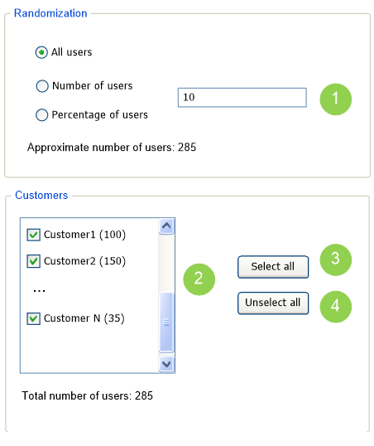

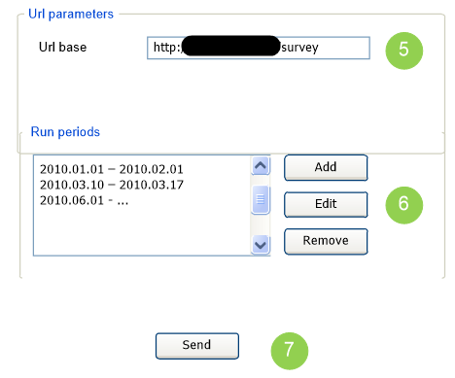

1. Randomization settings for the questionnaire (used to specify whether all users, a percentage of all users, or an absolute number of Users should be invited to fill the questionnaire). Also showed approximated number of users who will be invited.
2. List of customers whose users should be invited to fill the questionnaire (in parenthesis - number of users related to customer and who have not participated in the current questionnaire in the current period). Only these users can participate in questionnaire and view questionnaire reports. There is total number of users for all selected customers showed below the list.
3. Button to select all customers in the list.
4. Button to unselect all customers in the list.
5. URL which will be placed in invitation message.
6. Run periods’ list. New period can be added (both start and end dates must be in the future), existing period can be modified (start date can be modified only if it’s the future date; the same true for the end date) or deleted (only if both start and end dates represents future dates). Also selected period can be inactivated\activated. Two periods cannot be intersected.
7. Button to send invitations and run the questionnaire.

**Questionnaire run period editor window**



“No end date” means that period has no end date, in other words will never end.

**View Questionnaire report page**

This page allows administrator to view the questionnaire reports. The questionnaire is selected in the Manage questionnaires page. User can view report only for his customer’s questionnaires.



1. Report mode selector (options: Single period, Two periods comparison).
2. Report style selector (options: Text, Graphs, Text and Graphs).
3. Graph style selector (options: Pie, Bar).
4. Numeric mode selector (options: Absolute, Both).
5. Period selector (user can input arbitrary period or select one of questionnaire run periods). In “Two periods comparison” report mode, there are two period selectors.
6. Button to generate and display the report.

**Questionnaire report examples**

Used following options:

* report mode - two periods comparison;
* report style - text and graphs;
* graph style - bar;
* numeric mode - absolute.

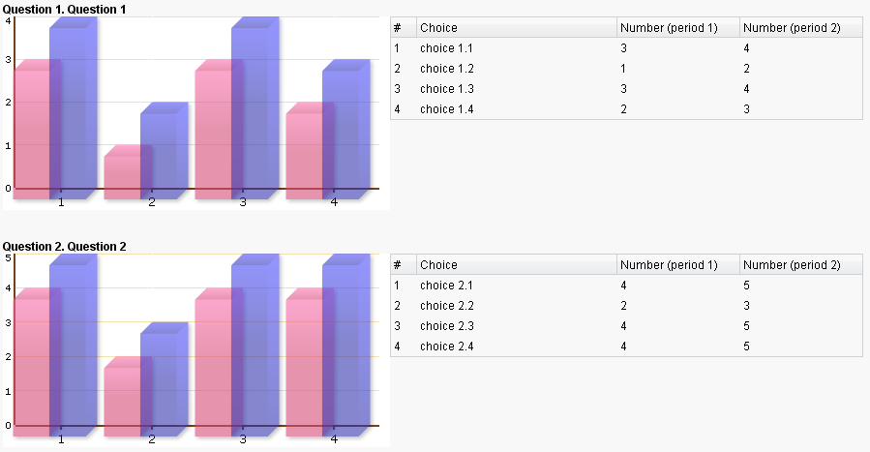

Same options, but graph style - pie.

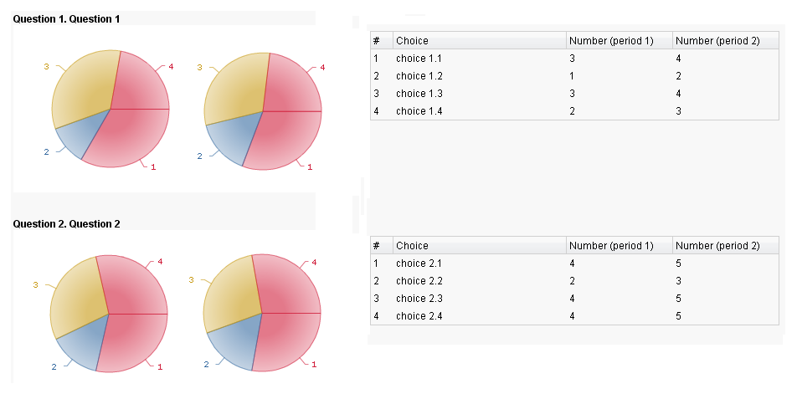

Also, on Questionnaire Report page you can view ratio of users, participated in questionnaire, to all invited user s (per period).

|  |  |  |
| --- | --- | --- |
| Period Start | Period End | Ratio |
| 2010.01.01 | 2009.02.01 | 40.0% |
| 2010.03.10 | 2010.03.17 | 35.8% |

**Email templates**

This setting allows Administrator to set up an email template for inviting Users to fill questionnaires.



1. Email message subject
2. Email message body
3. Button to insert user name substitution macro
4. Button to insert questionnaire URL substitution macro
5. Button to save the email template.

**User Area**

**Questionnaire pages**

Questionnaire pages are not accessible from Survey user interface. They are accessible only via URLs sent to users by Administrator.

Questionnaire pages are generated dynamically based on the questionnaire contents. The following figure shows the structure of each questionnaire page.



Text of questionnaire name, questions and choices is shown in language which is selected by in dropdown with list of predefined languages.

**View Questionnaire reports**

Survey user interface contains the Questionnaire Reports menu that opens the View Questionnaire Reports page. This page is similar to the one in the Admin Area. The only difference is that it contains the Questionnaire list that displays only the questionnaires that the user is authorized to see.