IS:240 PROJECT 2

Name: Chris Carr

Log on to Oracle SQL Developer using the account provided by your instructor. Query the HR sample database schema and answer the following questions.

  - Write a query to display the employee number, last name, salary, and salary increased by 15.5% (expressed as a whole number) for each employee. Label the column New Salary. Save your query.
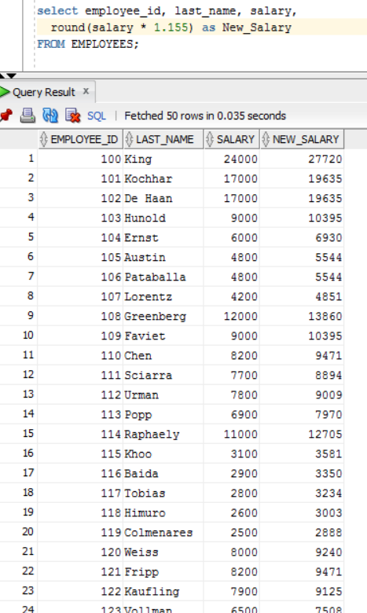

  - Modify the previous query to add a column that subtracts the old salary from the new salary. Label the column Increase.
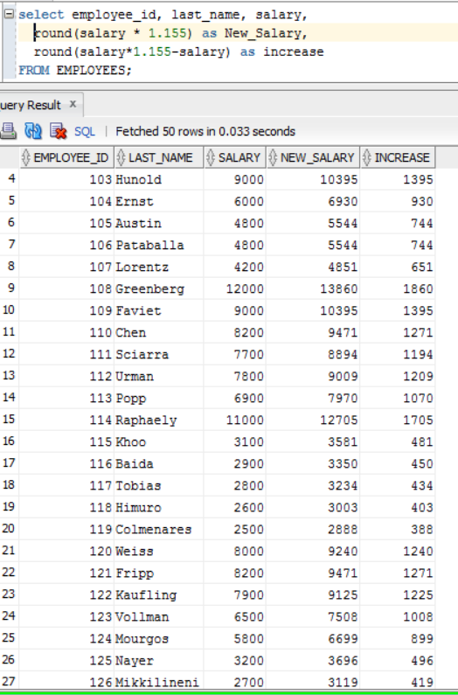

  - Create a query to find the duration of employment for each employee. For each employee, display the last name and calculate the number of months between today and the date on which the employee was hired. Label the column as MONTHS_WORKED. Order your results by the number of months employed. Round the number of months up to the closest whole number.

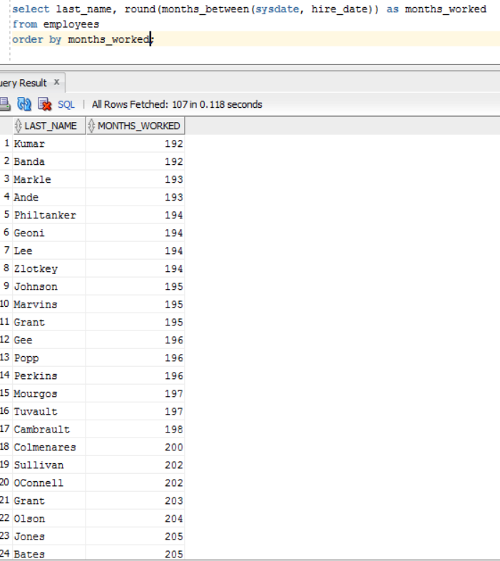

  - Write a query that displays the last name and the length of the last name for all employees whose name starts with the letters “J,” “A,” or “M.” Give each column an appropriate label. Sort the results by the employees’ last names.

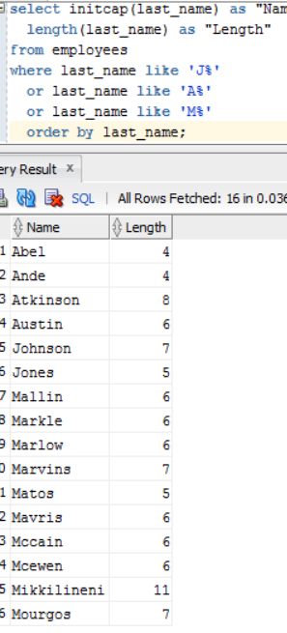

  - Rewrite the previous query so that the user is prompted to enter a letter that the last name starts with. When prompted for a letter, the output should show all employees whose last name starts with the letter.

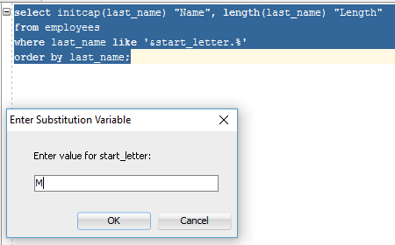
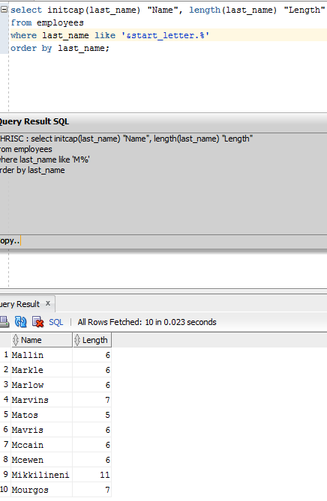

  - Create a query to display the last name and salary for all employees. Format the salary to be 15 characters long, left-padded with the $ symbol.

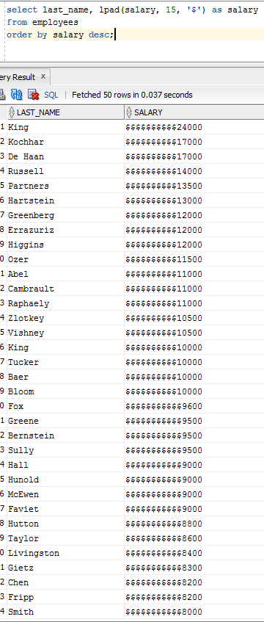

  - Create a query to display each employee’s last name, hire date, and salary review date, which is the first Monday after six months of service. Label the column REVIEW. Format the dates to appear in the format similar to “Monday, the Thirty-First of July, 2000.”

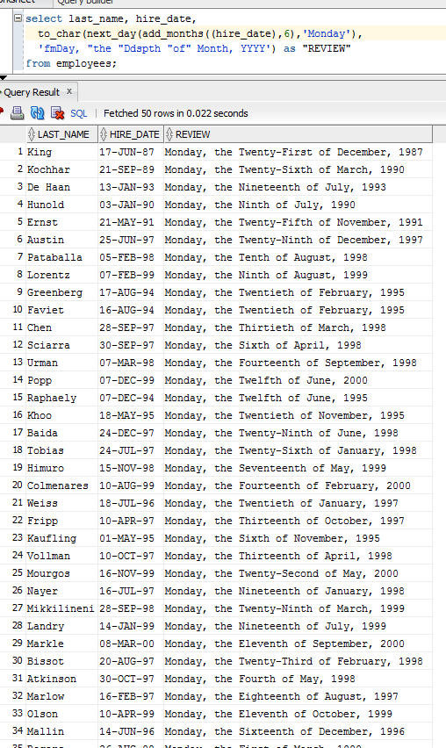

  - Create a query that displays the employees’ last names and commission amounts. If an employee does not earn commission, show “No Commission.” Label the column COMM.

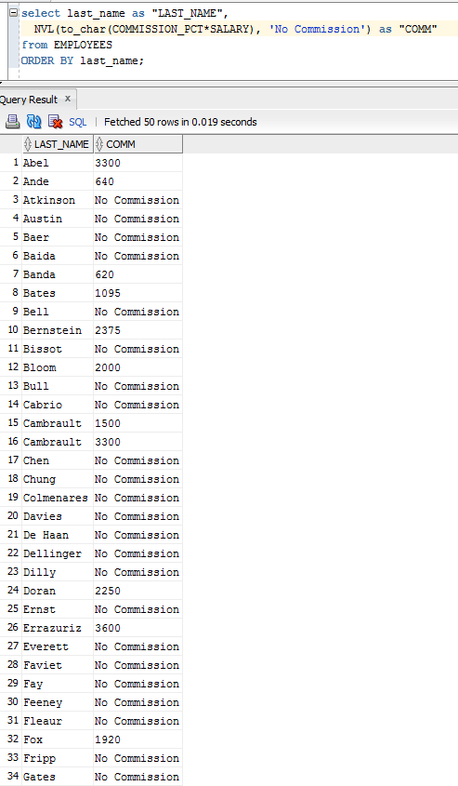
  - Using the DECODE or CASE function, write a query that displays the grade of all employees based on the value of the column JOB_ID, using the following data:

Job Grade
AD_PRES A
ST_MAN B
IT_PROG C
SA_REP D
ST_CLERK E
None of the above 0

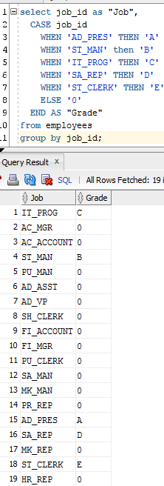
  - Write a query to display the system date. Label the column as Date.

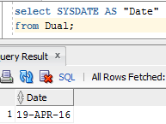
Take a screen shot of each query and its output screen(s) and paste them to your answer sheet.

