App Name

Demo

Import as Maven Project

>>test.code.assignment

Project Structure

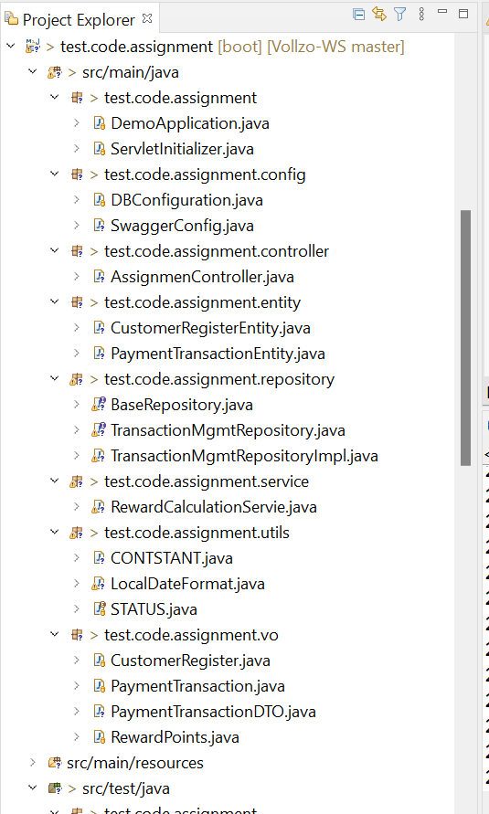

Test Case Run

[INFO]

[INFO] -------------------------------------------------------

[INFO] T E S T S

[INFO] -------------------------------------------------------

[INFO] Running test.code.assignment.**_[1mAssignmenControllerTest**_[m

10:37:45.241 [main] DEBUG org.springframework.test.context.BootstrapUtils - Instantiating CacheAwareContextLoaderDelegate from class [org.springframework.test.context.cache.DefaultCacheAwareContextLoaderDelegate]

10:37:45.248 [main] DEBUG org.springframework.test.context.BootstrapUtils - Instantiating BootstrapContext using constructor [public org.springframework.test.context.support.DefaultBootstrapContext(java.lang.Class,org.springframework.test.context.CacheAwareContextLoaderDelegate)]

10:37:45.279 [main] DEBUG org.springframework.test.context.BootstrapUtils - Instantiating TestContextBootstrapper for test class [test.code.assignment.AssignmenControllerTest] from class [org.springframework.boot.test.autoconfigure.web.servlet.WebMvcTestContextBootstrapper]

10:37:45.288 [main] INFO org.springframework.boot.test.autoconfigure.web.servlet.WebMvcTestContextBootstrapper - Neither @ContextConfiguration nor @ContextHierarchy found for test class [test.code.assignment.AssignmenControllerTest], using SpringBootContextLoader

10:37:45.291 [main] DEBUG org.springframework.test.context.support.AbstractContextLoader - Did not detect default resource location for test class [test.code.assignment.AssignmenControllerTest]: class path resource [test/code/assignment/AssignmenControllerTest-context.xml] does not exist

10:37:45.292 [main] DEBUG org.springframework.test.context.support.AbstractContextLoader - Did not detect default resource location for test class [test.code.assignment.AssignmenControllerTest]: class path resource [test/code/assignment/AssignmenControllerTestContext.groovy] does not exist

10:37:45.292 [main] INFO org.springframework.test.context.support.AbstractContextLoader - Could not detect default resource locations for test class [test.code.assignment.AssignmenControllerTest]: no resource found for suffixes {-context.xml, Context.groovy}.

10:37:45.293 [main] INFO org.springframework.test.context.support.AnnotationConfigContextLoaderUtils - Could not detect default configuration classes for test class [test.code.assignment.AssignmenControllerTest]: AssignmenControllerTest does not declare any static, non-private, non-final, nested classes annotated with @Configuration.

10:37:45.350 [main] DEBUG org.springframework.test.context.support.ActiveProfilesUtils - Could not find an 'annotation declaring class' for annotation type [org.springframework.test.context.ActiveProfiles] and class [test.code.assignment.AssignmenControllerTest]

10:37:45.393 [main] DEBUG org.springframework.context.annotation.ClassPathScanningCandidateComponentProvider - Identified candidate component class: file [C:\Users\tanma\Vollzo-WS\demo\target\classes\test\code\assignment\DemoApplication.class]

10:37:45.394 [main] INFO org.springframework.boot.test.context.SpringBootTestContextBootstrapper - Found @SpringBootConfiguration test.code.assignment.DemoApplication for test class test.code.assignment.AssignmenControllerTest

10:37:45.396 [main] DEBUG org.springframework.boot.test.autoconfigure.web.servlet.WebMvcTestContextBootstrapper - @TestExecutionListeners is not present for class [test.code.assignment.AssignmenControllerTest]: using defaults.

10:37:45.396 [main] INFO org.springframework.boot.test.autoconfigure.web.servlet.WebMvcTestContextBootstrapper - Loaded default TestExecutionListener class names from location [META-INF/spring.factories]: [org.springframework.boot.test.mock.mockito.MockitoTestExecutionListener, org.springframework.boot.test.mock.mockito.ResetMocksTestExecutionListener, org.springframework.boot.test.autoconfigure.restdocs.RestDocsTestExecutionListener, org.springframework.boot.test.autoconfigure.web.client.MockRestServiceServerResetTestExecutionListener, org.springframework.boot.test.autoconfigure.web.servlet.MockMvcPrintOnlyOnFailureTestExecutionListener, org.springframework.boot.test.autoconfigure.web.servlet.WebDriverTestExecutionListener, org.springframework.boot.test.autoconfigure.webservices.client.MockWebServiceServerTestExecutionListener, org.springframework.test.context.web.ServletTestExecutionListener, org.springframework.test.context.support.DirtiesContextBeforeModesTestExecutionListener, org.springframework.test.context.event.ApplicationEventsTestExecutionListener, org.springframework.test.context.support.DependencyInjectionTestExecutionListener, org.springframework.test.context.support.DirtiesContextTestExecutionListener, org.springframework.test.context.transaction.TransactionalTestExecutionListener, org.springframework.test.context.jdbc.SqlScriptsTestExecutionListener, org.springframework.test.context.event.EventPublishingTestExecutionListener]

10:37:45.409 [main] INFO org.springframework.boot.test.autoconfigure.web.servlet.WebMvcTestContextBootstrapper - Using TestExecutionListeners: [org.springframework.test.context.web.ServletTestExecutionListener@363042d7, org.springframework.test.context.support.DirtiesContextBeforeModesTestExecutionListener@366ac49b, org.springframework.test.context.event.ApplicationEventsTestExecutionListener@6ad59d92, org.springframework.boot.test.mock.mockito.MockitoTestExecutionListener@56f0cc85, org.springframework.boot.test.autoconfigure.SpringBootDependencyInjectionTestExecutionListener@62e20a76, org.springframework.test.context.support.DirtiesContextTestExecutionListener@2cc44ad, org.springframework.test.context.transaction.TransactionalTestExecutionListener@44b3606b, org.springframework.test.context.jdbc.SqlScriptsTestExecutionListener@1477089c, org.springframework.test.context.event.EventPublishingTestExecutionListener@663411de, org.springframework.boot.test.mock.mockito.ResetMocksTestExecutionListener@63dd899, org.springframework.boot.test.autoconfigure.restdocs.RestDocsTestExecutionListener@59d2400d, org.springframework.boot.test.autoconfigure.web.client.MockRestServiceServerResetTestExecutionListener@75cd8043, org.springframework.boot.test.autoconfigure.web.servlet.MockMvcPrintOnlyOnFailureTestExecutionListener@33b1c5c5, org.springframework.boot.test.autoconfigure.web.servlet.WebDriverTestExecutionListener@5b202a3a, org.springframework.boot.test.autoconfigure.webservices.client.MockWebServiceServerTestExecutionListener@10b9db7b]

10:37:45.413 [main] DEBUG org.springframework.test.context.support.AbstractDirtiesContextTestExecutionListener - Before test class: context [DefaultTestContext@17a1e4ca testClass = AssignmenControllerTest, testInstance = [null], testMethod = [null], testException = [null], mergedContextConfiguration = [WebMergedContextConfiguration@10ded6a9 testClass = AssignmenControllerTest, locations = '{}', classes = '{class test.code.assignment.DemoApplication}', contextInitializerClasses = '[]', activeProfiles = '{}', propertySourceLocations = '{}', propertySourceProperties = '{org.springframework.boot.test.autoconfigure.web.servlet.WebMvcTestContextBootstrapper=true}', contextCustomizers = set[[ImportsContextCustomizer@c5dc4a2 key = [org.springframework.boot.autoconfigure.cache.CacheAutoConfiguration, org.springframework.boot.autoconfigure.context.MessageSourceAutoConfiguration, org.springframework.boot.autoconfigure.data.web.SpringDataWebAutoConfiguration, org.springframework.boot.autoconfigure.freemarker.FreeMarkerAutoConfiguration, org.springframework.boot.autoconfigure.groovy.template.GroovyTemplateAutoConfiguration, org.springframework.boot.autoconfigure.gson.GsonAutoConfiguration, org.springframework.boot.autoconfigure.hateoas.HypermediaAutoConfiguration, org.springframework.boot.autoconfigure.http.HttpMessageConvertersAutoConfiguration, org.springframework.boot.autoconfigure.jackson.JacksonAutoConfiguration, org.springframework.boot.autoconfigure.jsonb.JsonbAutoConfiguration, org.springframework.boot.autoconfigure.mustache.MustacheAutoConfiguration, org.springframework.boot.autoconfigure.task.TaskExecutionAutoConfiguration, org.springframework.boot.autoconfigure.thymeleaf.ThymeleafAutoConfiguration, org.springframework.boot.autoconfigure.validation.ValidationAutoConfiguration, org.springframework.boot.autoconfigure.web.servlet.error.ErrorMvcAutoConfiguration, org.springframework.boot.autoconfigure.web.servlet.HttpEncodingAutoConfiguration, org.springframework.boot.autoconfigure.web.servlet.WebMvcAutoConfiguration, org.springframework.boot.test.autoconfigure.web.servlet.MockMvcAutoConfiguration, org.springframework.boot.test.autoconfigure.web.servlet.MockMvcWebClientAutoConfiguration, org.springframework.boot.test.autoconfigure.web.servlet.MockMvcWebDriverAutoConfiguration, org.springframework.boot.autoconfigure.security.oauth2.client.servlet.OAuth2ClientAutoConfiguration, org.springframework.boot.autoconfigure.security.oauth2.resource.servlet.OAuth2ResourceServerAutoConfiguration, org.springframework.boot.autoconfigure.security.servlet.SecurityAutoConfiguration, org.springframework.boot.autoconfigure.security.servlet.SecurityFilterAutoConfiguration, org.springframework.boot.autoconfigure.security.servlet.UserDetailsServiceAutoConfiguration, org.springframework.boot.test.autoconfigure.web.servlet.MockMvcSecurityConfiguration, org.springframework.boot.test.autoconfigure.web.reactive.WebTestClientAutoConfiguration]], org.springframework.boot.test.context.filter.ExcludeFilterContextCustomizer@225129c, org.springframework.boot.test.json.DuplicateJsonObjectContextCustomizerFactory$DuplicateJsonObjectContextCustomizer@479ceda0, org.springframework.boot.test.mock.mockito.MockitoContextCustomizer@97ce1b53, org.springframework.boot.test.autoconfigure.OverrideAutoConfigurationContextCustomizerFactory$DisableAutoConfigurationContextCustomizer@73302995, org.springframework.boot.test.autoconfigure.actuate.metrics.MetricsExportContextCustomizerFactory$DisableMetricExportContextCustomizer@51133c06, org.springframework.boot.test.autoconfigure.filter.TypeExcludeFiltersContextCustomizer@7023001b, org.springframework.boot.test.autoconfigure.properties.PropertyMappingContextCustomizer@a56b435, org.springframework.boot.test.autoconfigure.web.servlet.WebDriverContextCustomizerFactory$Customizer@67545b57, org.springframework.boot.test.context.SpringBootTestArgs@1, org.springframework.boot.test.context.SpringBootTestWebEnvironment@0], resourceBasePath = 'src/main/webapp', contextLoader = 'org.springframework.boot.test.context.SpringBootContextLoader', parent = [null]], attributes = map[[empty]]], class annotated with @DirtiesContext [false] with mode [null].

. ____ _ __ _ _

/\\ / ___'_ __ _ _(_)_ __ __ _ \ \ \ \

( ( )\___ | '_ | '_| | '_ \/ _` | \ \ \ \

\\/ ___)| |_)| | | | | || (_| | ) ) ) )

' |____| .__|_| |_|_| |_\__, | / / / /

=========|_|==============|___/=/_/_/_/

:: Spring Boot :: (v2.7.10)

2023-04-08 10:37:45.828 INFO 12084 --- [ main] t.c.assignment.AssignmenControllerTest : Starting AssignmenControllerTest using Java 11.0.9 on LAPTOP-Abhiraj with PID 12084 (started by tanma in C:\Users\tanma\Vollzo-WS\demo)

2023-04-08 10:37:45.829 INFO 12084 --- [ main] t.c.assignment.AssignmenControllerTest : No active profile set, falling back to 1 default profile: "default"

2023-04-08 10:37:47.093 INFO 12084 --- [ main] o.s.b.t.m.w.SpringBootMockServletContext : Initializing Spring TestDispatcherServlet ''

2023-04-08 10:37:47.093 INFO 12084 --- [ main] o.s.t.web.servlet.TestDispatcherServlet : Initializing Servlet ''

2023-04-08 10:37:47.095 INFO 12084 --- [ main] o.s.t.web.servlet.TestDispatcherServlet : Completed initialization in 2 ms

2023-04-08 10:37:47.118 INFO 12084 --- [ main] t.c.assignment.AssignmenControllerTest : Started AssignmenControllerTest in 1.673 seconds (JVM running for 3.446)

[INFO] **_[1;32mTests run: _[0;1;32m2**_[m, Failures: 0, Errors: 0, Skipped: 0, Time elapsed: 2.062 s - in test.code.assignment.**_[1mAssignmenControllerTest**_[m

[INFO] Running test.code.assignment.**_[1mDemoApplicationTests**_[m

2023-04-08 10:37:47.262 INFO 12084 --- [ main] .b.t.c.SpringBootTestContextBootstrapper : Neither @ContextConfiguration nor @ContextHierarchy found for test class [test.code.assignment.DemoApplicationTests], using SpringBootContextLoader

2023-04-08 10:37:47.262 INFO 12084 --- [ main] o.s.t.c.support.AbstractContextLoader : Could not detect default resource locations for test class [test.code.assignment.DemoApplicationTests]: no resource found for suffixes {-context.xml, Context.groovy}.

2023-04-08 10:37:47.263 INFO 12084 --- [ main] t.c.s.AnnotationConfigContextLoaderUtils : Could not detect default configuration classes for test class [test.code.assignment.DemoApplicationTests]: DemoApplicationTests does not declare any static, non-private, non-final, nested classes annotated with @Configuration.

2023-04-08 10:37:47.265 INFO 12084 --- [ main] .b.t.c.SpringBootTestContextBootstrapper : Found @SpringBootConfiguration test.code.assignment.DemoApplication for test class test.code.assignment.DemoApplicationTests

2023-04-08 10:37:47.269 INFO 12084 --- [ main] .b.t.c.SpringBootTestContextBootstrapper : Loaded default TestExecutionListener class names from location [META-INF/spring.factories]: [org.springframework.boot.test.mock.mockito.MockitoTestExecutionListener, org.springframework.boot.test.mock.mockito.ResetMocksTestExecutionListener, org.springframework.boot.test.autoconfigure.restdocs.RestDocsTestExecutionListener, org.springframework.boot.test.autoconfigure.web.client.MockRestServiceServerResetTestExecutionListener, org.springframework.boot.test.autoconfigure.web.servlet.MockMvcPrintOnlyOnFailureTestExecutionListener, org.springframework.boot.test.autoconfigure.web.servlet.WebDriverTestExecutionListener, org.springframework.boot.test.autoconfigure.webservices.client.MockWebServiceServerTestExecutionListener, org.springframework.test.context.web.ServletTestExecutionListener, org.springframework.test.context.support.DirtiesContextBeforeModesTestExecutionListener, org.springframework.test.context.event.ApplicationEventsTestExecutionListener, org.springframework.test.context.support.DependencyInjectionTestExecutionListener, org.springframework.test.context.support.DirtiesContextTestExecutionListener, org.springframework.test.context.transaction.TransactionalTestExecutionListener, org.springframework.test.context.jdbc.SqlScriptsTestExecutionListener, org.springframework.test.context.event.EventPublishingTestExecutionListener]

2023-04-08 10:37:47.270 INFO 12084 --- [ main] .b.t.c.SpringBootTestContextBootstrapper : Using TestExecutionListeners: [org.springframework.test.context.web.ServletTestExecutionListener@70d3cdbf, org.springframework.test.context.support.DirtiesContextBeforeModesTestExecutionListener@72a7aa4f, org.springframework.test.context.event.ApplicationEventsTestExecutionListener@537ca28e, org.springframework.boot.test.mock.mockito.MockitoTestExecutionListener@5b322873, org.springframework.boot.test.autoconfigure.SpringBootDependencyInjectionTestExecutionListener@35e2b89f, org.springframework.test.context.support.DirtiesContextTestExecutionListener@7ad889be, org.springframework.test.context.transaction.TransactionalTestExecutionListener@4c063cb9, org.springframework.test.context.jdbc.SqlScriptsTestExecutionListener@63de4fa, org.springframework.test.context.event.EventPublishingTestExecutionListener@26bb92e2, org.springframework.boot.test.mock.mockito.ResetMocksTestExecutionListener@18907af2, org.springframework.boot.test.autoconfigure.restdocs.RestDocsTestExecutionListener@658e7ead, org.springframework.boot.test.autoconfigure.web.client.MockRestServiceServerResetTestExecutionListener@cfd5cd2, org.springframework.boot.test.autoconfigure.web.servlet.MockMvcPrintOnlyOnFailureTestExecutionListener@762bf32d, org.springframework.boot.test.autoconfigure.web.servlet.WebDriverTestExecutionListener@6d7740f0, org.springframework.boot.test.autoconfigure.webservices.client.MockWebServiceServerTestExecutionListener@7b1a30e5]

. ____ _ __ _ _

/\\ / ___'_ __ _ _(_)_ __ __ _ \ \ \ \

( ( )\___ | '_ | '_| | '_ \/ _` | \ \ \ \

\\/ ___)| |_)| | | | | || (_| | ) ) ) )

' |____| .__|_| |_|_| |_\__, | / / / /

=========|_|==============|___/=/_/_/_/

:: Spring Boot :: (v2.7.10)

2023-04-08 10:37:47.325 INFO 12084 --- [ main] t.code.assignment.DemoApplicationTests : Starting DemoApplicationTests using Java 11.0.9 on LAPTOP-Abhiraj with PID 12084 (started by tanma in C:\Users\tanma\Vollzo-WS\demo)

2023-04-08 10:37:47.325 INFO 12084 --- [ main] t.code.assignment.DemoApplicationTests : No active profile set, falling back to 1 default profile: "default"

2023-04-08 10:37:47.796 INFO 12084 --- [ main] .s.d.r.c.RepositoryConfigurationDelegate : Bootstrapping Spring Data JPA repositories in DEFAULT mode.

2023-04-08 10:37:47.848 INFO 12084 --- [ main] .s.d.r.c.RepositoryConfigurationDelegate : Finished Spring Data repository scanning in 43 ms. Found 1 JPA repository interfaces.

2023-04-08 10:37:48.270 INFO 12084 --- [ main] com.zaxxer.hikari.HikariDataSource : HikariPool-1 - Starting...

2023-04-08 10:37:48.838 INFO 12084 --- [ main] com.zaxxer.hikari.HikariDataSource : HikariPool-1 - Start completed.

2023-04-08 10:37:48.894 INFO 12084 --- [ main] o.hibernate.jpa.internal.util.LogHelper : HHH000204: Processing PersistenceUnitInfo [name: default]

2023-04-08 10:37:48.944 INFO 12084 --- [ main] org.hibernate.Version : HHH000412: Hibernate ORM core version 5.6.15.Final

2023-04-08 10:37:49.003 INFO 12084 --- [ main] o.hibernate.annotations.common.Version : HCANN000001: Hibernate Commons Annotations {5.1.2.Final}

2023-04-08 10:37:49.145 INFO 12084 --- [ main] org.hibernate.dialect.Dialect : HHH000400: Using dialect: org.hibernate.dialect.Oracle10gDialect

2023-04-08 10:37:49.743 INFO 12084 --- [ main] o.h.e.t.j.p.i.JtaPlatformInitiator : HHH000490: Using JtaPlatform implementation: [org.hibernate.engine.transaction.jta.platform.internal.NoJtaPlatform]

2023-04-08 10:37:49.754 INFO 12084 --- [ main] j.LocalContainerEntityManagerFactoryBean : Initialized JPA EntityManagerFactory for persistence unit 'default'

2023-04-08 10:37:50.415 WARN 12084 --- [ main] JpaBaseConfiguration$JpaWebConfiguration : spring.jpa.open-in-view is enabled by default. Therefore, database queries may be performed during view rendering. Explicitly configure spring.jpa.open-in-view to disable this warning

2023-04-08 10:37:51.310 INFO 12084 --- [ main] t.code.assignment.DemoApplicationTests : Started DemoApplicationTests in 4.037 seconds (JVM running for 7.637)

[INFO] **_[1;32mTests run: _[0;1;32m1**_[m, Failures: 0, Errors: 0, Skipped: 0, Time elapsed: 4.008 s - in test.code.assignment.**_[1mDemoApplicationTests**_[m

2023-04-08 10:37:51.337 INFO 12084 --- [ionShutdownHook] j.LocalContainerEntityManagerFactoryBean : Closing JPA EntityManagerFactory for persistence unit 'default'

2023-04-08 10:37:51.339 INFO 12084 --- [ionShutdownHook] com.zaxxer.hikari.HikariDataSource : HikariPool-1 - Shutdown initiated...

2023-04-08 10:37:51.354 INFO 12084 --- [ionShutdownHook] com.zaxxer.hikari.HikariDataSource : HikariPool-1 - Shutdown completed.

[INFO]

[INFO] Results:

[INFO]

[INFO] **_[1;32mTests run: 3, Failures: 0, Errors: 0, Skipped: 0**_[m

[INFO]

[INFO] **_[1m------------------------------------------------------------------------**_[m

[INFO] **_[1;32mBUILD SUCCESS**_[m

[INFO] **_[1m------------------------------------------------------------------------**_[m

[INFO] Total time: 14.174 s

[INFO] Finished at: 2023-04-08T10:37:51-05:00

[INFO] **_[1m------------------------------------------------------------------------**_[m

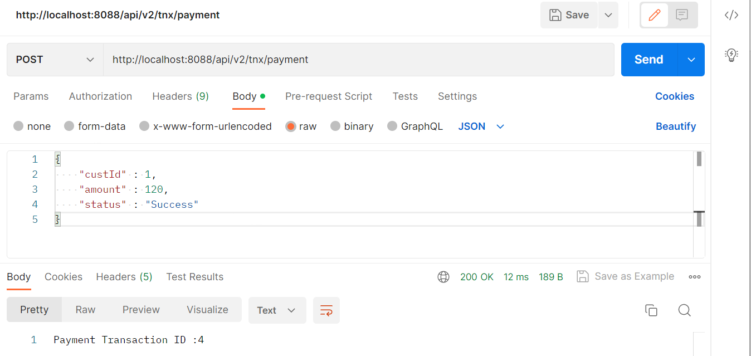

Get Reward file:

