**Support Manager**

Start a career in IT company

Basic knowledge languages including HTML, CSS, SQL, PYTHON. Strong background in project management and customer relations.

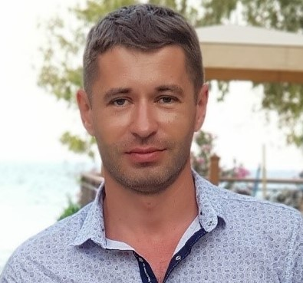

**Phone:**

+38 067 3343813

**E-Mail:**

m20.volodymyr@gmail.com

**Linkedin:**

linkedin.com/volodymyr moroz

# Skills

* SCRUM
* AGILE
* PYTHON
* HTML CSS
* SQL
* Basics of testing
* Team lead
* Project management
* Strong decision maker
* Complex problem solver
* Negotiations
* Strategic planning

# Languages

English B2

Polish B2

Russian

Ukrainian

# Experience

04/2016 to 08/2020

**Project manager - Openmind, Epikur Vinnytsia**

* Fully responsibility for operative management and all activities of the sales representation.
* Developping and implementing model of joint negotiations for branded goods including data models, analytics, tools, communication.
* Organization of teamwork and effective interaction of all structural divisions of the enterprise.

08/2006-12/2016

**Head of outlet - PrJSC Credit Agricole Bank, Volodymyr-Volynsky**

* Fully responsibility for operative management and all activities of branch
* Control the implementation of financial indicators, the sales plans and development plans

# Education

**Master of Human Resource Management and Labor Economics -**

**Ternopil National Economic Academy**

# Certifications

**Blockchain, Bitcoin & crypto:** Ministry of Digital Transformation of Ukraine.

**Python :** Udemy.

# About me

I have good analytical skills. I learn easily. I work well in a team.

Responsible, purposeful. Lead a healthy lifestyle.

VOLODYMYR MOROZ