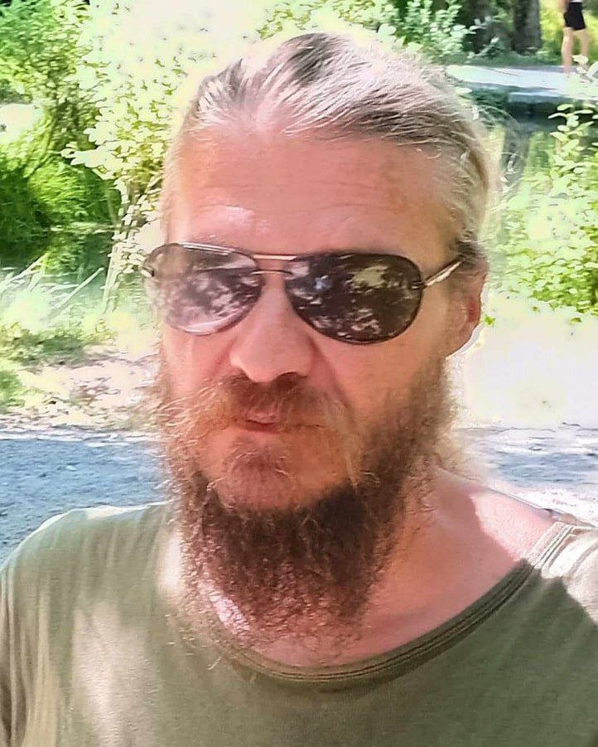**Volodymyr Serhiienko**

**Software Engineer**

📍 Oslo, Mikael Hertzbergs vei 10B, 0495

📞 +47 968 40 767 | ✉️ utos.vovik@gmail.com

born: 26. august 1982

[My personal](https://volodymyr-serhiienko.github.io/My-Resume/) website | [My LinkedIn](https://www.linkedin.com/in/volodymyr-serhiienko-a06468297/)

**Profile**

Motivated and structured graduate engineer who wants to join new, exciting and useful projects. I have experience from my own full-stack projects. My background as a manager in industry gave me strong skills in planning, organizing, teamwork and responsibility.

**Key Qualifications**

* Full-stack development of own projects from idea to finished solution
* Programming languages: HTML, CSS, JavaScript, C#, SQL
* Experience with C#.NET Core, API development, AI integration
* Fast learner, able to study new technologies quickly
* Strong organizational experience from management positions
* Structured, responsible and team-oriented

**Education**

|  |  |
| --- | --- |
| **2021 - 2023** | **Kharkiv National University of Radio Electronics, Ukraine** |
|  | Bachelor in Software Engineering, graduated with honors  Qualification project – web application for automatic calculations of astronomical, astrological, and numerological data. [ C#.NET, ASP.NET Core, MVC, Razor, Sqlite, ADO.NET, HTML, CSS, JavaScript ] |
| **1997 - 2012** | **Dnipro National Metallurgical University, Ukraine** |
|  | Master and Bachelor in Metallurgy (electrometallurgy, metal forming by pressure) |

**Work Experience**

|  |  |
| --- | --- |
| **2021-now** | **Developer**, personal projects  Developed and designed several full-stack web applications..  Projects:  **1. Study Languages** – language learning web application (user / admin interface + API). Project in progress, with adaptation for visually impaired users. [ C#.NET, ASP.NET Web API, Sqlite, ADO.NET, HTML, CSS, JavaScript ]  **2.** **AI-Astrologer** – web application for calculating astrological parameters and human characteristics for a chosen day (user interface + API). Project with AI integration. [ C#.NET, ASP.NET Web API, HTML, CSS, JavaScript ]  **3.** **Kolady Dar** – web application, ancient calendar system, automatic calculations, information (user interface + API). [ C#.NET, ASP.NET Web API, HTML, CSS, JavaScript ]  **4.** **Other projects** – web, mobile, and desktop applications on various topics. [ C#.NET, ASP.NET Core, MVC, Razor, MAUI, Sqlite, SQL Server, ADO.NET, HTML, CSS, JavaScript ] |
| **2009-2012** | **Engineer / Department Manager**, **«**Centravis Production Ukraine» (metallurgical factory) |
|  | Managed a team and responsible for production process. Planning, analysis, statistics and reporting. Cooperation with researchers and management, both national and international |
| **2002** | **Key Account Manager**, «DniproAvia Airlines» (airline company) |
|  | Work in commercial department with cargo and freight |
| **2001** | **Manager**, «Alternativ» Ltd (staffing agency) |
|  | Recruitment of employees, advertising and publishing job positions |

**Other**

* **Languages:** Ukrainian (native), Russian (native), Norwegian (B1), English (B1)
* **Courses:** Norwegian language course (ongoing)
* **Voluntary roles:** Leader in student union, conductor of orchestra/band
* **Interests:** Self-development, music, running, chess and books

**References**

Available upon request