TEST TEXT

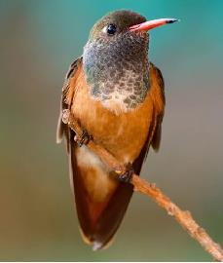
ANCRAGE Image 1



TEST TEXT 2

