1. Calculating the probability of a union of events:
   1. The union of several events is an event that contains all the outcomes from the original events without duplication. The probability of the union of several events is the sum of the probabilities of the separate events minus the probability of the intersection among the events. For two events, the equation is shown here, if events are disjoint, the probability of intersection is zero. And the equation for union simplifies to only adding up the separate probabilities.
   2. 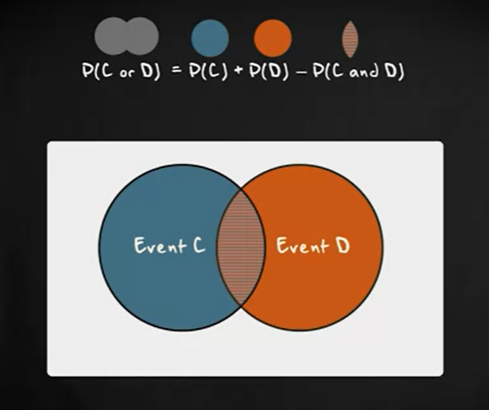
2. The Central Limit Theorem (CLT):
   1. The mean of the sampling distribution of means is equal to the mean of the population from which the samples were drawn
      1. Sample mean is a random variable
      2. Sample mean targets the population
   2. The variance of the sampling distribution of mean is equal to the variance of the population from which the samples were drawn devided by the size of samples
   3. If the original distribution is normally distributed the sampling distribution of the means will also be normal
3. Probability Distributions: Density Functions

Example:

* 1. Let be a continuous random variable whose probability density function is: $f\left(x\right)=3x^{2}$, find the probability of $0<x<1$

Solution:

$\int_{0}^{1}{3x^{2}dx=1-0=1}$

1. Variance of random variable:

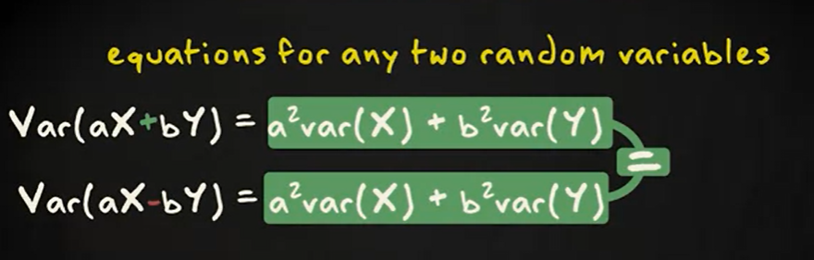

1. The mean of a random variable:

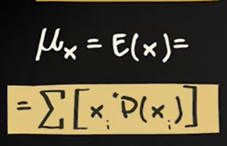

1. The Mean and variance of Bernoulli distributed variable

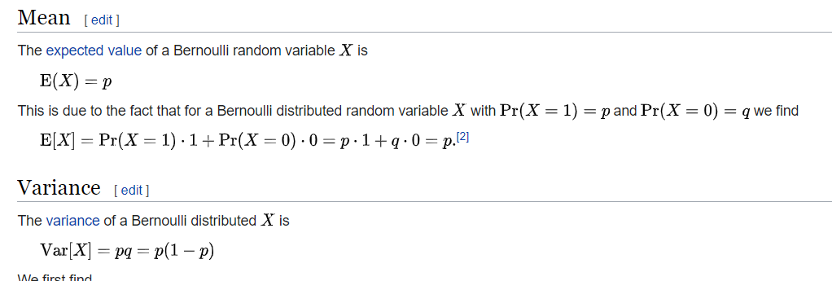

1. Binomial distribution:
   1. The binomial distribution is a discrete probability distribution that is used when a random variable can have two mutually exclusive outcomes, success and failure. It gives the probability of observing x successes in n outcomes of the random variable, so called trials, with the probability of success on a single trial denoted by p. The binomial distribution assumes that p is fixed for all trials.
   2. The mean of such a distribution is n times p
   3. standard deviation is the square root of n times p times 1 minus p
   4. 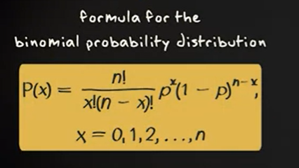
2. Residual - E, the residual, which is y- y hat. So every element of E for example if this distance. So E 5 would be the distance between Y 5 and Y hat 5. Is the vector that is orthogonal to the plane that points up to the data point y
3. R squared:
   1. Calculate as a square of correlation
   2. Strength of fit of linear model is commonly evaluated using R squared
   3. Always between 0 and 1