**Лабораторна робота №2. ОБЧИСЛЕННЯ ВИЗНАЧЕНОГО ІНТЕГРАЛУ**

**Луцкевич Володимир Андрійович РЕ-12**

Мета: Алгоритми обчислення визначеного інтегралу

|  |
| --- |
| #define _CRT_SECURE_NO_WARNINGS |
|  |

|  |
| --- |
|  |
|  |

|  |
| --- |
| #include <conio.h> |
|  |

|  |
| --- |
| #include <stdio.h> |
|  |

|  |
| --- |
| #include <stdlib.h> |
|  |

|  |
| --- |
| #include <math.h> |
|  |

|  |
| --- |
|  |
|  |

|  |
| --- |
|  |
|  |

|  |
| --- |
|  |
|  |

|  |
| --- |
| //double F(double x) { |
|  |

|  |
| --- |
| // return (-3 * x * x + 2 * x + 9); |
|  |

|  |
| --- |
| //} |
|  |

|  |
| --- |
| double I(double a, double b, int n, double y) { |
|  |

|  |
| --- |
| return ((b - a) / (2 * n) * y); |
|  |

|  |
| --- |
| } |
|  |

|  |
| --- |
|  |
|  |

|  |
| --- |
| double f(double x) |
|  |

|  |
| --- |
| { |
|  |

|  |
| --- |
| return sin(x * x + 2 * x); |
|  |

|  |
| --- |
| } |
|  |

|  |
| --- |
|  |
|  |

|  |
| --- |
| int main() { |
|  |

|  |
| --- |
| double a, b, eps; |
|  |

|  |
| --- |
| double nom = 0; |
|  |

|  |
| --- |
| printf("Enter your variant"); |
|  |

|  |
| --- |
| do { |
|  |

|  |
| --- |
|  |
|  |

|  |
| --- |
| scanf("\t%lf", &nom); |
|  |

|  |
| --- |
|  |
|  |

|  |
| --- |
| /*if (nom != 1 && nom != 2 && nom != 3 && nom != 4) |
|  |

|  |
| --- |
| { |
|  |

|  |
| --- |
| fprintf(stdout, "%s\n ", " Error"); |
|  |

|  |
| --- |
|  |
|  |

|  |
| --- |
| }*/ |
|  |

|  |
| --- |
|  |
|  |

|  |
| --- |
| } while (nom != 1 && nom != 2 && nom != 3 && nom != 4); |
|  |

|  |
| --- |
|  |
|  |

|  |
| --- |
|  |
|  |

|  |
| --- |
|  |
|  |

|  |
| --- |
| if (nom == 1) |
|  |

|  |
| --- |
| { |
|  |

|  |
| --- |
| printf("Metod1"); |
|  |

|  |
| --- |
|  |
|  |

|  |
| --- |
| double a, b; |
|  |

|  |
| --- |
| int n; |
|  |

|  |
| --- |
| printf("\na = "); |
|  |

|  |
| --- |
| scanf("%lf", &a); |
|  |

|  |
| --- |
| printf("\nb = "); |
|  |

|  |
| --- |
| scanf("%lf", &b); |
|  |

|  |
| --- |
| printf("\nn = "); |
|  |

|  |
| --- |
| scanf("%i", &n); |
|  |

|  |
| --- |
| double s = (f(a) + f(b)) / 2; |
|  |

|  |
| --- |
| double h = (b - a) / n; |
|  |

|  |
| --- |
| for (int i = 1; i <= n - 1; i++) |
|  |

|  |
| --- |
| { |
|  |

|  |
| --- |
| s += f(a + i * h); |
|  |

|  |
| --- |
| } |
|  |

|  |
| --- |
| double I = h * s; |
|  |

|  |
| --- |
| printf("%lf", I); |
|  |

|  |
| --- |
| } |
|  |

|  |
| --- |
| else if (nom == 2) |
|  |

|  |
| --- |
| { |
|  |

|  |
| --- |
| printf("Metod2"); |
|  |

|  |
| --- |
| double a, b; |
|  |

|  |
| --- |
| int n; |
|  |

|  |
| --- |
| printf("\na = "); |
|  |

|  |
| --- |
| scanf("%lf", &a); |
|  |

|  |
| --- |
| printf("\nb = "); |
|  |

|  |
| --- |
| scanf("%lf", &b); |
|  |

|  |
| --- |
| printf("\nn = "); |
|  |

|  |
| --- |
| scanf("%i", &n); |
|  |

|  |
| --- |
| double s = (f(a) + f(b)) / 2; |
|  |

|  |
| --- |
| double h = (b - a) / n; |
|  |

|  |
| --- |
| for (int i = 1; i <= n - 1; i++) |
|  |

|  |
| --- |
| { |
|  |

|  |
| --- |
| s += f(a + i * h); |
|  |

|  |
| --- |
| } |
|  |

|  |
| --- |
| double I = h * s; |
|  |

|  |
| --- |
| printf("%lf", I); |
|  |

|  |
| --- |
| } |
|  |

|  |
| --- |
| else if (nom == 3) |
|  |

|  |
| --- |
| { |
|  |

|  |
| --- |
| printf("Metod3"); |
|  |

|  |
| --- |
| int n ; |
|  |

|  |
| --- |
| double a, b, y = 0, dy, In; |
|  |

|  |
| --- |
| printf("\na = "); |
|  |

|  |
| --- |
| scanf("%lf", &a); |
|  |

|  |
| --- |
| printf("\nb = "); |
|  |

|  |
| --- |
| scanf("%lf", &b); |
|  |

|  |
| --- |
| printf("\nn = "); |
|  |

|  |
| --- |
| scanf("%i", &n); |
|  |

|  |
| --- |
| if (n > 1) { |
|  |

|  |
| --- |
| dy = (b - a) / n; |
|  |

|  |
| --- |
| y += f(a) + f(b); |
|  |

|  |
| --- |
| for (int i = 1; i < n; i++) { y += 2 * (f(a + dy * i)); } |
|  |

|  |
| --- |
| In = I(a, b, n, y); |
|  |

|  |
| --- |
| printf("%lf", In); |
|  |

|  |
| --- |
| } |
|  |

|  |
| --- |
| else { |
|  |

|  |
| --- |
| printf("Error"); |
|  |

|  |
| --- |
| } |
|  |

|  |
| --- |
|  |
|  |

|  |
| --- |
| } |
|  |

|  |
| --- |
| else if (nom == 4) |
|  |

|  |
| --- |
| { |
|  |

|  |
| --- |
| printf("Metod4"); |
|  |

|  |
| --- |
| printf("\na = "); |
|  |

|  |
| --- |
| scanf("%lf", &a); |
|  |

|  |
| --- |
| printf("\nb = "); |
|  |

|  |
| --- |
| scanf("%lf", &b); |
|  |

|  |
| --- |
| eps = 0.0001; |
|  |

|  |
| --- |
|  |
|  |

|  |
| --- |
|  |
|  |

|  |
| --- |
| double I = eps + 1, I1 = 0; |
|  |

|  |
| --- |
| for (int N = 2; (N <= 4) || (fabs(I1 - I) > eps); N *= 2) |
|  |

|  |
| --- |
| { |
|  |

|  |
| --- |
| double h, sum2 = 0, sum4 = 0, sum = 0; |
|  |

|  |
| --- |
| h = (b - a) / (2 * N); |
|  |

|  |
| --- |
| for (int i = 1; i <= 2 * N - 1; i += 2) |
|  |

|  |
| --- |
| { |
|  |

|  |
| --- |
| sum4 += f(a + h * i); |
|  |

|  |
| --- |
| sum2 += f(a + h * (i + 1)); |
|  |

|  |
| --- |
| } |
|  |

|  |
| --- |
| sum = f(a) + 4 * sum4 + 2 * sum2 - f(b); |
|  |

|  |
| --- |
| I = I1; |
|  |

|  |
| --- |
| I1 = (h / 3) * sum; |
|  |

|  |
| --- |
| } |
|  |

|  |
| --- |
| printf("%lf", I1); |
|  |

|  |
| --- |
| } |
|  |

|  |
| --- |
|  |
|  |

|  |
| --- |
|  |
|  |

|  |
| --- |
|  |
|  |

|  |
| --- |
| return 0; |
|  |

|  |
| --- |
| } |
|  |

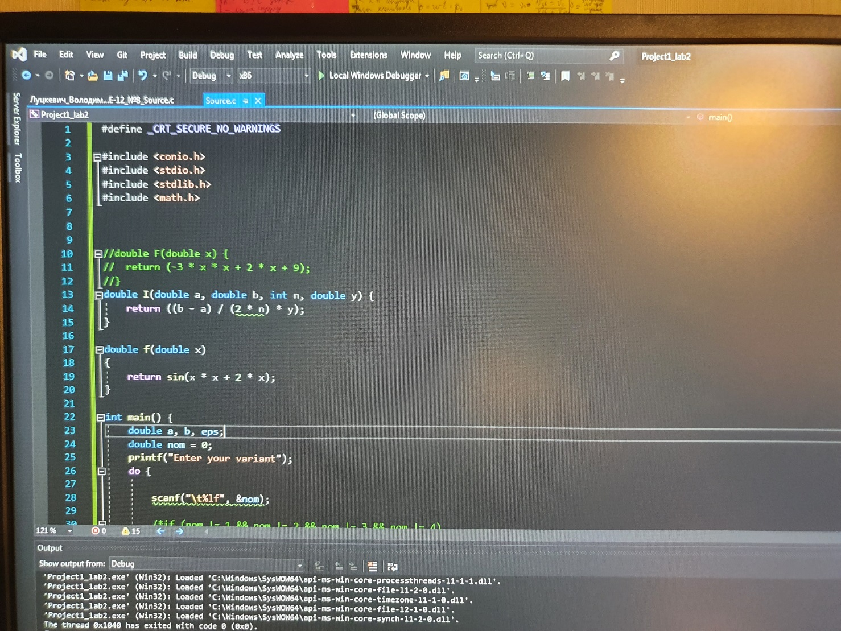

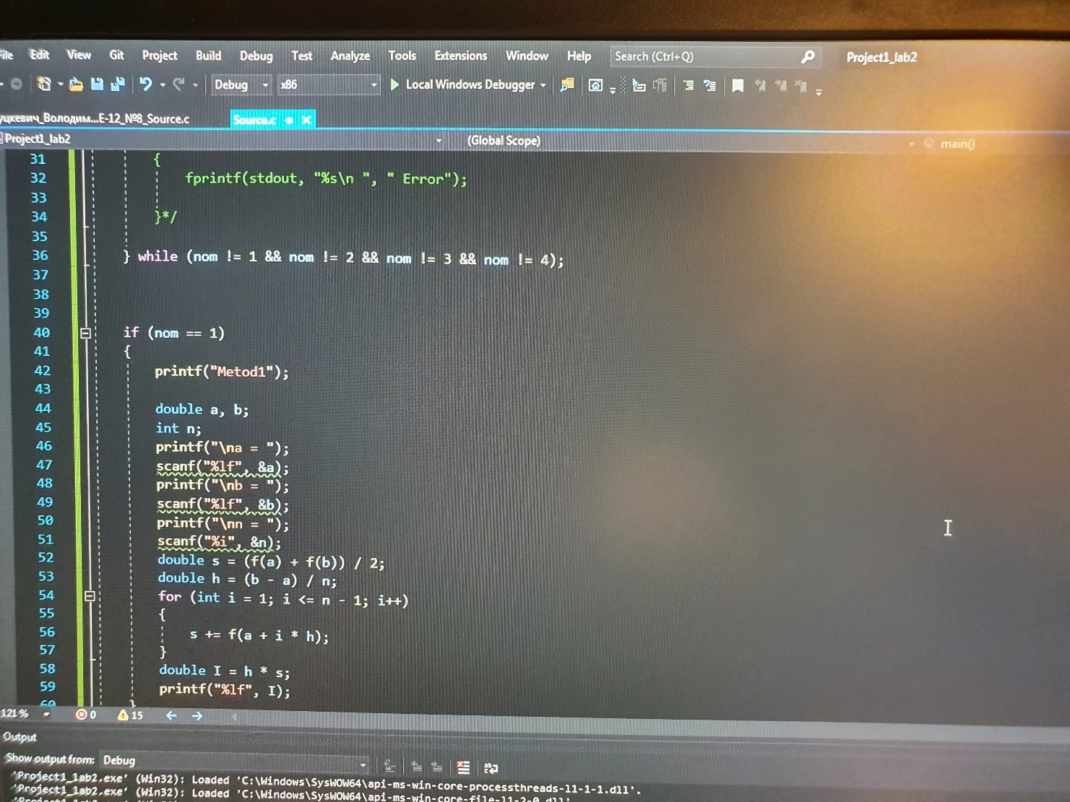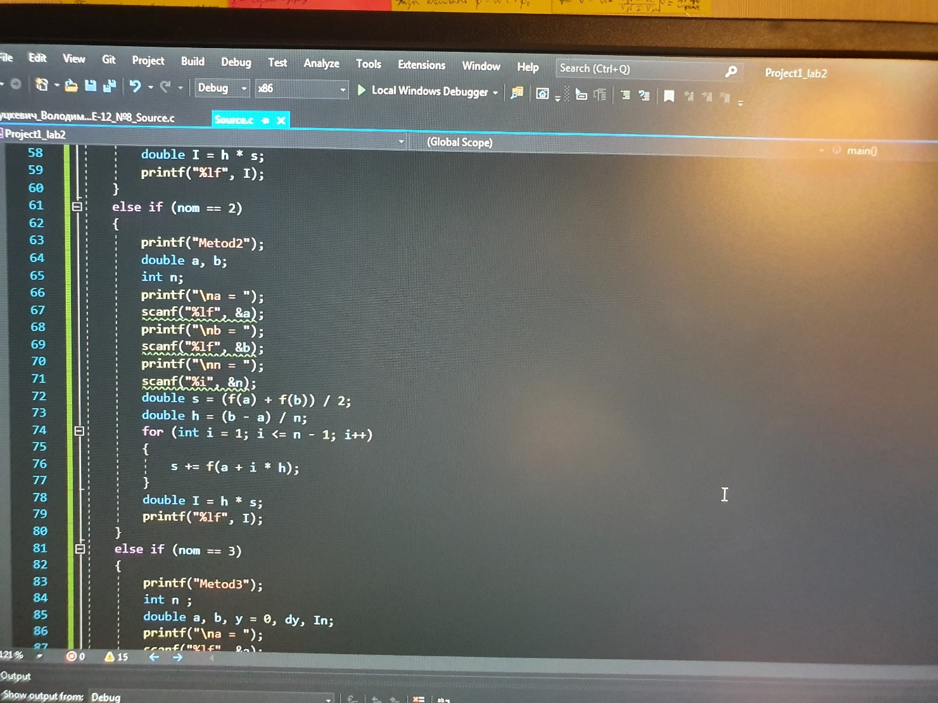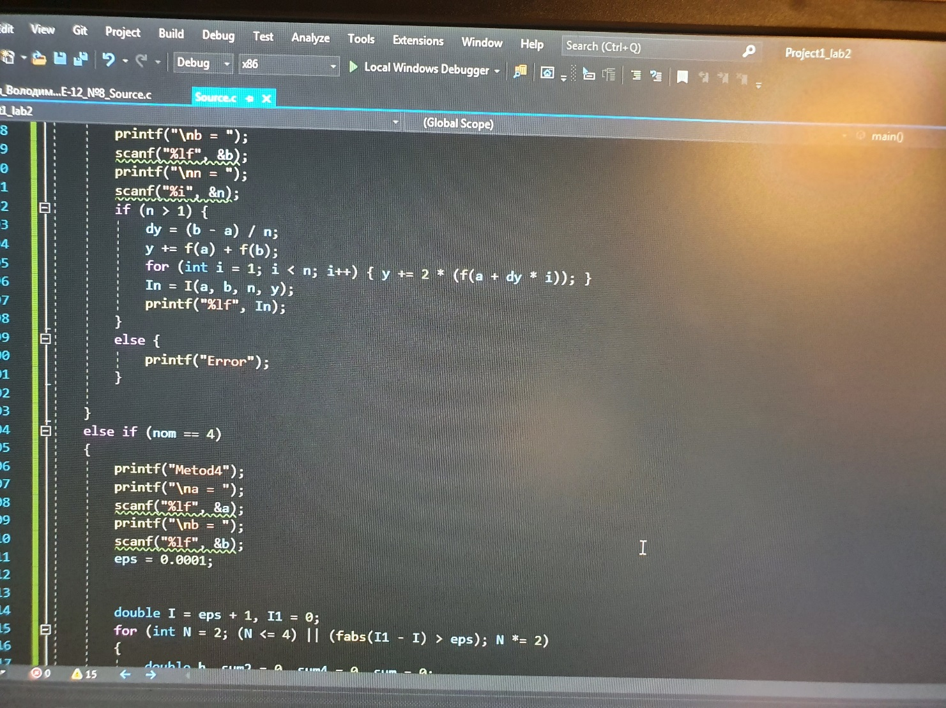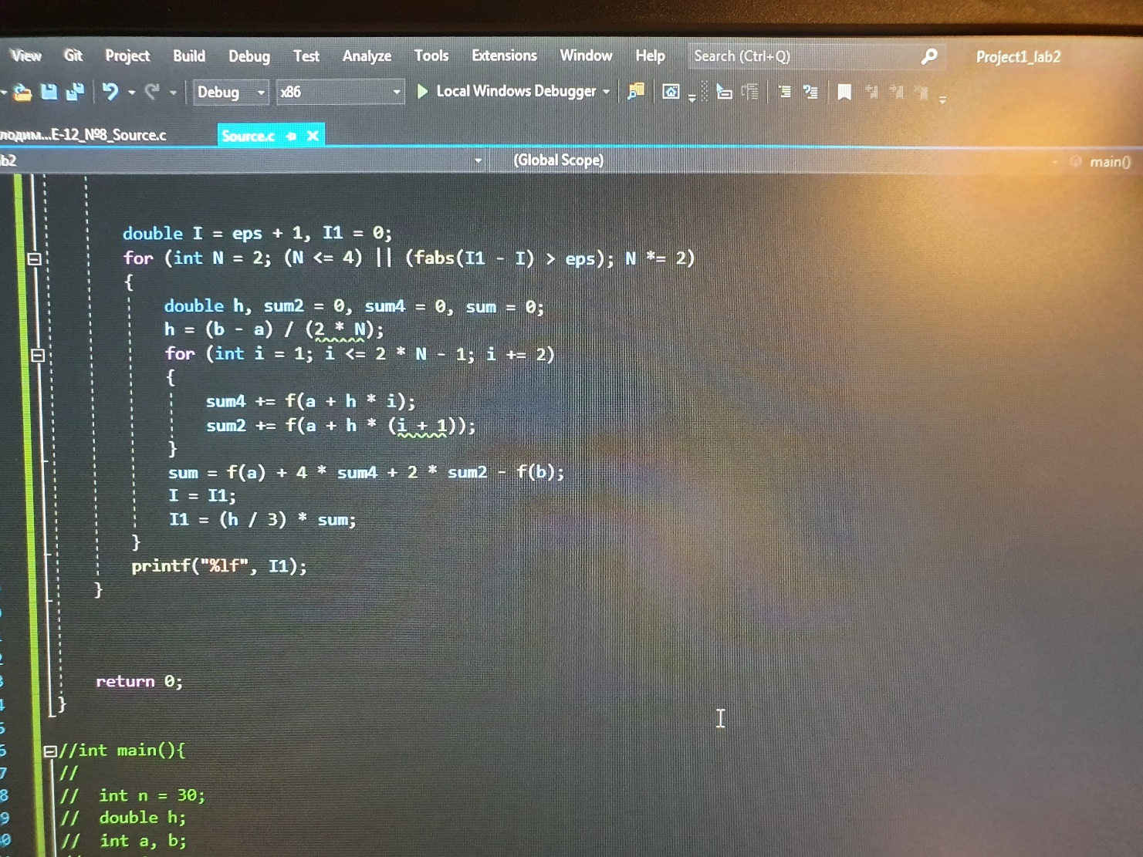

Обирається метод 1-4 за яким буде обчислюватися інтеграл.

Далі надається можливість ввести показник інтеграла.

Потім виводиться крок.

Виконується алгоритм розрахунку згідно з обраним методом.