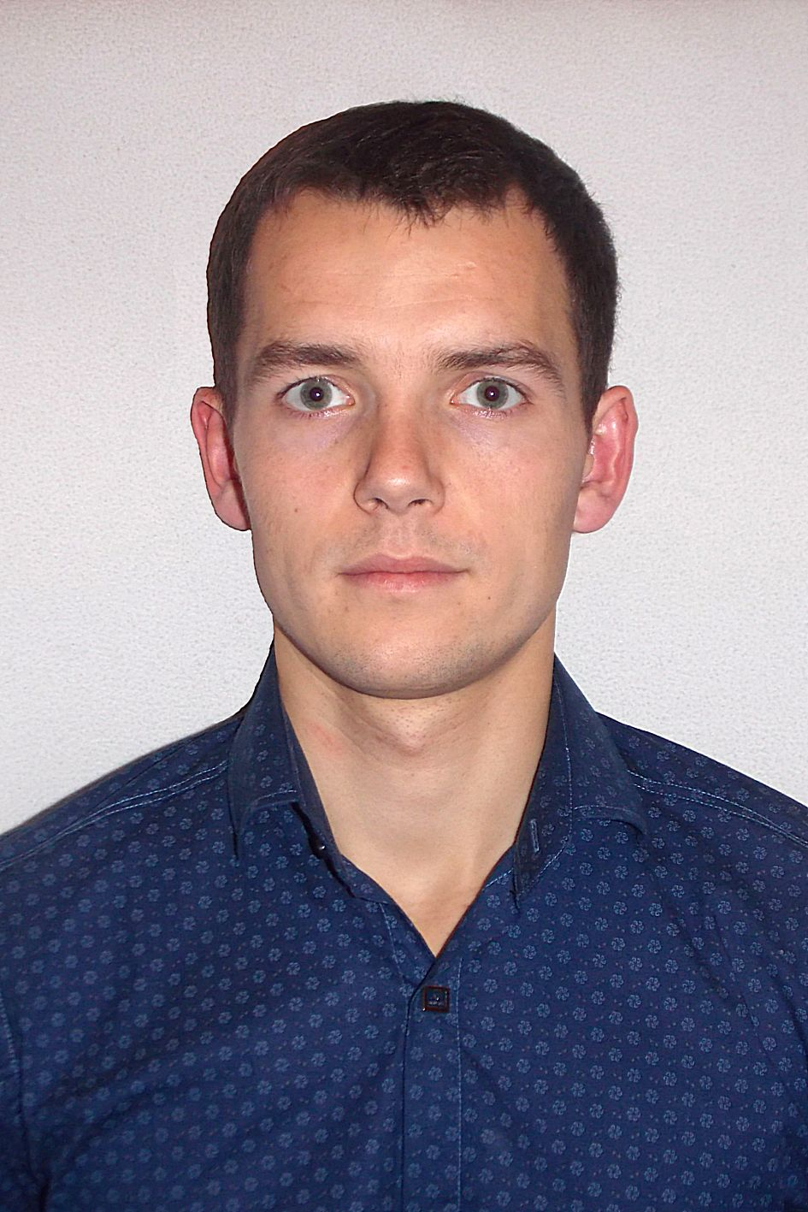

**Volodymyr Styk**

4, Lukasha Street, apt. 104

Lviv, 79012, Ukraine

e-mail: [v.o.v@i.ua](mailto:email@domain.com)

tell: +380977088243

web-site: <http://styk.zzz.com.ua>

<http://styk.byethost7.com>

<http://styk.esy.es>

**Web-developer**

**OBJECTIVE**

I am 5th-year a student at the Department of Telecommunications, in lviv Polytechnic.

I am Web-developer, which has coding only on HTML and CSS. But in the future I will be able to facilitate the users to websites with life through interactive pages. And it's all riding on the bike :-)

I want to be part of a team of professionals where I can grow and learn web-develop. The team in which I can fully realize themselves and my skills.

I KNOW THAT I CAN BECOME A GREAT WEB DEVELOPER

**EXPERIENCE**

**For Myself**  , Home

*HTML/CSS*

* Created sites for myself
* http://styk.zzz.com.ua
* http://styk.byethost7.com
* http://styk.esy.es

**EDUCATION**

**National University "The Lviv Polytechnic"**    Lviv

* Bachelor's degree (2011 - 2015)

National University "The Lviv Polytechnic" Department of Telecommunications Specialty: “Telecommunications”

**National University "The Lviv Polytechnic"**    Lviv

* Master's degree (2015 – 2016)

National University "The Lviv Polytechnic" Department of Telecommunications Specialty: “Information Communication Networks”

**SKILLS**

Programming Languages/ Technologies

* HTML/SCC
* LESS
* JavaScript basic

Operating Systems

* Microsoft Windows XP/7/8
* CISCO IOS - basic
* Linux Ubuntu - basic
* Google Android 1.5/1.6/2.0/2.1/2.2/2.3/2.4/3.0/4.0/4.1/4.2/4.3/4.4

Hardware

* Network technologies

**LANGUAGES**

* Ukrainian - native
* English – pre intermediate
* Polish – elementary
* Russian – upper intermediate

**INTERESTS**

* Interested in various computer innovations .
* Like sports, active recreation and travel.
* I plan to change this world for the better.