How to setup and test the Wowa-Sorter Application

- Download and unzip the compiled package from https://github.com/VolodymyrZhurakhovskyi/wowa-sorter/blob/master/package/wowa-sorter-package.zip

- The application uses 9092 port by default. If you need, you may change it in application.properties file:
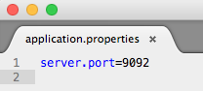
- Run the application on command prompt, using the following command:
java -jar wowa-sorter-demo-0.0.1-SNAPSHOT.jar

- To test the API using POSTMAN, you need to set Content-Type header, select the POST method, and provide one of the following 3 urls:
- http://localhost:9092/sorting/quick
- http://localhost:9092/sorting/bubble
- http://localhost:9092/sorting/builtin
You will see the response, like this:
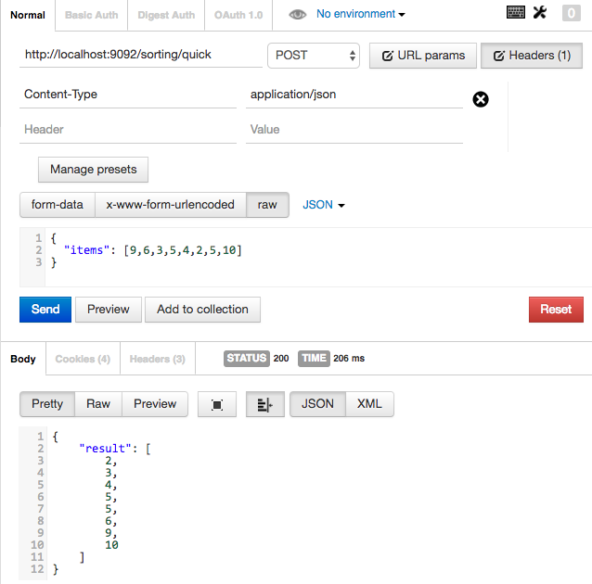
- If you provide the wrong method name, the response will contain error message:

