Quarterly Report — Q3 2026
Prepared by the analytics team. This document shows what the SDK can do: headings, lists, tables, links and images. Text can be selected, scaled with a pinch and searched. The viewer reflows text for small screens, keeps tables scrollable and adapts colors to the dark theme.

1. Key metrics
Revenue grew by 18.4%, while customer churn dropped to 2.1%. Details are on the Jetpack Compose website.
- New users: 124,500
- Average order: $34.20
- NPS: 61
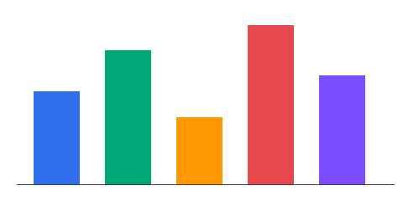

2. Sales by region
Region | Q1 | Q2 | Q3 | Change
North America | 12,400 | 13,900 | 15,750 | +13%
Europe | 8,100 | 8,650 | 9,920 | +15%
Asia Pacific | 3,300 | 3,410 | 3,980 | +17%
Latin America | 2,870 | 3,020 | 3,150 | +4%

3. Plan for next quarter
- Ship the in-app document viewer.
- Add search to PDF documents.
- Support the dark theme.

3.1. Risks
This document shows what the SDK can do: headings, lists, tables, links and images. Text can be selected, scaled with a pinch and searched. The viewer reflows text for small screens, keeps tables scrollable and adapts colors to the dark theme. This document shows what the SDK can do: headings, lists, tables, links and images. Text can be selected, scaled with a pinch and searched. The viewer reflows text for small screens, keeps tables scrollable and adapts colors to the dark theme.
Thank you!

