# Overview

As of 01/01/2013 no couple is allowed to participate at a WDSF registered event, which is not registered as an active couple at WDSF.

The intention of the WDSF Check-In software is to give the personnel at a competition check-in a chance to verify the WDSF Couple state. The intended use is in combination with a barcode scanner to scan the WDSF MIN’s directly from the ID-Cards of the couple. It is planed to issue these ID-Cards by end of 2012.

At the check-in the personnel would scan (or type) the MIN of both partners. The software then displays the state of the couple (that can be “Not Found” or valid).

This program is a reference implementation. Vendors of scrutinizing software should integrate this functionality in there software.

**Please test the software before you use it the first time**

# Installation

Prerequisite of the check-in software is the Microsoft .Net Framework Version 4. Please download this framework directly from the Microsoft website. The software will run on any windows based system that can run the .net framework.

Copy all files from the downloaded ZIP-file to a directory of your choice.

# Configuration

Open the file WDSF_Checkin.exe.config in a text editor. It looks like:

<?xml version="1.0" encoding="utf-8" ?>

<configuration>

<configSections>

…

</configSections>

<applicationSettings>

<WDSF_Checkin.AppSettings>

<setting name="API_User" serializeAs="String">

<value>guest</value>

</setting>

<setting name="API_Password" serializeAs="String">

<value>guest</value>

</setting>

<setting name="API_ProductionSystem" serializeAs="String">

<value>False</value>

</setting>

<setting name="CoupleFile" serializeAs="String">

<value>c:\temp\wdsfcouples.xml</value>

</setting>

<setting name="ParticipantsFile" serializeAs="String">

<value>C:\Temp\participants.tps</value>

</setting>

</WDSF_Checkin.AppSettings>

</applicationSettings>

</configuration>

|  |  |
| --- | --- |
| Configuration Value | Meaning |
| API_User | WDSF Username to access the API. Please ask your WDSF member body how to receive a User-Name and Password |
| API_Password | Password to access the API |
| API_ProductionSystem | True -> The product system will be used, False the test system will be used. Should be set to true |
| CoupleFile | Filename of a file where the software will store a local copy of the downloaded couples for offline mode |
| ParticipantsFile | Use this file if you want to see what competition this couple is registered to |

Only change the the values by editing the content between the <value>…</value> tags.

Please make sure that the application has write access to the above file locations.

# Usage

Start the program by clicking the WDSF_Checkin.exe. It might be usefull to create a shortcut on the computers desktop.

## Prior the competition

Download the current active couple list via the Menue File / “Get Couples via WDSF API”. This will open a new dialog to download the couples:

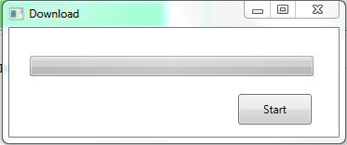

Click on “Start” to download the Couples.

Please download the couples prior a competition to have the most recent version available at the competition day. If the downloaded data is older then one week, a message box will inform you when starting the application.

The Download might take up to one hour depending on your internet connection.

## Check-In

To check-in a couple perform this steps:

* Place the cursor in the textbox labeled as “MIN Man” and scan (or type) the MIN of the male partner.
* Press Tab to place the cursor in the textbox labeled as MIN Womanand scan (or type) the MIN of the female partner
* Press tab to select the button “Next”, now the entered data will be validated.
* Press Enter or click the Next button to clear the imput and proceed with the next couple

The couple information will be displayed as in the example below:

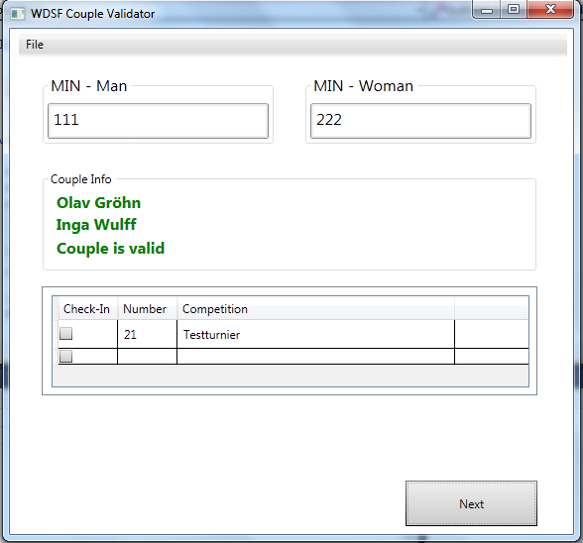

## Barcode Scanner

The software will work with any barcode scanner, that is able to send the scanned barcode as keyboard strokes emulation to the PC. Configure the barcode scanner to send a Tab (Character Code 7) after the barcode data.

Please not that then barcode scanner must be able to read <Code> barcodes.

# Feedback and Improvements

The software is published as open source. So please feel free to download it and change it to meet your own requirements.

If you have feedback please send an email to [olav.groehn@signalkontor.com](mailto:olav.groehn@signalkontor.com)

# Using the participation file

Using the participation file enables the check-in to get a list of registered competitions and start numbers of a couple that checks in.

## File Format

The file has to be a semicolon or comma separated file (csv format) with one entry per line. The file encoding has to be UTF-8.

The line contains couple names, competition and numbers and has to be of the following format:

<Competition>;1;;;<First name Man>;<Last name man>;<First name woman>;<Last name woman>;<Country>;;;<Star number in competition>

Please note that the empty columns are required!