OOPS = Object oriental programming language
Oops concept is concept of python language
Use it for save the time and decrease overtime
- Class (The Blueprint): { ANALOGY }
An architectural plan for a house. It defines where rooms go, what features the house has, and how doors open, but you can't live inside a blueprint.
A Class is like an object constructor, or a "blueprint" for creating objects.
- Object / Instance (The Actual House): { ANALOGY }
The actual house built using that blueprint. You can build 100 distinct houses from 1 single blueprint—each can have a different paint colour or owner, but they share the same structure.
Almost everything in Python is an object, with its properties and methods.
- Function : A function in Python is a reusable block of code that executes a specific task when called. Functions help break programs into smaller, modular, and manageable pieces.
- Constructors
Constructors are special methods used to initialize objects when they are created from a class.
And it automatically executes the program at the same time
Def __init__(self)
- Inheritance : same property and behaviour from parent class to child class
Types :
- Single : A single child class inherits from a single parent class. This is the simplest form.
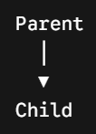

- Multilevel : same property of behaviour

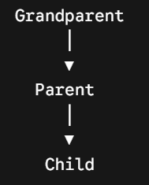
- Multiple : A child class inherits directly from more than one parent class. Python allows this, whereas languages like Java do not.

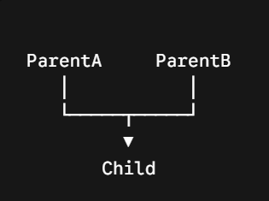
- Polymorphism:
1 person and many roles and many forms
Types :

- Compile time polymorphism (Overloading) : The program determines which specific method to call while the code is compiling (before the program actually runs).

- Run time polymorphism (Overriding) : The program determines which method to call while the program is actively running, based on the actual object being used at that moment.

- Encapsulation : wrapping or data & method into single unit.
Eg:- We mix several predictions in one capsule.

- Abstraction : hiding the internal data and show outer data
Abstraction | Intercase

Decorator :
Special functions that take another function as an argument and modify to return functions
Why we use : modify program , enhance code , decrease time
A decorator is like a gift wrapper for your function.
It takes your original function, adds extra features to it (like wrapping paper and a bow), and gives it back to you—all without touching the code inside the original function.
Example: Imagine your function is a plain cake. A decorator is the frosting you add on top to make it extra special, without having to change how the cake was baked!
Iterator is a function which iterates the value
Generator is a special a return function
Why we use generate value and return a statement
“YIELD”

What is a GIT ?
It is a software & distributed version control system.
Use maintains history and store data (test , project data etc.).
Git = local repo & GitHub = central repo
There are 4 sections:
- Working directory
- A stretching area
- Local repository server
- Central repository server
Commands:
Git init = initialize
Git status = current data status check
Git add file_name = add data to stretching area
Git commit = use to save and change and commit and change
Git clone = clone from central repo to local repo & find duplicate
Git push = share data send from local to central repo
Git pull = share data from central repo to local repo
ls = check how many files uploaded
GITHUB
It is a central repo server
Use :

DJANGO : High level web framework for PYTHON
Use : run fast , decrease time , secure , free open source , specially use for python.
Features : free , open source , run fast , secure data
Application : web application , mobile application , game application
Framework : maintenance and balance of automation files and code

