TradeX — SB Stocks Entity-Relationship (ER) Diagrams
TradeX Institutional Simulation Platform • Technical Specification Series

The SB Stocks ER Diagram acts as the structural foundation of the system, clearly showcasing how different entities are connected and interact with one another. At the center of the diagram are key entities such as Users, Stocks, Transactions, Portfolios, and Market Data. Each User is uniquely identified within the system and can create and manage multiple Virtual Portfolios. These portfolios are designed to hold a variety of Stocks, enabling users to diversify their simulated investments.
The Transaction entity plays a critical role by recording every buy or sell action performed by the user. Each transaction is directly linked to both a User (who initiates the action) and a Stock (being traded), ensuring a clear trace of trading activity. The Market Data entity enriches the system by providing both real-time stock prices and historical performance data, which support informed decision-making and accurate trading simulations.
The relationships between these entities highlight the depth and realism of the system. For example, one user can execute multiple transactions, and a single stock can exist simultaneously in numerous portfolios, reflecting real-world trading dynamics. This interconnected framework allows users not only to buy and sell stocks but also to monitor portfolio growth, test diverse trading strategies, and learn the intricacies of stock trading in a risk-free environment. Ultimately, the ER diagram captures the core essence of SB Stocks: a well-structured, interactive simulation that bridges learning and practice by modeling realistic market relationships.

📐 Visual ER Schema Diagram
The diagram below outlines the primary data collections, attributes, and hierarchical entity structures defined in the SB Stocks simulation database:

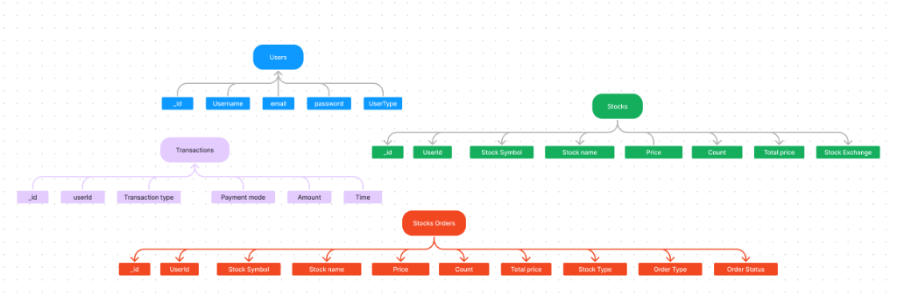
Figure: SB Stocks ER Diagram

📊 Schema & Entity Relationships
The interactive Mermaid entity-relationship diagram below maps out the entities, their structural attributes, foreign key dependencies, and relational cardinalities:
// Language: mermaid
erDiagram
USERS ||--o{ STOCKS : "holds in portfolio"
USERS ||--o{ STOCKS_ORDERS : "places"
USERS ||--o{ TRANSACTIONS : "executes"
STOCKS ||--o{ STOCKS_ORDERS : "referenced by"
USERS {
ObjectId _id PK "Unique User Identifier"
string Username "Trader username"
string email UK "Unique email address"
string password "Hashed credential"
string UserType "User | Admin"
}
STOCKS {
ObjectId _id PK "Unique Stock Holding ID"
ObjectId UserId FK "Owner reference"
string Stock_Symbol "Stock Ticker (e.g., AAPL)"
string Stock_name "Company name"
number Price "Purchase / current price"
number Count "Quantity of shares"
number Total_price "Calculated total value"
string Stock_Exchange "Exchange (e.g., NASDAQ, NYSE)"
}
TRANSACTIONS {
ObjectId _id PK "Unique Transaction ID"
ObjectId userId FK "Executing user ID"
string Transaction_type "Deposit | Withdrawal | Buy | Sell"
string Payment_mode "Wallet | Bank Transfer | UPI | Card"
number Amount "Monetary amount"
datetime Time "Audit timestamp"
}
STOCKS_ORDERS {
ObjectId _id PK "Unique Order ID"
ObjectId UserId FK "Placing user ID"
string Stock_Symbol "Stock Ticker (e.g., TSLA)"
string Stock_name "Company name"
number Price "Target / execution price"
number Count "Number of shares"
number Total_price "Total order amount"
string Stock_Type "Equity | ETF | Index"
string Order_Type "BUY | SELL"
string Order_Status "PENDING | EXECUTED | CANCELLED"
}

📋 Comprehensive Entity-Attribute Dictionary

1. `Users` Entity
The Users collection represents individual registered traders and platform administrators. It establishes identity, security authentication, and ownership of virtual portfolios and transactions.
Attribute | Data Type | Key / Constraint | Description | Example Value
:--- | :--- | :--- | :--- | :---
_id | ObjectId | Primary Key (PK) | System-generated unique identifier | ObjectId("652c1e8b7a9f1b001a1c4e01")
Username | String | Required | Unique display handle of the trader | "alex_trader"
email | String | Required, Unique (UK) | Contact email address used for login and notifications | "alex.investor@example.com"
password | String | Required | Salted and hashed password string (bcryptjs) | "$2a$12$e8xL...7KqY9"
UserType | String | Required, Enum | Role defining permissions (User \ | Admin) | "User"

2. `Stocks` Entity (Portfolio Holdings)
The Stocks collection represents active stock holdings belonging to a user's portfolio. It tracks positions, average acquisition costs, and total valuation across US market exchanges.
Attribute | Data Type | Key / Constraint | Description | Example Value
:--- | :--- | :--- | :--- | :---
_id | ObjectId | Primary Key (PK) | Unique identifier for the holding record | ObjectId("652c201d7a9f1b001a1c4e02")
UserId | ObjectId | Foreign Key (FK) | Reference to the owning Users._id | ObjectId("652c1e8b7a9f1b001a1c4e01")
Stock Symbol | String | Required, Indexed | Ticker symbol of the stock | "AAPL"
Stock name | String | Required | Full corporate name of the equity | "Apple Inc."
Price | Number | Required | Average acquisition or current unit price in USD | 182.50
Count | Number | Required, Min: 1 | Quantity of shares held in the portfolio | 10
Total price | Number | Required | Total valuation of the holding (Price * Count) | 1825.00
Stock Exchange | String | Required | Primary exchange where the equity trades | "NASDAQ"

3. `Transactions` Entity
The Transactions collection maintains an immutable audit trail of every financial activity in the system, including cash deposits, withdrawals, and stock order settlement receipts.
Attribute | Data Type | Key / Constraint | Description | Example Value
:--- | :--- | :--- | :--- | :---
_id | ObjectId | Primary Key (PK) | Unique transaction reference identifier | ObjectId("652c23ab7a9f1b001a1c4e03")
userId | ObjectId | Foreign Key (FK) | Reference to the initiating Users._id | ObjectId("652c1e8b7a9f1b001a1c4e01")
Transaction type | String | Required, Enum | Category (DEPOSIT \ | WITHDRAWAL \ | STOCK_BUY \ | STOCK_SELL) | "STOCK_BUY"
Payment mode | String | Required, Enum | Settlement method (WALLET \ | BANK_TRANSFER \ | UPI \ | CARD) | "WALLET"
Amount | Number | Required, Positive | Total monetary value involved in the transaction | 1825.00
Time | DateTime | Required, Timestamp | Exact timestamp when transaction occurred | 2026-10-15T12:05:02.000Z

4. `Stocks Orders` Entity
The Stocks Orders collection records order tickets submitted by traders, tracking fulfillment state, execution parameters, and status transitions through the trading lifecycle.
Attribute | Data Type | Key / Constraint | Description | Example Value
:--- | :--- | :--- | :--- | :---
_id | ObjectId | Primary Key (PK) | Unique order ticket identifier | ObjectId("652c24ef7a9f1b001a1c4e04")
UserId | ObjectId | Foreign Key (FK) | Reference to the placing Users._id | ObjectId("652c1e8b7a9f1b001a1c4e01")
Stock Symbol | String | Required, Indexed | Ticker symbol of the traded security | "NVDA"
Stock name | String | Required | Full corporate name of the security | "NVIDIA Corporation"
Price | Number | Required, Positive | Order execution or limit trigger price in USD | 460.00
Count | Number | Required, Min: 1 | Number of shares requested | 5
Total price | Number | Required, Positive | Gross order consideration (Price * Count) | 2300.00
Stock Type | String | Required | Asset classification (Equity \ | ETF \ | Index) | "Equity"
Order Type | String | Required, Enum | Action direction (BUY \ | SELL) | "BUY"
Order Status | String | Required, Enum | Lifecycle status (PENDING \ | EXECUTED \ | CANCELLED \ | REJECTED) | "EXECUTED"

🔗 Relational Architecture & System Dynamics

1. One-to-Many User Portfolio Ownership (`Users` 1 ──< N `Stocks`)
- A single user account can accumulate a diversified portfolio containing many individual stock positions across multiple sectors and exchanges.
- Simultaneously, any given stock symbol (e.g., AAPL or MSFT) can exist across multiple users' portfolios, modeling real-world equity market ownership.

2. Audit Trail & Financial Accountability (`Users` 1 ──< N `Transactions`)
- Every capital injection, cash withdrawal, or security liquidation is permanently recorded as an immutable transaction.
- Each transaction links back to the originating user, providing full financial transparency, compliance oversight, and historical P&L analytics.

3. Order Lifecycle & Execution Pipeline (`Users` 1 ──< N `Stocks Orders`)
- Traders initiate order tickets (BUY or SELL) specifying target quantities and prices.
- When an order reaches EXECUTED status:
- The user's liquid cash wallet is adjusted.
- The holding in the Stocks collection is created or updated.
- A corresponding Transaction settlement receipt is written to the ledger.

4. Real-Time Market Data Integration
- The Market Data layer feeds live prices and historical OHLCV data into the trading engine.
- Active orders evaluate their triggers against streaming quotes to simulate realistic slippage, liquidity depth, and execution timing without capital risk.

🔗 Related Documentation
- [System Architecture Specification](ARCHITECTURE.md): Deep dive into the 3-tier architecture, Express APIs, and request lifecycles.
- [SB Stocks MVC Pattern](MVC_PATTERN.md): Model-View-Controller design architecture, routing/controller mappings, and schema operations.
- [Platform Features Specification](FEATURES.md): Exhaustive catalog of functional capabilities, trader personas, and UX workflows.
- [SB Stocks User Flow Specification](USER_FLOW.md): Complete 9-stage user workflow, interactive flowchart, and state transition matrix.
- [README.md](../README.md): Main repository documentation, setup guides, and project overview.

