TradeX — SB Stocks User Flow Specification
TradeX Institutional Simulation Platform • Technical Specification Series

The SB Stocks User Flow maps out the comprehensive end-to-end journey of a user across the TradeX trading simulation platform. It illustrates how traders transition from first visiting the application and authenticating, through navigating the central dashboard, exploring US equities, executing simulated buy/sell orders, managing portfolios, auditing transactions, testing financial strategies, and securely ending their session.

📐 Visual User Flowchart
The diagram below illustrates the structural path and branching logic implemented across the application:

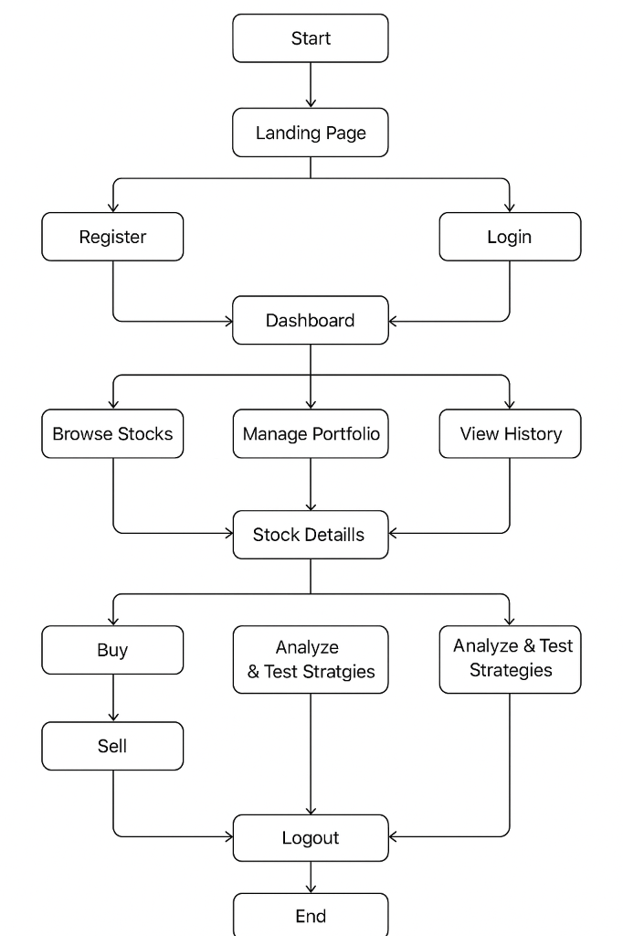
Figure: SB Stocks User Flow Diagram

🔄 Interactive User Flow Diagram
The flowchart below represents the interactive lifecycle and multi-path routing across the SB Stocks web platform:
// Language: mermaid
graph TD
START(["Start"]):::boundary --> LANDING["1. Landing Page<br/>(Entry Point)"]:::entry
LANDING -->|New User| REGISTER["2A. Register<br/>Enter Name, Email, Password, Contact"]:::auth
LANDING -->|Existing User| LOGIN["2B. Login<br/>Enter Credentials"]:::auth
REGISTER -->|Account Created| LOGIN
LOGIN -->|Authenticated & JWT Issued| DASHBOARD["3. Dashboard (Main Hub)<br/>Virtual Funds • Portfolios • Recent Activity"]:::hub
DASHBOARD -->|Explore Market| BROWSE["4. Browse & Explore Stocks<br/>Search US Stocks • Live Quotes • Trends"]:::market
DASHBOARD -->|Manage Investments| PORTFOLIO["6. Portfolio Management<br/>Create Portfolios • Track Holdings • P&L Charts"]:::portfolio
DASHBOARD -->|Audit Activity| HISTORY["7. Transactions History<br/>Review Log of Buy/Sell Orders with Timestamps"]:::history
DASHBOARD -->|Quick Trade| STOCKS_DETAIL["Stock Details & Charts<br/>Real-Time Price • Historical OHLCV • Overview"]:::market
BROWSE --> STOCKS_DETAIL
PORTFOLIO --> STOCKS_DETAIL
STOCKS_DETAIL -->|Initiate Buy/Sell| PAPER_TRADING["5. Paper Trading (Buy / Sell)<br/>Select Buy or Sell • Enter Qty • Confirm Order"]:::trading
STOCKS_DETAIL -->|Analyze Trends| STRATEGY["8. Learning & Strategy Testing<br/>Analyze Historical Data • Compare Portfolio Strategies"]:::testing
PAPER_TRADING -->|Trade Executed & Logged| PORTFOLIO
PAPER_TRADING -->|Order Settled| HISTORY
STRATEGY -->|Refine Orders| PAPER_TRADING
STRATEGY -->|Track Returns| PORTFOLIO
DASHBOARD -->|End Session| LOGOUT["9. Logout<br/>Clear Session & Revoke Tokens"]:::logout
PORTFOLIO -->|End Session| LOGOUT
BROWSE -->|End Session| LOGOUT
HISTORY -->|End Session| LOGOUT
STRATEGY -->|End Session| LOGOUT
LOGOUT --> END(["End"]):::boundary
classDef boundary fill:#f3e5f5,stroke:#8e24aa,stroke-width:2px,color:#4a148c;
classDef entry fill:#e3f2fd,stroke:#2196f3,stroke-width:2px,color:#0d47a1;
classDef auth fill:#fff3e0,stroke:#ff9800,stroke-width:2px,color:#e65100;
classDef hub fill:#e8f5e9,stroke:#4caf50,stroke-width:2px,color:#1b5e20;
classDef market fill:#ede7f6,stroke:#673ab7,stroke-width:2px,color:#311b92;
classDef trading fill:#fbe9e7,stroke:#ff5722,stroke-width:2px,color:#bf360c;
classDef portfolio fill:#e0f2f1,stroke:#009688,stroke-width:2px,color:#004d40;
classDef history fill:#f9fbe7,stroke:#c0ca33,stroke-width:2px,color:#827717;
classDef testing fill:#fff8e1,stroke:#ffb300,stroke-width:2px,color:#ff6f00;
classDef logout fill:#ffebee,stroke:#e91e63,stroke-width:2px,color:#880e4f;

🚀 The 9-Stage User Journey Breakdown

1. 🌐 Entry Point
- Context: The user first discovers and navigates to the SB Stocks web application.
- UI Route: / (LandingPage.jsx)
- Key Interactions:
- Displays platform value proposition, live market indices, top gainers/losers ticker, and trading features.
- Presents clear calls-to-action: "Get Started / Register" for newcomers and "Sign In / Login" for returning traders.
- System Responsibilities:
- Serves static responsive assets with high performance.
- Queries public market ticker preview without requiring user authentication.

2. 🔐 Authentication
The platform provides distinct onboarding and sign-in channels to verify trader identity and protect user assets.

2A. New User Registration Flow
- User Action: Clicks Register on the landing page or navbar.
- Input Fields:
- name: Full trader name.
- email: Valid contact and login email address.
- password: Secure passphrase (minimum 8 characters with strength validation).
- contact: Contact phone number for verification and security alerts.
- Client-Side Validation: Checks password matching, email regex formatting, and required field completeness.
- Backend Processing:
- Endpoint: POST /api/auth/register
- Verifies email uniqueness in MongoDB (Users collection).
- Hashes password with bcryptjs (salt rounds: 12).
- Initializes trader profile with a default virtual cash wallet balance (e.g., $50,000.00 USD).
- Outcome: Displays success notification modal/toast and immediately redirects user to Login.

2B. Existing User Login Flow
- User Action: Clicks Login and inputs registered email and password credentials.
- Backend Processing:
- Endpoint: POST /api/auth/login
- Compares credentials against database hash (bcrypt.compare).
- Issues signed stateless JSON Web Token (JWT) containing userId and user permissions.
- Outcome: Client stores JWT token (localStorage / secure cookie), sets global auth context, and redirects to the Dashboard.

3. 📊 Dashboard (Main Hub)
- Context: The command center and primary focal point for all authenticated trader interactions.
- UI Route: /dashboard (UserHome.jsx)
- Key Displays:
- Overall Virtual Funds: Live cash wallet balance available for simulated trading.
- Portfolio Summary: Aggregate market value across all user portfolios with daily unrealized P&L indicator.
- Recent Activity Feed: Real-time snapshot of the 5 most recent orders and transactions.
- Market Snapshot: Quick widget tracking major US stock movements.
- Core Hub Navigation Options:
- Browse Stocks: Explore the complete US market catalog.
- Create Portfolio: Set up a new isolated virtual portfolio.
- View Portfolio: Inspect existing portfolio holdings, distribution, and performance.
- Trade Stocks: Launch the quick order slip to execute paper trades.

4. 🔍 Browse & Explore Stocks
- Context: Market research and stock discovery interface.
- UI Route: /stocks (BrowseStocks.jsx)
- Key Interactions:
- Instant Search: Search US-listed stocks by ticker symbol (e.g., AAPL, MSFT, TSLA, GOOGL, NVDA) or corporate name.
- Sector Filtering: Filter equities by sector (Technology, Healthcare, Energy, Finance, Consumer Goods).
- Real-Time Price & Trends: Live Bid/Ask quotes, daily price change dollar amounts, percentage changes, and 24-hour volume.
- Stock Inspection: Clicking any stock card navigates to the detailed view with historical candlestick/line charts, 52-week ranges, market cap, and company profiles.

5. 📈 Paper Trading (Buy/Sell)
- Context: Realistic, risk-free simulated trade execution without financial capital exposure.
- UI Route: /trade/:symbol or Trade Modal (StockOrders.jsx)
- Trading Workflow:
- Select Stock: Chooses target equity ticker (e.g., AAPL).
- Choose Direction: Toggles between BUY and SELL order modes.
- Order Parameters: Selects order category (MARKET or LIMIT) and enters desired share quantity.
- Cost Estimation: Dynamic calculator computes Total Cost = Quantity × Current Price + estimated simulated fees.
- Validation Check:
- For Buy: Verifies that available cash balance is sufficient (cashBalance >= totalCost).
- For Sell: Verifies that the user owns sufficient shares in the selected portfolio (sharesOwned >= quantity).
- Confirm Transaction: Trader clicks Confirm Order.
- System Execution & Real-Time Sync:
- Endpoint: POST /api/orders
- Atomic database update: Deducts/credits cash balance in Users, creates an entry in Orders, updates portfolio holdings in Stocks, and appends a record in Transactions.
- Emits real-time state update to client UI; portfolio valuation and transaction lists refresh instantly without page reload.

6. 💼 Portfolio Management
- Context: Multi-portfolio management, asset allocation, and performance tracking.
- UI Route: /portfolios (PortfolioPage.jsx)
- Key Capabilities:
- Create Multiple Virtual Portfolios: Set up separate portfolios dedicated to distinct strategies (e.g., "Tech Growth", "Dividend Income", "Short-Term Momentum").
- Add/Remove Stocks: Allocate purchased shares to specific portfolios or rebalance positions.
- Holdings Table: Displays ticker, company name, shares count, average acquisition price, live market price, current total value, and unrealized profit/loss.
- Performance Charts:
- Asset Allocation: Interactive pie chart displaying sector and stock weighting.
- P&L Visualizer: Bar charts showing gain/loss trajectories across daily, weekly, and monthly intervals.

7. 📜 Transactions History
- Context: Complete, immutable financial and order settlement audit log.
- UI Route: /transactions (TransactionsPage.jsx)
- Ledger Information:
- Unique Transaction Reference ID.
- Exact timestamp of execution.
- Transaction Type (STOCK_BUY, STOCK_SELL, DEPOSIT, WITHDRAWAL).
- Stock Symbol and Company Name.
- Executed Price, Share Count, and Net Monetary Total.
- Payment Mode (WALLET).
- Settlement Status (SUCCESS, PENDING, FAILED).
- Filtering & Search: Search transactions by date range, specific stock symbol, or order direction.

8. 🧠 Learning & Strategy Testing
- Context: Strategy experimentation, quantitative evaluation, and skill refinement.
- UI Route: /analytics (StrategyTesting.jsx)
- Capabilities:
- Historical Trend Analysis: Review multi-period OHLCV charts (1D, 1W, 1M, 1Y, 5Y) to spot recurring technical patterns (support/resistance, moving average crossovers).
- Strategy Comparison: Compare returns between different virtual portfolios (e.g., comparing a high-beta growth portfolio against a low-beta dividend portfolio).
- Execution Review: Analyze win/loss rates, average gain per winning trade vs. average loss per losing trade, and maximum portfolio drawdown.
- Iteration: Refine limit prices, trade sizing, and exit disciplines based on empirical simulation results.

9. 🚪 Logout
- Context: Secure termination of user session.
- Workflow:
- Trader clicks Logout from user dropdown menu or navigation bar.
- Client clears stored JWT authentication token from browser storage.
- Resets in-memory React application state (user profile, cash wallet balance, active portfolio cache).
- Securely redirects trader back to the public Landing Page (/).

🗺️ State Transition Matrix
The table below outlines how user actions trigger state transitions across the frontend views, backend APIs, and persistence collections:
Current State | User Action / Trigger | Next State | Frontend View | Backend API Endpoint | Database Collection Impact
:--- | :--- | :--- | :--- | :--- | :---
Unauthenticated | Enters website URL | Landing Page View | LandingPage.jsx | Static Asset Serve | None
Landing Page | Clicks "Register" | Register Screen | RegisterModal.jsx | None | None
Register Screen | Submits credentials | Login Screen (Redirect) | LoginModal.jsx | POST /api/auth/register | Users (Insert user record)
Login Screen | Submits login credentials | Authenticated Dashboard | UserHome.jsx | POST /api/auth/login | Users (Fetch & verify credentials)
Dashboard | Clicks "Browse Stocks" | Stock Catalog View | BrowseStocks.jsx | GET /api/stocks | Stocks (Read market catalog)
Browse Stocks | Selects specific stock | Stock Detail & Chart | StockDetail.jsx | GET /api/stocks/:symbol | Stocks (Read quote & history)
Stock Detail | Clicks "Buy Stock" | Buy Order Confirmation | OrderSlip.jsx | POST /api/orders | Orders, Users, Stocks, Transactions
Stock Detail | Clicks "Sell Stock" | Sell Order Confirmation | OrderSlip.jsx | POST /api/orders | Orders, Users, Stocks, Transactions
Dashboard | Clicks "Manage Portfolio" | Portfolio Overview | PortfolioPage.jsx | GET /api/portfolios | Stocks (Read user holdings)
Portfolio View | Creates new portfolio | Updated Portfolio List | PortfolioModal.jsx | POST /api/portfolios | Portfolios (Create portfolio)
Dashboard | Clicks "View History" | Transactions Log View | TransactionsPage.jsx | GET /api/transactions | Transactions (Query ledger)
Stock Detail | Clicks "Analyze Strategies" | Strategy Analytics View | StrategyTesting.jsx | GET /api/stocks/:symbol/history | Stocks (Historical data read)
Any Authenticated | Clicks "Logout" | Public Landing Page | LandingPage.jsx | Client Token Purge | None

🛡️ Error & Edge Case Handling in User Flow
- Duplicate Email During Registration:
- Backend returns 409 Conflict.
- UI displays clear notification: "An account with this email already exists. Please login instead."
- Invalid Login Credentials:
- Backend returns 401 Unauthorized.
- UI flags invalid fields without exposing whether email or password was the incorrect element.
- Insufficient Funds on Buy Order:
- Trade modal disables submit button with warning: "Insufficient virtual cash balance. Requires $X, available $Y."
- Overselling Shares on Sell Order:
- Order validation rejects requests when orderQuantity > ownedShares.
- UI warns: "Cannot sell more shares than currently held in portfolio."
- Token Expiration / Invalid Session:
- Express authMiddleware returns 401 Unauthorized.
- Client interceptor clears stale token, presents a session expiration notice, and redirects user to /login.

🔗 Related Documentation
- [README.md](../README.md): Main project overview, quickstart instructions, and system tier summary.
- [SB Stocks MVC Pattern](MVC_PATTERN.md): Model-View-Controller design architecture, routing/controller mappings, and schema operations.
- [Platform Features Specification](FEATURES.md): Exhaustive breakdown of features, trader capabilities, and UX matrices.
- [System Architecture Specification](ARCHITECTURE.md): Detailed tier-by-tier architecture, component communication, and system responsibility rules.
- [SB Stocks ER Diagrams](ER_DIAGRAMS.md): Relational schema, collection attribute dictionaries, and data models.

