Mercury | Mobility/Flexibility | Quicksilver | Green & Silver | Mercurial
Venus | Creation/perfection | Copper | Blue & Green | Cytherean
Mars | Martial | Iron | Red & Black | Martial
Jupiter | Resources/Numerical advantage | Tin | Red & White | Jovian
Saturn | Control/permission | Lead | Black & Gold | Saturnine
Sol | Life/immortality | Gold | White & Gold | Helian
Luna | Death/resurrection | Silver | Blue & Silver | Lunar
Silver

Blue
Luna
Black
Green
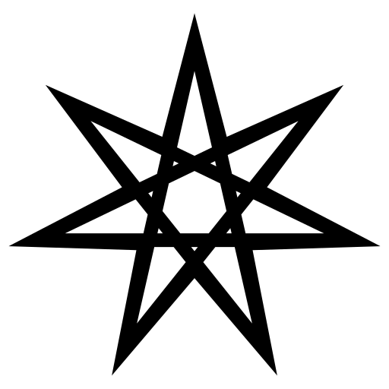
Gold
Blue

Venus
Saturn

Mercury
Jupiter
Silver
Red

White
Green

Mars
Sol
Red
Gold

Black
White

Hermetic | Blue | Mobility/Speed/Flexibility
Shamanic | Green | Power/Toughness
Ancient Egyptian (Scarabic?) | Blue Gold | Immortality/Permanence
Druidic | Green White | Life/Protection
Aztec (Mesoic?) | Red | Death/Sacrifice
Voodoo | Purple | Control/Manipulation
Divine | Gold White | Support
Faustian | Black White | Resources/Numerical Advantage
Far Eastern (Adept?) | Red Gold | Martial Strength

Hermetic:
More Action Points
Move further
Evade supression
Not lose mobility when hit
Dive further
Not suffer no-shoot penalty on diving

Faustian:
More Astral Points
Astral Point gain over time (artefact/enchantment)
Take opposition's Action Points
Reduce cost of Actions/Spells
Draw more cards
Make opponent discard cards

Shamanic:
Add life to (uninjured) character
Increase damage for ranged attacks
Reduce damage from incoming (mêlée? ranged?) attacks
Free vault (push through obstacles)
Heal character that got hit this turn but didn't move
Push character to another tile (and out of mêlée range)

Scarabic:
Ignore fatal damage from last hit
Permanent to ignore modifiers to attack/defence
Reset character to base attack/defence
On death, resurrect character in weakened form
Sustain permanent that should be destroyed by opponent spell
Make spell with one-turn effect last for more turns

Druidic:

