|  |
| --- |
|  |

**TITLE OF YOUR THESIS OR DISSERTATION**

Author’s Full Name

A [ dissertation or thesis ] submitted to the faculty at the University of North Carolina at Chapel Hill in partial fulfillment of the requirements for the degree of [ insert degree ] in the [ insert department or program name ] in the [ named school ].

Chapel Hill

20XX

Approved by:

Supervisor

Committee chair

Committee member 1

Committee member 2

Committee member 3

|  |
| --- |
|  |

© 20XX

Author’s Full Name (as it appears on the title page)

ALL RIGHTS RESERVED

|  |
| --- |
|  |

**ABSTRACT**

Author’s Name: Title of Thesis/Dissertation

(Under the direction of [Advisor’s Name])

Lorem ipsum dolor sit amet, consectetuer adipiscing elit. Proin porta vulputate pede. Cum sociis natoque penatibus et magnis dis parturient montes, nascetur ridiculus mus. Vestibulum convallis neque. Pellentesque ac sem. Nulla laoreet. Integer porta urna et dolor. Quisque augue lorem, venenatis sed, rhoncus nec, gravida consequat, purus. Nulla ut purus vel felis tristique fermentum. Pellentesque sit amet purus. Sed in elit sed nisl volutpat elementum. In nonummy odio at ipsum.

Integer consectetuer, libero ut accumsan sodales, felis magna consectetuer orci, et dictum purus libero dapibus quam. Suspendisse potenti. Integer nisi risus, sodales a, porttitor ac, aliquet id, augue. Suspendisse pharetra lacus vitae ipsum. Phasellus leo justo, facilisis et, pellentesque non, lobortis et, dui. Morbi vel eros. Phasellus sodales. Fusce ligula. Vestibulum purus. Etiam molestie faucibus massa. Proin ultricies vestibulum diam. Praesent cursus ligula sit amet sem. Praesent accumsan. Maecenas rutrum posuere justo. Quisque ut ante quis ipsum suscipit tempor. Nullam quis mauris ullamcorper arcu consequat tincidunt. Pellentesque in tortor ac nulla dapibus rutrum. Nunc non arcu in nunc placerat consectetuer.

|  |
| --- |
|  |

To my mentor and friend, I couldn’t have done this without you.

Thank you for all your support along the way.

|  |
| --- |
|  |

**ACKNOWLEDGEMENTS**

Lorem ipsum dolor sit amet, consectetuer adipiscing elit. Aenean eleifend. Integer 1” dapibus vulputate tortor. Vestibulum sit amet odio a erat adipiscing ullamcorper. Proin pharetra ligula a leo. Sed euismod erat. Nulla facilisi. Sed posuere. Vivamus tincidunt sagittis velit. Etiam gravida pellentesque purus. Phasellus fermentum, ligula vel nonummy pulvinar, augue ligula vulputate dolor, quis aliquam risus nibh ut eros. Suspendisse potenti. Curabitur dolor pede, nonummy quis, dapibus id, faucibus in, eros. Fusce justo odio, accumsan nec, suscipit ac, egestas vitae, dui. Morbi sagittis libero et ligula. Ut quis nulla. Fusce lobortis. Mauris nibh purus, mollis vel, pulvinar sed, viverra eu, nisi. Phasellus felis nisl, egestas consectetuer, facilisis vitae, rhoncus a, augue. Pellentesque habitant morbi tristique senectus et netus et malesuada fames ac turpis egestas. Mauris lacus elit, sagittis in pulvinar eget suscipit ac nisi.

|  |
| --- |
|  |

**PREFACE**

If you are including previously published work in your thesis or dissertation, you may want to include information in the preface about the publication. You will include basic citation information in a footnote or endnote at the beginning of the chapter of previously published work. Additional information about the publication or research can be explained in your preface.

Ut commodo in nostrud Lorem quis dolore Ut id nostrud in pariatur fugiat laborum. Dolor consectetur in in consequat. Ex sit aute dolore reprehenderit ullamco minim in irure et eiusmod undefined eu aute sunt ut proident, commodo aliqua. Dolore minim qui fugiat enim ut velit consequat. Proident, aliquip elit, et qui deserunt consequat. Proident, deserunt non exercitation consequat. Voluptate magna irure qui aliqua. Sunt sunt aliqua.

|  |
| --- |
|  |

**TABLE OF CONTENTS**

LIST OF TABLES viii

LIST OF FIGURES ix

LIST OF ABBREVIATIONS AND SYMBOLS x

CHAPTER 1: TITLE OF CHAPTER 1 1

Introduction 1

Section 1.1 1

CHAPTER 2: TITLE OF CHAPTER 2 4

Introduction 4

Ad Nulla Dolor Dolor Magna Quis ex in Aute Tempor Magna Convallis Lacus Eiusmod in est Commodo et Veniam 4

# LIST OF TABLES

Table 2.1. CASP 15 results for R1189. 4

# LIST OF FIGURES

Figure 1.1. Scheme of Frag-MaP experimental procedure 1

Figure 1.2. Frag-MaP sites identified in the *B. subtilis* 23S rRNA using the linezolid functionalized probes 2

# LIST OF ABBREVIATIONS AND SYMBOLS

|  |  |
| --- | --- |
| % | percent |
| °C | degrees Celsius |
| 13C | NMR carbon-13 nuclear magnetic resonance |
| 1H | NMR proton nuclear magnetic resonance |
| 5-TAMRA | 5-Carboxytetramethylrhodamine |
| Å | angstrom |
| apo | ligand-free |
| A-site | aminoacyl-site |
| ATCC | american type culture collection |
| avg | arithmetic average |
| cDNA | complementary DNA |
| cm | centimeter |
| con loop | consecutive loop |
| cryo-EM | cryogenic electron microscopy |
| cryo-EM | cryogenic electron microscopy |
| d | doublet |
| *D* | cluster distance (Å) |
| DCM | dichloromethane |
| dd | doublet of doublets |
| DFAME | 3-[4-(difluoromethyl)phenyl]-2-[(2-methylpropan-2-yl)oxycarbonylamino]propanoic acid |
| DFHBI | 3,5-difluoro-4-hydroxybenzylidene imidazolinone |
| DFHBI-1T | (Z)-4-(3,5-difluoro-4-hydroxybenzylidene)-2-methyl-1-(2,2,2-trifluoroethyl)-1H-imidazol-5(4 H)-one |
| DIPEA | N,N-Diisopropylethylamine |
| dis | distant long-range interaction |
| DMHBI | 3,5-dimethoxy-4-hydroxybenzylidene imidazolone |
| DMSO | dimethyl sulfoxide |
| DNA | deoxyribonucleic acid |
| DTT | dithiothreitol |
| EDC-HCl | N-Ethyl-N′-(3-dimethylaminopropyl)carbodiimide hydrochloride |
| eRMSD | estimated root mean square deviation |
| ESI-QTOF | electrospray ionization quadrupole time of flight |
| EtOAc | ethyl acetate |
| FMN | flavin mononucleotide |
| Frag | small molecule fragment |
| *g* | gravitational constant |
| G4 | G-quadruplex |
| HBC | benzylidene-cyanophenyl |
| HIV-1 | human Immunodeficiency virus-1 |
| HOBt | 1-Hydroxybenzotriazole hydrate |
| holo | ligand-bound |
| HRMS | high resolution mass spectrometry |
| Hz | Hertz |
| *i* | number of alpha spheres |
| *J* | coupling constant |
| J | joules |
| LSU | large ribosomal subunit |
| M | molar |
| *m* | minimum alpha sphere radius |
| *M* | maximum alpha sphere radius |
| m/z | mass to charge ratio |
| MaP | mutational profiling |
| Methanol-d4 | deuterated methanol |
| mg | milligram |
| MHJ | multihelix junction |
| MHz | megahertz |
| min | minute |
| mL | milliliter |
| mM | millimolar |
| mmol | millimole |
| mRNA | messenger RNA |
| MW | molecular weight |
| n | sample size |
| NEB | new england biolabs |
| ng | nanogram |
| NMR | nuclear magnetic resonance |
| nt | nucleotides |
| OD600 | optical density at 600 nm |
| PDB | protein data bank |
| pH | potential of hydrogen |
| PK | pseudoknot |
| pM | picomolar |
| PPDA | pyrimido[4,5-d]pyrimidine-2,4-diamine |
| ppm | parts per million |
| ppv | positive-predictive value |
| PreQ1 | pre-queuosine1 |
| P-site | peptidyl-site |
| PTC | peptidyl transfer center |
| PTLC | preparative thin layer chromotography |
| QED | quantitative estimate of druglikeness |
| RNA | ribonucleic acid |
| rpm | revolutions per minute |
| rRNA | ribosomal RNA |
| RT | reverse transcriptase |
| S | Svedberg unit |
| SAH | S-Adenosyl homocysteine |
| SAM | S-Adenosyl methionine |
| SASA | solvent accessible surface area |
| sens | sensitivity |
| SSU | small ribosomal subunit |
| TAL2 | theophylline aptamer ligand 2 |
| TAR | trans-activation response element |
| TBTA | tris(benzyltriazolylmethyl)amine |
| TLC | thin layer chromotography |
| TPP | thiamine pyrophosphate |
| Tris | tris(hydroxymethyl)aminomethane |
| tRNA | transfer RNA |
| TWEEN-20 | Polyoxyethylene (20) sorbitan monolaurate |
| UV | ultraviolet |
| YO3-biotin | oxazole yellow biotin |
| ZMP | 5-amino-4-imidazole carboxamide ribose-5′-monophosphate |
| δ | chemical shift |
| μg | microgram |
| μL | microliter |
| μM | micromolar |
| π-π | pi-pi interaction |

|  |
| --- |
|  |

# CHAPTER 1: TITLE OF CHAPTER 1

## Introduction

This chaper contains footnote references while chapter 2 contains endnote references. You must pick one style or the other and apply it consistently throughout. The sample pages include both styles to demonstrate formatting options only.

This page also illustrates how to include a note identifying that the chapter has been previously published and the source of publication.

## Section 1.1

Lorem ipsum dolor sit amet, consectetuer adipiscing elit. Proin ipsum purus, accumsan sed, accumsan nec, euismod vitae, dolor. Praesent ligula nulla, iaculis quis, hendrerit id, mollis ut, lorem. Sed convallis urna non ligula. Sed enim. Nunc magna velit, pulvinar ut, cursus at, nonummy ultrices, nisi. Curabitur convallis lacus a ligula. Nam dapibus. Duis metus libero, laoreet in, fringilla sit amet, sollicitudin vitae, erat.

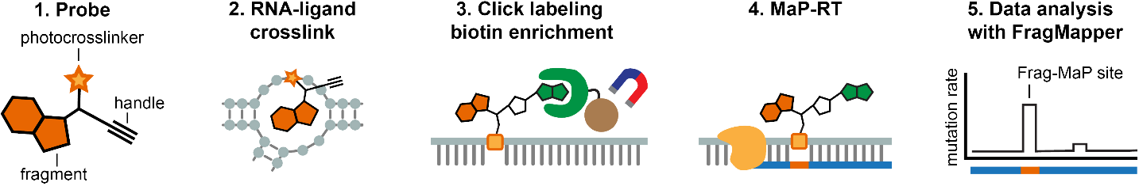

**Figure 1.1. Scheme of Frag-MaP experimental procedure****.**

Proin quam nulla, vehicula elementum, elementum quis, feugiat vel, mi. Suspendisse potenti. Pellentesque rutrum. Nunc a nisl.

Aenean sit amet velit vel enim malesuada blandit. Duis gravida odio faucibus purus. Aenean nisi. Praesent ac orci quis mi blandit venenatis. Morbi dui lacus, ornare eget, facilisis eget, tincidunt eu, quam. Sed iaculis accumsan diam. Nam feugiat. Sed vitae purus. Vivamus ultricies.

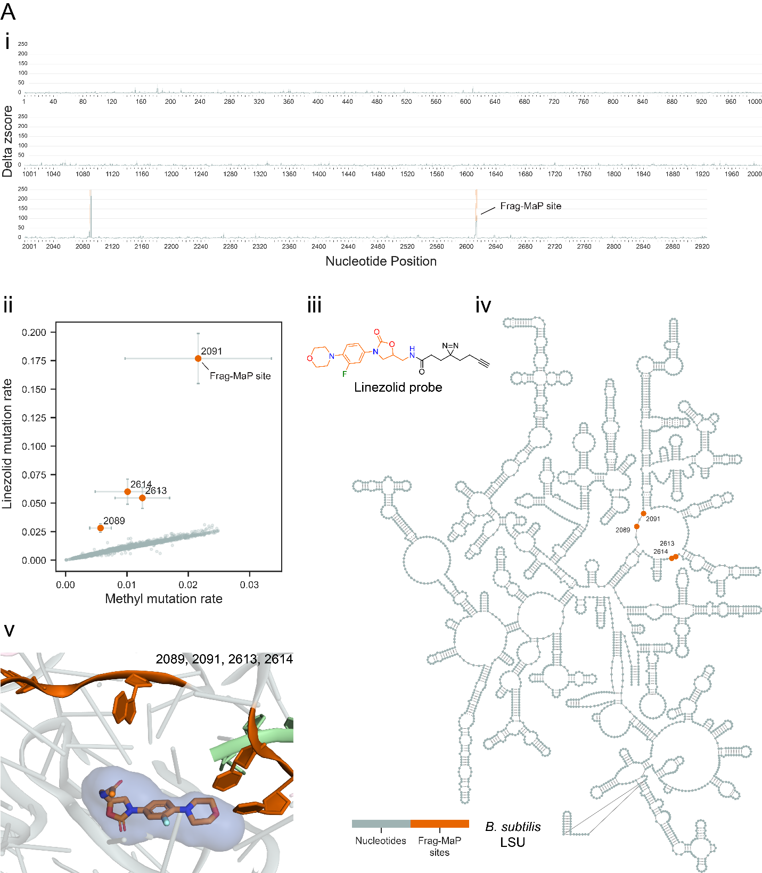

**Figure 1.2. Frag-MaP sites identified in the *B. subtilis* 23S rRNA using the linezolid functionalized probes****.** For each panel: (*i*) Frag-MaP profiles displaying z-score of the difference in mutation rate between the fragment and methyl probes for each nucleotide. Frag-MaP sites analyzed in this work are depicted in orange. Frag-MaP sites at RNA-protein interactions or in structurally unvisualized regions, not analyzed in this work, are purple. Error is shown as the standard error of the mean. (*ii*) Comparison of the per-nucleotide mutation rate between the fragment and methyl probes. (*iii*) Structure of the functionalized fragment probe. (*iv*) Location of Frag-MaP sites (orange) within the secondary structure of the *B. subtilis* large subunit (LSU). (*v*) Proximity of Frag-MaP sites (orange) to pockets predicted by fpocketR (colored spheres) (PDB: 7AS8) (6).

|  |
| --- |
|  |

# CHAPTER 2: TITLE OF CHAPTER 2

## Introduction

This chaper contains endnote references while chapter 1 contains footnote references.

You must pick one style or the other and apply it consistently throughout. The sample pages

include both styles to demonstrate formatting options only.

## Ad Nulla Dolor Dolor Magna Quis ex in Aute Tempor Magna Convallis Lacus Eiusmod in est Commodo et Veniam

Lorem ipsum dolor sit amet, consectetuer adipiscing elit. Proin ipsum purus, accumsan sed, accumsan nec, euismod vitae, dolor. Praesent ligula nulla, iaculis quis, hendrerit id, mollis ut, lorem. Sed convallis urna non ligula. Sed enim. Nunc magna velit, pulvinar ut, cursus at, nonummy ultrices, nisi. Curabitur convallis lacus a ligula. Nam dapibus. Duis metus libero, laoreet in, fringilla sit amet, sollicitudin vitae, erat. Proin quam nulla, vehicula elementum, elementum quis, feugiat vel, mi. Suspendisse potenti. Pellentesque rutrum. Nunc a nisl.Aenean sit amet velit vel enim malesuada blandit. Duis gravida odio faucibus purus. Aenean nisi (Author, 23). Praesent ac orci quis mi blandit venenatis. Morbi dui lacus, ornare eget, facilisis eget, tincidunt eu, quam. Sed iaculis accumsan diam. Nam feugiat. Sed vitae purus.vivamus ultricies.

Table 2.1. CASP 15 results for R1189.

|  |  |  |  |  |  |  |
| --- | --- | --- | --- | --- | --- | --- |
| **Model** | **Group** | **RMSD** | **LDDT** | **TM_score** | **GDT_TS** | **Clashscore** |
| R1189TS444_3 | CoDock | 26.39 | 0.531 | 0.288 | 22.88 | 0.00 |
| R1189TS131_2 | Kiharalab_Server | 26.44 | 0.53 | 0.281 | 22.67 | 6.53 |
| R1189TS494_5 | Venclovas | 26.48 | 0.527 | 0.281 | 20.98 | 4.96 |
| R1189TS232_4 | AIchemy_RNA2 | 25.78 | 0.5 | 0.278 | 20.97 | 15.15 |
| R1189TS081_1 | RNApolis | 20.32 | 0.542 | 0.276 | 22.46 | 12.54 |
| R1189TS147_2 | SHT | 23.75 | 0.475 | 0.273 | 23.09 | 1.57 |
| R1189TS444_4 | CoDock | 27.59 | 0.525 | 0.27 | 20.97 | 0.00 |
| R1189TS227_2 | GinobiFold | 23.29 | 0.434 | 0.269 | 18.01 | 0.26 |
| R1189TS081_2 | RNApolis | 18.7 | 0.534 | 0.262 | 18.86 | 10.45 |
| R1189TS035_3 | Manifold-E | 24.87 | 0.521 | 0.261 | 22.88 | 14.36 |

# References