# Economy System

Create a GameObject under GameManager and add EconomySystem component to it.

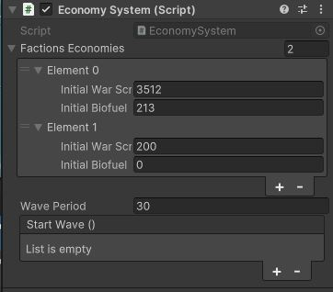

Figure .Economy system component

* Faction Economies:
  + Based on the number and order of factions that defined on the GameManager, set the number and parameters of each faction economy.
* Wave period that defined here will be used for unit spawn and income payments.
* Start Wave event in invoking all the assigned methods at the beginning of each wave

# Unit Placement Cost

Select the target unit's prefab and attach the UnitPlacementCosts component to it.

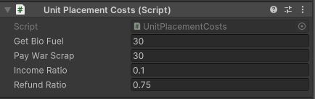

Figure .Unit placement costs

* Get Bio Fuel: The amount of biofuel the unit's faction gets when it positioned in the scene
* Pay War Scrap: The amount of warscrap the unit's faction pays to put the unit in the scene
* Income Ration: the ration of warscrap that added to wave periodic income
* Refund Ration: the ration of warscrap that refunded on the unit deletion

# Unit Kill Event Handler

The class to handle events when a unit kill another unit. Some changes have been done on RTS engine source code for this class to work correctly.

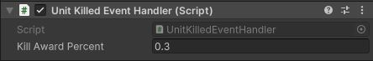

Figure .UnitKilledEventHandler to run hand methods on unit termination

* Kill Award Percent: The percent of unit warscrap cost which will be given the faction which its unit killed this unit.

# Income UI Text

Attach the IncomUIText to a GameObject with TextMeshProUGUI on it to show the amount of periodic income on that UI-Text.

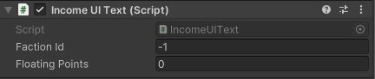

Figure . IncomeUIText to present income of faction

* Faction Id: the id of faction to monitor its income, the default number -1 means local faction.
* Floating Points: the number of floating-point digits to show on UI

# War Scrap UI Text

Attach the IncomUIText to a GameObject with TextMeshProUGUI on it to show the amount of WarScrap on that UI-Text.

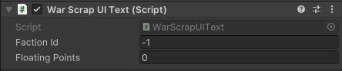

Figure . WarScrapUIText to show the amount of Warscrap on UI

* Faction Id: the id of faction to monitor its war scraps, the default number -1 means local faction.
* Floating Points: the number of floating-point digits to show on UI

# Bio Fuel UI Text

Attach the IncomUIText to a GameObject with TextMeshProUGUI on it to show the amount of BuiFuel on that UI-Text.

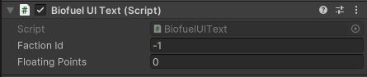

Figure . BiofuelUIText to show the amount of BioFuel on UI

* Faction Id: the id of faction to monitor its bio fuels, the default number -1 means local faction.
* Floating Points: the number of floating-point digits to show on UI