

CAPSTONE PROJECT REPORT

**Report 1 – Project Introduction**

– Da Nang, January 2022 –

**Table of Contents**

1. Record of Changes 1
2. Project Introduction 2
   1. Overview 2
      1. Project Information 2
      2. Project Team 2
         1. Supervisors 2
         2. Members 2
   2. Product Background 2
   3. Existing Systems 3
      1. TOKAGO - ス トリ ート ウェ アclothes shop 3
      2. Thegioididong 4
   4. Business Opportunity 5
   5. Software Product Vision 6
   6. Project Scope & Limitations 6
      1. Major Features 6
         1. Admin Site 6
         2. Staff Site 6
         3. Guess Site 7
         4. Customer Site 7
      2. Limitations & Exclusions 7

# Record of Changes

|  |  |  |  |
| --- | --- | --- | --- |
| **Date** | **A\***  **M, D** | **In charge** | **Change Description** |
| 7/4/2022 | M | NhiNTT | Modified “Product Background”, “Existing System”,  “Business Opportunity”, Project Scope” and picture of “Major Feature” |
|  |  |  |  |
|  |  |  |  |
|  |  |  |  |
|  |  |  |  |
|  |  |  |  |
|  |  |  |  |
|  |  |  |  |
|  |  |  |  |
|  |  |  |  |
|  |  |  |  |
|  |  |  |  |
|  |  |  |  |

*A - Added M - Modified D - Deleted

# Project Introduction

## Overview

### Project Information

* Project name: **Online shopping with the recommendation system.**
* Project code: SOS
* Group name: Spotlight On Style
* Software type: Web and Mobile App

### Project Team

#### Supervisors

|  |  |  |  |
| --- | --- | --- | --- |
| **Full Name** | **Role** | **Email** | **Mobile** |
| Võ Đức Hoàng | Supervisor 1 | [hoangvd7@fe.edu.vn](mailto:hoangvd7@fe.edu.vn) | 0906477283 |
| Lý Quỳnh Trân | Supervisor 2 | [tranlq@fe.edu.vn](mailto:tranlq@fe.edu.vn) | 0934915655 |

#### Members

|  |  |  |  |
| --- | --- | --- | --- |
| **Full Name** | **Role** | **Email** | **Mobile** |
| Võ Thị Thúy Hằng | Leader | [hangvttse63286@fpt.edu.vn](mailto:hangvttse63286@fpt.edu.vn) | 0973764045 |
| Nguyễn Thị Thục Nhi | Member | [nhinttde130011@fpt.edu.vn](mailto:nhinttde130011@fpt.edu.vn) | 0783271440 |
| Trần Đức Huy | Member | [huytdde140261@fpt.edu.vn](mailto:huytdde140261@fpt.edu.vn) | 0848050620 |
| Nguyễn Hoàng Tùng | Member | [tungnhde140061@fpt.edu.vn](mailto:tungnhde140061@fpt.edu.vn) | 0944577518 |
| Nguyễn Tuấn Đạt | Member | [datntde140182@fpt.edu.vn](mailto:datntde140182@fpt.edu.vn) | 0915252196 |

## Product Background

There is no doubt that online shopping can help the customers to find and purchase items comfortably and easily to cancel the transactions at home or workplace with the refund/cancelation policy. For the business side, the online stores do not have space constraints and a wide variety of products can be displayed on websites; which saves a lot of budgets to implement. Furthermore, in recent years, with the complicated epidemic situation Covid-19, people are limited going out to avoid the spreading of the virus and to ensure the safety of themselves and others. Therefore, there is a high need for online shopping in our society.

The help of technology, there are a lot of online store was taken to satisfy the user’s requirements such as:

* Direct, personalized communication with your customers.
* Improved customer loyalty and retention.
* Full access to customer information (email, browsing/purchase history).
* Faster dispute resolution.
* Optimized business decisions, operations, products and services.
* Keep 100% of your sales revenue (instead of splitting it with third parties).
* Resilience against copycat companies and products.
* Complete business autonomy (you set the rules).

After the survey, we realized that when searching for products on a regular website, sometimes too many products appear randomly, this makes the products according to the customer's desired style mixed in with other items, unintentionally making customers psychologically bored, confused and do not want to buy anymore. Therefore, customers want an app or website that can solve those outstanding problems so that online shopping can be easier and faster.

For these reasons, our group decided to create a system that includes the fundamental capabilities of a website as well as an application with a recommendation system. With the large selection of items offered and the service the business provides, this system may personalize product recommendations depending on a customer's style. When consumers buy with us, we expect them to have the greatest experience possible.

## Existing Systems

### TOKAGO - ス トリ ー トウ ェ ア clothes shop

TOKAGO - ス ト リ ー ト ウ ェ ア is a store established in 2021, producing self- designed and Japanese-oriented fashion clothes. This website is designed in a straightforward manner, with a white backdrop and two primary text colors, red and black. The site's primary language is Vietnamese, with some Japanese terms thrown in for good measure. Although the website does not show too many toolbars, it can assist users in locating the taskbar they are searching for and avoiding confusion. To attract more clients, Tokago also highlighted new-arrival and best-selling items on the front page. They also utilize a fairly ingenious pricing strategy in which practically all items are listed at the previous price and the price has been dropped, making it a highly appealing point for buyers.

Website: <https://tokago.vn/>

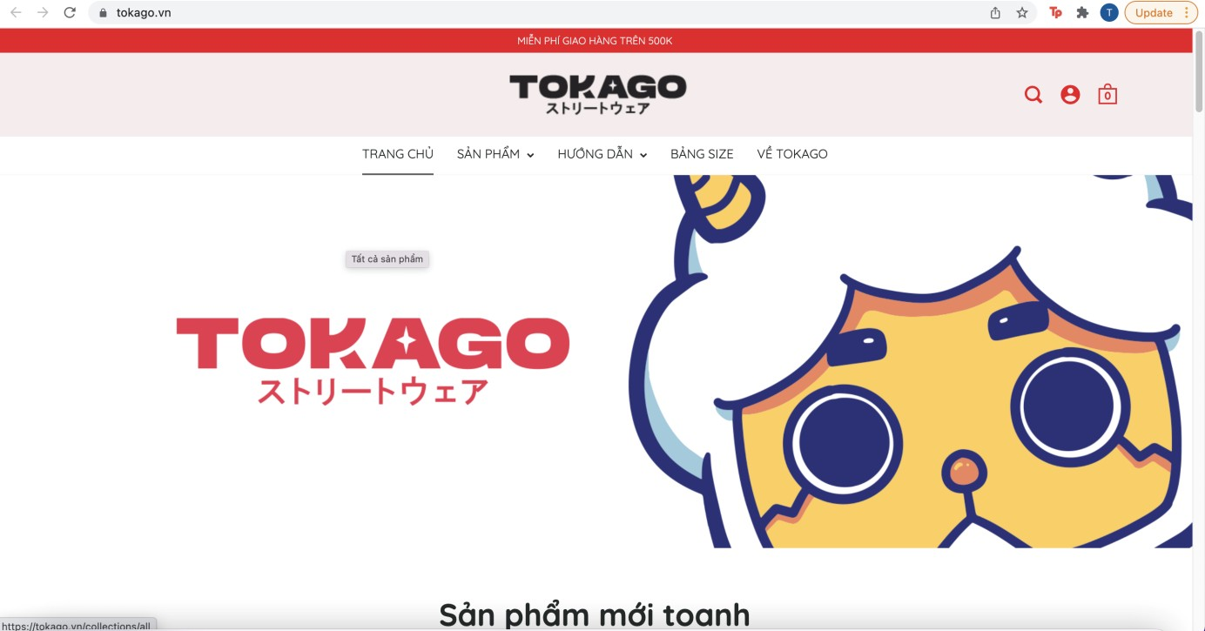

* Advantage:

***Figure 1: TOKAGO -* ストリートウェア*website***

* + The number of daily page visits up to thousand of times.
  + Nice interface, easy to buy and support customers so well.
  + Tokago has a simple website design, but it is quite neat and smart.
  + New-arrival and best-selling items are highlighted on the front page to attract customers.
* Disadvantage:
  + This online shop doesn’t have a mobile app.
  + The new website only lists products, and doesn't recommend products that customers are interested in.

### Thegioididong

Thegioididong.com is an e-commerce website with more than 1,200,000 daily visits, providing detailed information on prices, technical features of more than 500 phone models and 200 laptop models of all major brands. Those interested in purchasing electrical equipment can visit the store's website to view numerous models. Thegioididong's website is primarily in Vietnamese; there is no English version. When users access the website, we can easily see that thegioididong has been divided into eight main categories, which are displayed on the front page and are: phones, laptops, tablets,..., so that users can quickly search based on the pre-divided table of contents. There are additional toolbars for searching, Q&A, and searching order history. Thegioididong has offered consumers a pleasant experience while purchasing through the website, with simple ordering stages and order payment methods with numerous options for clients, such as online payment or payment on delivery.

Website: <https://www.thegioididong.com/>

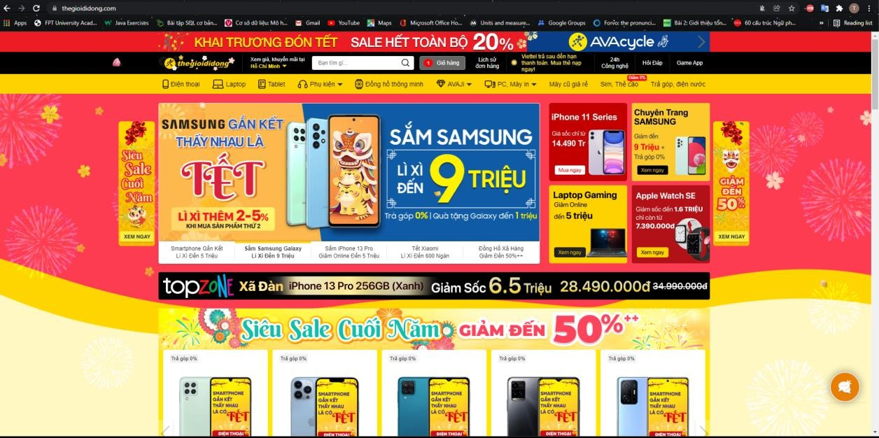

* Advantages:

***Figure 2: Thegioididong website***

* + The interface of the website is fully functional for users: ordering, rating, commenting on products, …
  + The interface attracts users by displaying products on sale and promotions at the top of the page.
  + Users do not need to log in, they still view products, comment on products, make purchases, track orders 🡪 Process optimization for customers.
  + Save viewing history when customers log in to the website.
  + Suggestion system: users do not need to log in, the system still suggests related products when customers view any product 🡪 Show products that customers are interested in
  + With simple ordering steps and order payment methods with many choices for customers, such as online payment or payment on delivery.
  + The website has a large number of interactive customers, so you can see detailed product reviews and comments from people who have purchased these products.
* Disadvantage:
  + Website doesn’t have a mobile app.

## Business Opportunity

Nowadays, the trend of customers using the internet, especially social media, is increasing. This can help customers easily know our application and website, which can increase our brand image and awareness.

Furthermore, many offline retailers must be closed during the COVID-19 epidemic time; additionally, people are limited to coming to crowded locations, making it incredibly difficult to buy directly at stores. As a result, during the epidemic time, internet shopping is increasingly popular and perfectly satisfies people's buying demands.

Shopping online or in a store will take a long time for married individuals and office employees who don't have much time but yet like shopping. This set of potential customers will be attracted to an online shopping website or app with a recommendation system that proposes things that fit their style.

## Software Product Vision

Our online shopping system is an Internet-based and smartphone-enabled application that provides a full range of trending fashion items. In addition, the system will help suggest products that customers have shopping needs through the recommendation system. It is considered as a consultant to help customers make the right purchasing decisions. Besides, the system offers special promotions for customers to refer to. This helps people to go shopping comfortably right on their own phones or computers and just need an internet connection. Customers just select the product that they like (they can see the feedback or rate of product in this post), and the order will be delivered directly to them. This will help people save time and effort going out to the streets to shop during the epidemic.

## Project Scope & Limitations

The online shopping system was deployed by us for a period of 4 months from January 1, to April 26, 2022. The purpose of the project is to create an online shopping platform for everyone in the country. To be specific, people can access our system via website or phone to shop online, then they can view fashion products, product’s price, feedback and rate of products. If customers are logged in to their account, they can place an order by adding products in the shopping cart and proceed to pay by online payment (VNPay) or paying at home. In addition, our system through customer shopping will recommend related products or products they are interested in. That will help customers get the best experience when using our system.

### Major Features

#### Admin Site

FE-01: Manage products: view, search, add, update and delete

FE-02: Manage orders: view, search, change order status, print invoice

FE-03: Manage voucher: view, search, add, update , change activation and delete FE-04: Manage account of staffs and customers: Add, delete and change role

FE-05: Extract feature of product for recommend FE-06: View sales statistics month by month.

#### Staff Site

FE-01: Manage account

FE-02: Search, view products and vouchers.

FE-03: Manage orders: view, search, change order status, print invoice.

#### Guess Site

FE-01: Display related products or products the viewer is interested in.

FE-02: Search, view products (including selling price), feedbacks and rate of these products.

#### Customer Site

FE-01: Manage account

FE-02: Search, view products (including selling price), feedbacks and rate of these products.

FE-03: Display related products or products the user is interested in. FE-04: Manage cart.

FE-05: Apply a voucher when placing an order. FE-06: Place order and track order status.

FE-07: Product reviews and comments.

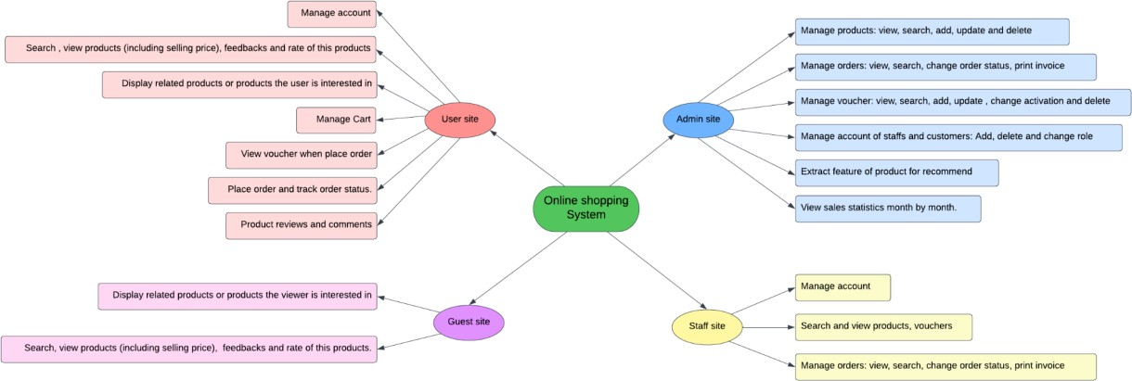

***Figure 3: Major Feature Map***

### 6.2 Limitations & Exclusions

LI-1: Our system does not support shopping, delivery and payment for orders outside of the country.