2.3. Wireframe

2.3.1. Home Page ( User)

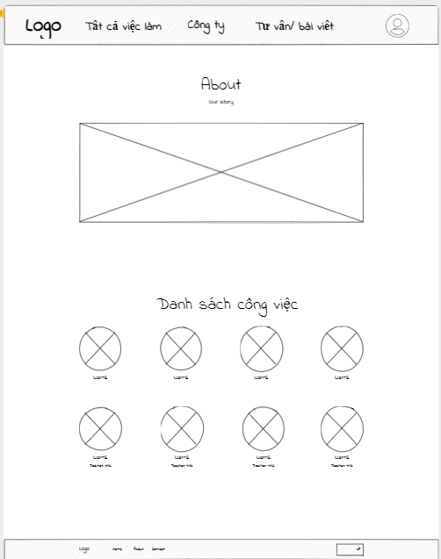

2.3.2 View job listings(User)

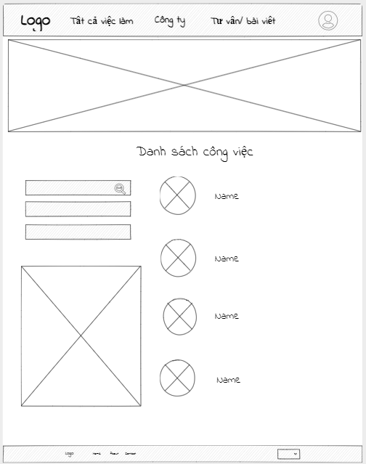

2.3.3. View profile (User)

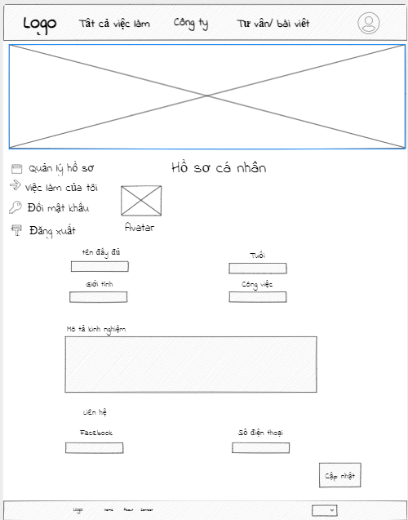

2.3.4. Post job vacancies (User)

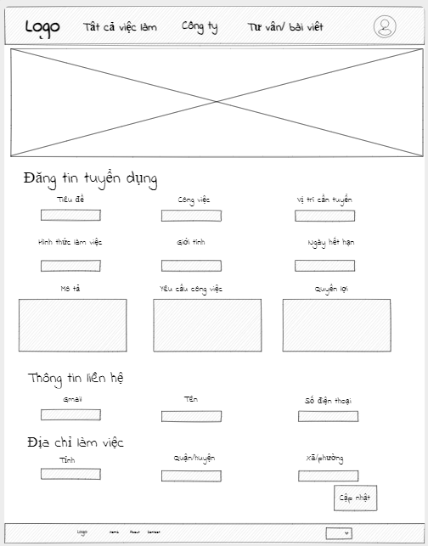

2.3.5. Change password (User)

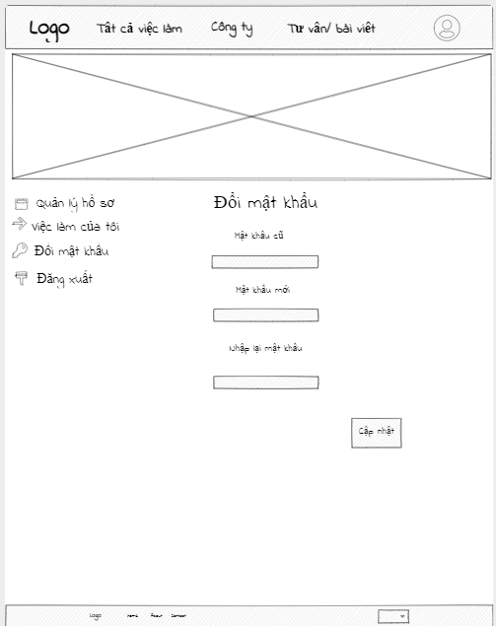

2.3.6. Management dashboard (Admin / Staff)

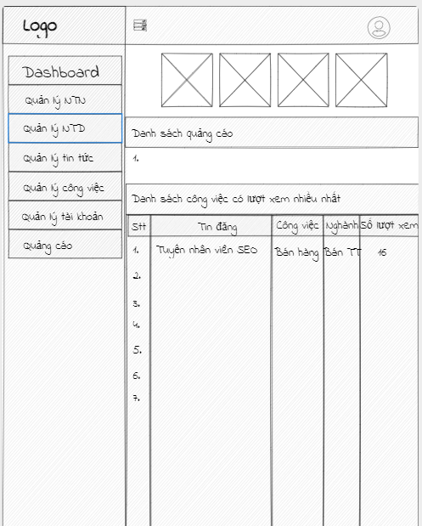

2.3.7. Job Seeker Management (Admin/Staff)

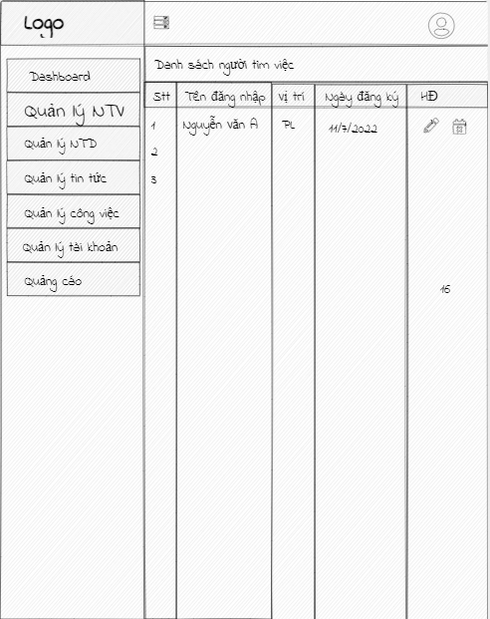

2.3.8. News manager (Admin/Staff)

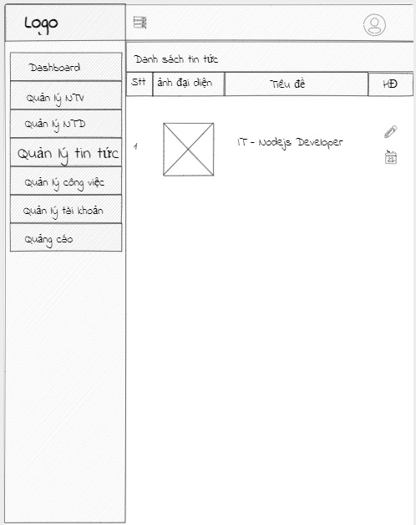

2.3.9. Account Management (Admin)

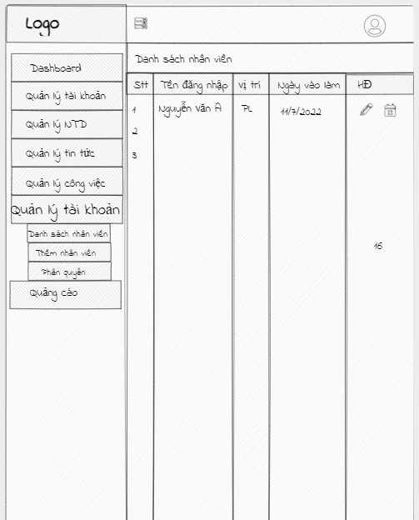

2.3.10. Add account (Admin)

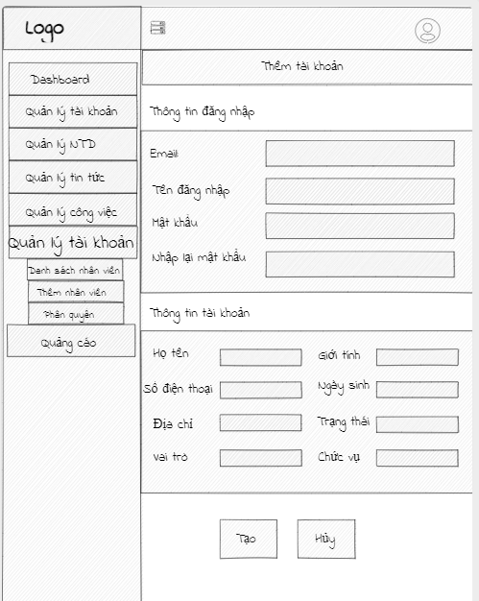

2.3.11. Assign work (Admin)

