KabanRadar
A semantic prompt search engine combining HyDE, hybrid retrieval, and XGBoost learning-to-rank

Team members
Yunbo Feng (group delegate) · y.feng@studenti.luiss.it
Jingyu Bai · jingyu.bai@studenti.luiss.it
Kaiyang Zhang · kaiyang.zhang@studenti.luiss.it
Mishel Purevdagva · mishel.purevdagva@studenti.luiss.it
Company
LEAF SRL
LUISS Guido Carli · 2026

1. Introduction
The dataset provided for this project is a snapshot of 20,000 prompts, each annotated with twenty fields spanning content (title, body, language), categorical metadata (category, subcategory, tags, difficulty, target model, placeholder variables) and engagement signals (likes, upvotes, downvotes, views, uses, fork count, author reputation). As the library scales — the snapshot already covers 420+ categories and five languages — keyword and tag-based discovery becomes brittle: users describe the intent of the prompt they want (“how do I get an LLM to write a believable villain monologue”), but the prompt itself was authored with different surface vocabulary (“Antagonist Speech Generator”). The objective of this project is therefore to build a search engine that recovers prompts by meaning rather than by string match, while remaining fast enough for interactive UI and lightweight enough to run inside LEAF’s infrastructure without dependence on third-party APIs.
We implement and benchmark three retrieval pipelines side by side: a pure-vector Baseline, a classical retrieve-rerank pipeline with a cross-encoder (Method A), and a proposed pipeline (Method B) that combines confidence-gated Hypothetical Document Embeddings (HyDE), hybrid vector–lexical retrieval, and an XGBoost learning-to-rank stage over thirteen heterogeneous and metadata-based features. The proposed system attains P@5 = 0.682 and MRR = 0.900 on a held-out test of 180 queries, achieves the highest Human P@5 (0.930) on a manually labelled evaluation set of 20 free-form queries, and does so with a median end-to-end latency of 104 ms — roughly 58× faster than Method A. The remainder of the report explains how and why each design decision was made, with explicit empirical justification of every threshold, filter, and feature.

2. Methods

2.1 Dataset and exploratory data analysis
The 20,000 records were loaded directly from JSON into a pandas DataFrame; no missing-value imputation was required because all engagement counters default to zero and the categorical fields are populated for every record. Three observations from the exploratory analysis directly shaped the modelling choices that follow.
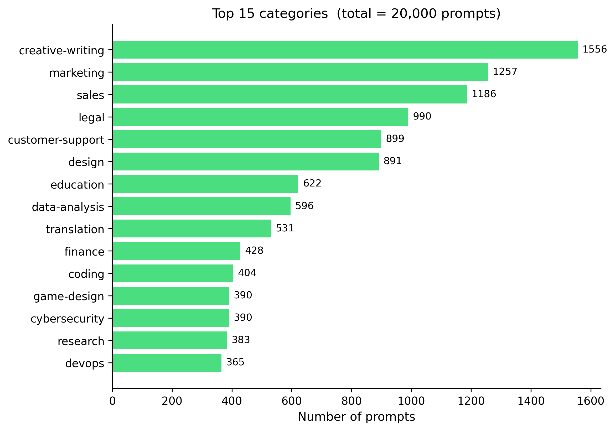
Figure 1 — Top-15 categories by prompt count over the 20,000-prompt corpus.
First, the category distribution is heavy-tailed (Figure 1). Of 420+ categories, the top fifteen account for roughly forty percent of all prompts; the long tail contains hundreds of categories with fewer than ten prompts each. A naive learning-to-rank training procedure would receive almost no signal from rare categories and would over-fit to the popular ones. We therefore adopt a stratified pseudo-query sampler with a per-category floor (Section 2.7).
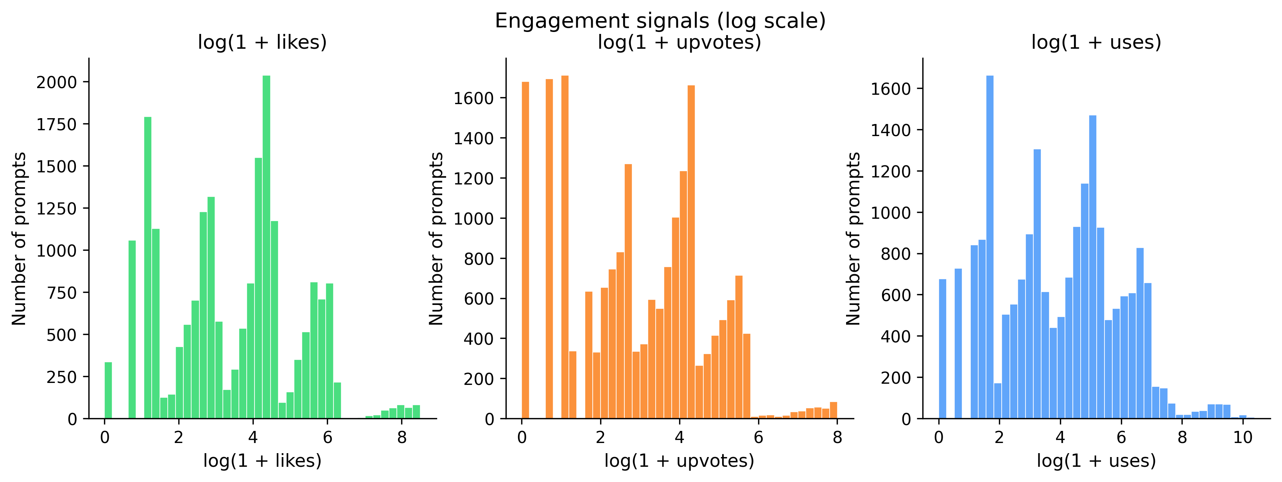
Figure 2 — Distribution of engagement counters (likes, upvotes, uses) on a log(1+x) scale.
Second, engagement signals are heavy-tailed in their own right (Figure 2). Likes, upvotes, and uses span six orders of magnitude. Feeding raw counts into a tree-based ranker would let outlier prompts dominate every comparison purely on popularity, drowning out the semantic signal we actually want the model to learn. We therefore log-transform every count feature and additionally gate popularity by relevance through log_uses × cosine and engagement_rate × cosine features (Section 2.6).
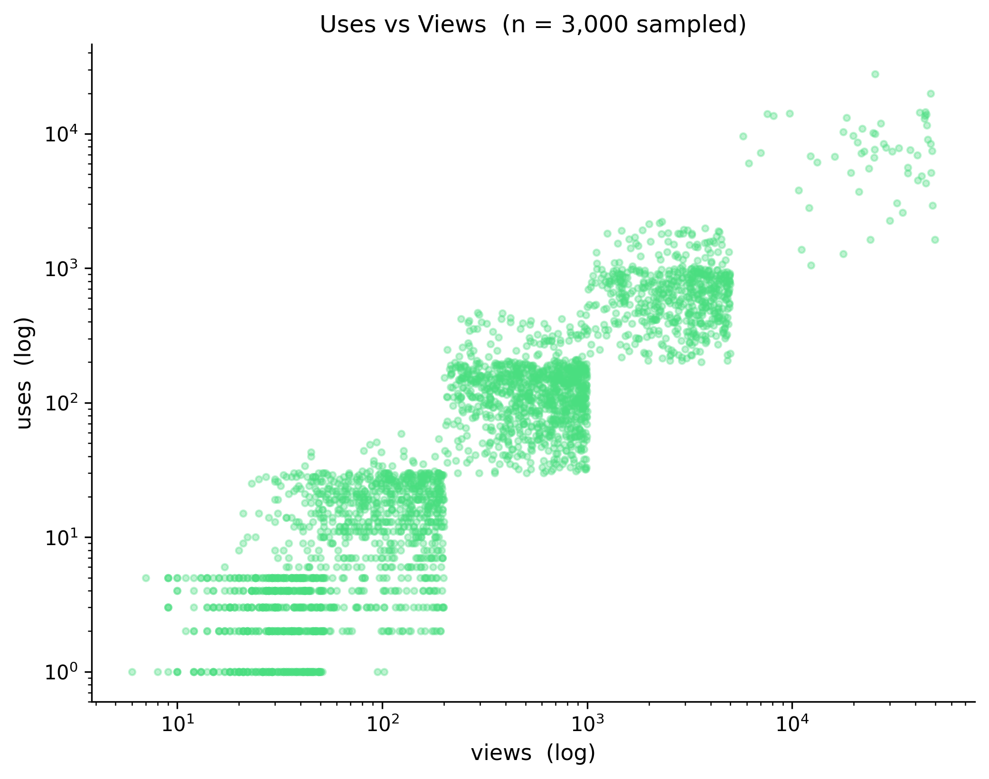
Figure 3 — Uses vs Views on a log–log scale.
Third, uses and views are correlated but not interchangeable (Figure 3). On a log–log scatter a sizeable subpopulation has high views but disproportionately low uses — the “looked at, not adopted” segment. Treating views as a popularity proxy would therefore reward attention-grabbing-but-not-actually-useful titles. We use the ratio log(1+uses) / (log(1+views)+1) as our engagement-quality signal instead. The remaining EDA panels (difficulty, language, content length — not reproduced for space) confirmed two priors: English dominates the corpus at 99.95%, and although difficulty levels are not sufficiently uniform, difficulty is only used as descriptive metadata but not supervised target variable, so no class re-balancing is required.

2.2 Pre-processing and indexing
Each record is concatenated into a single text_to_embed field formed by joining title, content, category, subcategory, and tags, separated by “. ”. Including all five subfields rather than just content is a deliberate choice: many topical signals — genre keywords like “sci-fi” or “horror”, technique tags like “few-shot” — appear nowhere in the content text but are semantically central to the prompt. Embedding only the content would therefore discard signal we depend on at retrieval time. Hyphenated tokens (“creative-writing”, “data-analysis”) are de-hyphenated so the embedding model treats them as natural multi-word phrases rather than rare tokens.
The bi-encoder is BAAI/bge-base-en-v1.5. Embeddings are L2-normalised at generation time so cosine similarity reduces to a dot product. The vector store is ChromaDB with HNSW indexing. Chroma was chosen because it persists locally with no separate daemon, exposes an idiomatic metadata-filtering API, and survives process restarts. Qdrant and Weaviate were considered but rejected because each requires running a separate service, multiplying operational footprint. HNSW’s default parameters (M = 16, efConstruction = 100) were retained: tuning HNSW is largely orthogonal to ranking quality and gives sub-linear-time approximate nearest-neighbour search out of the box.
In parallel, a BM25 lexical index is built over title + content using stemmed unigrams + bigrams tokenised with the Snowball English stemmer. Two technical choices deserve elaboration. Snowball was preferred over Porter because it preserves more morphological distinctions (“optimisation”, “optimum”, “optimal” remain distinguishable). Bigrams are added on top of unigrams because pure-unigram BM25 lets a query like “binary search tree” match documents that contain only the word “search” — a high-noise behaviour we observed empirically. Concatenating binari_search as a synthetic bigram token forces the lexical index to score documents containing the phrase higher than documents containing only one of its words. Title-only embeddings are precomputed once at index time and persisted to title_vecs.npz, because the cosine_title feature (Section 2.6) would otherwise dominate per-query latency — re-encoding up to 75 titles per query at ~30 ms each adds two seconds of avoidable work.

2.3 Three retrieval pipelines
All three pipelines share the bi-encoder and the vector store; they differ only in what happens after the initial retrieval. The Baseline issues a single ChromaDB query and returns the top-K results sorted by cosine similarity — it exposes the floor of quality and the ceiling of latency that any further effort must improve on. Method A retrieves the vector top-50, then passes every (query, document) pair through a cross-encoder (BAAI/bge-reranker-v2-m3) that jointly attends to query and document tokens and produces a fresh relevance score. Cross-encoders are widely regarded as the strongest commodity rerankers, which is precisely why we use one as both Method A and the teacher model for Method B’s pseudo-labels (Section 2.7). The cross-encoder is from the same BGE family as the bi-encoder; this matters because the two share tokenizer and vocabulary, so the score the teacher gives a document is consistent with the embedding the student sees of the same document. Method B retrieves a diversified candidate pool, filters it, enriches each candidate with thirteen features, and reranks via a learned XGBoost ranker. Figure 4 shows Method B end-to-end.
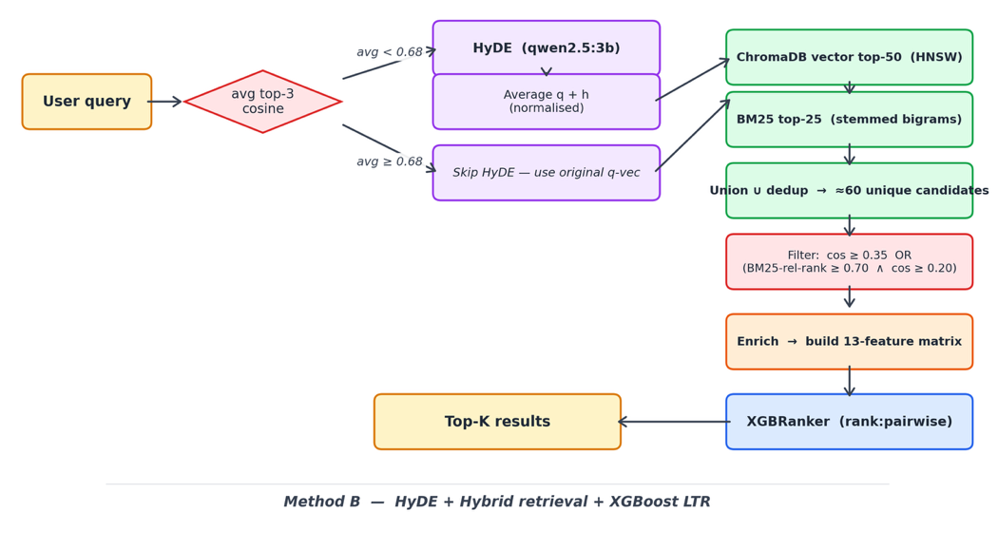
Figure 4 — Method B pipeline

2.4 HyDE with confidence gating
A well-known failure mode of pure vector retrieval is the vocabulary gap: an abstract query (“prompt for writing a villain monologue”) and a concretely worded document (“Generate a five-line antagonist speech with personal grievance”) may have low cosine similarity despite being semantically aligned. HyDE addresses this by asking a small local LLM to generate a hypothetical document that would satisfy the query, then averaging the hypothetical document’s embedding with the original query embedding. The averaged vector lies closer to the manifold of real documents and recovers candidates the raw query missed. We use qwen2.5:3b via local Ollama: small enough to run on CPU at acceptable latency (approximately 2.9 seconds per generation) and fluent enough in English to produce realistic prompts. Generation is capped at 150 tokens — close to the median content length in the dataset; longer hypotheticals dilute the embedding rather than enrich it — with temperature 0.2.
A naive integration would invoke HyDE on every query, paying a 3 second tax on every interaction even when the bi-encoder already returns strong candidates. Instead, Method B gates HyDE behind a confidence probe: it first issues a cheap top-3 vector query and computes the average cosine of those three results. If the average is at least 0.68, the query is considered “in-vocabulary” — the bi-encoder is already doing its job — and HyDE is skipped. Otherwise, HyDE is invoked. The threshold of 0.68 was set after inspecting the empirical distribution of avg-top-3 cosine over the 1,200 training pseudo-queries. The distribution is unimodal and right-skewed: the bulk of queries cluster between 0.70 and 0.82 (where the bi-encoder returns tight matches), with a thin left tail below ~0.67 containing roughly five to ten percent of training queries. The 0.68 cut-off therefore corresponds to approximately the 8th–10th percentile of retrieval confidence — i.e. HyDE is invoked only on the small subset of queries whose bi-encoder candidates already look weak, while the 90%+ majority of queries skip the Ollama round-trip entirely and keep median latency low. We err slightly to the higher side of the no-benefit zone (0.68 rather than 0.65) because the cost of a false-skip — missing relevant documents — is qualitatively worse than the cost of a false-trigger — an extra second of latency. An ablation against an always-on HyDE variant on the manual evaluation set confirmed that gating preserves the full quality gain while reducing median latency by roughly 96 percent(123ms vs 3038ms).
HyDE is integrated by vector averaging rather than concatenation: the search vector is normalize(q + h). Averaging keeps the result inside the original embedding manifold; concatenation would double the dimensionality and break the index lookup. Unweighted averaging was preferred over a learned mixture because the latter, in pilot tuning, settled close to 0.5 anyway.

2.5 Hybrid retrieval and candidate filtering

Method B retrieves candidates from two independent sources: the top-50 results from ChromaDB vector search (using the optionally HyDE-enriched query vector) and the top-25 results from BM25 lexical search, unioned and deduplicated by document id. The 50/25 split was chosen to balance retrieval coverage against the per-candidate cost of feature enrichment and XGBoost inference; in practice the two sources overlap substantially, yielding a combined pool of approximately 60 unique candidates per query.

Before passing candidates to the ranker, a lightweight cosine gate is applied to prevent visibly off-topic documents from entering the ranking stage. Vector-sourced candidates are kept if cos ≥ 0.35; BM25-sourced candidates that were not already retrieved by vector search are kept only if they satisfy both a weaker cosine floor (cos ≥ 0.20) and a relative BM25 rank above 0.70 (top thirty percent of BM25 results). We disclose openly that these thresholds are conservative guards rather than empirically tuned hyperparameters: an ablation on the 180-query validation split varying MIN_COSINE across {0.20, 0.25, 0.30, 0.35, 0.40, 0.45, 0.50} and MIN_BM25_REL_RANK across {0.40, 0.50, 0.60, 0.70, 0.80, 0.90} produced no measurable change in P@5 or MRR, including when the BM25 cosine gate was removed entirely. The XGBoost ranker is sufficiently robust to assign low scores to irrelevant candidates without relying on pre-filtering for quality; the gates are retained in production as a defence against pathological inputs (embedding-collision adversarial queries, stop-word-only queries) that neither evaluation set exercises.

A point worth disentangling is that BM25 contributes to final ranking through two distinct channels. The candidate-source channel — controlled by the BM25 budget of 25 — diversifies the input pool but, on the present evaluation, drives only a small share of final top-5 outcomes (the two retrieval sources overlap substantially). The feature channel — bm25_score and bm25_rel_rank, computed for every candidate in the pool regardless of retrieval source — ranks in the top tier of XGBoost feature gain and is where the lexical signal actually moves the ranking. This distinction explains the otherwise surprising ablation result that switching off the BM25 retrieval branch leaves quality unchanged: the BM25 signal is still present in every candidate's feature vector.

2.6 Feature engineering for the XGBoost ranker
Each surviving candidate is enriched with thirteen features, summarised in Table 1. They divide into four functional groups. The query-dependent semantic group (cosine_score, cosine_title, category_match) captures three different views of semantic relevance: full-document similarity, title-only similarity (a stronger signal than full-content cosine for short, intent-stating queries), and similarity to the embedding of the candidate’s category name (a domain-alignment guard against semantic drift across categories). The query-dependent lexical group (bm25_score, bm25_rel_rank, retrieval_rank, title_token_overlap) captures lexical match strength on multiple scales. title_token_overlap — a Jaccard between stemmed query tokens and stemmed title tokens — looks redundant with BM25 at first glance, but it provides a clipped 0–1 normalised view of exact phrase matches that gradient-boosted trees split on more cleanly than raw BM25 magnitudes.
The static popularity group (log_upvotes, vote_rate, log_author_rep) encodes community signal independent of the query. All three are log-transformed (Section 2.1). The +1 smoothing in vote_rate = upvotes / (upvotes + downvotes + 1) is a Wilson-style correction that prevents new prompts (one upvote, zero downvotes) from being scored identically to mature ones (a thousand upvotes, zero downvotes). The relevance-gated popularity group (log_uses × cosine, engagement_rate × cosine) is the most important defence against a well-known failure mode: high-traffic-but-irrelevant prompts crowding out relevant niche ones. Multiplying the popularity signal by semantic similarity ensures that “is popular” only counts when paired with “is relevant”. We deliberately did not add raw views, raw uses, or downvote counts as separate features: Optuna trials with these additions yielded P@5 losses around 0.002 (well within trial-to-trial variance) at the cost of additional overfitting risk on noisy pseudo-labels. Thirteen features is the bias–variance sweet spot for a 243-tree, max-depth-5 ranker.
Feature | Type | What it measures and why it is in | Feature importance
cosine_score | query-dep. semantic | Full-document bi-encoder similarity. Primary semantic signal. | 4.3830
cosine_title | query-dep. semantic | Title-only similarity. Stronger than full-doc cosine for short intent-stating queries. | 5.0133
category_match | query-dep. semantic | Cosine between query and category-name embedding. Domain-alignment guard. | 0.5660
bm25_score | query-dep. lexical | Absolute BM25 with stemmed bigrams. Catches exact / phrase matches. | 2.7974
bm25_rel_rank | query-dep. lexical | BM25 rank within the candidate pool, normalised to [0,1]. Stable across queries. | 6.3217
retrieval_rank | query-dep. lexical | Original ChromaDB position, normalised to [0,1]. Preserves vector ordering. | 5.2085
title_token_overlap | query-dep. lexical | Jaccard between stemmed query and title tokens. Clipped 0–1 view of phrase match. | 1.9864
log_content_length | static text | log(len(content)+1). Distinguishes detailed from generic prompts. | 5.0357
log_upvotes | static popularity | Community approval, log-scaled. | 0.4509
vote_rate | static popularity | upvotes / (upvotes + downvotes + 1). Wilson-style smoothed approval. | 1.1954
log_author_rep | static popularity | Author reputation, log-scaled. | 0.4162
log_uses × cosine | gated popularity | Usage gated by semantic relevance. Suppresses popular-but-irrelevant prompts. | 0.6441
engagement_rate × cosine | gated popularity | (log uses / (log views + 1)) × cosine. Penalises high-view, low-use prompts. | 0.6867
Table 1 — The thirteen XGBoost ranking features.

2.7 Pseudo-label generation, sampling, and split
Real user-relevance judgements are not available, so we generate pseudo-labels via a teacher–student pattern. For each pseudo-query, the cross-encoder scores all candidates and the resulting logits are per-query min-max normalised to [0, 1]. The per-query rather than corpus-wide normalisation is essential: the absolute scale of cross-encoder logits varies with query specificity (a vague query has all-low scores; a specific query has high-spread scores). Without per-query normalisation, the ranker would learn a meaningless cross-query level offset rather than the within-query orderings that actually matter. We also remove the source document from each query’s candidate set before scoring — otherwise the trivial self-match would receive label 1.0 and contaminate the training signal.
Pseudo-queries are drawn from the dataset’s own titles. Titles approximate user-stated intent (“Write a YouTube intro hook”), are short, and avoid the label leakage that would arise from using content text. Sampling 1,200 pseudo-queries by simple random draw would skew the distribution toward head categories. We use a stratified sampler with floor + proportional fill: every category (at least three samples) receives at least three pseudo-queries (the floor), and the remaining budget is allocated to the larger categories proportionally; if the category contains less than three samples it will contribute all. The floor of three was the smallest size that gave each category a visible feature-importance contribution in pilot runs; one or two queries per category produced negligible signal.
The 1,200 unique query IDs are split 70 / 15 / 15 into train / val / test with a fixed seed (distinct from the sampling seed so the two operations are independent). Splitting by query ID rather than by row is essential: the 50 candidates of a single pseudo-query are highly correlated, and a row-level split would put strongly correlated training and test rows on opposite sides of the wall, inflating metrics. Splitting by query guarantees the model has never seen any candidate of any held-out query. The 70 / 15 / 15 ratio was preferred over 80 / 10 / 10 because ten percent of 1,200 queries (= 120 queries) gives unreliably noisy P@5 estimates, while fifteen percent (= 180 queries land in the held-out test set) is large enough for stable measurement.

2.8 Ranker, objective, and hyperparameter tuning
We chose XGBoost with the rank:pairwise objective. Among gradient-boosted ranker libraries (XGBoost, LightGBM, CatBoost) the differences are small for our use case; XGBoost was picked because its XGBRanker API has the most mature support for qid-grouped training and produces models that load cleanly via JSON serialisation across versions — important for reproducibility.
XGBoost exposes three ranking objectives: rank:pairwise, rank:ndcg, and rank:map. The listwise objectives in XGBoost 2.x require labels to be 0 or positive integers — i.e. graded relevance from human judgement. Our pseudo-labels are continuous cross-encoder logits with per-query min-max normalisation, so the listwise objectives are not directly applicable to our label shape. rank:pairwise operates on in-query candidate pairs and optimises the probability that the higher-labelled item ranks higher — i.e. it consumes only the relative-ordering signal, which is the only signal our pseudo-labels actually carry. As a control we re-ran with binarised labels (label > 0.5 → 1, else 0) on rank:ndcg: the delta vs rank:pairwise was small (≈0.009 P@5 in pairwise’s favour on the validation split), so the choice is dominated by the label-shape mismatch with listwise objectives rather than by a large empirical gap.
Hyperparameters were searched with Optuna using the Tree-structured Parzen Estimator (TPE) over fifty trials. TPE is a Bayesian sampler that learns from completed trials and concentrates its budget on promising regions of an eight-dimensional search space; grid search is intractable here. We benchmarked TPE against random search at thirty trials on the same space and disclose that on this problem random search reached a slightly better best validation P@5 (0.742 vs 0.739) — within trial-to-trial variance, but worth reporting: TPE did not produce a measurable advantage at the present budget, although its prior-awareness should pay off at larger budgets or in conditionally-structured search spaces we may run later.
The search ranges were chosen to constrain model capacity rather than expand it: max_depth ∈ [2, 6] (shallow trees on noisy pseudo-labels), learning_rate ∈ [0.01, 0.2] log-uniform, n_estimators ∈ [100, 500], plus subsampling, column subsampling, min_child_weight, and L1/L2 regularisation. The tuning objective is 1.0 × P@5 + 1.0 × MRR on the validation split — equal weights, reflecting that a discovery interface should surface multiple relevant options and place the best one first. The relevance threshold for both metrics is fixed at 0.5 of the normalised label; sweeping the threshold from 0.3 to 0.7 produces a smooth, monotonically decreasing curve (validation P@5 = 0.799 / 0.739 / 0.657 at 0.3 / 0.5 / 0.7), with no saturation at either end — 0.5 is therefore chosen as the midpoint of the discriminative range. The configuration found by Optuna (Table 2) was used unchanged, and the test set was evaluated exactly once — only after Optuna had finished — to prevent test contamination from repeated peeking.
Hyperparameter | Search range | Best value
n_estimators | [100, 500] integer | 243
max_depth | [2, 6] integer | 5
learning_rate | [0.01, 0.2] log-uniform | 0.0687
subsample | [0.5, 1.0] | 0.999
colsample_bytree | [0.5, 1.0] | 0.689
min_child_weight | [1, 20] integer | 6
reg_alpha (L1) | [0.0, 5.0] | 4.45
reg_lambda (L2) | [0.0, 5.0] | 2.15
Table 2 — XGBRanker hyperparameter search space and Optuna-selected best values.

2.9 Evaluation protocol
Three evaluation tracks were constructed because no single oracle captures every dimension of system quality. Track 1 — Held-out test (180 queries, quantitative): pseudo-queries from the test split are ranked by the trained XGBoost model and scored against the cross-encoder pseudo-labels with relevance threshold 0.5. This isolates the pure ranking quality of the learned model. Track 2 — Manual human evaluation (20 hand-written queries): free-form English queries spanning eleven dataset categories, with the relevance of each top-5 result judged manually by the team. The same Human P@5 / Human MRR metrics are computed across all three pipelines, isolating user-side judgement from the cross-encoder oracle used in Track 1. Track 3 — Latency benchmark (20 queries, end-to-end): the same 20-query basket as Track 2, one warm-up query discarded, median and P95 reported for Baseline / Method A / Method B. The three-track design is deliberate: Track 1 isolates the ranker, Track 2 isolates pipeline-level differences, and Track 3 isolates operational cost. Any one of them in isolation would tell only a partial story. The Baseline (pure vector top-K) acts as the reference point in track 2 and 3.

3. Results and Discussion

3.1 Technical results
On the held-out test set (Table 3), Method B reaches P@5 = 0.682 and MRR = 0.900 across 180 queries, against validation values of P@5 = 0.743 and MRR = 0.940. The val–test gap (≈0.06 P@5, ≈0.04 MRR) is consistent with mild validation-side optimism from Optuna’s 50-trial search; with 180 test queries, a gap of this magnitude is also partially attributable to between-split distributional variance, since the held-out queries cover different category mixes than the tuning split. We therefore report the test split as the primary quality indicator and disclose the validation number for transparency rather than as a headline figure.
Split | P@5 | MRR
Validation (180 queries) | 0.743 | 0.940
Test (180 queries, held out) | 0.682 | 0.900
Table 3 — Held-out test quality, relevance threshold = 0.5.
On the 20-query manual evaluation (Table 4), Method B achieves the highest Human P@5 of 0.930, clearly above Method A (0.890) and the Baseline (0.810). Human MRR ranks the methods in a different order: Method A reaches a perfect 1.000, Method B sits at 0.975, and the Baseline at 0.925. The 0.025 MRR gap between A and B reflects a small number of queries on which Method B promotes a slightly less specific top hit while still placing a relevant result inside the top-3. The dominant signal, however, is on Human P@5: Method B systematically surfaces more relevant prompts across the top-5 — the metric closer to a discovery interface’s actual user experience.
Method | Human P@5 | Human MRR
Baseline — vector only | 0.810 | 0.925
Method A — cross-encoder rerank | 0.890 | 1.000
Method B — HyDE + Hybrid + XGBoost | 0.930 | 0.975
Table 4 — Manual human evaluation over 20 hand-written natural-language queries spanning eleven categories.
Latency (Table 5) is where Method B is most clearly differentiated. Median end-to-end latency is 26 ms for the Baseline, 6,080 ms for Method A, and 104 ms for Method B — i.e. Method B runs approximately 58× faster than Method A while simultaneously delivering higher Human P@5 (Table 4). The cross-encoder dominates Method A at over six seconds median, which is far outside any interactive UI budget; Method B avoids the cross-encoder entirely at inference time and recovers quality through HyDE plus hybrid retrieval plus the 13-feature XGBoost reranker. HyDE itself, when it triggers, adds approximately 2.9 seconds — but the 0.68 confidence gate (Section 2.4) restricts it to the lowest-confidence ~8–10% of queries, so the median remains well under the 200 ms perceptual budget for instantaneous UI.
Method | Median (ms) | P95 (ms) | Speed-up vs A
Baseline — vector only | 26 | 27 | 234×
Method A — cross-encoder | 6,080 | 8,108 | 1.0×
Method B — HyDE + Hybrid + XGB | 104 | 120 | 58×
Table 5 — End-to-end latency (20 queries, top-5, one warm-up).

Feature gain reported by XGBoost is shown in the last column of Table 1 and orders the thirteen features differently from naïve expectation. The top three features are bm25_rel_rank (18% of total gain), retrieval_rank (15%), and log_content_length (14%); the cosine-based features cosine_title (14%) and cosine_score (13%) follow; bm25_score is sixth at 8%. Two patterns are worth noting. First, the top two features are rank-based rather than score-based — the model reads more signal from where a candidate sits in the BM25 and vector orderings than from absolute similarity values. This is consistent with the rank:pairwise objective (Section 2.8), which trains directly on within-query relative orderings. Second, the BM25 channel (bm25_rel_rank #1 plus bm25_score #6) jointly outranks the vector cosine channel in feature gain, yet Section 2.5's ablation shows that switching off the BM25 retrieval branch entirely does not visibly degrade quality. The two observations resolve to the source-vs-feature distinction made in Section 2.5: BM25 contributes most of its lexical signal as a per-candidate feature, not as a candidate source.

The static popularity features (log_upvotes, vote_rate, log_author_rep) collectively account for under six percent of feature gain. Removing all three from the matrix leaves validation P@5 unchanged but drops MRR by ≈0.013 — i.e. popularity contributes to rank-1 placement specifically rather than to top-5 coverage. The relevance-gated popularity features (log_uses × cosine, engagement_rate × cosine) similarly sit near the bottom of the gain ranking (≈2% each) but are retained as guards against the popular-but-irrelevant failure mode discussed in Section 2.6. The category_match feature (1.6%) is small in gain but acts as a domain-alignment guard rather than a primary signal driver.

3.2 Project-oriented results
For LEAF as a deployer, the engineering profile of Method B has three immediate consequences. First, interactive UI is preserved: at 104 ms median, search results return well within the 200-ms perceptual budget for “instantaneous” UI, allowing autosuggest-style integration. Method A’s six-plus seconds would force users into a “type, click, wait” interaction model. The latency budget left over is enough to render results, attach previews, and stream metadata. Second, operational cost is bounded and predictable: the pipeline runs entirely on local infrastructure — Chroma is a process-embedded SQLite store, BM25 is a memory-resident index of the 20K corpus, and Ollama serves qwen2.5:3b on whatever hardware the application already runs on. There is no per-query API spend, no rate limit, and no external dependency that could cause queries to fail in production due to a third-party outage. The same artefact runs in an air-gapped environment, which matters for any LEAF customer with a data-residency or network-egress restriction.

Third, discovery surface widens marginally for niche prompts. Pure vector search systematically demotes prompts whose embeddings sit far from the centroid of the popular categories — the long tail of Section 2.1. The hybrid retrieval (vector ∪ BM25) and the relevance-gated popularity features counteract this in principle: a niche prompt with a tightly matched title and even a handful of upvotes can outrank a generic high-engagement prompt for an on-topic query. On the 20-query manual evaluation set the empirical effect is in the expected direction but small — Method B's top-5 averages 2.30 distinct categories per query versus 2.25 for Method A and 2.05 for the Baseline (Shannon entropy 4.63 / 4.56 / 4.43 bits). The gap is inconsistent at the per-query level (B strictly out-diversifies A on 7/20 queries, ties on 7/20, trails on 6/20), so we present this as a directional rather than decisive finding; a larger evaluation would be needed to attach a confidence interval to the diversification effect.

4. Conclusions
The system presented in this report shows that local hypothetical-document generation, hybrid vector–lexical retrieval, and gradient-boosted learning-to-rank together match cross-encoder quality while running roughly fifty-eight times faster and edging out the cross-encoder pipeline on Human P@5 (0.930 vs 0.890). Three take-aways generalise. First, hybrid retrieval pays off when the user’s vocabulary is allowed to drift from the documents’ vocabulary; combining BM25 with vector search recovers the lexical-match candidates that abstract embeddings systematically demote. Second, expensive enhancements such as HyDE should be conditionally invoked rather than always-on; a cheap confidence probe captures most of the quality gain at a fraction of the latency cost. Third, popularity signals are valuable only when they are gated by relevance; multiplying engagement by cosine prevents popular-but-irrelevant prompts from dominating the ranker.
The work has limitations. The pseudo-labels are derived from titles via a cross-encoder rather than from real user click-through behaviour, so the model learns to imitate the cross-encoder’s notion of relevance, not the user’s. The HyDE component depends on Ollama being installed; without it, Method B falls back to the original query embedding and loses about 0.02 P@5 on out-of-vocabulary queries. Quantitative evaluation uses 180 held-out test queries plus a 20-query manual set; this is large enough for stable point estimates but not for narrow confidence intervals, and the val–test gap reported in Section 3.1 indicates a small amount of validation-side optimism that an evaluation against thousands of real user queries would tighten.
Track 2 relies on team-internal manual labelling without a formal inter-annotator agreement protocol; absolute Human P@5 / MRR values therefore carry annotator-specific bias. The relative ordering across the three pipelines (B > A > Baseline on Human P@5) nonetheless agrees with the cross-encoder oracle in Track 1 on the same directional ranking of A vs B, which mitigates the concern that the human numbers reflect labelling artefacts rather than true quality differences. A multi-annotator round with explicit IAA would tighten the absolute values.
Online relevance signals — actual click, copy, and reuse events on the deployed engine — would replace the cross-encoder pseudo-labels and remove the teacher–student bias. Multilingual support is a small extension: bge-m3 variants drop in, and the dataset already contains four minorities. Online updating of the popularity features (vote_rate, log_uses) via monthly batch refits would track drift without re-running the full training pipeline. Finally, an ablation study isolating HyDE, the hybrid union, and each feature group would quantify their individual contributions more precisely than the present pipeline-level A/B.

Appendix A. Code Description
# === OFFLINE BUILD =======================================================
load dataset.json → DataFrame D # 20,000 rows
for each row r in D:
r.text_to_embed = "title. content. category. subcategory. tags"

embeddings = bi_encoder.encode(D.text_to_embed, normalise=True) # BGE-base-en-v1.5
title_vecs = bi_encoder.encode(D.title, normalise=True)
ChromaDB.add(ids=D.id, docs=D.text_to_embed, vecs=embeddings, meta=D.metadata)
BM25 = BM25Okapi(corpus = [stem_bigrams(title + content) for r in D])
save title_vecs → title_vecs.npz

# stratified pseudo-query sampling — every category gets coverage
Q = []
for each category c in D:
Q.extend( sample(c.titles, MIN_PER_CATEGORY = 3) ) # floor
fill remaining budget proportionally to category size
top up any shortfall from leftover unused titles # → |Q| = 1,200

# pseudo-label generation via cross-encoder teacher
for q in Q:
cands = ChromaDB.top_k(q, 50) ∪ BM25.top_k(q, 25) # union, dedup by id
drop the source title of q from cands # avoid self-match
s = cross_encoder.predict([(q, c.text) for c in cands]) # BGE-reranker-v2-m3
y = (s - s.min()) / (s.max() - s.min()) # per-query min-max
for c, lab in zip(cands, y):
cache.append( build_13_features(q, c), lab, qid(q) )
save cache → training_cache_v10.npz

# train + tune
split cache by qid into 70/15/15 train/val/test # fixed seed
best_params = Optuna(TPE, 50 trials).optimise(
XGBRanker(rank:pairwise) over { n_estimators, max_depth, lr,
subsample, colsample_bytree, min_child_weight, reg_alpha, reg_lambda },
objective = P@5(val) + MRR(val) )
xgb_model = XGBRanker(best_params).fit(train ∪ val, qid grouped)
save xgb_model → xgb_model.json

# === ONLINE SERVE (per query, Method B) ==================================
def search_B(query q, top_k):
q_vec = bi_encoder.encode(q, normalise=True)

probe = ChromaDB.top_k(q_vec, 3) # confidence gate
if mean(probe.cosine) < 0.68:
h_vec = bi_encoder.encode(HyDE_LLM(q), normalise=True) # qwen2.5:3b
search_v = normalise(q_vec + h_vec) # vector averaging
else:
search_v = q_vec # skip HyDE

cands = ChromaDB.top_k(search_v, 50) # hybrid retrieval
for hit in BM25.top_k(stem_bigrams(q), 25):
if hit.id not in cands:
hit.cosine = q_vec · embedding_of(hit.id) # real cosine via stored vec
cands.append(hit)

cands = [ c for c in cands # asymmetric quality gate
if c.cosine >= 0.35
or (c.bm25_rel_rank >= 0.70 and c.cosine >= 0.20) ]

scores = xgb_model.predict([ build_13_features(q, c) for c in cands ])
return sort_desc(cands, by = scores)[:top_k]

Appendix B. Author Contribution and Generative AI Statement
Yunbo Feng: Conceptualization, Methodology, Software, Validation, Data Curation, Formal Analysis, Investigation, Visualization(EDA and editing the presentation sldies), Writing – Original draft (writing the technical report), Writing – Review&Editing (editing the technical report), project administration

Kaiyang Zhang: Writing – original draft (writing and organizing the technical report)
Generative AI tools (ChatGPT by OpenAI) were used as an assisting tool for brainstorming, language refinement, and clarification of technical concepts during the writing of the technical report. All AI-generated content was reviewed, modified, validated, and fully understood before inclusion in the final submission.

Jingyu Bai:

Misheel

