Nama : Vony Ayu Anggraeni

Kelas : 5B

Nim : 18090100

**Source Code**

1. view-latihan1.php : application/views
2. Model1.php : application/models
3. Latihan1.php : application/controllers
4. Latihan2.php : application/controllers

**Url**

Latihan1.php:

<http://localhost/pustaka_booking_vony/index.php/latihan1/penjumlahan/4/5>

Latihan2.php:

<http://localhost/pustaka_booking_vony/index.php/latihan2/penjumlahan/4/2>

**Capture Hasil**

1. Latihan1.php

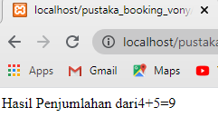

1. Latihan2.php

