|  |  |  |  |  |  |  |  |
| --- | --- | --- | --- | --- | --- | --- | --- |
| **S/NO** | **LAYERS** | **UNITS** | **ACTIVATION FUNTION** | **LOSS FUNTION** | **DROUPOUT FUNCTION** | **RESULTS** | |
| **X_Test** | **Y_test** |
| 1. | 1 Layers | 32 Units | Binary cross entropy | RELU | N/A | 0.42 | 0.86 |
| 2. | 1 Layers | 64 Units | Binary cross entropy | RELU | N/A | 0.5510 | 0.8669 |
| 3. | 3 Layers | 32 Units | tanH | MSE | Dropout (0.5) | 0.0965 | 0.8733 |
| 4. | 3 Layers | 64 Units | tanH | MSE | Dropout (0.5) | 0.0863 | 0.883 |

**Observations:**

* “**Rmsprop**” is used as the optimizer, and **binary_crossentropy** is used as the loss function in 3 Layers Model where as “**mean_squared_error**” as loss function
* 3Training our model is done with 20 epochs and 512 batches.
* In 1 Layers model with 16 Units and activation function as Binary Cross Entropy, Validation loss and overfitting has increased after the third epoch. Therefore, it is preferrable to remodel using three or four epochs.
* **1 hidden Layer with 32Units, Binary cross entropy activation function, RELU:** When only one hidden layer is used, validation accuracy begins to fluctuate after the second epoch with minimal changes while training accuracy continues to rise. The training loss clearly shows a decreasing trend in the graph, whereas the validation loss initially decreased but increased after the fifth epoch, indicating overfitting.

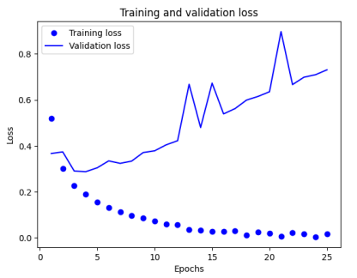

* **3Hidden Layers with 64 Units, tanH activation function, MSE, Dropout (0.5):** When using three hidden layers, validation accuracy increased for three epochs and then began to fluctuate, and training accuracy kept increasing. The training loss clearly shows a decreasing trend in the graph after 2 epochs, whereas the validation loss initially decreased but increased after the third epoch, indicating overfitting.

* **3 Hidden Layers with 32 Units, tanH activation function, MSE, Dropout (0.5):** When using three hidden layers, validation accuracy increased for two epochs and then began to fluctuate and was constant after 10 epochs, and training accuracy kept increasing. The training loss clearly shows a decreasing trend in the graph after 2 epochs, whereas the validation loss initially decreased but increased after the third epoch, indicating overfitting.

**Conclusion:**

* Adding more layers resulted in less accuracy. In all the cases, the Training accuracy steadily increased, whereas validation accuracy increased until 8 to 10 epochs and then nearly decreased. But, using the dropout technique, accuracy improved over many epochs, and the graph showed no significant change in validation accuracy.