Luca Siegel Moreno & Jan Siegel, IO-CSIC, 30/03/2026
Revisiting Laser8 FORTRAN code to simulate nm fs laser-induced melting and solidification of Si(100)
- Continue from previous study (9/3/2026) “status-quo-laser8-Luca-fs-Si.docx”
- There best matches for pulse duration 5 ps and OPD = 125 nm and max fluence 250 mJ/cm^2.
- Boiling T and exp max melt duration 10.5 ns for Si100 (recrystall.): best match 125 nm, 250 mJ/cm^2
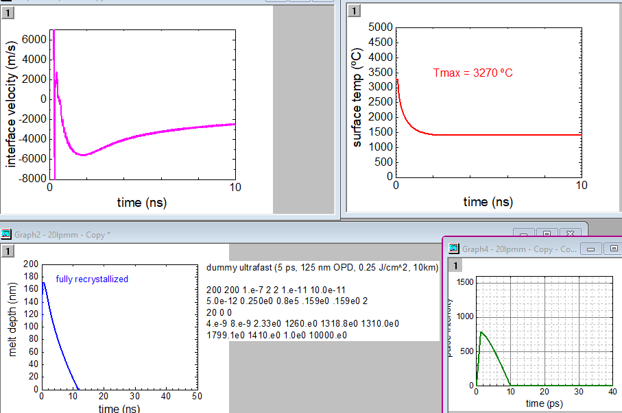
- Use these OPD and fluence to simulate Si111: achieve amorphization when reducing V = 10km/s to 1.5 km/s
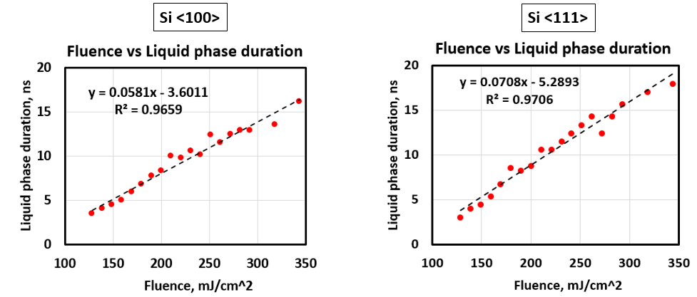
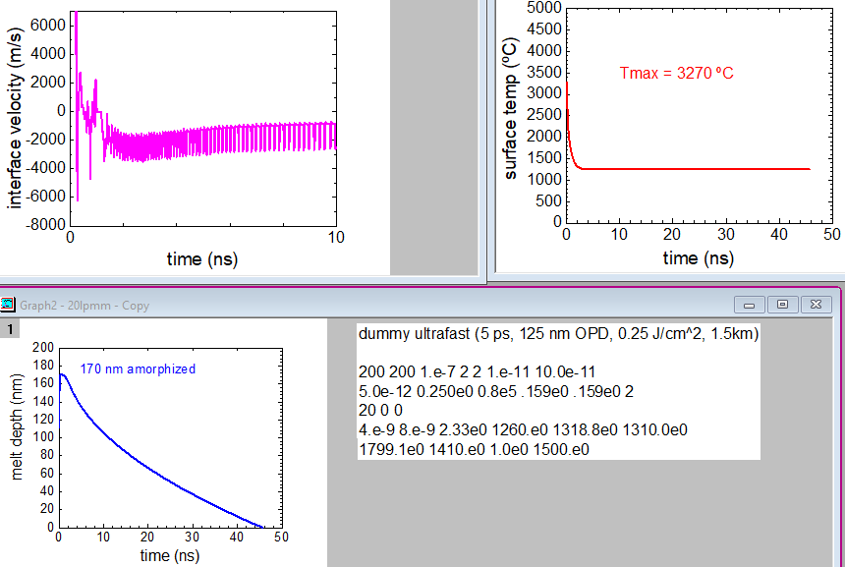
- Achieve (of course boiling T) but max melt duration too long (46 ns) and too thick a-Si layer (exp ≈ 70nm)
But at fluences < 250 mJ/cm^2 (tested 200, 150, 100 mJ/cm^2) no recrystallization is possible
- Try changing OPD (arguing that fluence dependent non-linear absorption)
- Even for strong increase to OPD = 200 nm, no recrystallization is possible at 200 mJ/cm^2 (at 20 km/s)
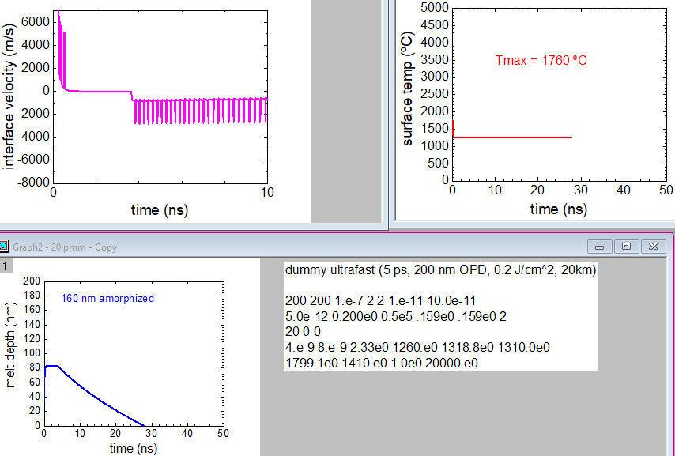

Use longer pulses (50 ps) to achieve recrystallization for all fluences at 10 km/s to account for the fact that the model is made for ns pulses.
- Boiling T and exp max melt duration 14 ns (slightly too long) for Si100 (10km/s): 50 ps, OPD 250 nm, 400 mJ/cm^2. For Si111 (1.5 km/s) way too long melt duration. But too high fluences.
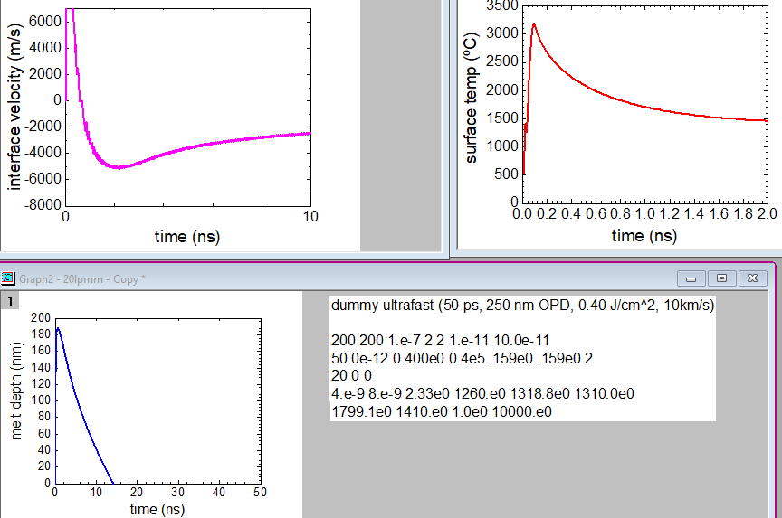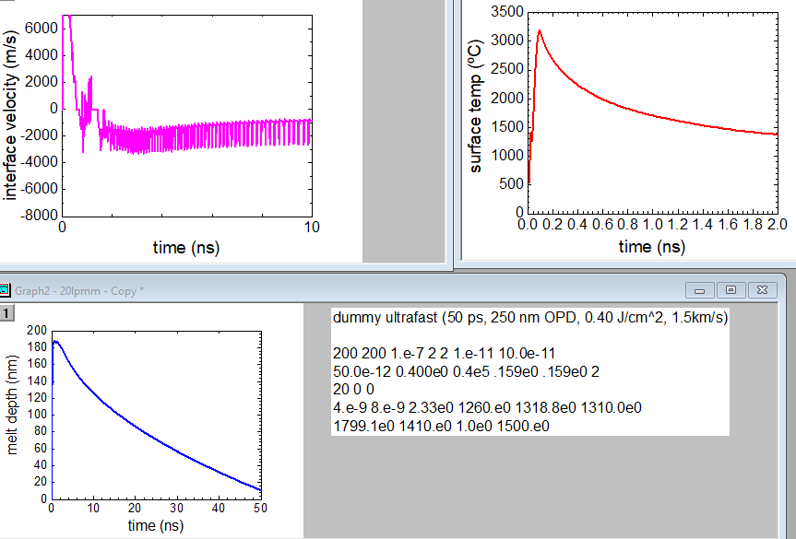

- Since these parameters seem to work for Si111 and Si100, let’s look at lower fluences scan for Si100 (10 km/s), and see if recrystallization works
- 300 mJ/cm^2 and 200 mJ/cm^2, 10 km/s: Looks ok, 200 mJ/cm^2 is threshold, factor 2 below Fmax, as exp.
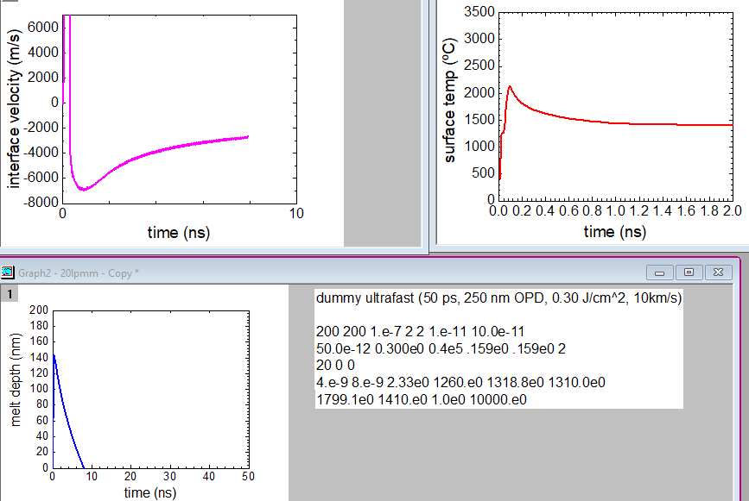 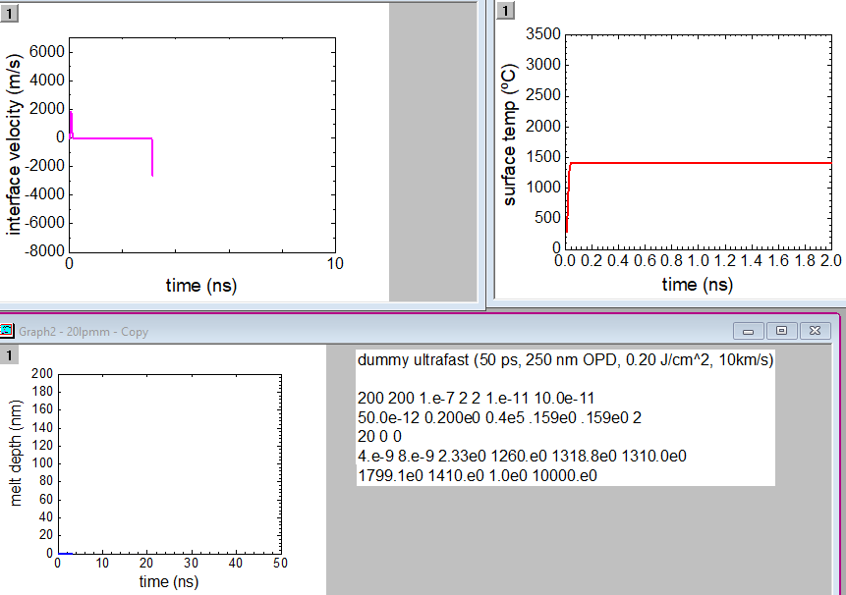
- 300 mJ/cm^2 and 200 mJ/cm^2, 1.5 km/s: One amorphization, the other threshold
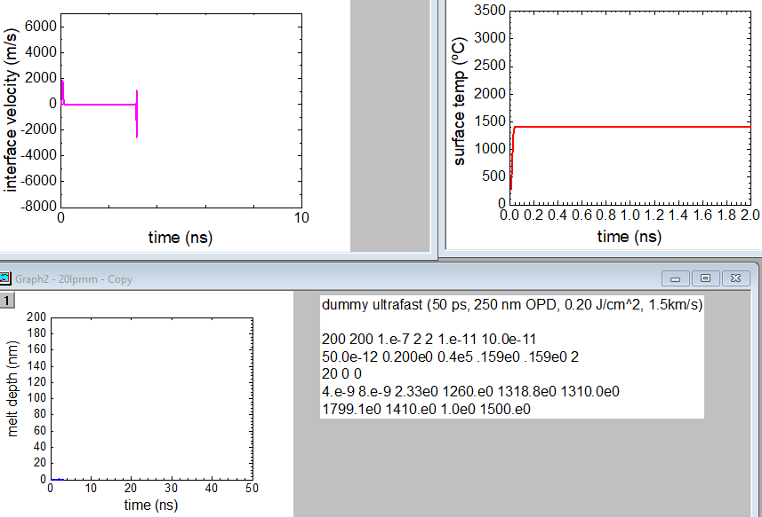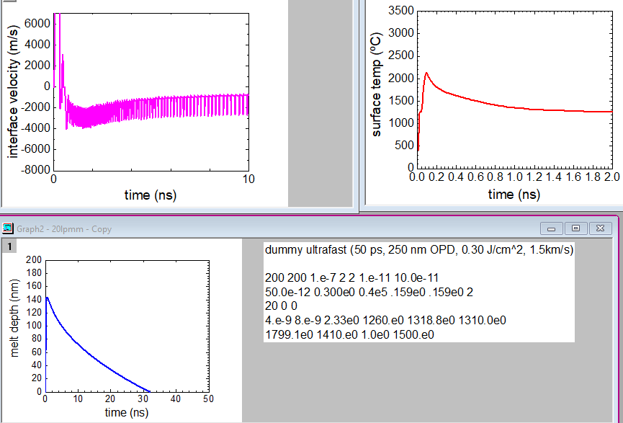
- The use longer pulses (50 ps) solves the amorphization/crystallization issue. But amorphization times are way too long. Also, high fluences need to be explained by only partial energy deposition, which contradicts Belen loose focusing normal incidence results.
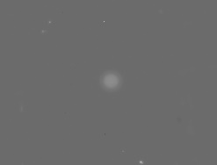
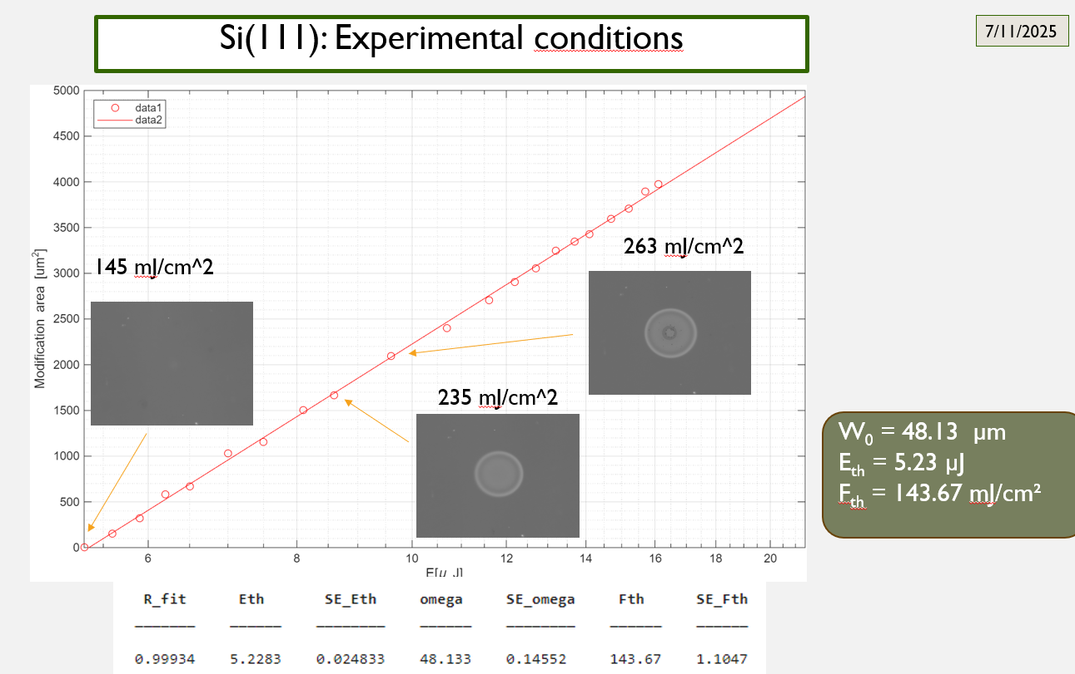
153 mJ/cm^2

- Increase NVS,NVW (# time steps two positions, # time steps velocity) from 2, 2 to 120, 100 (standard values). No changes for 250 mJ/cm^2 and Si111 and Si100. Also increasing temporal resolution to 1 ps, 10 ps (from 10 ps, 100 ps) DTOUTG,DTOUTD (time step graph, time step energy) brings no real change. But also for these parameters, any fluence < 250 mJ/cm^2 for 10 km/s does not yield recrystallization as it should.
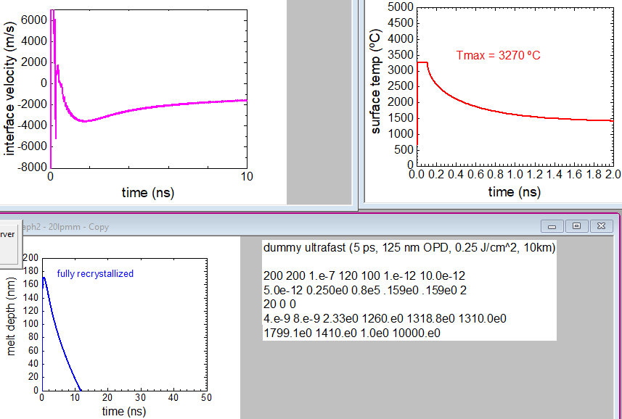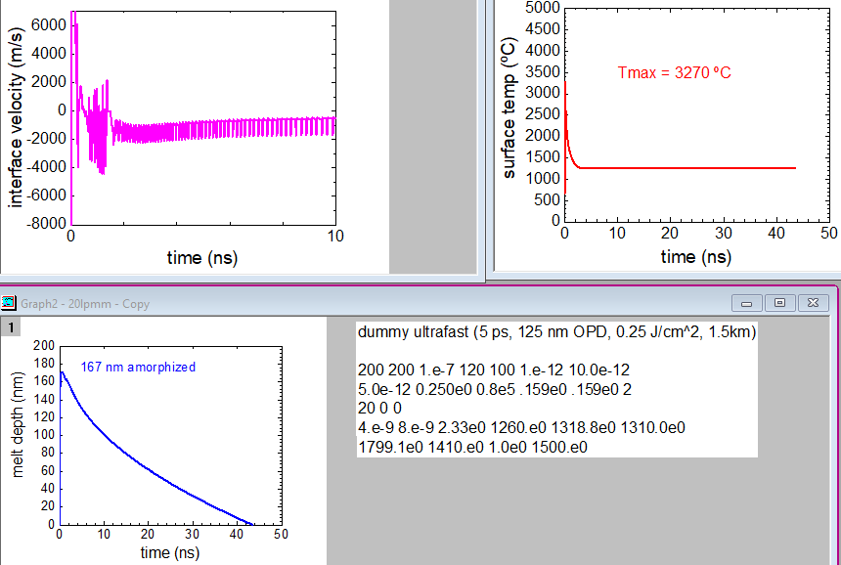
- Let’s fine-tune OPD to get Belen’s experimental melting threshold (Fm = 144 mJ/cm^2) right. Currently, we get 100 nm melting depth. If we use the criterium to get Tm for a short time (<1 ns) for Fm+1 = 153 mJ/cm^2, we obtain OPD = 333 nm. But this is rel. thick mushy phase and for 250 mJ/cm^2 we only get mushy phase. This could mean that OPD = f(fluence), meaning OPD = 125 nm for max fluence. If we use the criterium of “L” or “S” (in this case) in the state diagram to find OPD at melting threshold, we get OPD = 182 nm. Let’s agree on this latter criterium. If we calculate with this OPD for 250 mJ/cm^2, the peak temp is below melting point (and amorphization). Suggests we need to shorted OPD for higher fluence, which makes sense. For OPD = 154 nm reach Tboil. But since latent heat of evaporation is not implemented in program, this is not sufficient for ablation. So probably OPD = 125 nm is more realistic, or even shorter since latent heat of evaporation is 3-4 times larger than the one for melting.
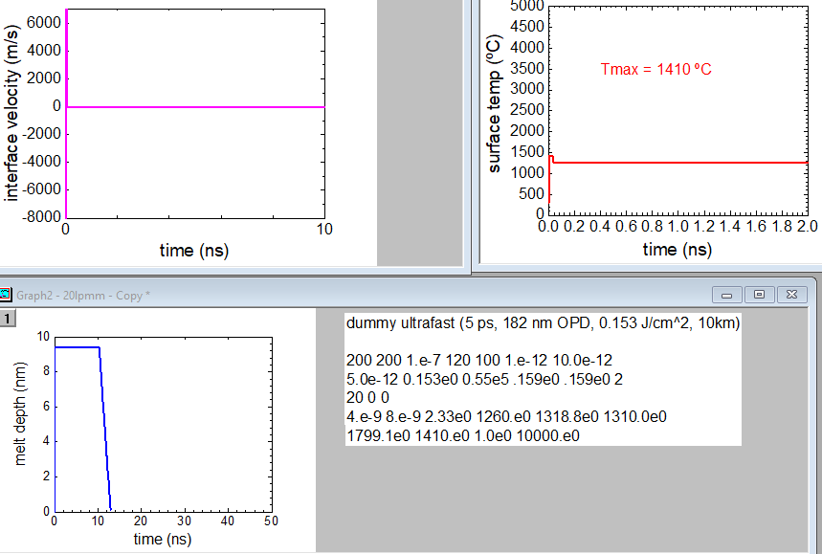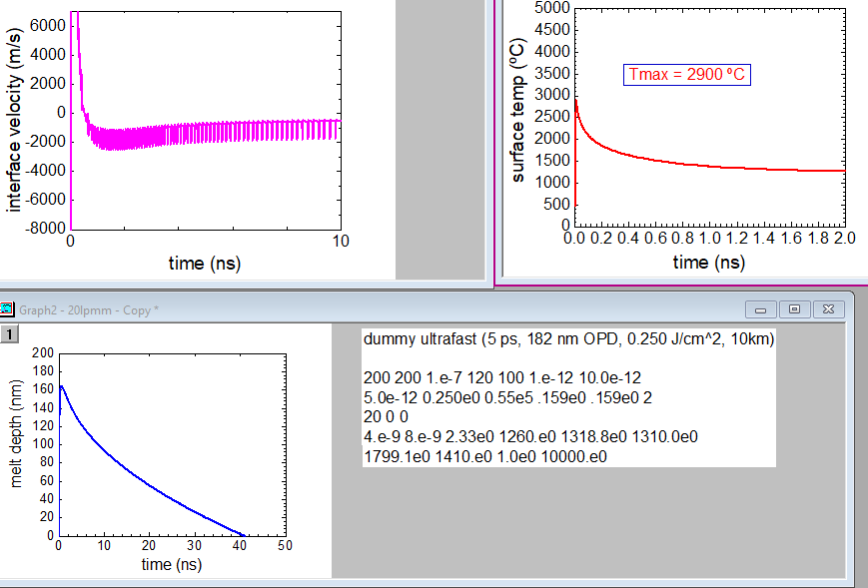
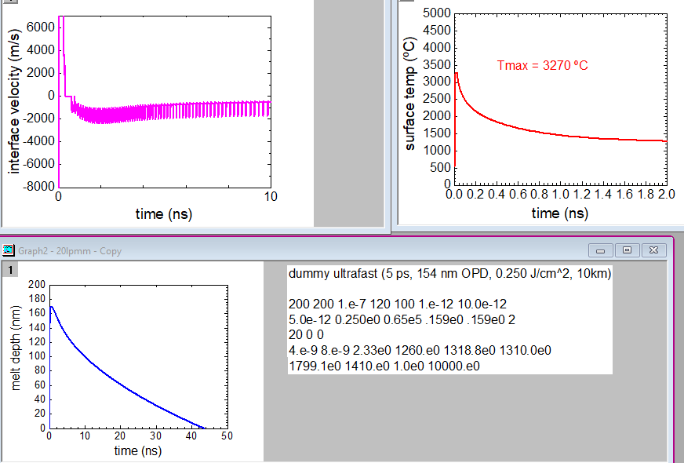

- Notice a problem with the nodes N and NMAX set to 200, 200. Supposedly it: “If N equals NMAX then a new node will not be added. Instead, E(NKAX) is found by extending 12 nodes deep into the slab. Each node is twice as wide as the previous one so the Maximum depth reached by these nodes Is greater than 4096 * DX. The accuracy will be degraded if NMAX is so low that the melt front reaches into this region.” When using very high fluences, melt depth saturates at 200 nm. Check if all the above calculations are affected by this, increasing to 400, 400, running OPD = 125 nm, 250 mJ/cm, 10 km/s. Does not work. Better to keep 200, 200 and increase depth step to 2 nm. This changes the output slightly (max melt depth and melt duration).
- Notice some improvement in possibility to recrystallize for lower fluences when increasing NVS and NVW to 600 and 500 (most likely to a better averaging necessary for the high temporal resolution.
Fluence series For Si100 (10 km/s): 250, 200, 180, 160, 140, 120 mJ/cm^2
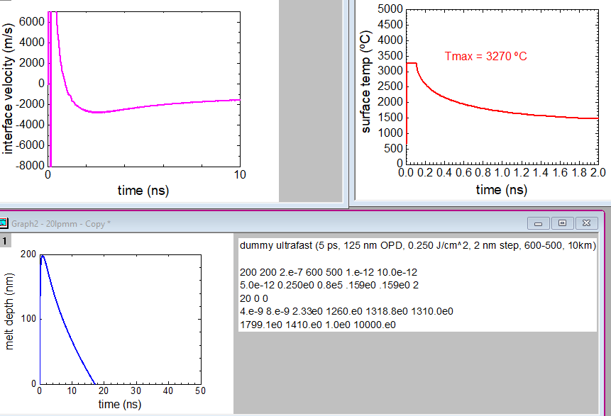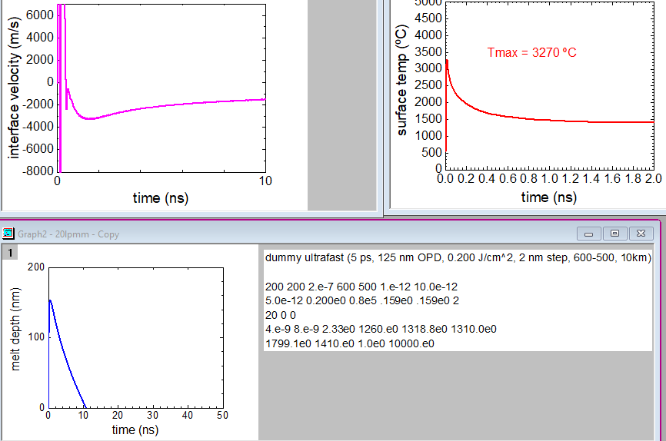
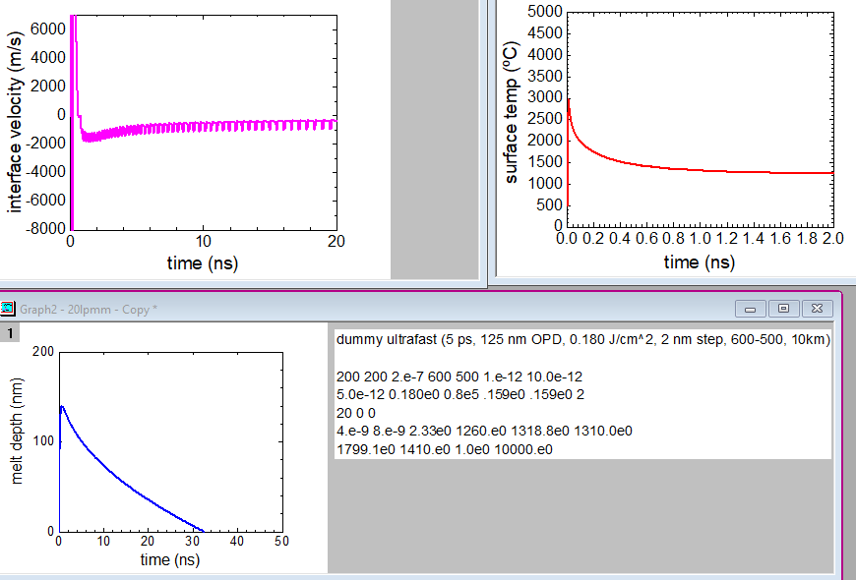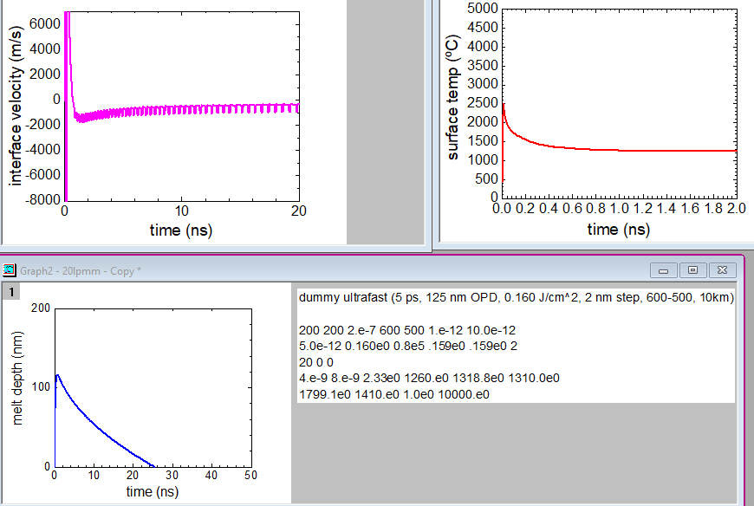

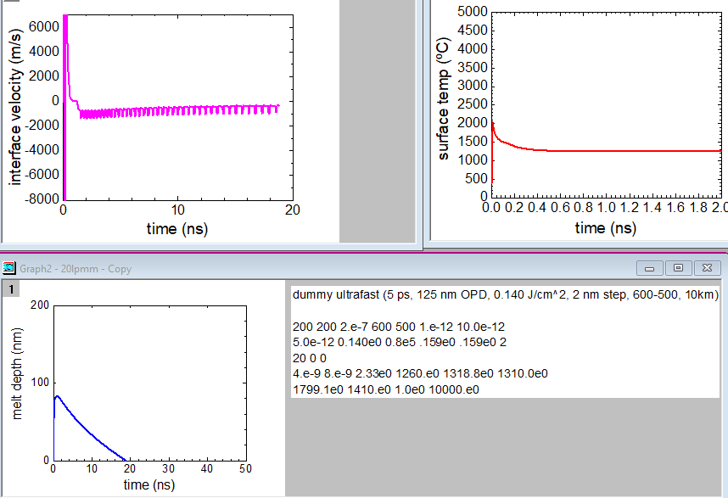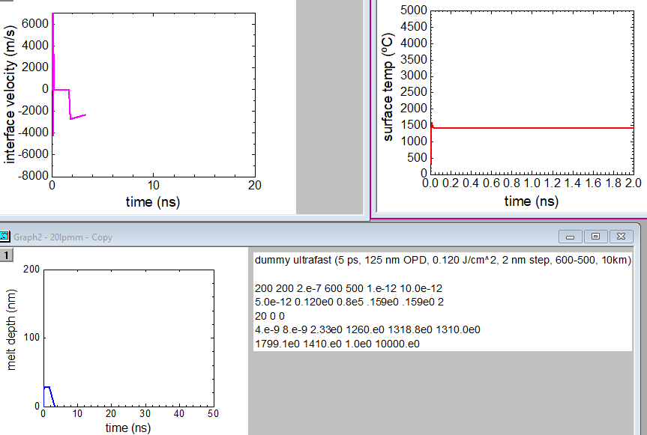

For Si111 (1.5 km/s): the two fluences that recrystallize for Si100: 200 and 120 mJ/cm^2
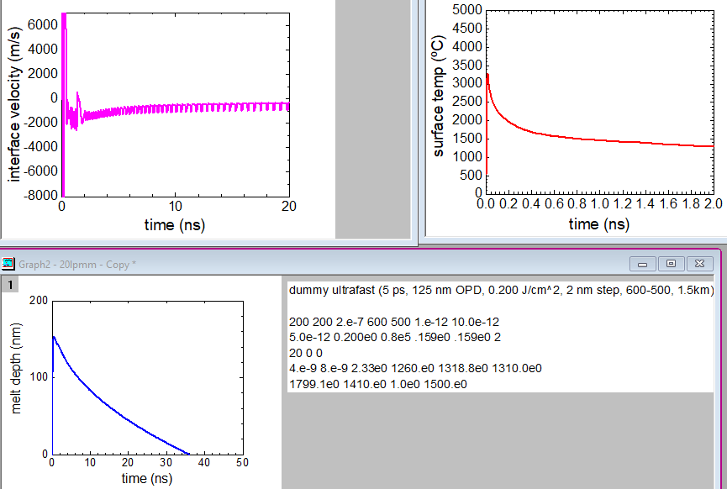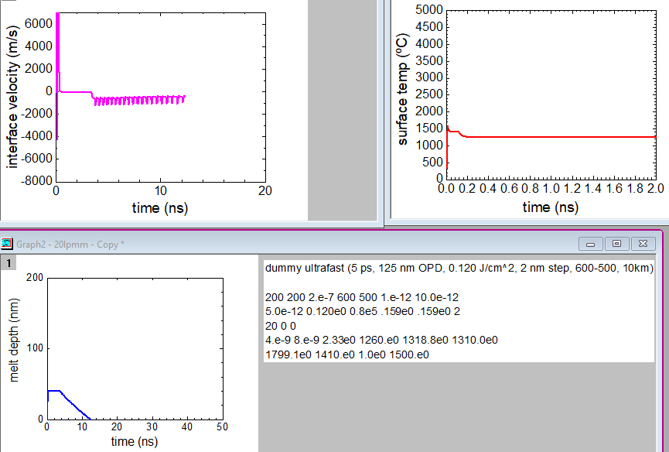

Currently best ultrafast 1/4/2026 for velocity dependent amorphization
5 ps, 125 nm OPD, 0.200 J/cm^2, 2 nm step, 600-500, 10km

200 200 2.e-7 600 500 1.e-12 10.0e-12
5.0e-12 0.200e0 0.8e5 .159e0 .159e0 2
20 0 0
4.e-9 8.e-9 2.33e0 1260.e0 1318.8e0 1310.0e0
1799.1e0 1410.e0 1.0e0 10000.e0

Blue parameters (pulse energy and critical velocity) need to be adapted to situation
Green parameter (absorption coefficient = 1/ OPD) might be necessary to adapt for fluence dependent absorption

N,NMAX,DX,NVS,NVW,DTOUTG,DTOUTD (nodes, max nodes, space step, # time steps two positions, # time steps velocity, time step graph, time step energy)
TH,EL,ALPHA,RS,RL,ISHAPE (half of total width, fluence in J, inv of penetration depth in cm-1, Rsolid, Rliquid=Rsolid(for fs), pulse shape (2 for triangular)
TINIT,XA,ISTART (initial temp, depth of amorphous layer, start time (0 for single pulse))
TP,TD,RH0,TA,HA,TN (nuclei lifetime, nucleation delay poly, density, melt temp aSi, latent heat aSi, Tcrit nuclei)
HC,TC,CL,VMAX (latent heat cryst, melt temp cryst, specific heat melt, velocity amorphization)

- Luca to do list:
  - pulse shape.dat file is very large. Save only every 20 data points (current step size 5 fs)
  - If I plot depth profiles of temperature, I don´t know the depth scale. Put generate a vector with depth values for each space step.
  - Generate colour images: Depth is vertical dimension, time is horizontal and state in specific colours, corresponding to each phase. Display legend.
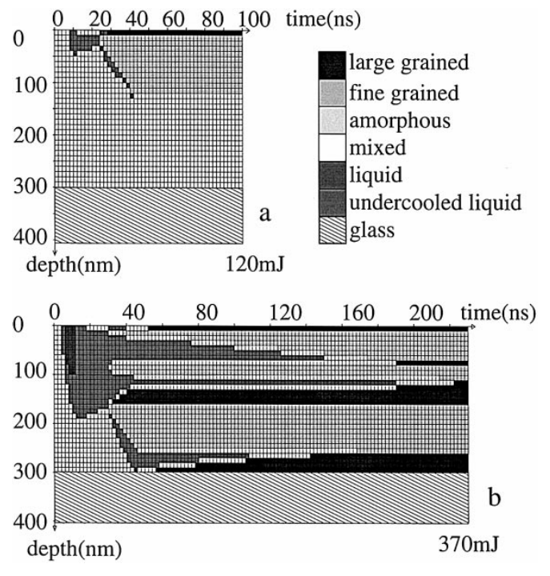
  - Same for temperature, with a false colour scale from blue (cold) to red (hot), Display legend.
  - Why is time step for current setting 5 fs? In relation to DTOUTG,DTOUTD? How can I change it 100 fs?
  - Look into discrepancy of plotted velocity always < 8 km/s but amorphization even for vcrit = 20 km/s. As well as spike problem of plotted velocity. Perhaps this allows solving the still existing problem that at some fluences no recrystallization occurs even for vcrit = 20 km/s

