Vision and Scope Document
for
<EasyTalk>
Version 1.0 approved
Prepared by <ByteBuilders>
< 26.02.2024 >

Business Requirements

Background

EasyTalk is entering the market to address the challenges and complexities associated with the communication between employers and job seekers. In the current landscape, the process of hiring and job searching can be cumbersome, with multiple platforms and disconnected tools. Employers often face difficulties managing job postings and applications efficiently, while job seekers find it challenging to showcase their resumes effectively and connect with potential employers. This inefficiency in the hiring process creates a need for a streamlined communication platform.

The background involves recognizing the existing gaps in the job market, such as the lack of a centralized and user-friendly platform for job-related communication. EasyTalk aims to simplify and enhance the overall experience for both employers and job seekers by providing a dedicated space that brings together job posting, resume management, and real-time communication.

Business Opportunity

Efficient Hiring Process: By providing a centralized dashboard for application management, EasyTalk streamlines the hiring process, making it more efficient for employers to find the right candidates.

Enhanced Job Seeker Visibility: For job seekers, EasyTalk offers a platform to showcase and manage their resumes effectively, increasing their visibility to potential employers and improving their chances of finding suitable opportunities.

Real-time Communication: The real-time communication feature facilitates quick and effective interaction between employers and candidates, potentially speeding up the decision-making process and reducing the time-to-fill for job vacancies.

Market Demand for Simplified Platforms: With the increasing reliance on digital solutions in the job market, there is a growing demand for platforms that simplify the hiring process. EasyTalk positions itself to meet this demand and become a go-to platform for both employers and job seekers.

Customer or Market Needs
Employers: Efficient job posting and candidate management.
Job seekers: Simplified resume submission and easy access to job opportunities.
Both parties: Real-time communication and data visualization for informed decision-making.

Business Risks
There are similar products on the market with an existing user base (UpWork, Fiverr, Wishup, LinkedIn) that can implement the functionality we offer.

Vision of the Solution

Major Features
Our project is distinguished by the presence of a special timeline for tracking project management.

Operating Environment
- Are the users widely distributed geographically or located close to each other? How many time zones are they in?
Users are widely distributed through the world.

- Can the users tolerate service interruptions or is continuous access to the system critical for the operation of their business?
System must provide continious access.
- What access security controls and data protection requirements are needed?
- Hashed passwords
- Message encryption
- Authorization

Use-case diagram
https://drive.google.com/file/d/1smCCzJ2MiIcX4CBiIYv_6BaPOvgt0vFa/view?usp=sharing
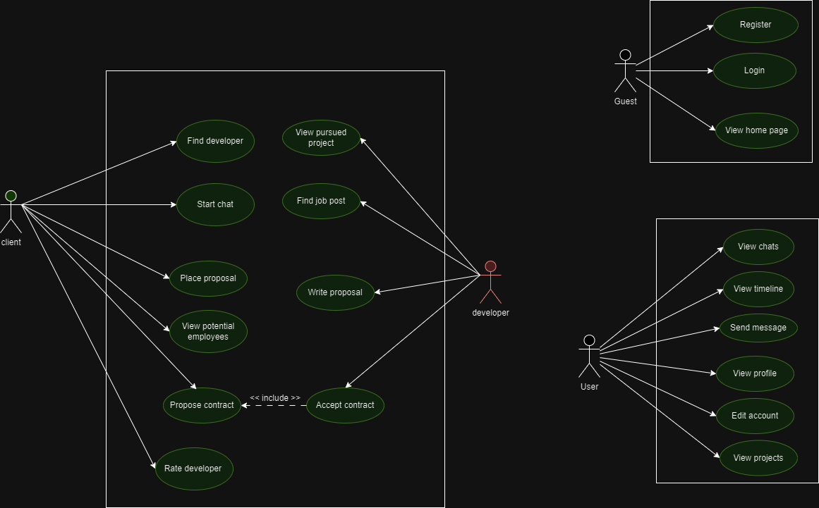

Sequence diagrams
https://app.eraser.io/workspace/hLJMni2AZfKR49UJQSHR?origin=share

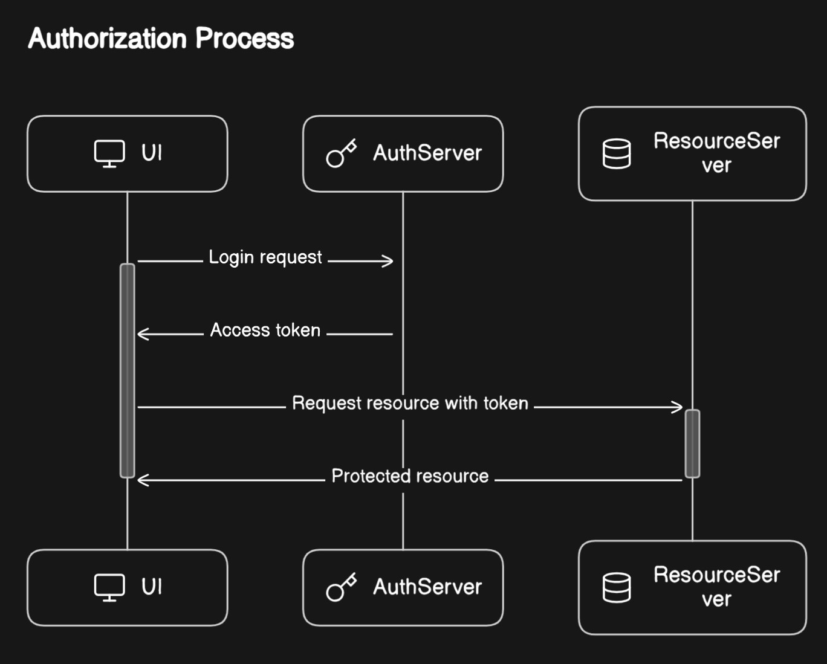

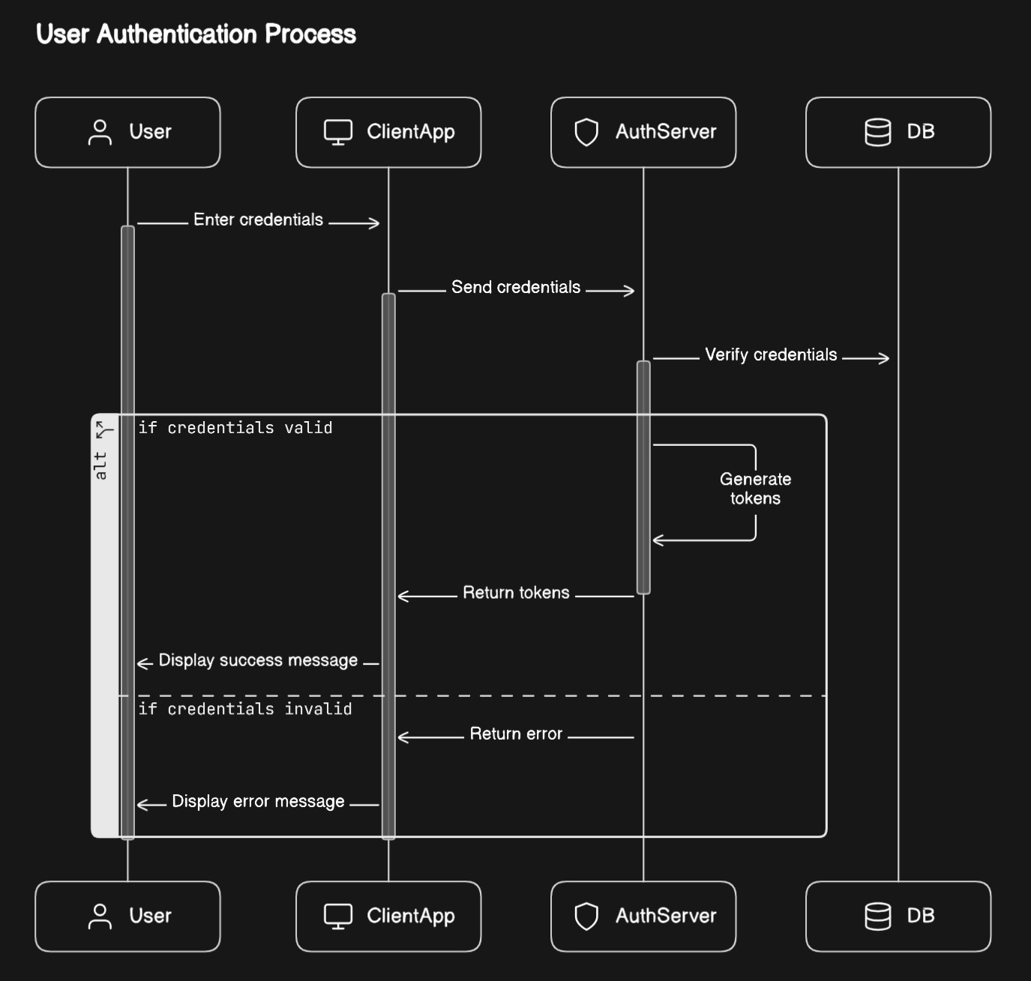

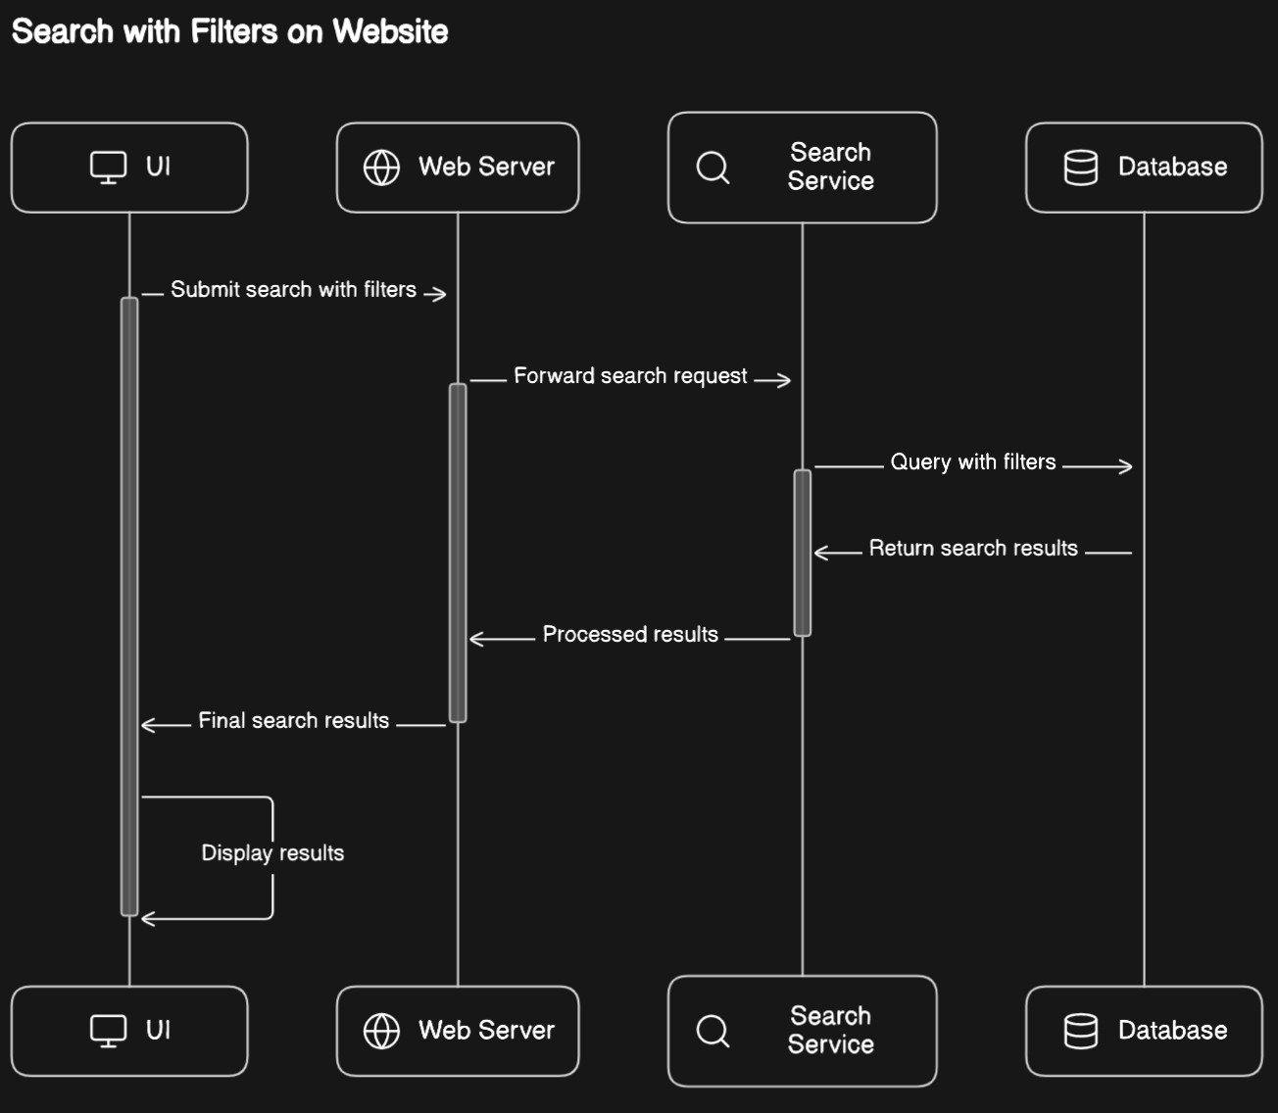

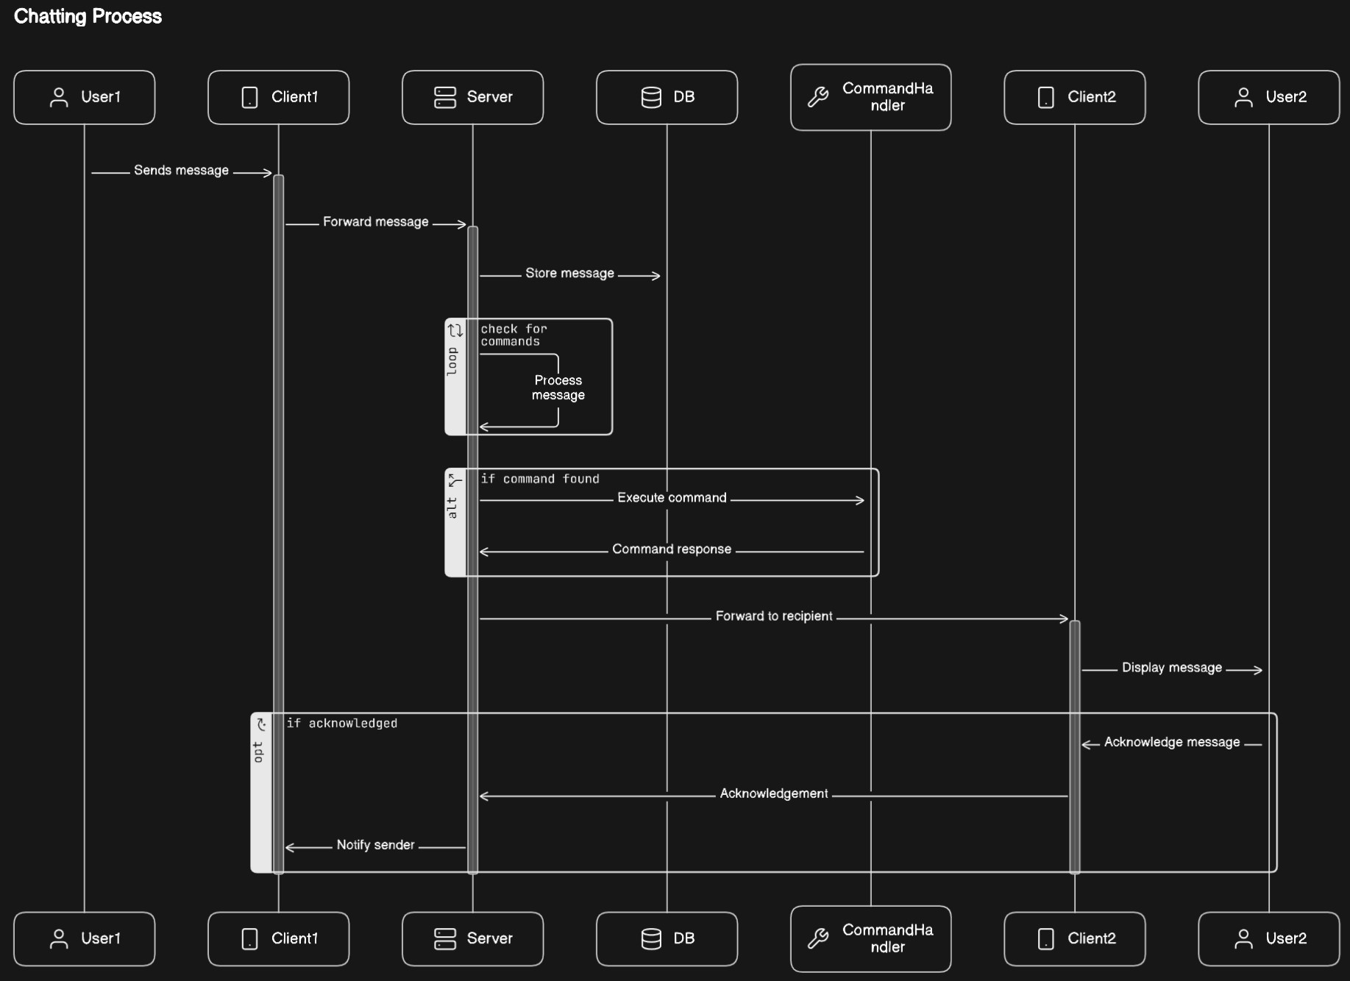

User story
https://miro.com/app/board/uXjVN52Sckc=/?share_link_id=163730735838

