Issue | How we solved it
Game ran much slower in the build than it did in the Unity test window. | We went to Build Settings > Project Settings > Player and ensured we selected 'Fullscreen Window' and ticked the checkbox next to 'Default is Native Resolution'.  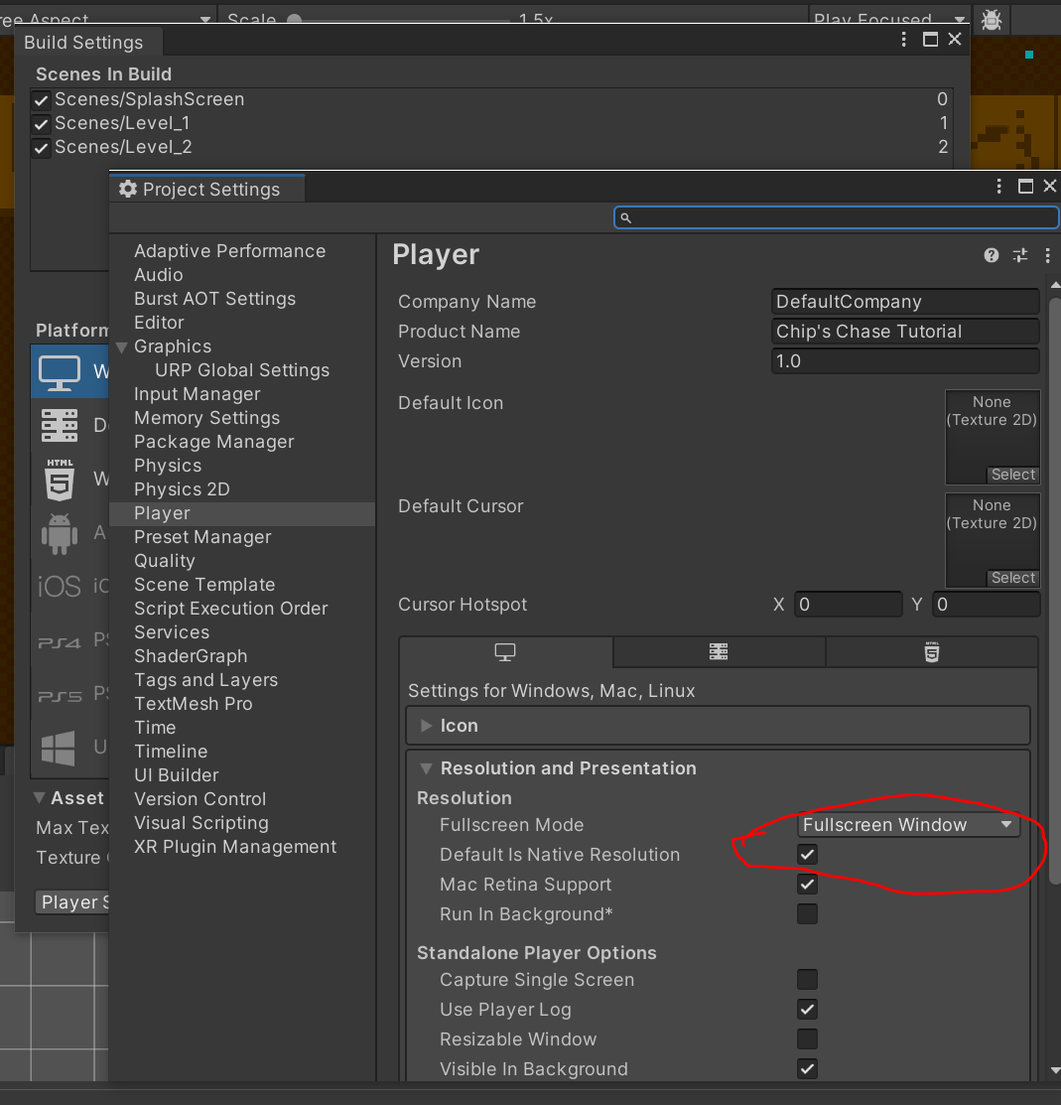
Randomly corrupts my files with no error log or anything | Creating a new project
Different sized images when slicing up tile sheets (usually in the case that you wanted more than 8 tiles).  Image is not 2048x1024. | Try 'Grid by Cell Count' instead of 'Isometric Grid'.  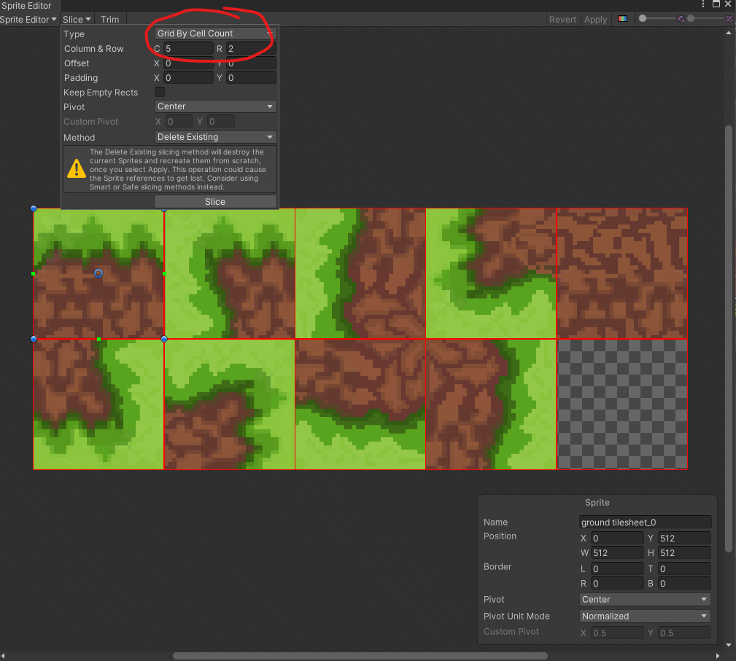  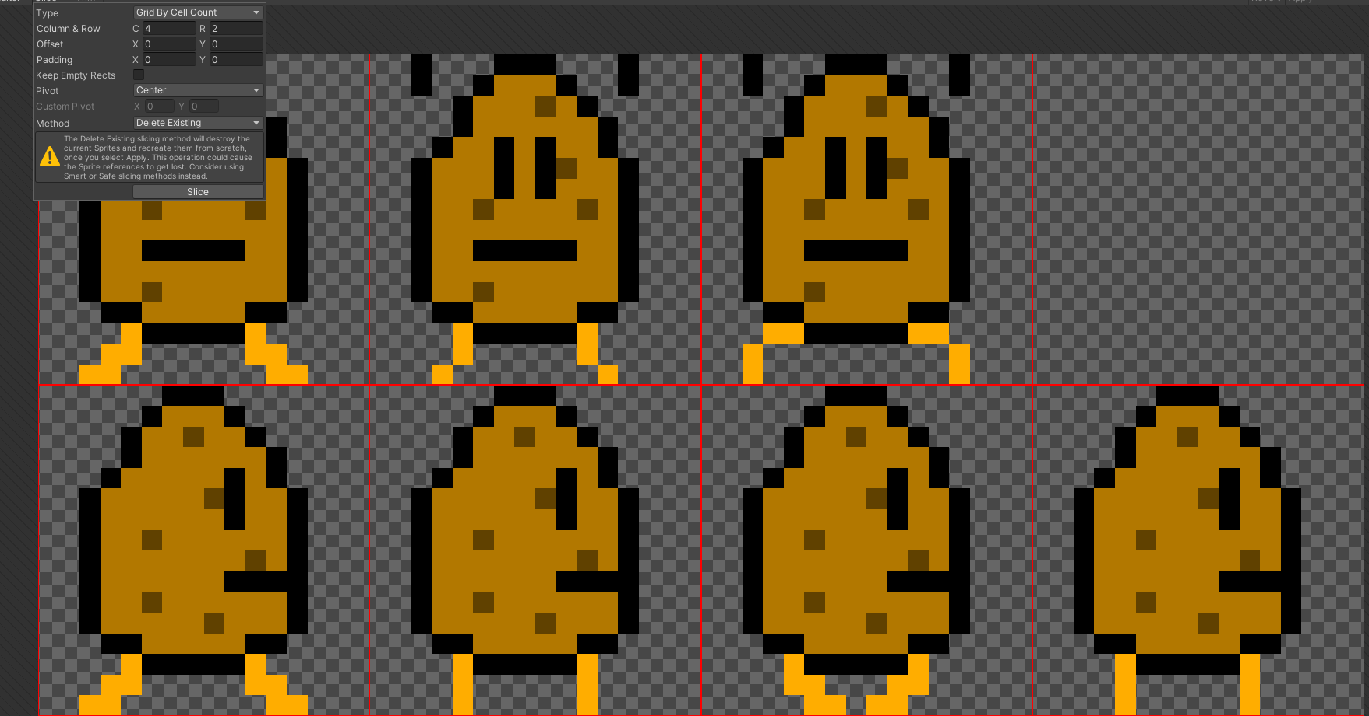  Note: the other solution is to change the sizes to suit the size of your image.
Cannot access 'Sample Rate' to change from 60 to 12 in the animation window. | Click three dots on right hand side of the window and select 'Show Sample Rate'  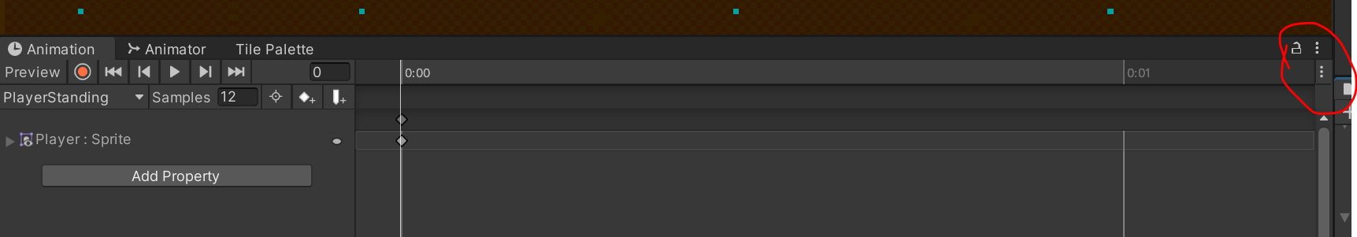  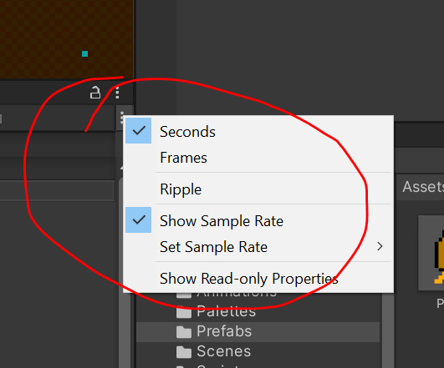
Cannot access the “Tile Palette” window | 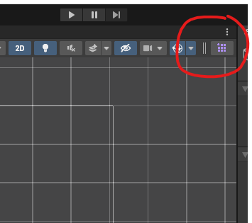
Cannot permanently change the size of the camera:  Enter the .cs file for the camera follow code and change the value “cam.orthographicSize” from 15 to your desired value. | 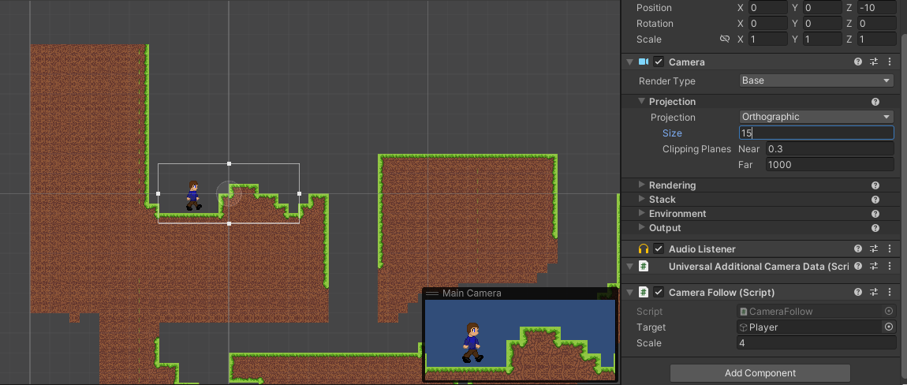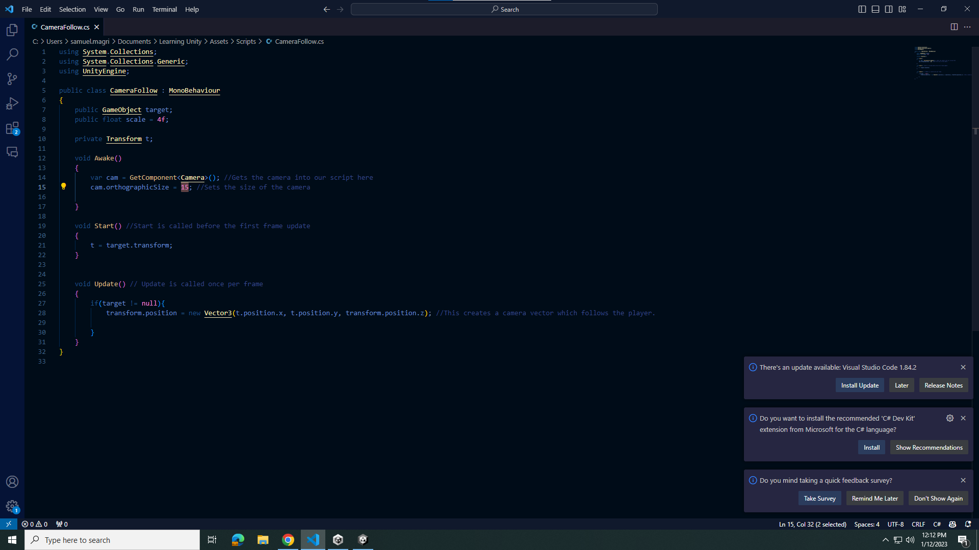
Wormy friend not die when touch | Don’t forget to click ‘is trigger’ in the collider 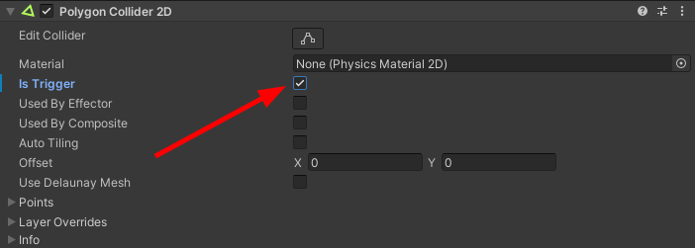
Pixel Art Sprite had different colours in unity than in photos and lost details.  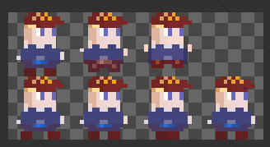  When it should've been  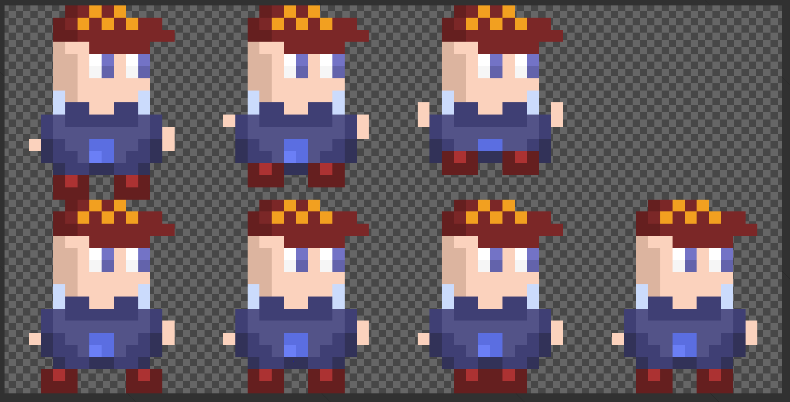 | 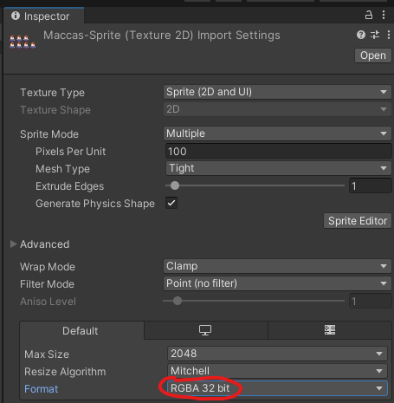
Tiles when placed are very small  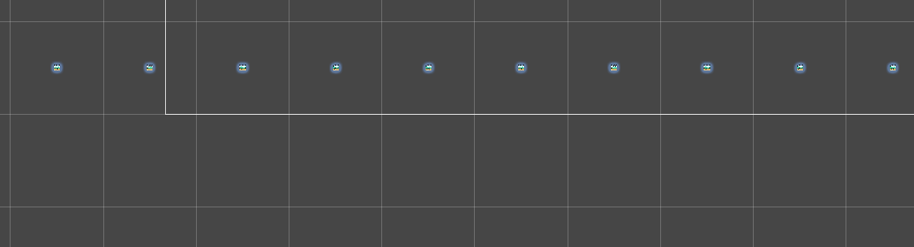 | Change the pixels per unit of your tileset image to a smaller number (then press apply)  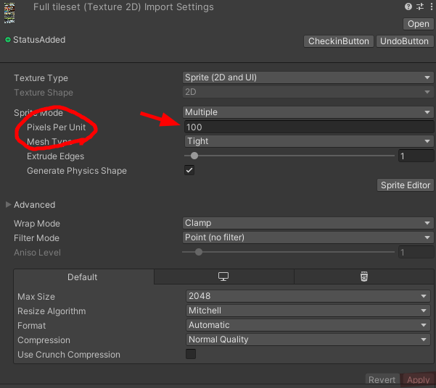
Want to change the hitboxes of tiles  (You can see the hitboxes by clicking the grid: 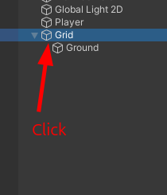) | In the sprite editor of the full tileset image 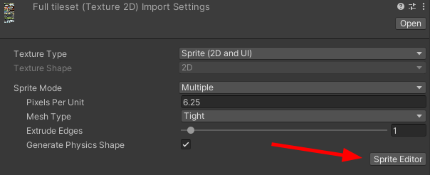, Change the dropdown in the top left to ‘Custom physics shape’ 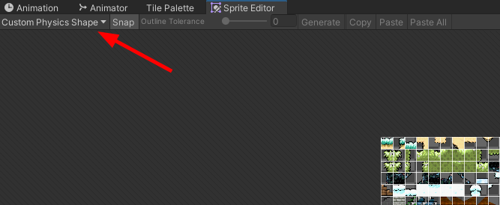, Click on the tiles you want to change, press ‘generate’ and move the points to make a shape. Press ‘Apply’, then in the ground object, find the tilemap collider, press the 3 dots and then press ‘Reset’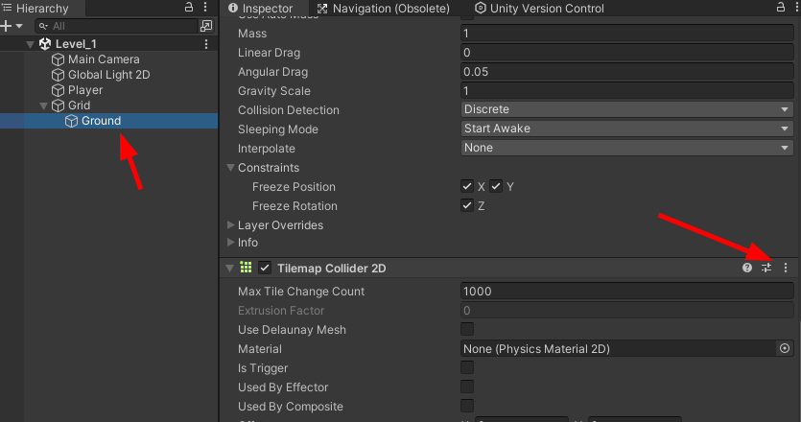
Obstacles can be passed through but the floor stays solid
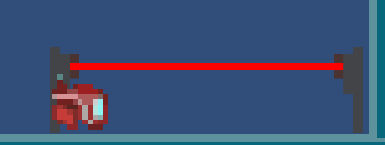
The Unity interface is missing all of your scenes inspector etc and you can’t open any of them and are stuck in the project folder and even after restarting you can’t fix it.  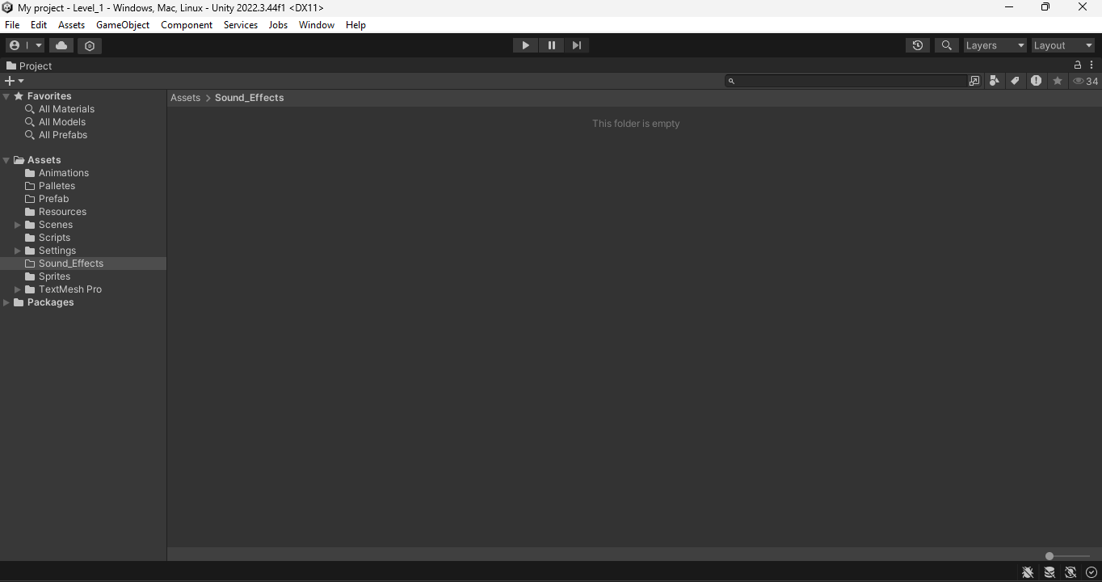 | All you have to do is click Shift + Space which then returns it to normal and you can edit your scene.  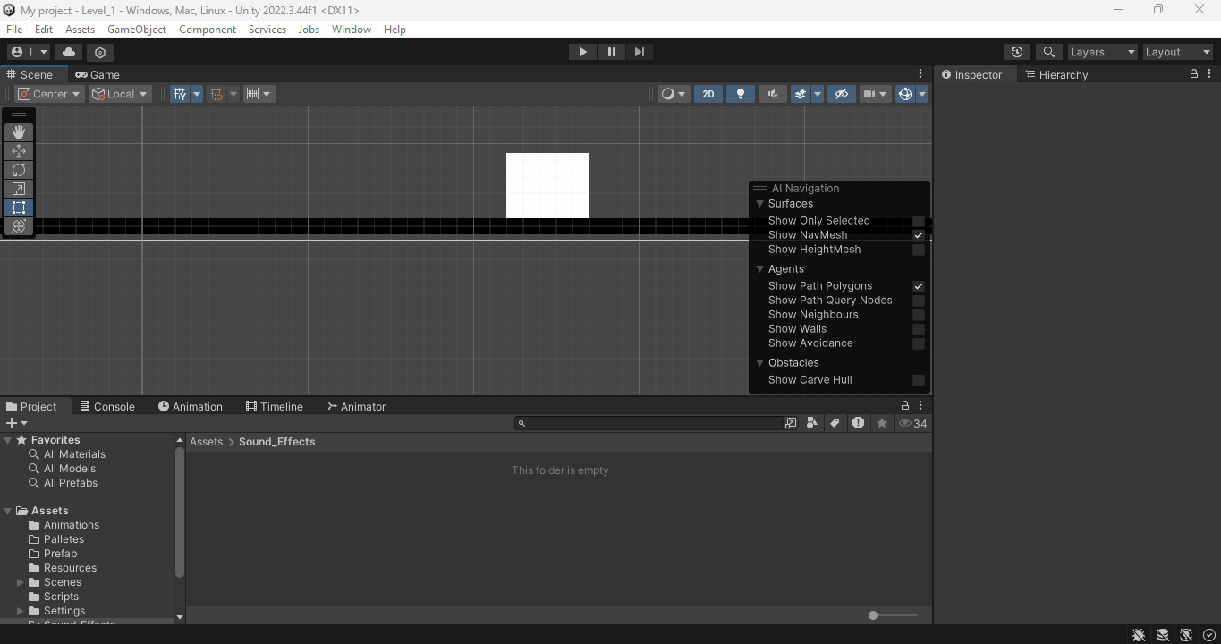
Sign in button doesn’t work on Unity Hub | Restarting your computer
Screen tearing in the final build of the game | Setting VSynch to Every V Blank Under Edit → Project Settings - > Quality  Link to solution thread- https://discussions.unity.com/t/weird-glitchy-lines-traveling-from-top-to-bottom-of-the-screen-when-camera-moves-in-build/931242
FPS jumping and dipping causes your sprite to go faster and slower. | Create a new C# file in Scripts. Name file FPSLimiter. Click on new file. Delete everything and paste in the code. Save the code. Create a new child under hierarchy. Name it FPSLimiter. Drag new C# file into the child. Or you can just follow the YT Tutorial  Unity C# Tutorial - How to set target FPS | How to limit FPS in your game in Unity (youtube.com)  using System.Collections;  using System.Collections.Generic;  using UnityEngine;  public class FPSLimiter : MonoBehaviour  {  public int targetFPS = 60;  void Start()  {  QualitySettings.vSyncCount = 0;  Application.targetFrameRate = targetFPS;  }  }
The error ‘AnimationEvent has no function name specified’ appears, even when the game is otherwise fine | 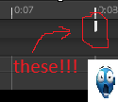  Find any Animation Events in your animations and THANOS SNAP them
Following errors appear without any scripts or whatnot written.  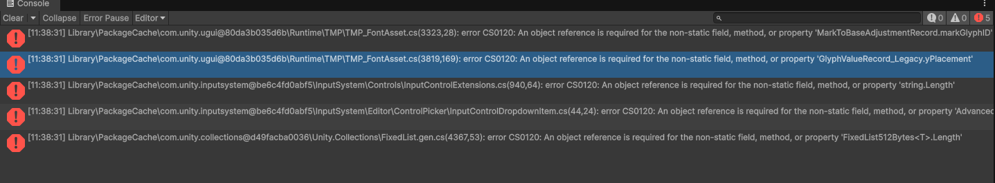 | Unity errors:  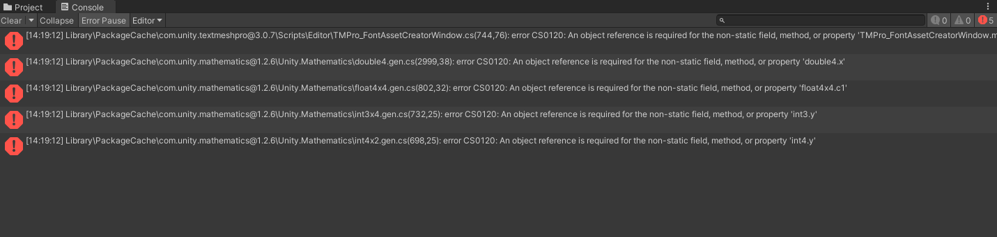 | Install Errors on Personal Device. No known fix. Using School PCs is best solution. Sorry can’t resolve.
When playing the game, the character walks. When it is built and run, the character stats are in the same position and can only jump | Unity6_Build_Run_Freeze_Fix.md
Unity errors: | Install Errors on Personal Device. No known fix. Using School PCs is best solution. Sorry can’t resolve.
Build and Run (doesn’t work) but works in game preview |  | SpriteMovementFix.md

