Assignment 1 Distributed and Mobile Systems: Vaughn Carroll – Solo Submission

Information:  
Netbeans 8.2  
glassfish 5.0.1  
I can’t remember if I needed to specify a driver so here’s what I used

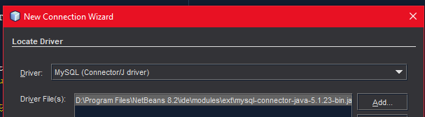

My Database tables were:  
DD_Customers  
DD_Orders  
DD_Products

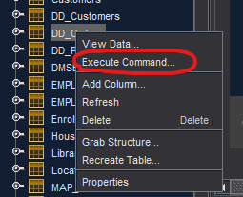

To see all the combined order data, right click database and execute query and paste this:

SELECT * FROM testUnrestricted.DD_Orders, testUnrestricted.DD_Customers, testUnrestricted.DD_Products

WHERE testUnrestricted.DD_Orders.Product_ID = testUnrestricted.DD_Products.Product_ID

AND testUnrestricted.DD_Orders.Customer_ID = testUnrestricted.DD_Customers.Customer_ID

Home page

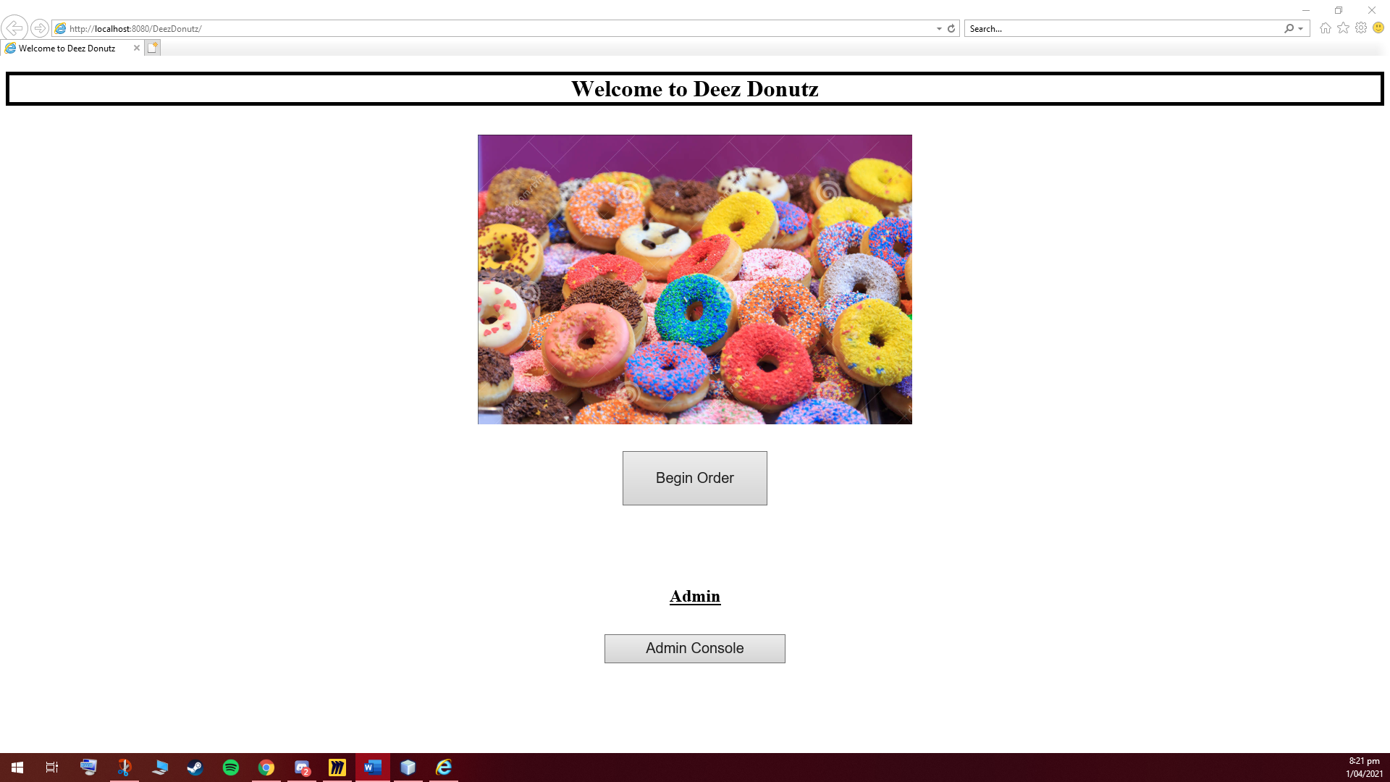

Begin order – enter email – if found in DB skip the customer details page

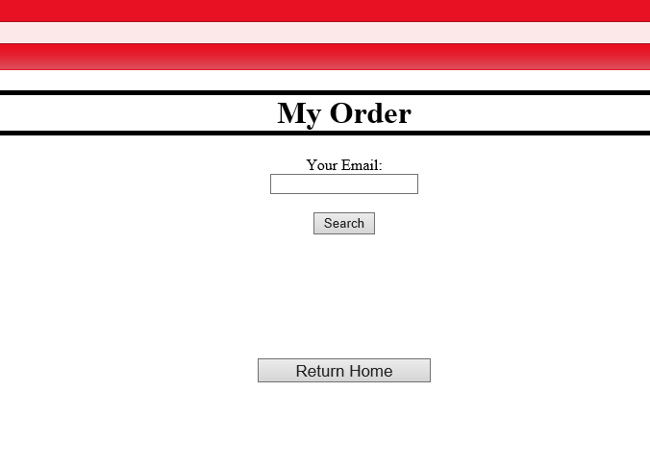

[therock@gmail.com](mailto:therock@gmail.com) is existing in DB so This is customer Details if email not found

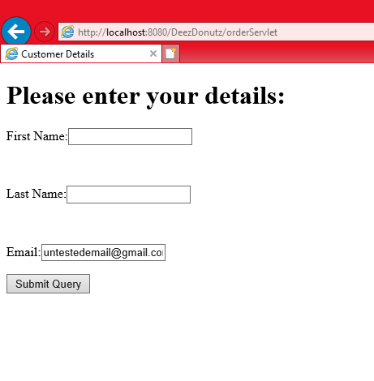creates bean using DB information

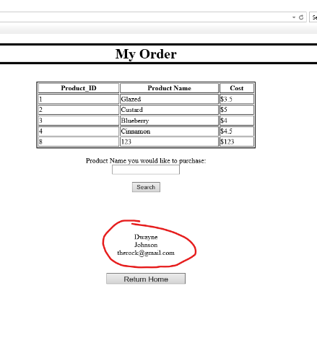

Skipped Customer details

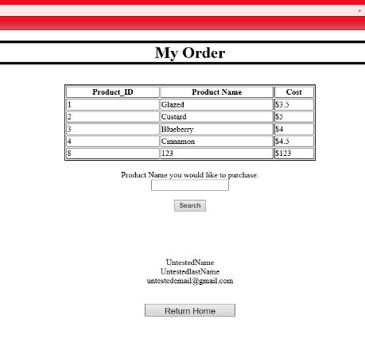

If product name found then display cost and ask for address for the order – enter address then place order which logs the customers information, their order details and the date and address for order

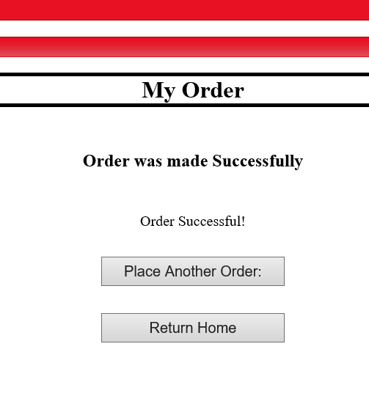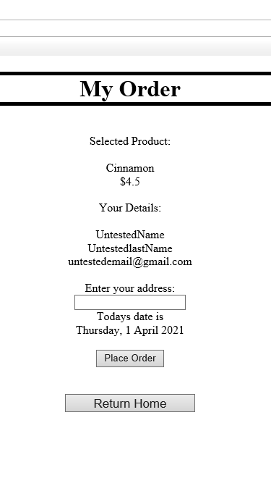

Can choose to then place another order which uses the same customer information beans

Entity Relationships:

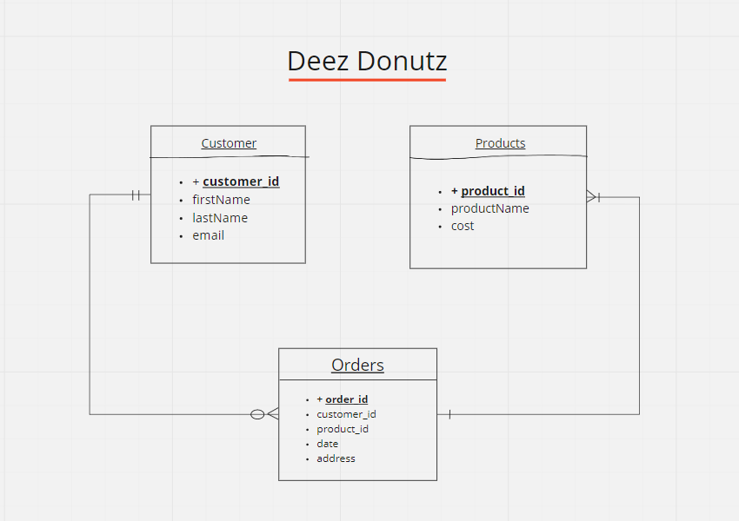

Schematic Plan

