1. MCU - ESP32

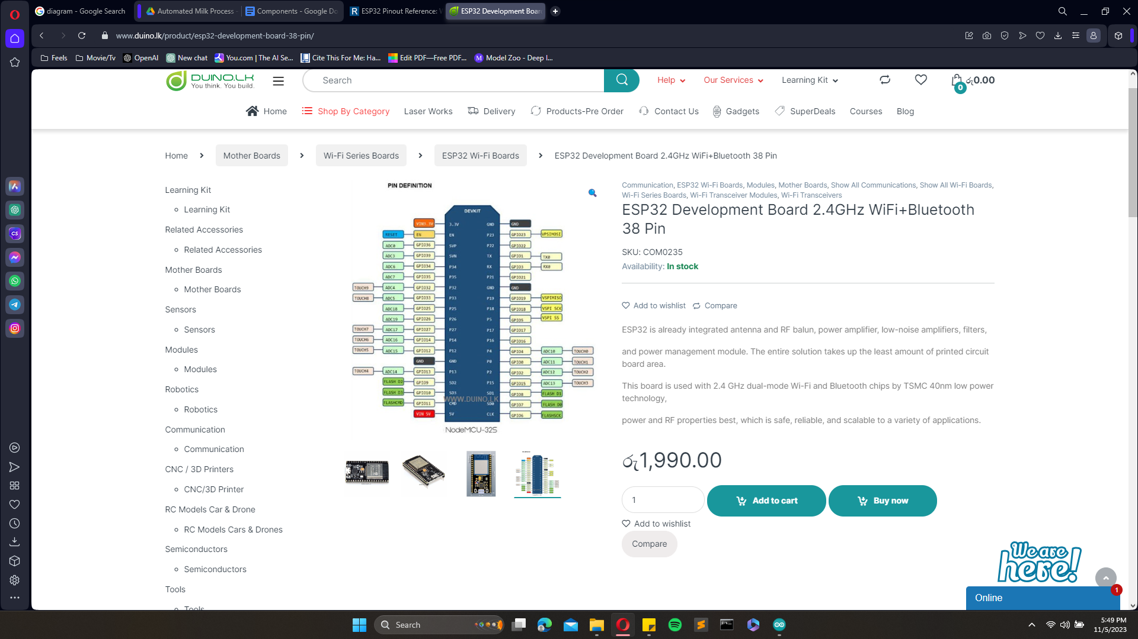

<https://www.duino.lk/product/esp32-development-board-38-pin/>

1. Relay modules

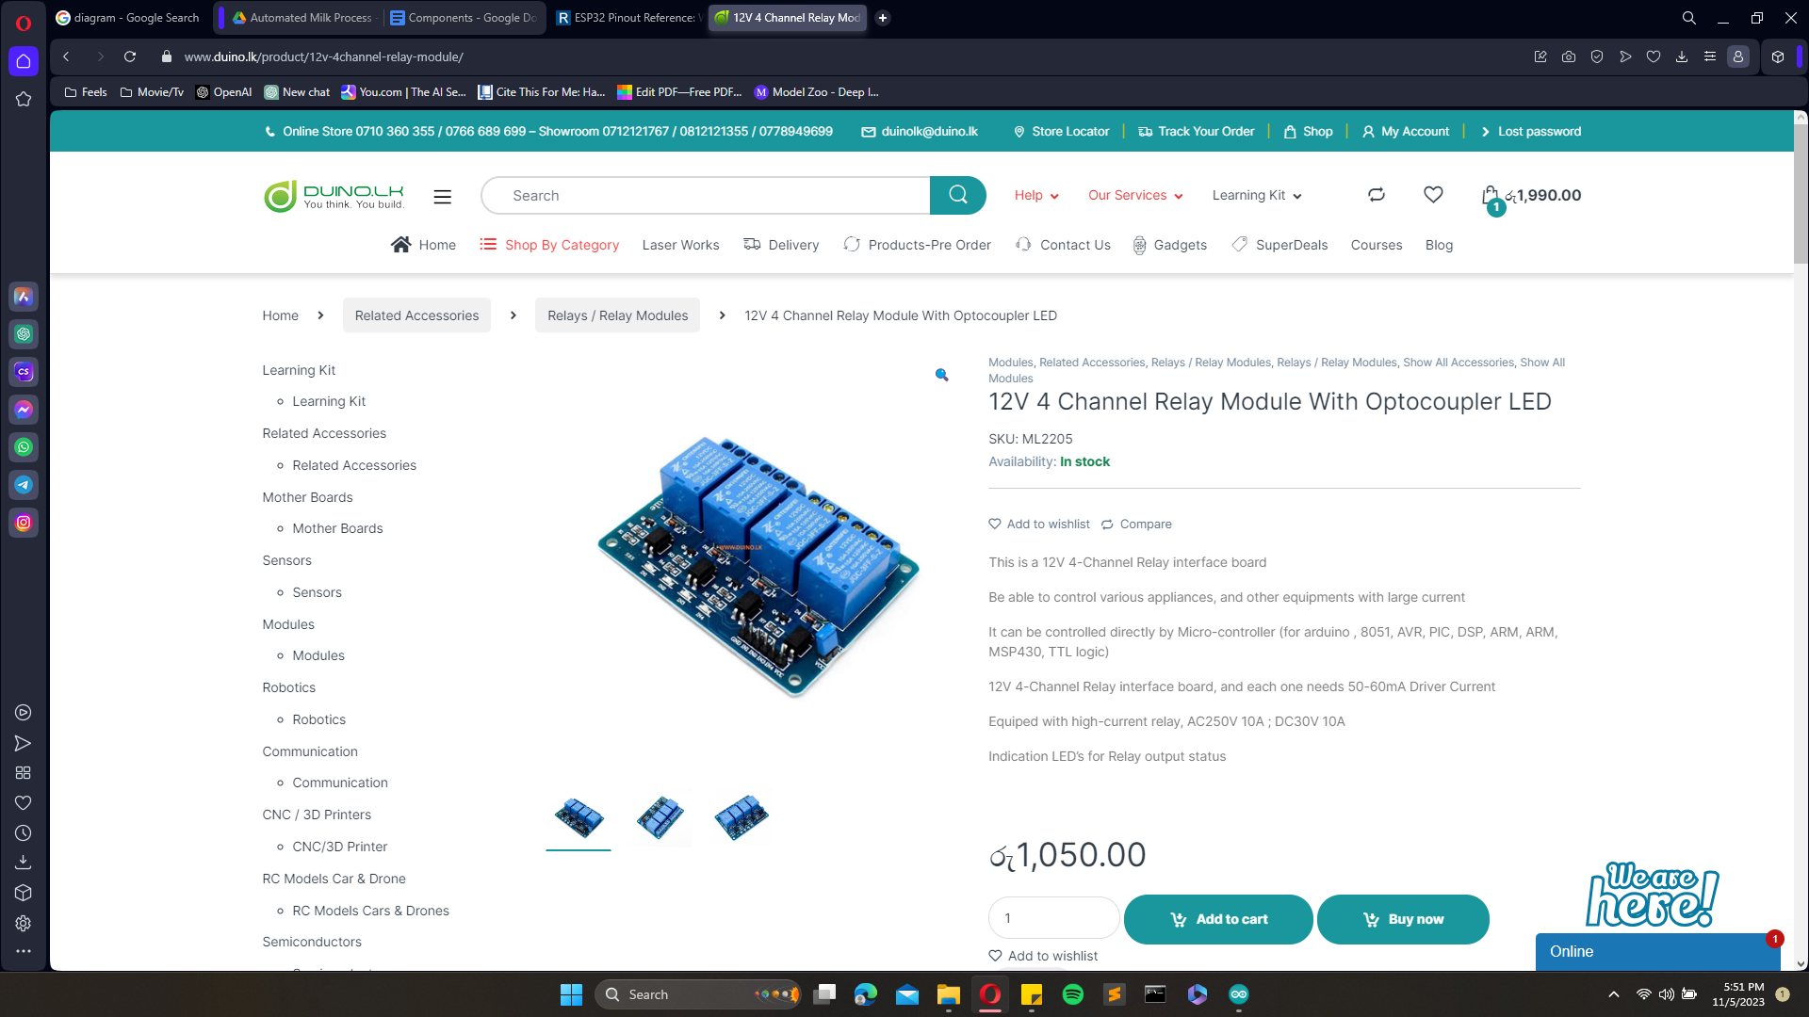

<https://www.duino.lk/product/12v-4channel-relay-module/>

1. Display

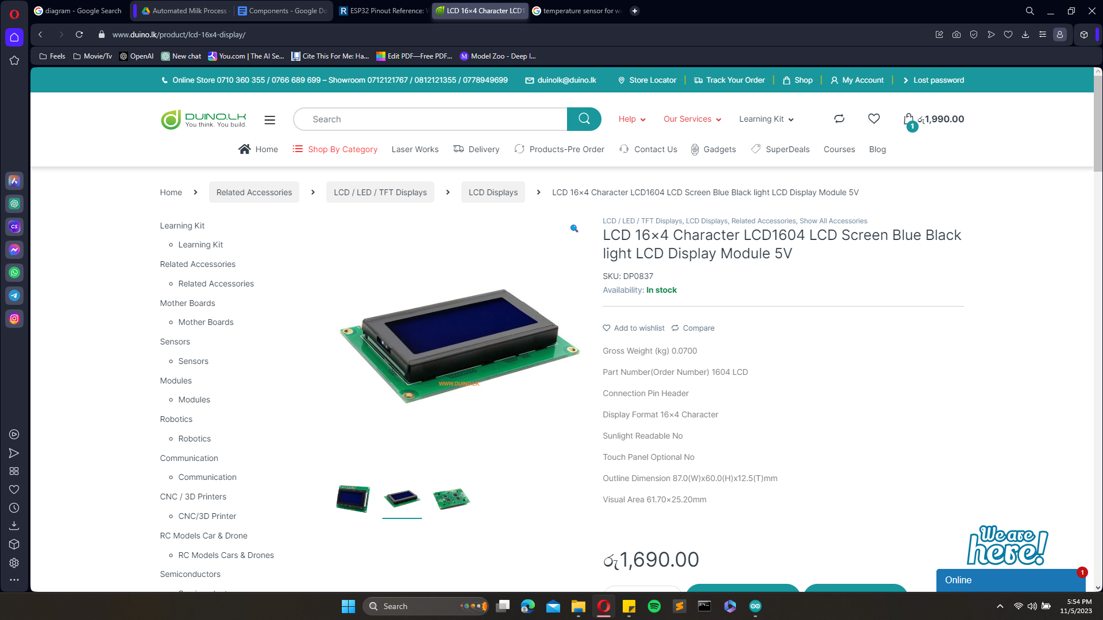

<https://www.duino.lk/product/lcd-16x4-display/>

1. SPI Serial interface

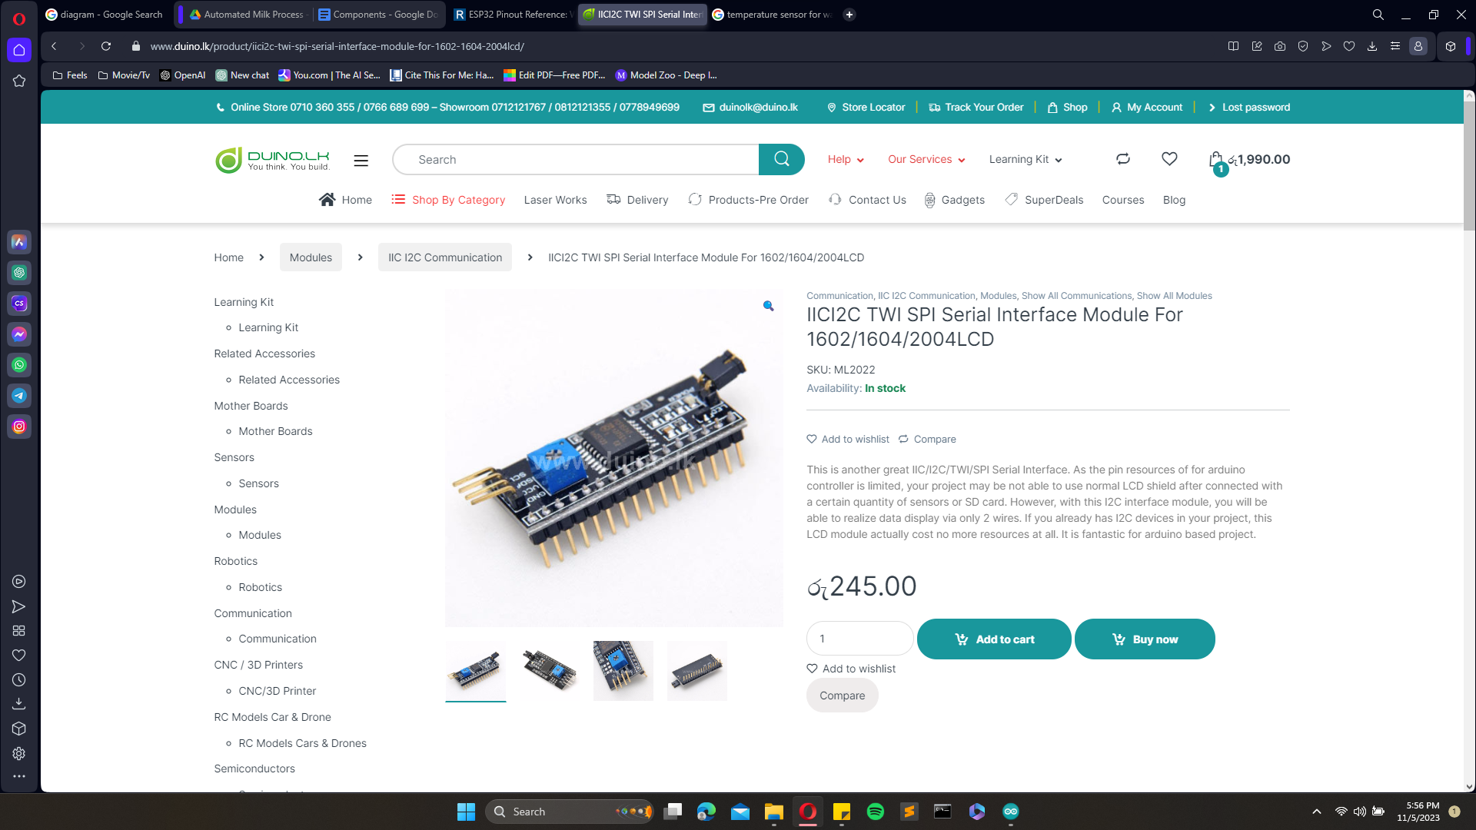

<https://www.duino.lk/product/iici2c-twi-spi-serial-interface-module-for-1602-1604-2004lcd/>

1. Temp sensor

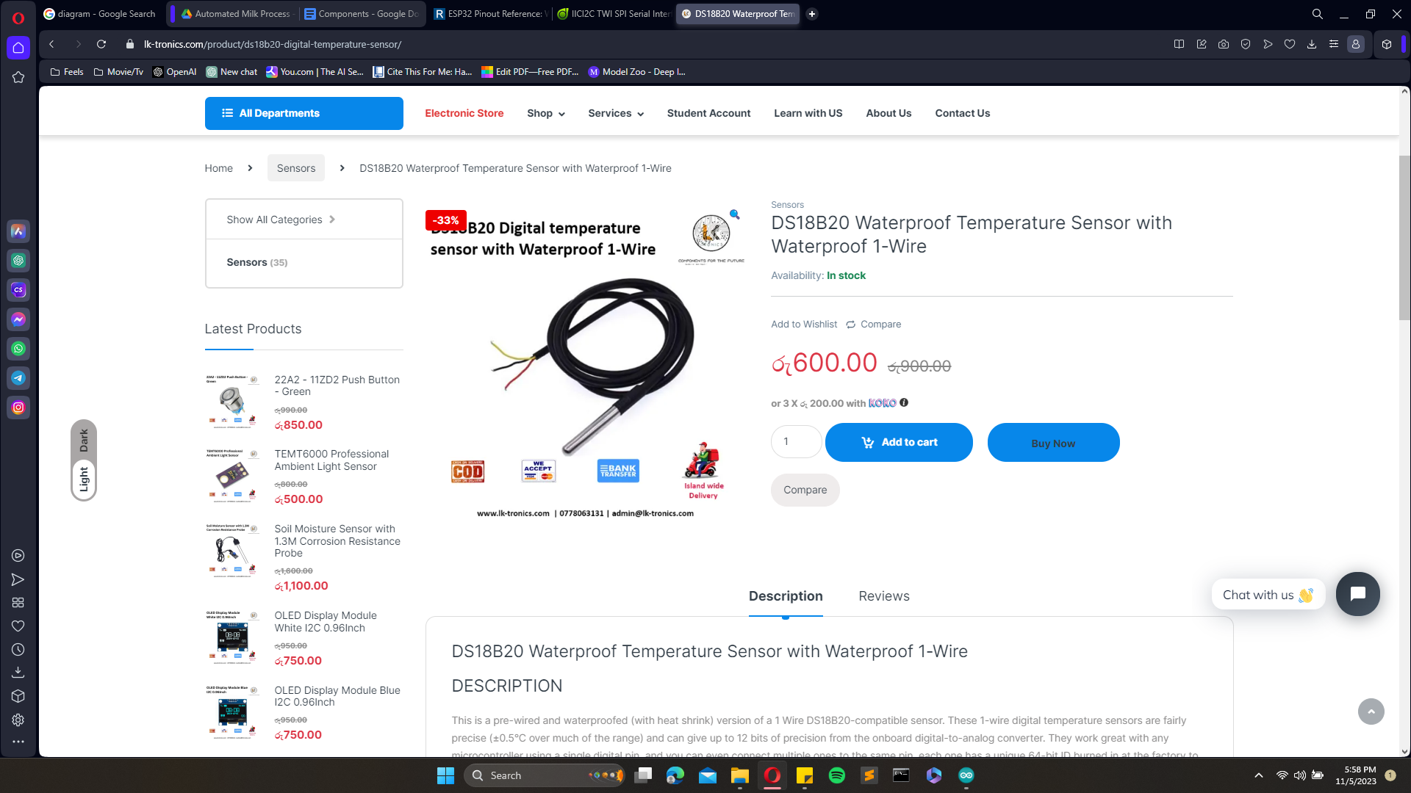

<https://lk-tronics.com/product/ds18b20-digital-temperature-sensor/>

|  |  |  |
| --- | --- | --- |
| Number | Quantity | Price Rs. |
| 1 | 1 | 1,990 |
| 2 | 2 | 2,100 |
| 3 | 1 | 1,690 |
| 4 | 1 | 245 |
| 5 | 3 | 1,800 |
| Total | | Rs. 7,825 |