WAND
DESCRIPTION
I found the this wand. I don’t know whose wand is so i need to find it and also the flag is inside this image. Go on, you may find the hint.

--I USED “STRINGS” COMMAND FOR FINDING HINTS OR ANY HIDDEN DATA


--AFTER I HAVE SEEN THE HINT “Dpassword: Full name of the weilder without spaces in small letters” After I used steghide for hidden files which are presented and I used the password, the password is “wang holder”
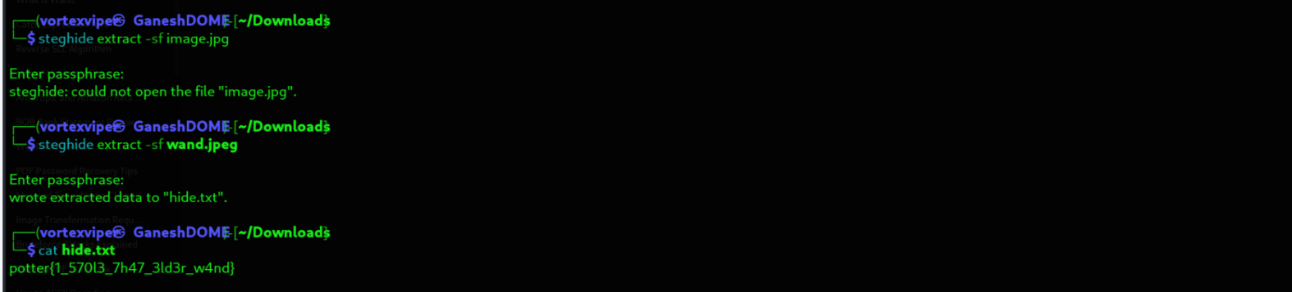

--Then I have got the flag!!!

