EECE 435L
Lab 5
Postman Screenshots
Running the Flask app:
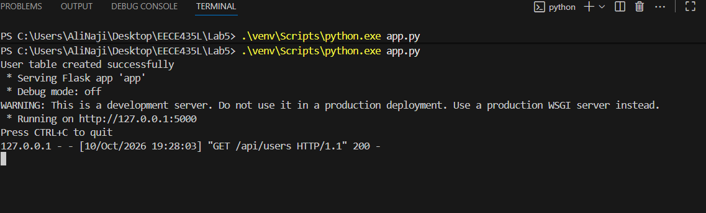

Before testing I created Lab 5 Local environment with required environment tools in this case base url for the flask app:
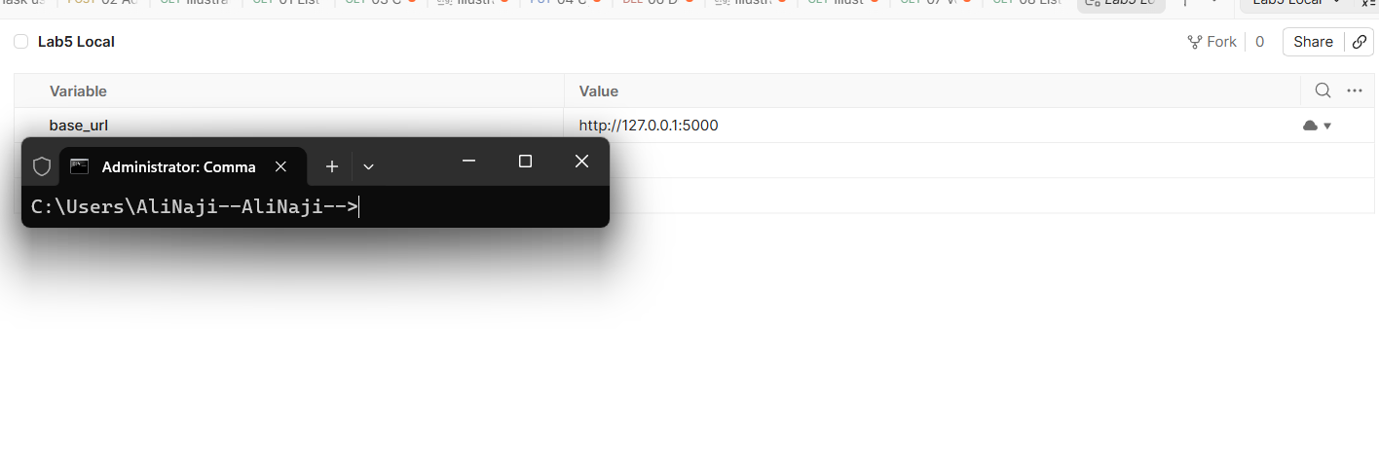

First testing GET /api/users:
Base_url is defined in Lab5 local environment that I defined before testing.
It gave 200 OK and empty list since database is empty at first.
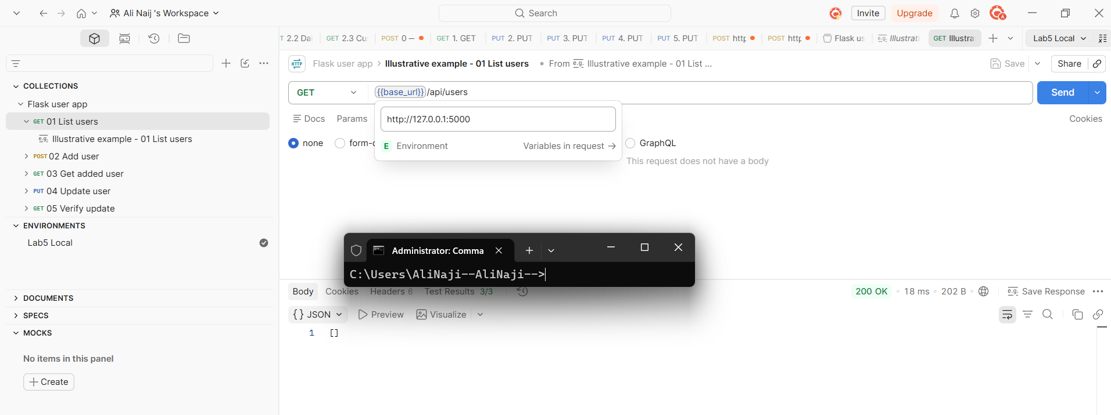
Adding Jane Doe user by using POST request for /api/users/add endpoint. In the request I specified the body which the backend expects as seen below:
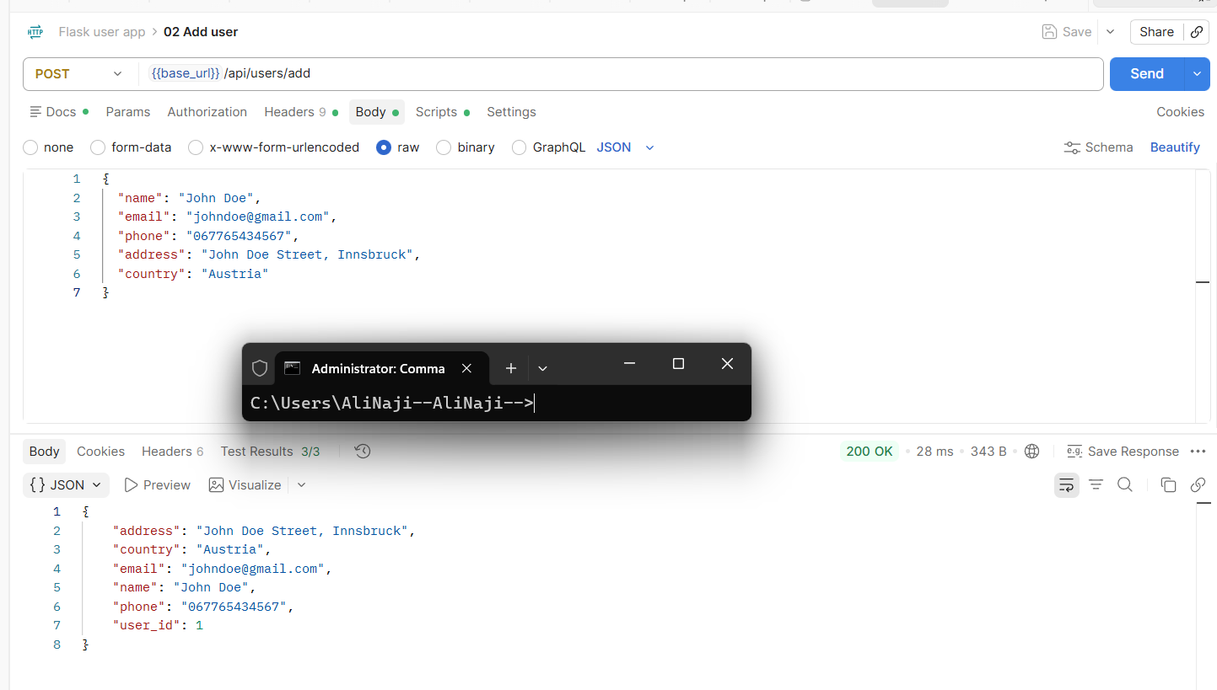
Now when I run GET /api/users we can see our newly created user instead of an empty list:
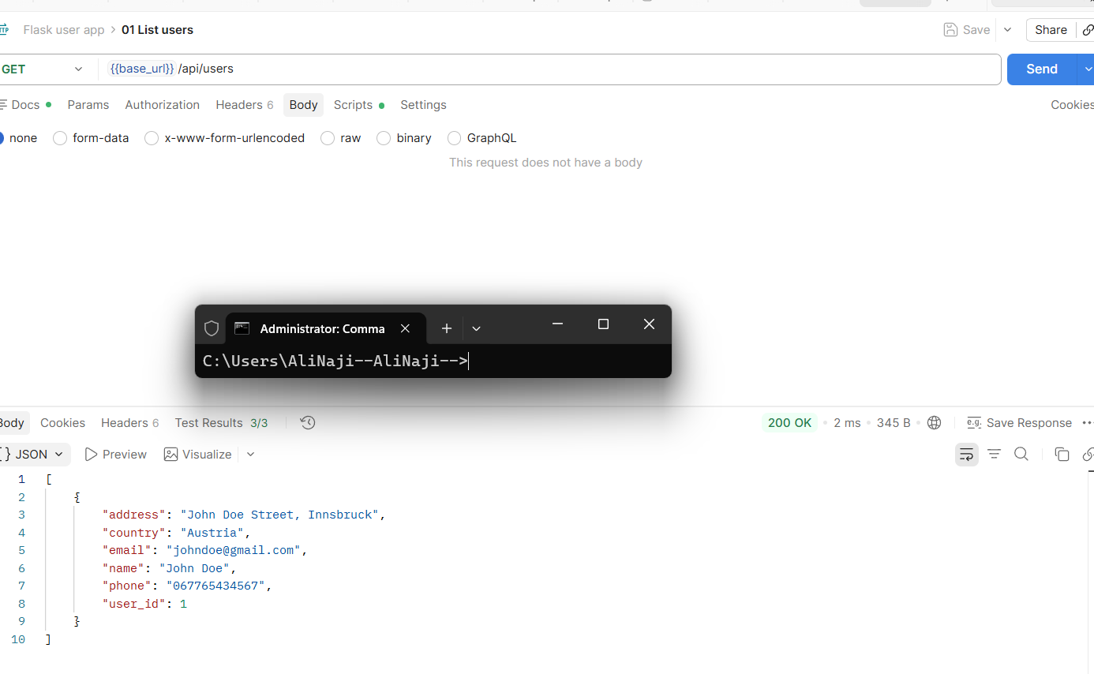
Get added user by id (in my case 1):
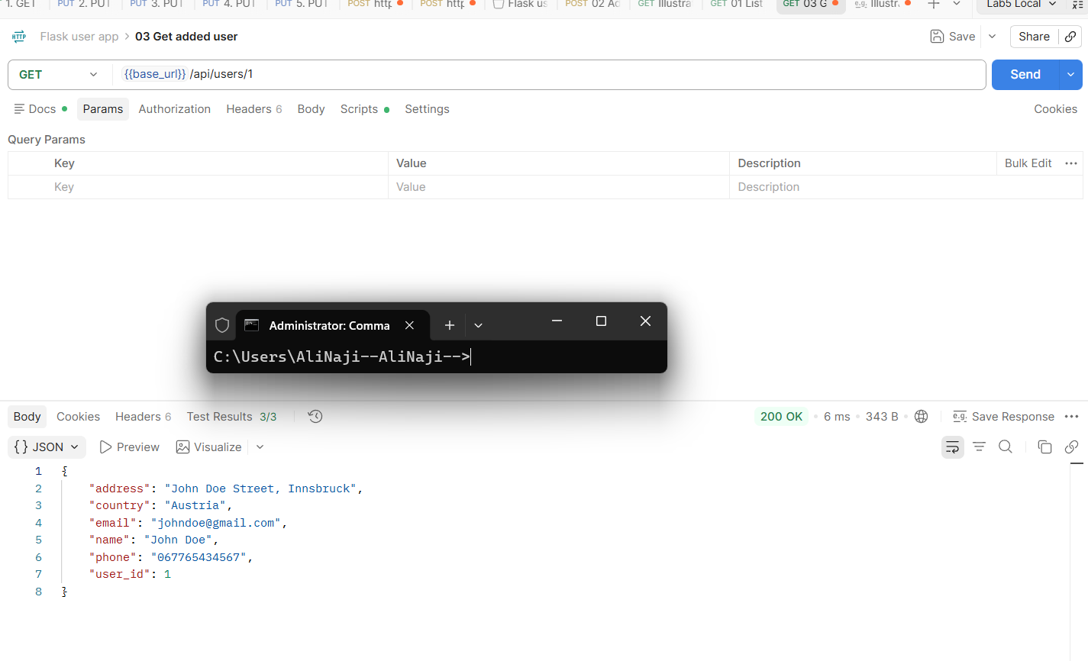
Testing Updated user endpoint by sending PUT request to /a[i/users/update. I specify which user to update in user_id field which the flask app expects:
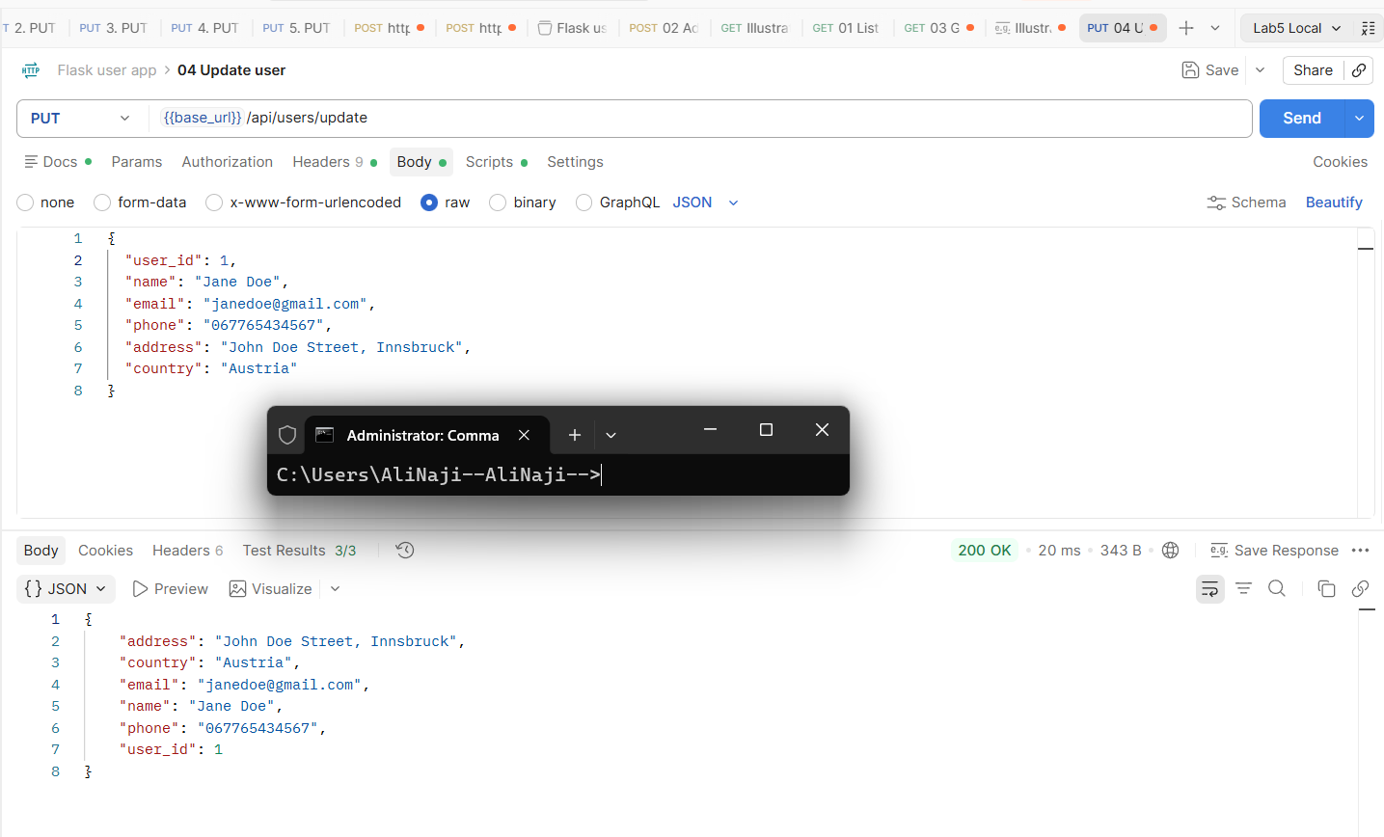
Verifying update by sending GET request to users endpoint with id 1 :
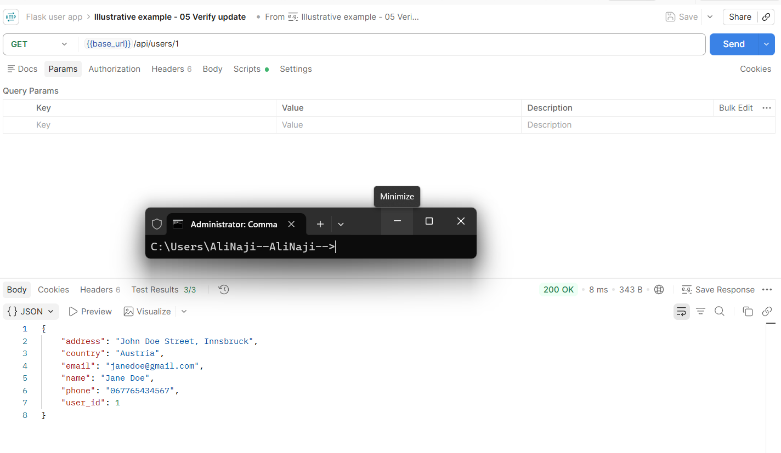
Deleting User 1 :
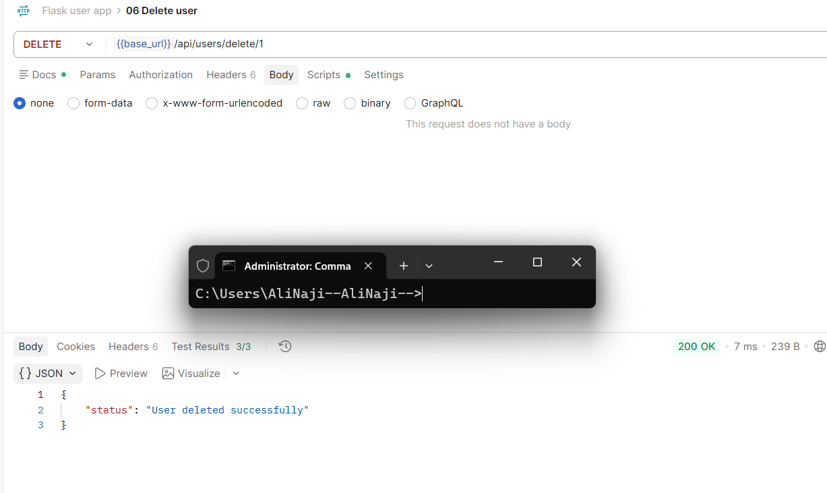

When sending a GET request for user 1 we get status code 404 as expected since now user doesn’t exist:
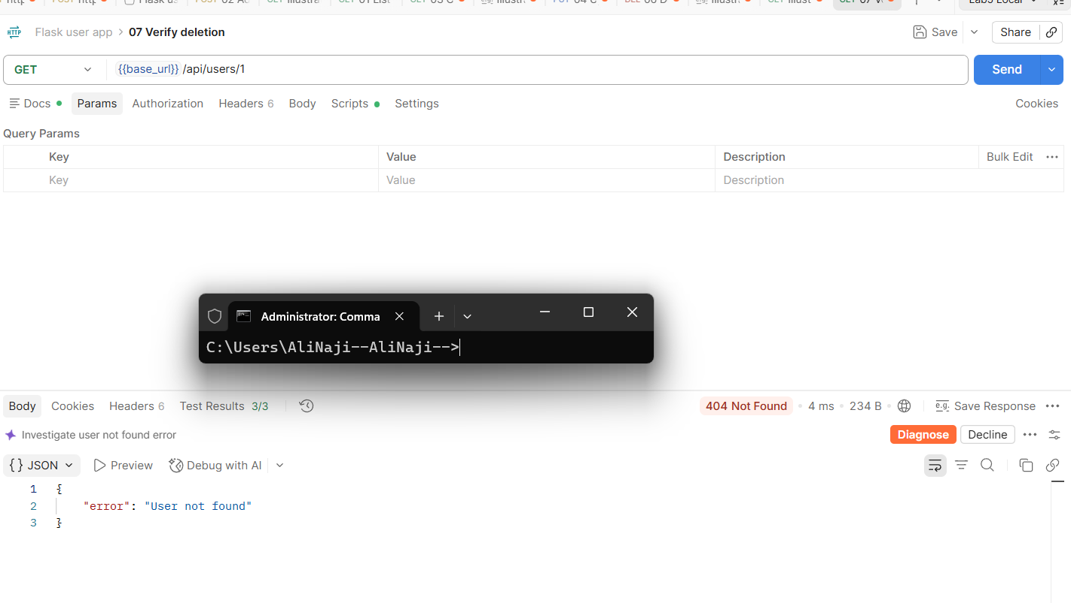

Now GET request for users endpoint returns empty list again now that only user that existed was deleted:
