EECE 435L
Lab 8

The below command will show all running and stopped Docker container on my host machine.
Output shows 3 containers which are currently running. We can see ID for each container, image used to create that container, command running inside the containers (python3 app.py), when was the container created, status of the containers (in this case running about a minute ago for first 2 and exited for last container). Human readable container names (lab8_users and lab8_api, and flask_docker_app containers)
We can see that Docker is listening on all IPv4 network interfaces on my machine (0.0.0.0). Application inside lab8_users container listens on port 3000 and 5000 on lab8_api container.
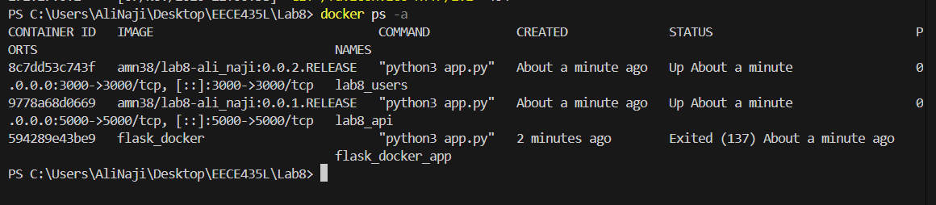

Stopping the lab8_api container:
Docker returned lab8_api which confirms that the container was stopped successfully.

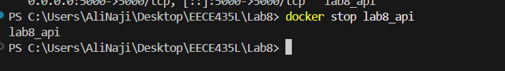

The logs command shows the previous output produced by the application inside the container, even though the container is now stopped. . The logs show that the application successfully created the user table and launched a Flask application named app with debug mode disabled. The Flask development server was configured to listen on all interfaces using 0.0.0.0, and the application was accessible internally through 127.0.0.1:5000 and the container's Docker-network IP address 172.17.0.2:5000. The logs also show a successful HTTP request to the /api/users endpoint. The request returned status code 200, confirming that the API endpoint was reached and responded successfully. A subsequent request for /favicon.ico returned status code 404, indicating that no favicon resource was defined
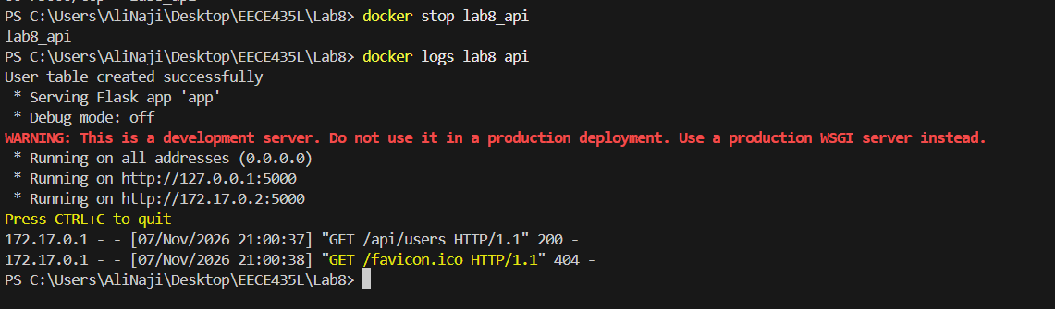

Activity 2:
Docker Desktop showed four locally stored images that were created in the lab. Each image has its own image ID, creation time, and size, while Docker may reuse common layers between images to reduce storage usage.


