Requirements for BPM

Jiganto BPM Module — Requirements Definition

1️⃣ What should a user be able to do?
Users must be able to:
- Create, edit, version, and publish:
  - Flowcharts
  - Business Process Flows (BPF)
  - Business Process Master List (Levels 1 to 5)
  - Org Charts
  - Network & Database Diagrams
  - Architecture Diagrams
- Use a drag-and-drop visual canvas for all diagram types
- Create hierarchical process structures (L1 → L5 drill-down)
- Attach attributes and metadata to every object/node
- Link diagrams together (process → system → org → SOP → document)
- Calculate rollups (cost, time, resources) across process levels
- Create AS-IS and TO-BE process versions
- Compare process versions
- Publish diagrams to Jiganto Portal for consumption
- Export to PDF, PNG, SVG, JSON
- Share with role-based access
- Attach SOPs, policies, learning materials
- Link process steps to Jiganto modules (projects, tasks, documents, risks, controls)

2️⃣ What process types matter most?
Support these primary diagram/process types:

Business-Focused
- Flowchart
- Business Process Flow (stage-based progression)
- Business Process Master List (Levels 1 to 5)
- SOP Flow
- Value Chain Maps
- Cross-functional swimlane diagrams

Organization-Focused
- Org Chart
- Responsibility maps (RACI overlays)

Technical-Focused
- Network Diagram
- Database ER Diagram
- Application Architecture Diagram
- Integration/Data Flow Diagram
Each diagram type must load with:
- Predefined stencil/shapes library
- Rules & validation logic
- Templates

3️⃣ What shapes/elements are needed on the canvas?

Core BPM Shapes
- Start / End events (circles)
- Tasks / Activities (rectangles)
- Decisions (diamonds)
- Gateways (parallel, exclusive, inclusive)
- Sub-process blocks
- Swimlanes
- Pools
- Connectors/arrows
- Data objects
- Documents
- Systems
- Manual task
- Automated task
- API call
- Event trigger
- Delay/wait step

Org Chart Shapes
- Person box
- Role box
- Department box
- Contractor/external marker
- Dotted-line relationship connector

Technical Diagram Shapes
Architecture
- App component
- Service
- API
- Database
- Queue
- External system
- Cloud service
- User interface
- Integration connector
Network
- Server
- Router
- Firewall
- Switch
- Device
- Network zone
Database
- Table
- Entity
- Relationship line
- PK/FK markers

4️⃣ What attributes per activity/node?
Each node should support configurable attributes.

Universal Attributes
- Name
- Description
- Type
- Owner
- Department
- Role responsible
- Version
- Status (Draft / Approved / Published)
- Tags
- Notes
- Attachments

Process Metrics Attributes (critical for Jiganto)
- Process time (min/max/avg)
- Cost per execution
- Frequency per period
- Resource count
- Resource skill type
- Automation level (%)
- Risk rating
- Control points
- SLA
- Input
- Output
- Dependencies
- Compliance requirement
- System used
- Data used/produced

Aggregation Requirements
System must auto-calculate:
- Total process cost
- Total process duration
- Total resource effort
- Bottleneck indicators
- Automation opportunity score
Across:
- Sub-process rollups
- L1–L5 rollups
- Swimlane totals
- Department totals

5️⃣ What should the right-side properties panel show?
Dynamic based on selected object.

Properties Panel Sections
General
- Name
- Type
- Description
- Owner
- Status
Process Metrics
- Cost
- Duration
- Frequency
- Resources
- SLA
Responsibility
- Role
- Department
- RACI selection
System/Data
- System used
- Data object
- API involved
Governance
- Risk
- Control
- Compliance link
- Policy link
Attachments
- SOP
- Training doc
- Video
- Link to Jiganto Document module
Relationships
- Parent process
- Child process
- Linked diagrams

6️⃣ Who uses it and how?

Primary Users
Consultants
- Run process workshops
- Capture AS-IS maps live
- Build TO-BE models
- Export client deliverables
Business Analysts
- Model processes
- Attach metrics
- Define automation candidates
Enterprise Architects
- Create architecture diagrams
- Map system dependencies
HR / Ops
- Maintain org charts
- Map responsibility structures
IT Teams
- Maintain network/database diagrams
Training Teams
- Publish learning journeys

7️⃣ What happens after a process is mapped?
Must support lifecycle:

Draft → Review → Approved → Published
After publishing:
- Available in Jiganto Portal
- Searchable knowledge asset
- View-only mode
- Interactive drill-down
- Training mode walkthrough
- Linked to SOPs
- Linked to roles
- Linked to systems
- Linked to risks/controls
- Version history maintained

Output Options
- Publish to Portal
- Export PDF
- Export image
- Export JSON model
- Embed in other Jiganto modules
- Share externally (secure link)

8️⃣ Architecture diagram special requirements
Architecture diagrams must support:
- Layered views
  - Business layer
  - Application layer
  - Data layer
  - Infrastructure layer
- Integration mapping
- API direction arrows
- Data flow labels
- Protocol types
- Environment tags (Dev/Test/Prod)
- Deployment zones
- Security boundaries
- Cloud/on-prem markers

9️⃣ Cross-Module Integration (Important for Jiganto)
BPM objects must link to:
- Projects
- Tasks
- Risks
- Controls
- SOP documents
- Learning materials
- Test cases
- Change requests
- AI agents
- Automation workflows

🔟 Mandatory Platform Capabilities

Drag & Drop Canvas
- Snap-to-grid
- Alignment guides
- Zoom & pan
- Multi-select
- Copy/paste
- Templates
- Auto-layout option

Versioning
- Version control
- Compare versions
- Rollback
- Change log

Permissions
- View
- Edit
- Approve
- Publish
- Comment

AI Assist (future-ready for Jiganto vision)
- Suggest process improvements
- Detect bottlenecks
- Recommend automation
- Generate draft process maps from text
- SOP generation from L4/L5 maps

Examples of the Key Outputs

Flowcharts
- Flowcharts must be able to have colour in the diagram

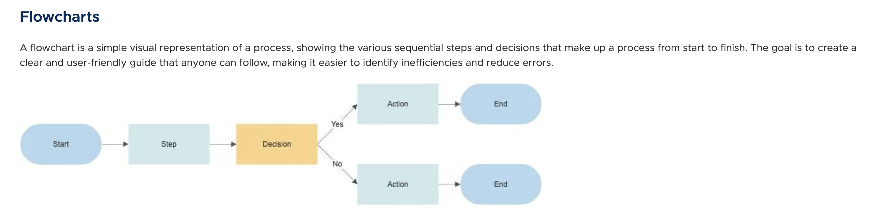

Business Process Flows (BPF)
- Business process flows must support vertical and horizontal swim lines and also have the ability to colour code not just the swim lanes themselves but also the individual diagrams

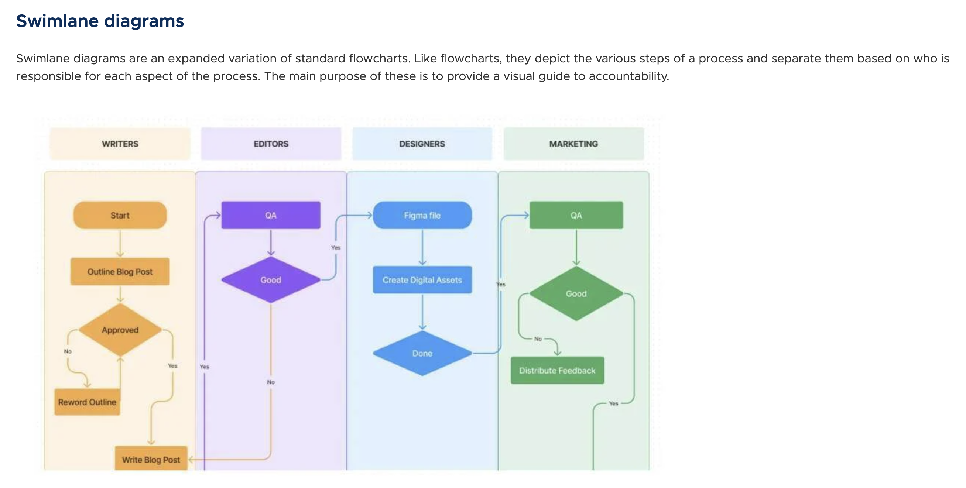

- The process map shows attributes on the right hand side, where you can collect, for example, cost for processing particular steps, or the duration, to perform a certain step, or the frequency of certain processes, or the resources that are needed, and or
- if there’s any learning material attached to the individual process steps, like a user guide, or a quick reference, guide or a simulation video, etc.

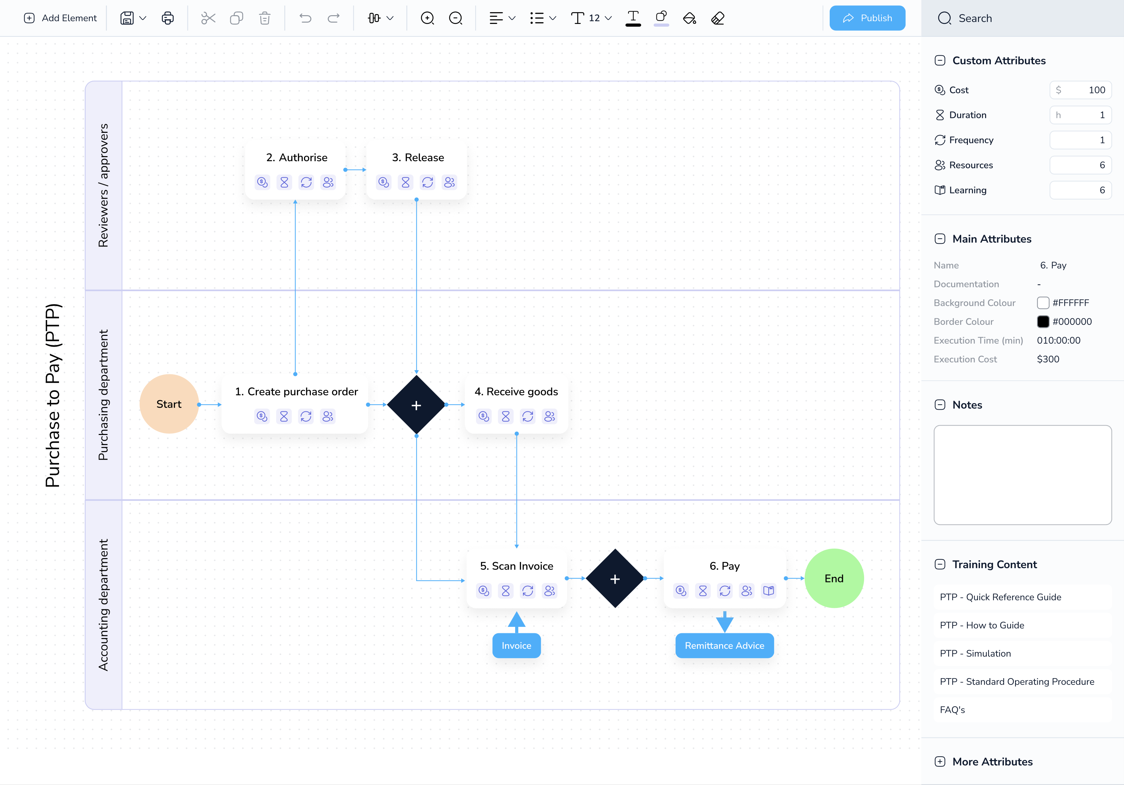

Business Process Master List (Levels 1 to 5)
- Business process, master list is typically a list of all the business processes that the company will adopt.
- Typically, when you implement an ERP system or any of the new IT or Saas software system, one has to document the processes using the document management system, but also keep a track of the business process in the BPML master list
- The number of levels can vary from company to company, but the five levels listed below are your classical levels you would expect with any, and with most organisations globally
- As well as the business process master list, there are often additional attributes that users will want to track and it is critical that the BPML function allows users to add additional columns to the matrix or table to track.
- Below is a list of fields that often come up relating to BPML. This is not an exhaustive list, but rather a typical representative of data that quite often gets used and the definitions are listed below:
  - RAGB – A Simple RAG tracker to track status anf highlight if anything is red, amber, green or blue and therefore red means delayed, Amber means at risk, green means on track and blue means completed
  - Which Entities – when you define new business processes, you need to confirm, for which legal entities and or departments this will be valid for
  - Which Countries – when you define new business processes, you need to confirm, for which Countries and or Regions this will be valid for
  - ERP Build Progress - sometimes a business process is agreed before it’s actually even implemented, and once agreed, the SI or the IT team will then track to see once it has been built and is ready to be tested
  - Test Script Reference – if a business process needs to be tested, a test script will need to be defined in, so I need to track if the test script has been created or not.
  - Train – equally, if new business processes are being defined, we need to track with a certain training needs to take place to educate the people within the business.
  - SOP – in addition, if business processes are changing, or being added to, we need to specify if they need to be part of a standard operating procedure
  - Role Access – in addition, we need to understand if certain roles and authorisations need to be amended in the respective ERP to accommodate any changes or new processes
  - Commentary – In projects, the business process management team will want to maintain commentary against each process, and therefore this field is needed
  - Draft / Under Review / Awaiting Sign off / Approved / Final – finally, as you go through the different phases of defining the business processes, they will either be draft, or in progress, or under review, or waiting signature for approval or finalised.

- Excel Upload and Template Download – BPML documents are typically very large and therefore quite often users just want to 1st maintain it in an excel sheet and then uploaded into Jiganto for ongoing maintenance. Having the ability to download a template in Excel format, and then updated and uploaded into Jiganto is vital as this is a huge time saving and value, adding device.
- Note, in the Munday board design, we have the ability to do grouping and this requirement will be absolutely needed for the BPML tracking. The ability to group processes by different levels as well as filter by different levels will be paramount and then the ability to create a separate tab or multiple tabs with a filter of the master data will also be needed

- Level 1: Enterprise Process (Process Categories)
- The highest-level view of the organization’s major functional areas. These are often referred to as "Process Areas" or "Categories".
- Examples: Finance, Human Resources, Supply Chain Management, Sales and Marketing.
- Level 2: Process Group (Tactical Level)
- Examples: Recruitment (within HR), Accounts Payable (within Finance), Lead Generation (within Sales).
- Level 3: Detailed Process (Workflow Level)
- A step-by-step workflow of an L2 process. It maps how a specific process is executed across different roles, often using cross-functional flowcharts or "swimlanes".
- Examples: Interview Scheduling (within Recruitment), Invoice Verification (within Accounts Payable).
- Level 4: Activity Level (Task Level)
- Specific activities performed by a person or system to complete one step in the L3 workflow. This level identifies the "who" and "what" of a single action.
- Examples: Sending an interview invite, checking an invoice for errors, entering data into a CRM.
- Level 5: Work Instructions / SOPs (Granular Detail)
- The most detailed level, often taking the form of Standard Operating Procedures (SOPs), transaction codes (in IT systems), or specific screenshots. It provides the exact instructions on how to perform a task.

Org Charts
- Having all charts, and the ability to define multiple org charts for a project is vital.
- A typical customer, a large project could have multiple org charts, e.g.
  - Stakeholder Map
  - Project Team
  - Steering Committee
  - CAB Change Advisory Board
- Having the ability to have all charts and then also display them in a table format is important, including the use of photos and personalised colours for the various charts

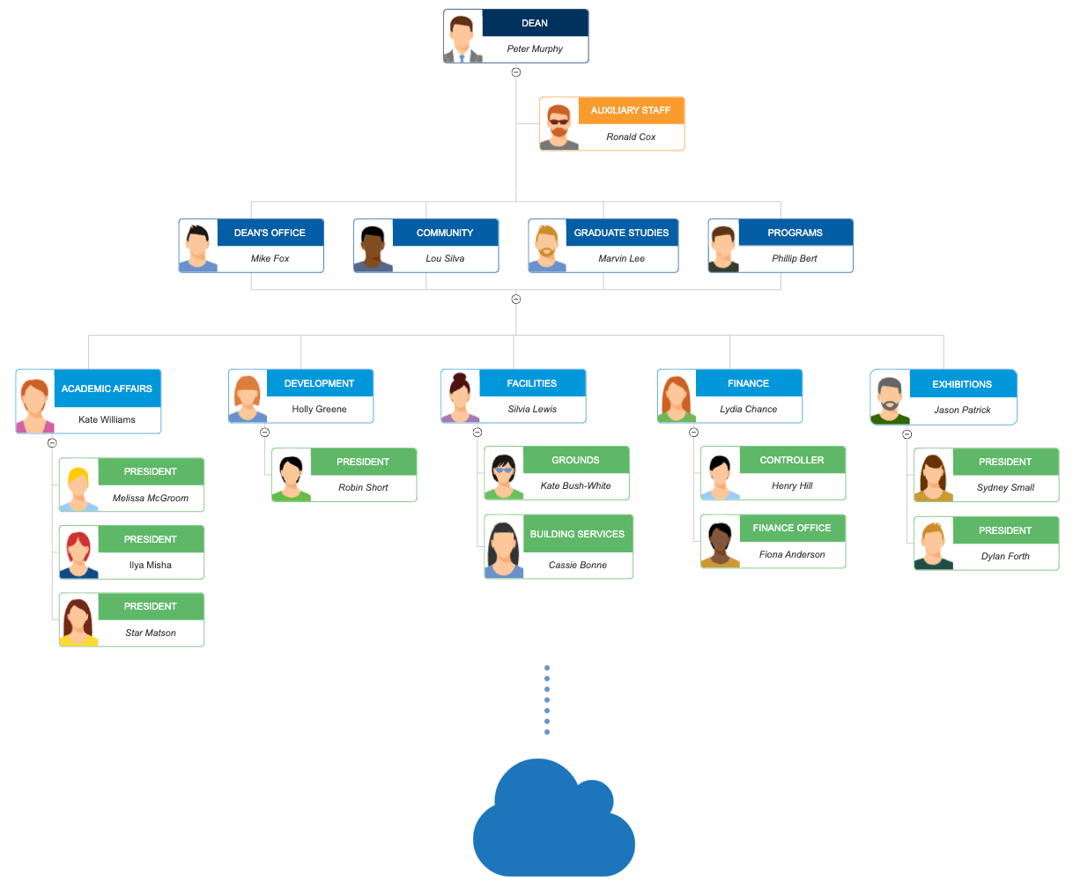

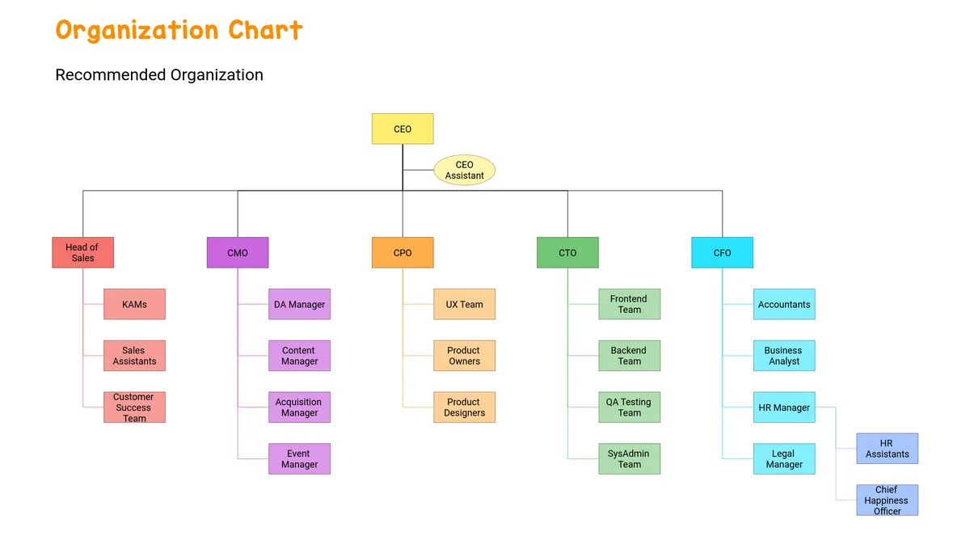

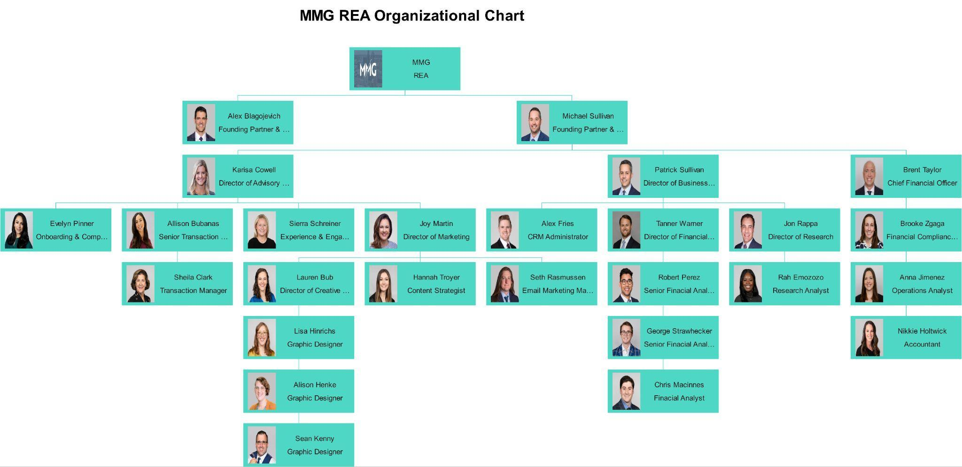

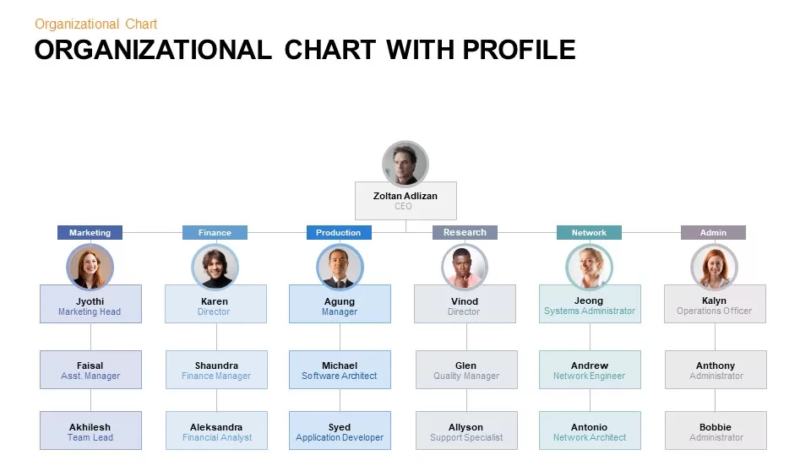
Architecture, Network & Database Diagrams
- Often, when a new ERP or IT or SAAS software system is implemented, A network or database diagram is needed to help the IT department understand how this will all flow and integrate with other systems and what changes may be needed from the API or security level.

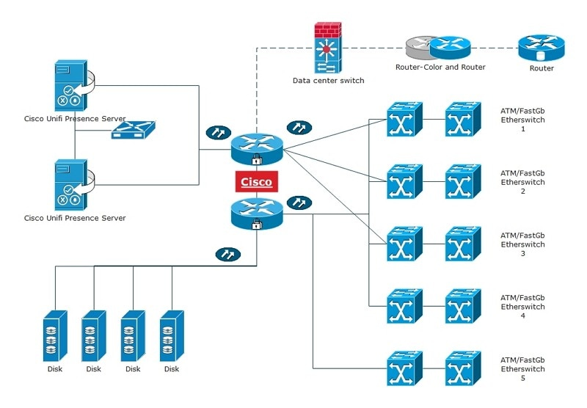

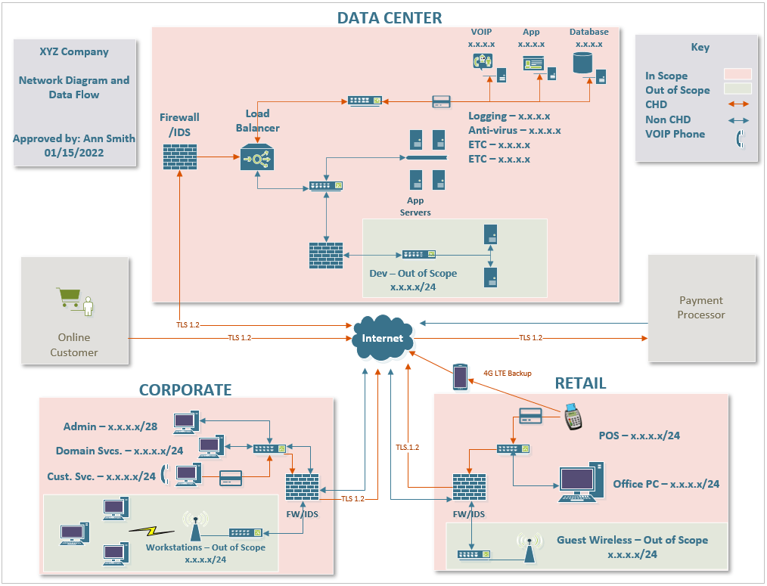

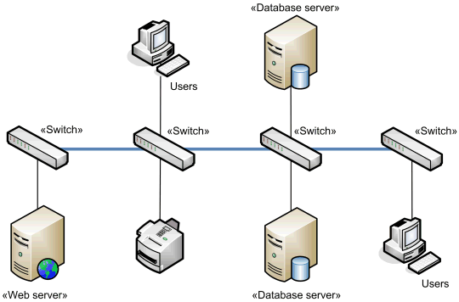

Workflow Diagrams
- In today’s world, workflow is standard with the majority of systems out there, and therefore the ability to document new or existing workflow requirements is imperative

