This instruction is intended for personal use only.
All materials contained herein belong to the Hollywool store.
Any distribution or commercial use is
a violation of copyright according to the Civil Code of the Russian Federation, part 4
If you have any questions regarding the description, you can contact us via
WhatsApp or
Telegram
+7 950-225-65-47
SWEATER
GEMS
Hollywool is a place where it is always cozy and warm. It is a community where you are understood, accepted, and your interests are fully shared. Gauge
Yarn, needles, hooks, accessories: each item has undergone thorough testing by our specialists before hitting the store shelves and the website showcase. It is important to us that everything related to the yarn purchased from us brings you nothing but pleasure and joy.
Online storeHOLLYWOOL.RU
HOLLYWOOL.RU
accepts your orders around the clock. Experienced consultants will help you choose the color, texture, and quantity of yarn, the size and length of the tool, and will provide detailed information about the features of using knitting accessories.
In our store, you will find everything you need for knitting with needles and hooks!
You can buy everything you want and pay gradually for the purchased goods thanks to the option of installment purchase.
You can significantly save on your purchase with bonus points that we award for purchases.
On our social media accounts on Instagram, VKontakte, and Telegram, there are many engaging tips and ideas. There we post detailed information about the yarn brands available in our stores, knitting patterns, and you have the opportunity to participate in giveaways and earn Hollywool bonus points!

You can buy everything you like:
on the website HOLLYWOOL.RU


And in our retail store in St. Petersburg:
- Gleb Uspensky, 3a (Metro Moskovskie Vorota)

KNITTING DESCRIPTION
The sweater is knitted in one piece from top to bottom without seams, with an Asian yoke. Required skills include knit, purl, fair isle (if you are knitting fair isle for the first time, you need to practice on samples), cast on using a waste yarn, and a seam "backstitch" for binding off the sleeves and body. Bind off Gauge
Dimensions:
The sweater is designed for sizes 42-44(I), 46-48(II), and 50-52(III).
Width of the finished product: I - 98cm, II - 104cm, and III - 110cm.

Materials and tools:

Yarn:BC Garn Semilla Melange

- BC Garn Semilla Melange
(100% sheep wool; 175m in 50 g.)
circular needles 4,5 mm on a cable 40, 60, 80 and 100cm for fair isle and main fabric/sleeves; for ribbing 3,5 mm;
- knitting needle;
- waste yarn;
- scissors;
- Stitch marker;
- measuring tape.

Consumption:

For sizes I, II: Main color – 5 skeins, for patterned yoke - 1 skeins.

For size III: Main color – 6 skeins, for patterned yoke – 1 skeins.

Gauge after washing and blocking:

20k.*26r. =10*10 cm (stockinette stitch).
To accurately determine the gauge, it is recommended to knit a swatch on circular needles, measure the length and width, perform blocking, and measure again. If your gauge differs from that specified in this description - use smaller or larger needles.

START OF WORK

NECKLINE.

Cast on stitches using any convenient method: for size I 96 st., for size II 96 st., for size III 100 st. on 3,5 mm *40cm needles, join the knitting in the round.
Knit 10 rounds in 1k*1p ribbing.

Mark the beginning of the round with a stitch marker (this will also be the center back), change to 4,5 and knit one round with knit stitches.

In the second round of the yoke, we make increases. When knitting this sweater, all increases are made from the stitch of the lower round.
Size I – increase by 8 stitches, resulting in 104 stitches. Increases are made according to the pattern: *12 k, increase* - repeat to the end of the round.
Size II – increase by 16 stitches, resulting in 112 stitches. Increases are made according to the pattern: *6 k, increase* - repeat to the end of the round.
Size III – increase by 20 stitches, resulting in 120 stitches. Increases are made according to the pattern: *5 k, increase* - repeat to the end of the round.

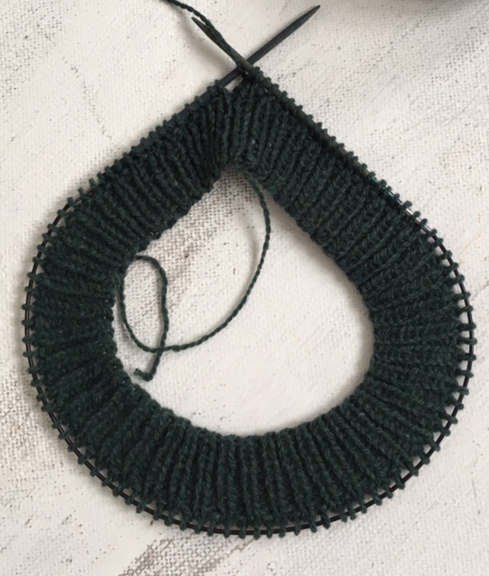

YOKE.

Count the stitches after making the increases before starting the pattern.

Let's proceed to the pattern chart.
The rows in the Pattern are numbered, we start knitting from row 1. Do not knit the gray cells, only the black and white cells are in use.

Calculations for size I:

1 round of the Pattern - 104 loop.
7 row – increase by 52 stitches, resulting in 156 stitches. Increases are made according to the pattern: *1k, inc., 3k according to the pattern, inc.*
14 row – increase by 52 stitches, resulting in 208 stitches. Increases are made according to the pattern: *1k, inc., 5k according to the pattern, inc.*
23 row – increase by 52 stitches, resulting in 260 stitches. Increases are made according to the pattern: *1k, inc., 7k according to the pattern, inc.*

Calculations for size II:

1 round of the Pattern - 112 loops.
7 row – increase by 56 stitches, resulting in 168 stitches. Increases are made according to the pattern: *1k, inc., 3k according to the pattern, inc.*
14 row – increase by 56 stitches, resulting in 224 stitches. Increases are made according to the pattern: *1k, inc., 5k according to the pattern, inc.*
23 row – increase by 56 stitches, resulting in 280 stitches. Increases are made according to the pattern: *1k, inc., 7k according to the pattern, inc.*

Calculations for size III:

1 round of the Pattern - 120 loop.
7 row – increase by 60 stitches, resulting in 180 stitches. Increases are made according to the pattern: *1k, inc., 3k according to the pattern, inc.*
14 row – increase by 60 stitches, resulting in 240 stitches. Increases are made according to the pattern: *1k, inc., 5k according to the pattern, inc.*
23 row – increase by 60 stitches, resulting in 300 stitches. Increases are made according to the pattern: *1k, inc., 7k according to the pattern, inc.*

Knit to the end of the Pattern, then knit 2 rows in the main color, adding a few rows in the main color if necessary. For example, if you are knitting a sweater for a height above 175cm, you should add 4-6 rows.
When knitting the yoke, change to a longer cable as needed. The stitches should move freely on the needles and cable. If the cable is too short and the fabric gathers in folds - it is harder to control the jacquard. The fabric may end up being tight or overly loose. Periodically check the gauge of your knitting if you have little experience in knitting jacquard.
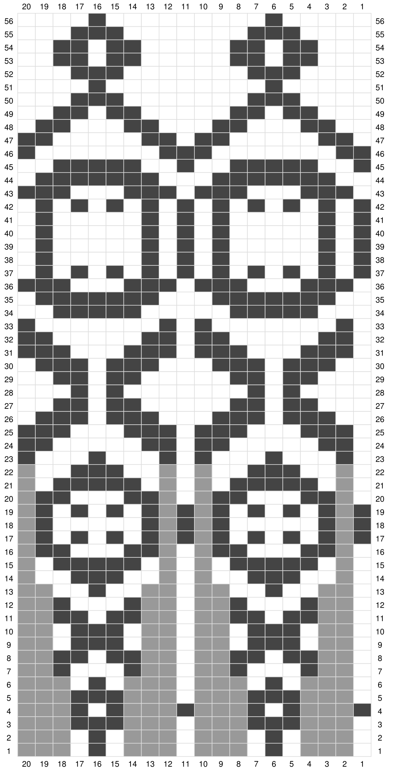
Lay the yoke on the table, determine the center of the back, and mark it with a stitch marker. We proceed to distribute the stitches.

I size: we measure from 42 loops on the left and right of the center back, marking with stitch markers. The width of the front 84 loops, the sleeve by 46 loops, the width of the back 84.

Size II: count 45 stitches to the left and right of the center back, marking with stitch markers. The width of the front is 90 stitches, the sleeve is 50 stitches, the width of the back is 90.

Size III: Count 47 stitches to the left and right of the center back, mark with a stitch marker. The width of the front is 90 stitches, the sleeve is 56 stitches, the width of the back is 90.

Determine the center front, separate the body and sleeves. Transfer the sleeve stitches to a spare needle.
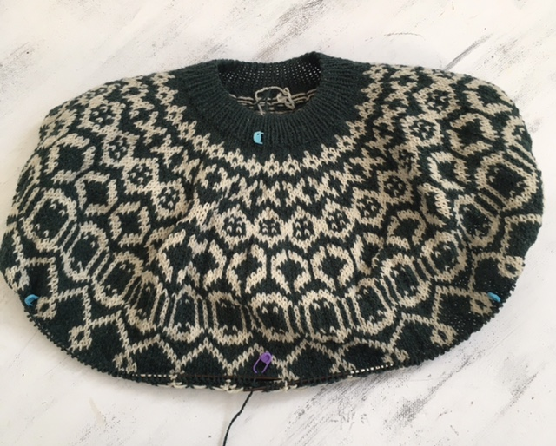

SHORT ROWS

Short rows are worked on the back stitches in turning rows.
In each purl row, increase by 2 stitches according to the pattern:
(edge, p, increase, Purl to the last two stitches of the row, increase, p, edge).
Knit the knit rows without increases.

For size I – knit 14 rows, we will get 14 increases.
For size II – knit 14 rows, we will get 14 increases.
For size III – knit 16 rows, we will get 16 increases.
Finish knitting the back neck in the knit row.
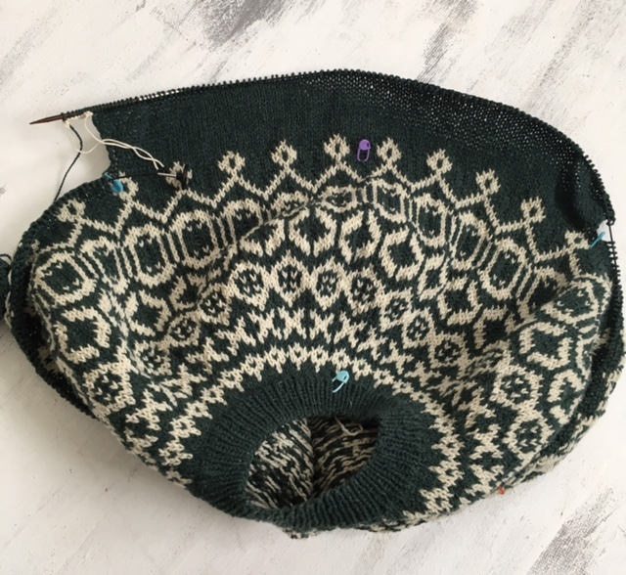

BODY

On a spare thread, cast on stitches to form the undercuts.
For size I – cast on 7 stitches.
For size II – cast on 7 stitches.
For size III – cast on 8 stitches.
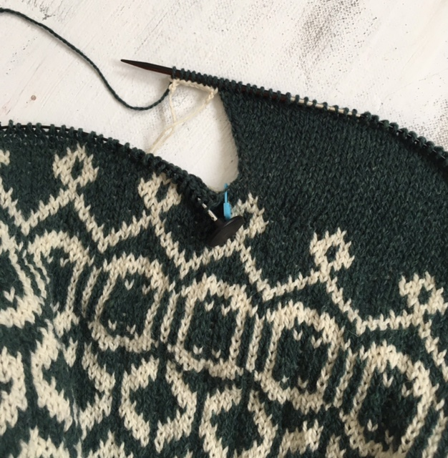

Continue knitting the front stitches until the second undercut. Cast on stitches for the undercut on the spare thread similarly to 1 undercut. Continue knitting the back stitches until the first undercut. Count the body stitches on the needles.
For size I – 196 stitches (front 84, back 98, 7*2 – undercuts).
For size II – 208 stitches (front 90, back 104, 7*2 – undercuts).
For size III – 220 stitches (front 94, back 110, 8*2 – undercuts).
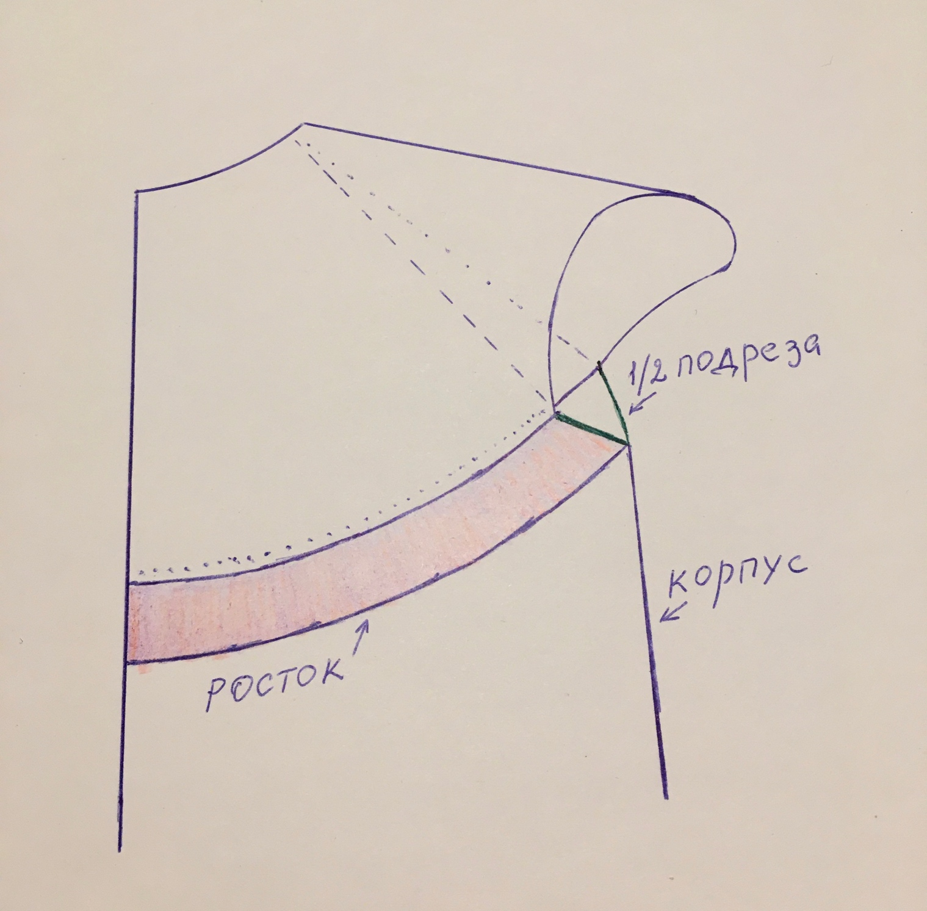

Next, knit the body in the round until the required length is reached.
For even and comfortable knitting, use needles on a cable 100-120cm (depending on the size).
For knitting the ribbing, change the needles to 3,5mm. Knit ribbing 1k*1p, ribbing width 16 rows.

Bind off stitches with a stretchy seam using a knitting needle.

SLEEVES

Next, we will need needles for knitting the sleeves. Start knitting each sleeve from the junction of the back neck and undercut.
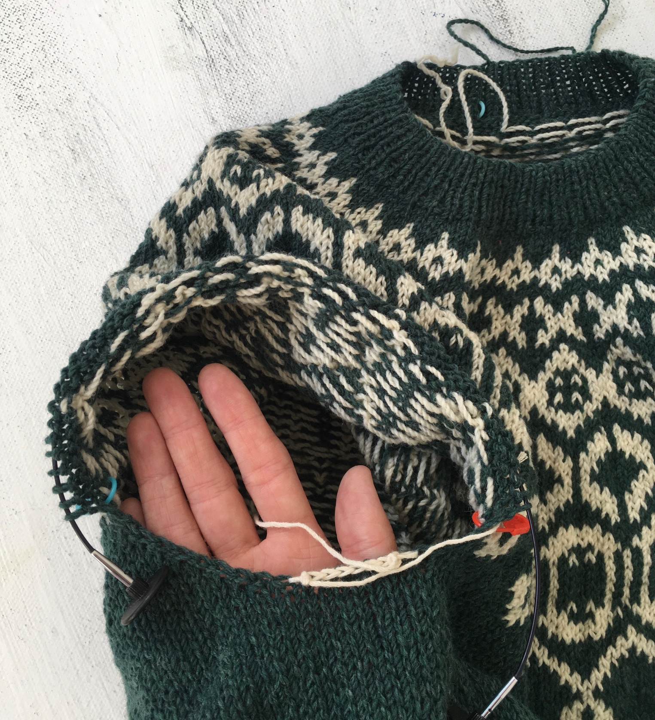

At the beginning of the row from the back neck – on the working thread, use the needle to pick up stitches from the first knit stitches along the edges. Pick up stitches from every second row, for size I cast on 7 stitches (from 14 rows), for size II cast on 7 stitches (from 14 rows), for size III cast on 8 stitches (from 16 rows).
After the cast on, we continue knitting along the stitches of the sleeve until the thread. We remove the thread, transfer the open stitches to the left needle, and knit.
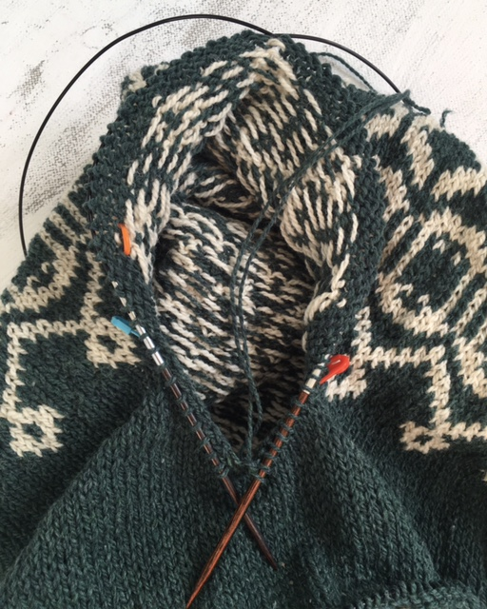

Start the second sleeve with the stitches cast on the spare thread, then knit the sleeve stitches on the yoke and cast on the remaining stitches for the undercut from the back neck. Join the knitting in the round.

Count the stitches before continuing to knit the sleeves.

Size I 60 stitches (46 sleeve stitches and 14 undercut stitches).
Size II 64 stitches (50 sleeve stitches and 14 undercut stitches).
Size III 72 stitches (56 sleeve stitches and 16 undercut stitches).

Mark the beginning of the row with a stitch marker (the middle of the decrease).
Knit the sleeves in the round without decreases until the required length is reached.
For height 160-170 cm
Size I 28cm
Size II 25cm
Size III 20cm

Next, proceed to decreases.

We make reductions in each 7 row according to the Pattern: Pins
2 k, 2 together with a left slant, k until the last 4 stitches, 2 together with a right slant, 2 k.
Size I 60 stitches, after decreases – 54 stitches
Size II 64 stitches, after decreases – 56 stitches
Size III 72 stitches, after decreases – 54 stitches.

With a height above 170 cm – it is necessary to knit another 3-5 cm before starting decreases.

Next, change the needles to 3,5 mm and knit ribbing 1k*1p, 16 rows.
Bind off stitches with a stretchy seam using a knitting needle.

Knit the second sleeve exactly the same as the first.

Thread the ends of the yarn with a needle, cut the tips so that no more than 1 cm remains.

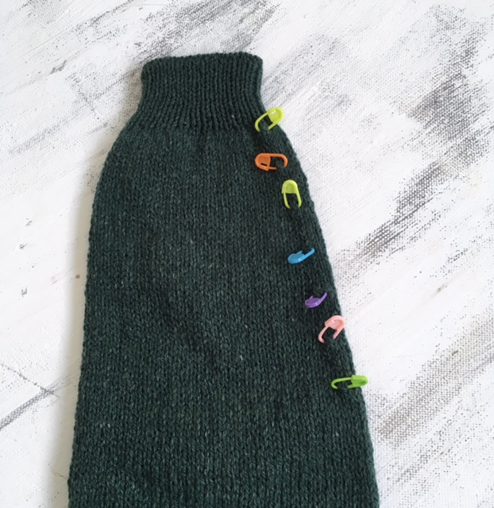

WASHING INSTRUCTIONS
Gently wash your item in cool water with a special detergent. For example, useтвердое или жидкое мыло с ланолином Hollywool,

solid or liquid soap with lanolin Hollywool,
rinse well until the water is completely clear, gently squeeze the sweater without wringing it out. Lay it to dry on a thick terry towel, when it has absorbed most of the water – replace it with a dry one. Lay the sweater out with a measuring tape to ensure the width corresponds to the size.

