Date: 26/10/26
CO-2 Assessment-2
ANALYTICAL PROBLEM SOLVING
Course Code: -DSA 0308
Course Name: -Natural Language Processing
Name: - V Vishnu Sai Reg no: -192325028

EXPERIMENT / SCENARIO 1: Morphological Processing System for Search Engine Indexing
Aim
To design and implement a rule-based morphological processing system for search engine indexing that decomposes "analyzing", "analysis", and "analytical" into root and affixes, categorizes them into inflectional and derivational forms, and standardizes them into a common index representation.
Tools & Libraries Used
Tool / Library | Purpose / Functionality
Python Standard Library (Core Interpreter) | Execution environment for morphological analysis logic
String Slicing & Methods (endswith) | Suffix pattern matching and affix-root stripping operations
Dictionary Data Structures (dict) | Structured schema representation for inverted index metadata
Format Specification Mini-Language (str.format) | Multi-column table alignment for terminal and document export
Algorithm
- Start the execution.
- Define the input dataset: ["analyzing", "analysis", "analytical"].
- Construct morphological identification rules for Greek/Latin derived roots:
  - Identify base verbal lexeme: analyze.
  - Match -ing: Rule strips suffix, accounts for silent $e$-deletion (analyz- + e $→$analyze), and flags as Inflectional (Present Participle / Gerund).
  - Match -sis: Rule handles Greek nominal alternation ($-sis↔-ze$), extracting root analyze, and flags as Derivational (Nominalization: $\text{Verb}→\text{Noun}$).
  - Match -tical: Rule removes composite adjectival suffix (-tic + -al), maps back to base analyze, and flags as Derivational ($\text{Noun/Verb}→\text{Adjective}$).
- Map all three variations to the unified indexing token analyze to maximize retrieval recall.
- Format and display the morphological report in a structured table.
- Stop the execution.

Code:
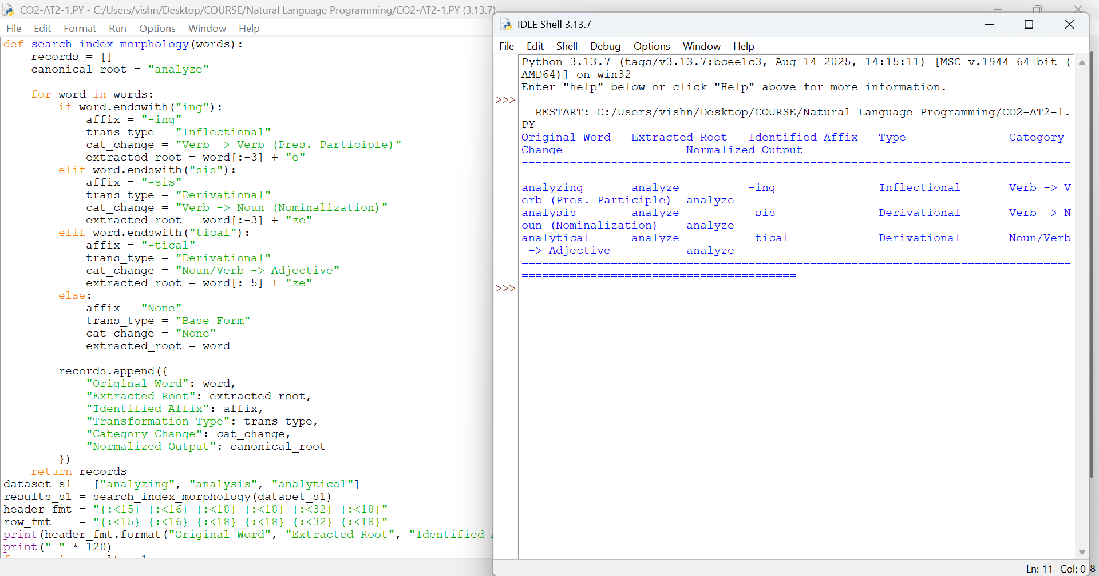Result
The morphological engine successfully decomposed the search query variants, segregated inflectional participle forms from derivational noun and adjective forms, and unified them to the common index term analyze.
EXPERIMENT / SCENARIO 2: Morphological Parser for Sentiment Analysis
Aim
To develop a rule-based morphological parsing module for sentiment analysis that isolates prefixes, suffixes, and base forms for "disagree", "agreement", and "agreeable", evaluates derivational valence modifications, and normalizes them to "agree".
Tools & Libraries Used
Tool / Library | Purpose / Functionality
Python Standard Library (Core Interpreter) | Execution environment for rule-based parsing logic
Prefix & Suffix String Handlers (startswith, endswith) | Parsing directional affix changes and semantic valence shifts
Tabular String Formatting Engine | Visual display and tabular report generation
Algorithm
- Start the execution.
- Initialize the input product review tokens: ["disagree", "agreement", "agreeable"].
- For each word, check for prefix and suffix transformations:
  - Prefix Check: Test if word starts with dis-. If true, extract prefix dis-, strip from stem, and assign Polarity Inversion ($+→-$ valence).
  - Suffix Check 1: Test if word ends with -ment. If true, extract suffix -ment, strip from stem, and classify as Derivational Nominalization (State/Entity formation; retains base valence).
  - Suffix Check 2: Test if word ends with -able. If true, extract suffix -able, strip from stem, and classify as Derivational Adjectivalization (Disposition/Ability; retains base valence).
- Isolate the base form agree across all tokens.
- Classify all transformations as Derivational since they alter word classes or flip semantic polarity.
- Display the sentiment parsing results in a formatted table.
- Stop the execution.
Code:
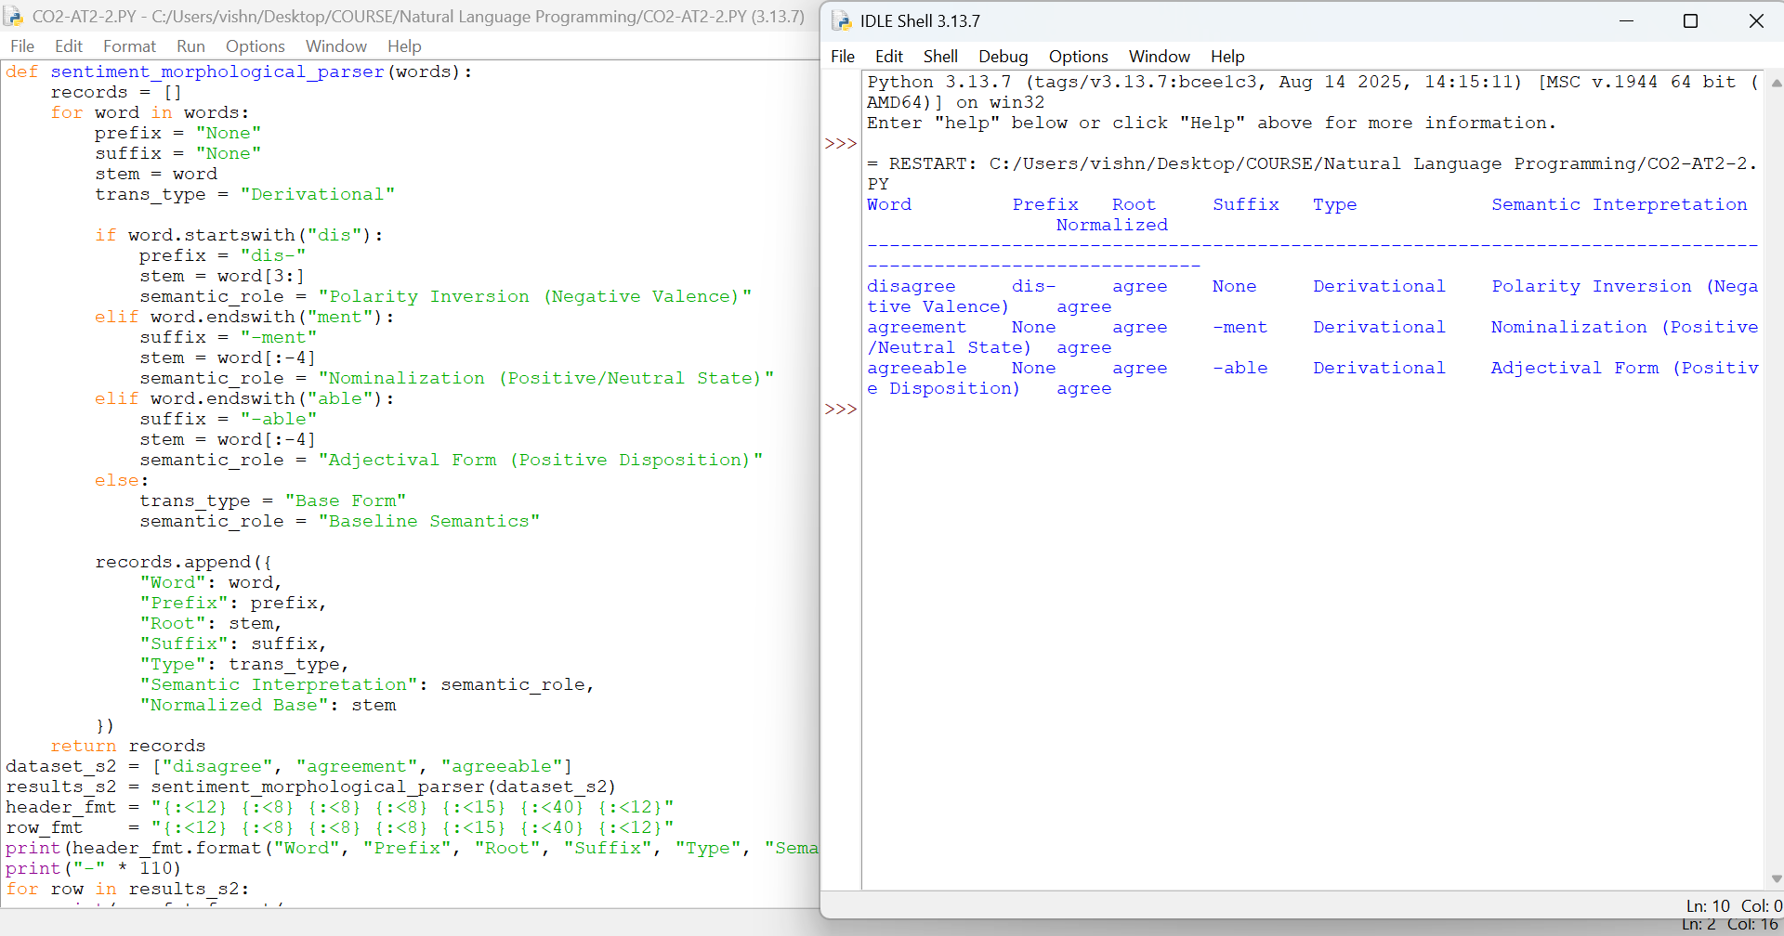
Result
The parser accurately identified that the prefix dis- inverts the sentiment polarity of the base root, while -ment and -able alter grammatical category while maintaining underlying positive valence.
EXPERIMENT / SCENARIO 3: Morphology-Based Normalization for Topic Modelling and Clustering
Aim
To construct a morphology-based normalization module for a news text analytics pipeline that decomposes "govern", "government", and "governance" into root and derivational layers, mapping them to a standardized lexical representation for document clustering.
Tools & Libraries Used
Tool / Library | Purpose / Functionality
Python Standard Library (Core Interpreter) | Execution environment for text preprocessing logic
Sequential Pattern Matching (str.endswith) | Detecting hierarchical derivational suffix strata
Data Structuring Collections (list of dict) | Corpus vocabulary token mapping for LDA / Topic Modeling
Algorithm
- Start the execution.
- Initialize input news article keywords: ["govern", "government", "governance"].
- Set the base lemma: govern (Root Verb, Level 0 derivation).
- Evaluate suffix layers and structural hierarchy:
  - For govern: No suffix; Level 0 (Primitive Base).
  - For government: Detect suffix -ment. Suffix strip to base govern. Set Derivational Hierarchy to Level 1 (Base $→$Concrete/Institutional Noun).
  - For governance: Detect suffix -ance. Suffix strip to base govern. Set Derivational Hierarchy to Level 1 (Base $→$Abstract Process/Action Noun).
- Unify all three forms to the single feature token govern to prevent vocabulary fragmentation in topic modeling algorithms.
- Display results in a structured format and stop.
Code:
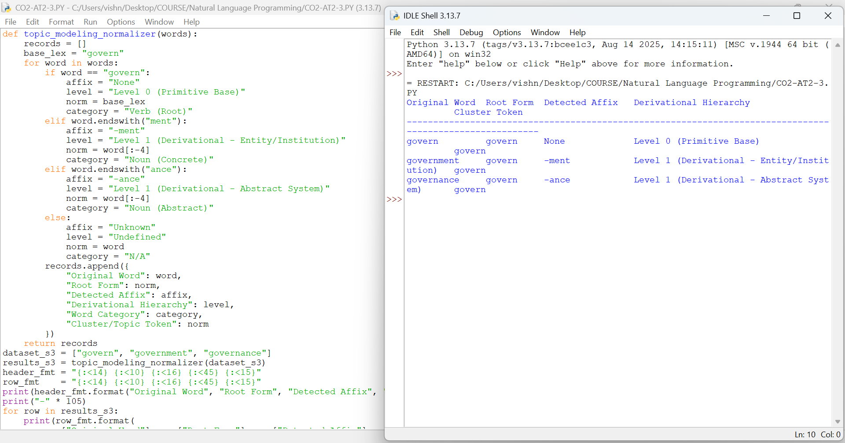

Result
The module analyzed the derivational hierarchy across institutional and abstract terms, mapping all three forms to the base token govern to eliminate vocabulary dispersion in LDA topic clusters.
EXPERIMENT / SCENARIO 4: Multi-Layer Morphological Parsing for Document Classification
Aim
To construct and implement a multi-layer morphological parser for document classification that processes "activate", "activation", and "reactivation" by identifying prefixes, suffixes, and roots, tracking sequential derivational layers, and evaluating shifts in word classes.
Tools & Libraries Used
Tool / Library | Purpose / Functionality
Python Standard Library (Core Interpreter) | Execution environment for compositional morphology parsing
Positional Substring Indexing (Slicing) | Stripping nested prefixes and suffixes in hierarchical order
Tabular Formatter (str.format) | Generating multi-column classification audit reports
Algorithm
- Start the execution.
- Initialize input classification tokens: ["activate", "activation", "reactivation"].
- Set the base lexeme: activate ($\text{Verb}$).
- Parse sequential derivational layers for each token:
  - activate: Base verbal form ($\text{Verb}$). Derivational sequence: $\text{Base}→\text{Verb}$.
  - activation: Verbal base activates + nominal suffixion with $e$-deletion ($\text{Verb}→\text{Noun}$). Derivational sequence: $\text{Base}→\text{Verb}→\text{Noun}$.
  - reactivation: Iterative prefix re- + verbal base activates + nominal suffixion. Derivational sequence: $\text{Base}→\text{Verb}→\text{Noun}→\text{Prefixed Iterative Noun}$.
- Normalize all terms to the base lexeme activate for document classification indexing.
- Print the structural hierarchy and Stop.
Code:
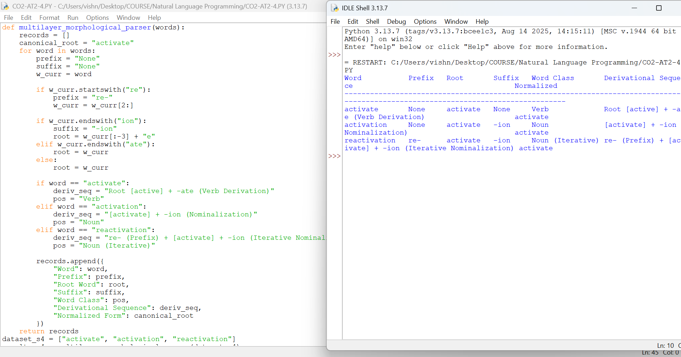
Result
The parser accurately traced compositional affixation, identifying the prefix re- and nominal suffix -ion, tracking the part-of-speech progression, and normalizing all variants to activate.

EXPERIMENT / SCENARIO 5: Inflectional Morphology-Based Normalization for Search Optimization
Aim
To design and implement an inflectional morphology normalization module for search optimization that recognizes grammatical suffixes on "create", "creates", and "creating", identifies tense/aspect features, and normalizes them to the common base form "create".
Tools & Libraries Used
Tool / Library | Purpose / Functionality
Python Standard Library (Core Interpreter) | Execution environment for inflectional paradigm analysis
String Suffix Strip & Substitution | Handling grammatical endings (-s, -ing) and restoring silent $e$
Formatted Output Engine | Structured presentation for search optimization metrics
Algorithm
- Start the execution.
- Initialize the input queries dataset: ["create", "creates", "creating"].
- Construct an inflectional verb paradigm table for base create:
  - If word is create: Suffix = $∅$, Grammatical Category = Base Form / Non-3rd Present, Root = create.
  - If word ends with s: Suffix = -s, Grammatical Category = 3rd Person Singular Present, strip -s $→$Root = create.
  - If word ends with ing: Suffix = -ing, Grammatical Category = Present Participle / Progressive Aspect, strip -ing and restore silent $e$(creat- + e) $→$Root = create.
- Preserve semantic identity while normalizing all grammatical inflections to create.
- Display the output report for search query optimization.
- Stop the execution.
Code:
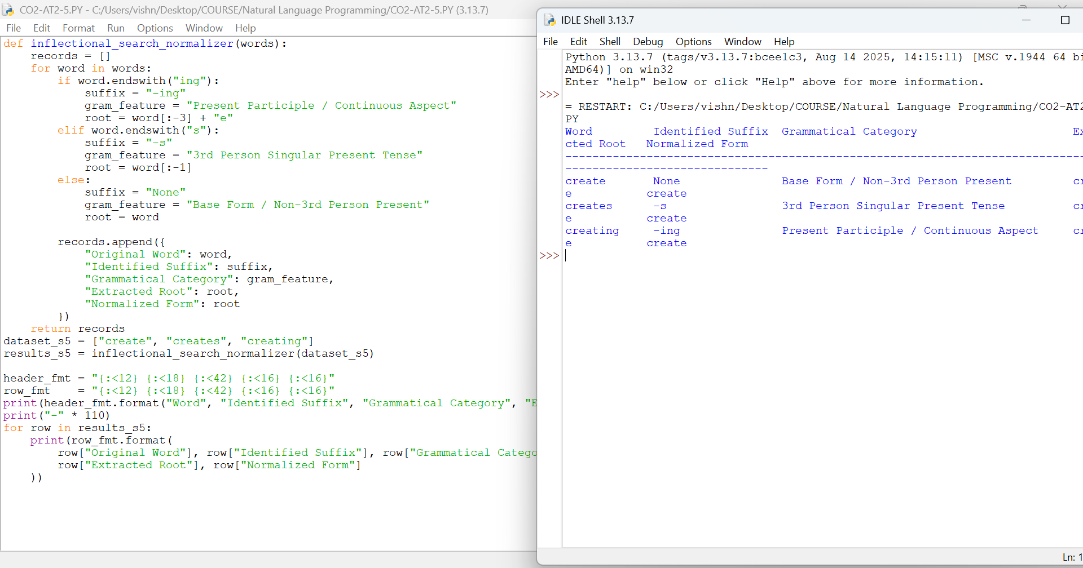
Result
The inflectional module identified grammatical tense and aspect suffixes without altering underlying verbal semantics, handled silent $e$-restoration, and mapped all forms to create.

