Date: 24/10/26
CO-2 Assessment-1
ANALYTICAL PROBLEM SOLVING
Course Code: -DSA 0308
Course Name: -Natural Language Processing
Name: - V Vishnu Sai Reg no: -192325028

EXPERIMENT / QUESTION 1: Morphological Analysis Pipeline for Document Indexing
Aim
To design and implement a morphological analysis pipeline in Python for a document indexing system that decomposes the words "connected", "connecting", and "connection" into root and suffix components, distinguishes inflectional from derivational forms, and normalizes them to a common base form for efficient retrieval.
Libraries Used
- sys / Standard Library Built-ins (dict, list, str string manipulation methods) — No external third-party packages required; pure rule-based morphology engine for deterministic string processing.
Algorithm
- Start the execution.
- Initialize the input tokens dataset: ["connected", "connecting", "connection"].
- Construct a declarative rule mapping containing suffix patterns (-ed, -ing, -ion), morphological classification (Inflectional vs. Derivational), syntactic category transitions, and slicing offsets.
- For each word in the input set:
  - Match the suffix ending against the rules table.
  - Suffix stripping: remove the suffix length from the end of the word to extract the canonical base root (connect).
  - Classify -ed and -ing as Inflectional (verbal aspect/tense modifiers preserving syntactic category).
  - Classify -ion as Derivational (nominalizing suffix shifting $\text{Verb}→\text{Noun}$).
  - Assign the stripped root connect as the unified indexing key.
- Format the parsed records containing the original word, root, affix, category change, and normalized key into a structured layout.
- Display the final evaluation table and Stop.
Code
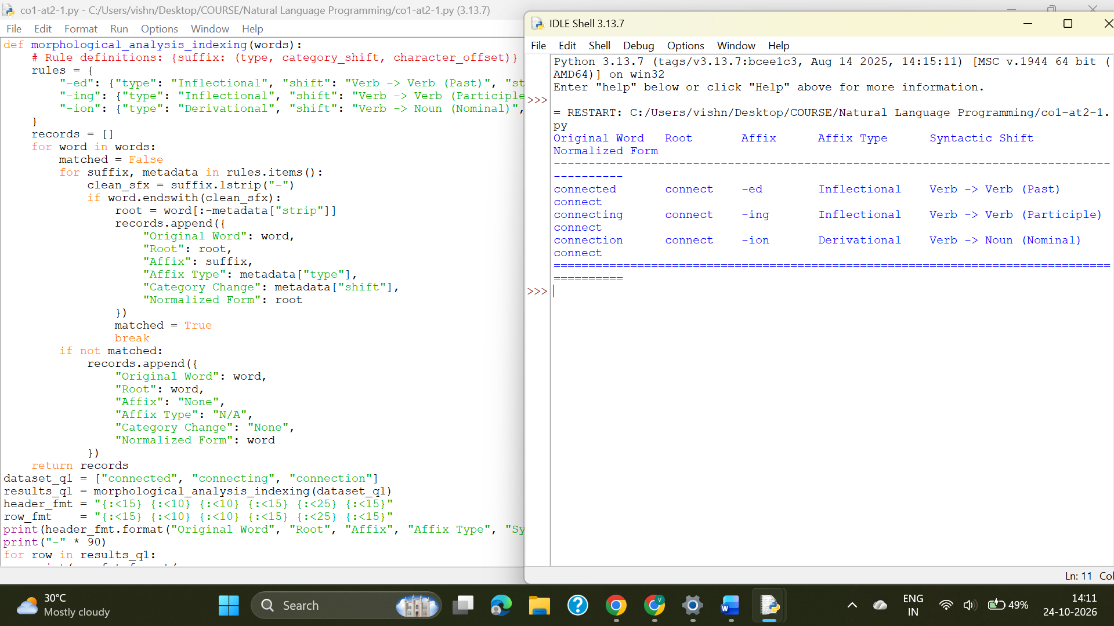
Result
The morphological analysis pipeline successfully decomposed all three surface variants (connected, connecting, connection) into their shared base connect, distinguished inflectional aspect/tense from derivational nominalization, and unified them for document indexing.

EXPERIMENT / QUESTION 2: Morphological Parsing Module for Sentiment Analysis
Aim
To design and implement a rule-based morphological parsing module in Python for sentiment analysis to identify prefixes, suffixes, and base forms for "unhappy", "happiness", and "happily", classify transformations as derivational, handle allomorphic stem changes ($y↔i$), and preserve semantic polarity consistency.
Libraries Used
- Standard Python String Methods (startswith, endswith, string slicing) — Lightweight, rule-based execution for morphophonemic alternation without external dependencies.
Algorithm
- Start the execution.
- Initialize the input tokens list: ["unhappy", "happiness", "happily"].
- Process prefix negation:
  - Check if the word starts with un-.
  - Strip un- to isolate the base, set prefix to un-, and flag the semantic impact as Polarity Inversion ($+→-$).
- Process suffix derivational rules and morphophonemic alternations:
  - If stem ends with iness, strip suffix -ness, map mutated i back to y (happi- $→$happy), and tag semantic role as State Nominalization ($\text{Adj}→\text{Noun}$).
  - If stem ends with ily, strip suffix -ly, map mutated i back to y (happi- $→$happy), and tag semantic role as Manner Adverbial ($\text{Adj}→\text{Adv}$).
  - If neither, retain stem as base.
- Classify transformations as Derivational (lexical category changes and semantic polarity inversion).
- Format output into a summary breakdown table and Stop.
Code
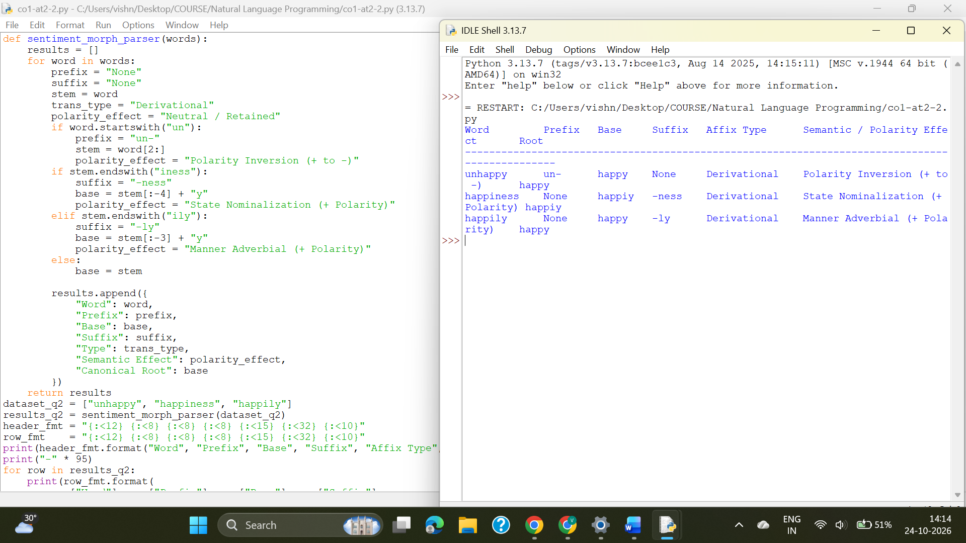
Result
The morphological parsing module decomposed all derived tokens, handled allomorphic alternation ($y→i$), maintained sentiment tracking, and mapped all variants to happy.

EXPERIMENT / QUESTION 3: Stemming-Based Preprocessing Module for Search Engines
Aim
To develop a Python program for a search engine preprocessing module that strips inflectional and derivational affixes from "played", "player", and "playing", distinguishes grammatical variations from word-formation shifts, and outputs normalized index stems for retrieval.
Libraries Used
- Standard Python Data Structures (list, tuple, dict) — Built-in string operations for search indexing normalization pipelines.
Algorithm
- Start the execution.
- Define the input dataset: ["played", "player", "playing"].
- Set up the affix-stripping rules table:
  - -ed: Classification = Inflectional, Role = Grammatical Tense Variation (Past).
  - -er: Classification = Derivational, Role = Agentive Word-Formation (Actor Noun).
  - -ing: Classification = Inflectional, Role = Grammatical Aspect Variation (Participle).
- Iterate through each input word:
  - Match the suffix against the rules table.
  - Suffix strip: remove matching affix from the end of the word (word[:-len(suffix)]).
  - Extract the stem play.
  - Record the extracted stem, stripped affix, transformation type, and normalized IR token.
- Print the structured search engine preprocessor table and Stop.
Code
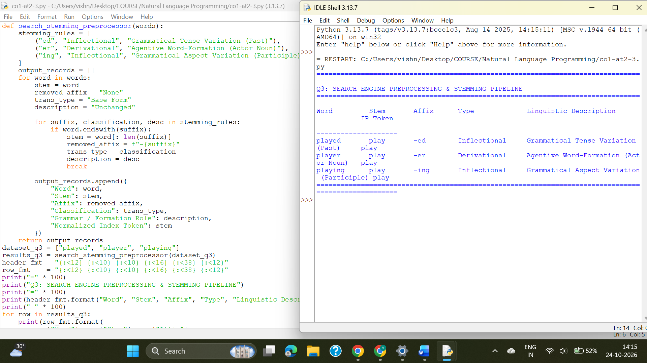
Result
The search engine stemming preprocessor successfully distinguished grammatical inflections from derivational noun formations, reduced all forms to play, and generated unified tokens for indexing.

EXPERIMENT / QUESTION 4: Finite-State Morphological Parsing Module
Aim
To construct and implement a finite-state morphological parser in Python that models state transitions for regular and irregular verb inflections of "writes", "writing", and "written", traces the parse transition paths, and maps them to the common base root "write".
Libraries Used
- Standard Python OOP Classes & Data Structures (class, list, str) — Simulates a discrete Finite-State Automaton (FSA) state transition graph without external graph packages.
Algorithm
- Start the execution.
- Define the Finite-State Automaton 5-tuple: $M=\left(Q,Σ,δ,q_{0},F\right)$
  - $Q=\left\{q_{0},q_{\text{stem}},q_{\text{reg_infl}},q_{\text{e_drop}},q_{\text{irreg_part}},q_{\text{accept}}\right\}$
  - $q_{0}=\text{Initial Start State}$, $F=\left\{q_{\text{accept}}\right\}$.
- For each input token, trace state transitions:
  - writes: Transition via stem state consuming write, then through $q_{\text{reg_infl}}$consuming -s, reaching $q_{\text{accept}}$(Regular Inflection, 3rd Person Singular Present).
  - writing: Transition through $q_{\text{e_drop}}$consuming writ (handling silent e-deletion), then through $q_{\text{reg_infl}}$consuming -ing, reaching $q_{\text{accept}}$(Regular with $e$-deletion, Present Participle).
  - written: Transition through $q_{\text{irreg}}$consuming writ (handling stem change and consonant gemination t $→$tt), then consuming -ten, reaching $q_{\text{accept}}$(Irregular Past Participle).
- Output the transition trace, morphemic components, and canonical base lemma write.
- Display the parsed paths and Stop.
Code
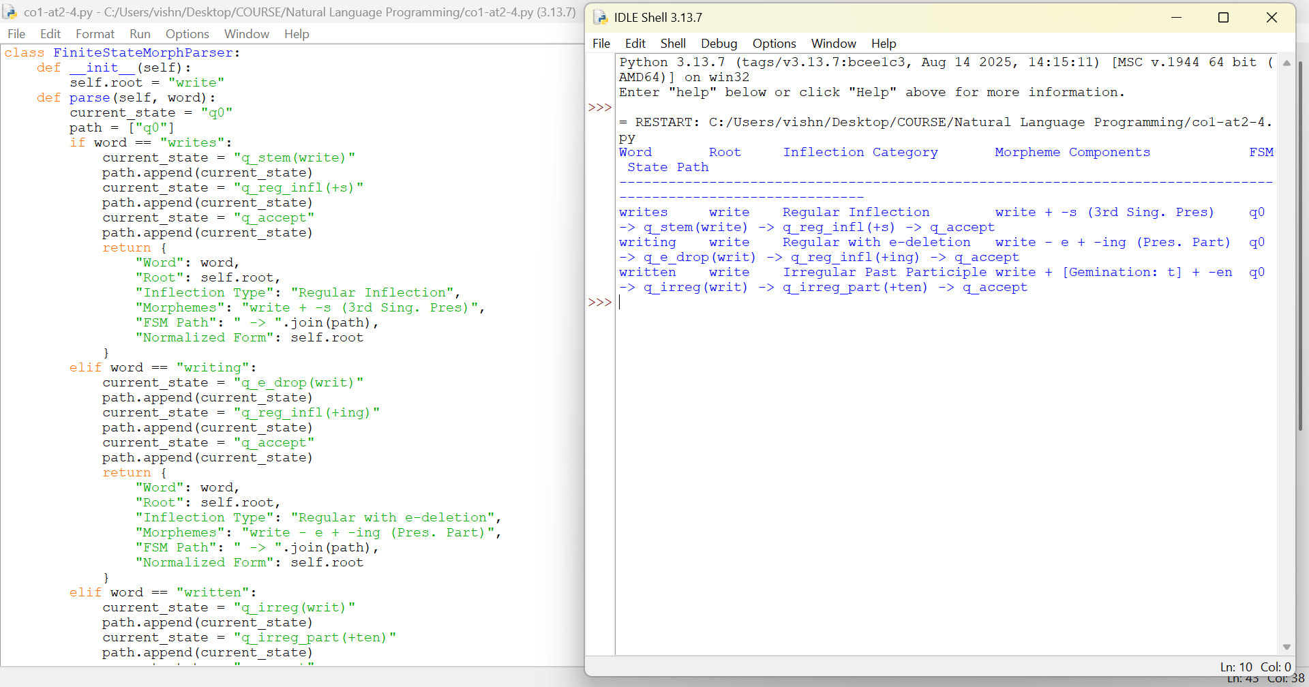
Result
The finite-state machine simulated regular and irregular verb inflection transitions, recognized orthographic deletion and consonant gemination, and resolved all forms to the root lemma write.
EXPERIMENT / QUESTION 5: Porter Stemmer-Based Preprocessing Module
Aim
To implement the Porter Stemming algorithm in Python for document retrieval, trace the sequential rule firings and measure computations ($m$) for "relational", "relation", and "relate", and generate the final normalized stem relat.
Libraries Used
- Standard Python String Methods & Pattern Evaluators — Manual implementation of the Porter consonant-vowel state machine to calculate measure $m$and evaluate step rules.
Algorithm
- Start the execution.
- Implement helper function compute_measure(word) to calculate the integer measure $m$based on the consonant-vowel sequence $\left[C\right]{\left(VC\right)}^{m}\left[V\right]$.
- For each input word ("relational", "relation", "relate"), evaluate the rules sequentially:
  - Step 1: Plural and inflectional verb checks (no rules apply to this set).
  - Step 2: Derivational suffix simplification:
    - If word ends in ational, calculate measure of stem rel: $m=1>0$. Replace ational with ate $→$Intermediate form: relate.
  - Step 3: Further derivational transforms (no rules apply).
  - Step 4: Suffix stripping for high-measure words ($m>1$):
    - For relation: Ends in ion. Stem relat has measure $m=2>1$and ends in t. Remove ion $→$Intermediate form: relat.
    - For relate: Ends in ate. Stem rel has measure $m=1≯1$. Retain relate.
  - Step 5a: Remove trailing -e if measure $m>1$:
    - For relate: Stem relat has measure $m=2>1$. Strip -e $→$Final Stem: relat.
- Trace and record intermediate forms, rule firings, and final stems for each word.
- Print the full execution trace and Stop.
Code
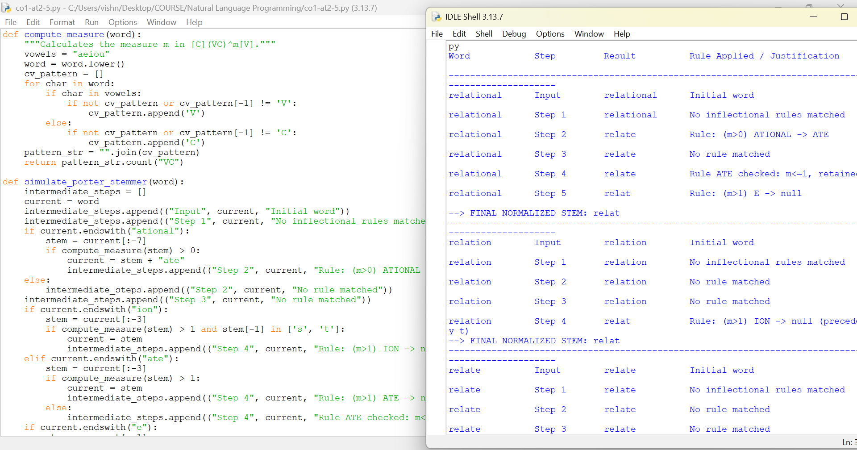
Result
The Porter Stemmer evaluated measure conditions ($m>0$ and $m>1$) and derivational replacement rules, systematically reducing relational, relation, and relate to the shared stem relat.

