https://github.com/VovaBlyzniuk01/vote-app

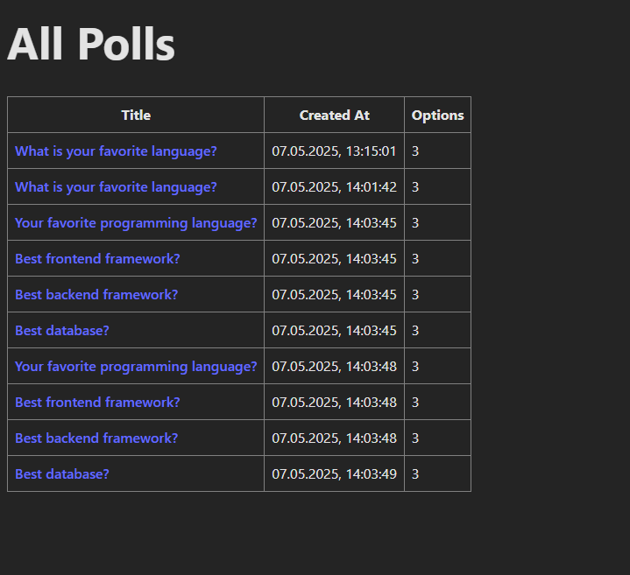

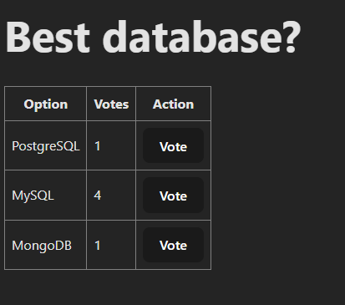

https://github.com/VovaBlyzniuk01/vote-app