https://github.com/VovaBlyzniuk01/vote-app

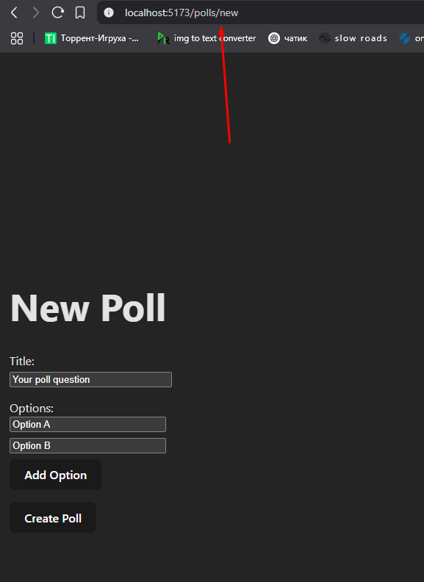

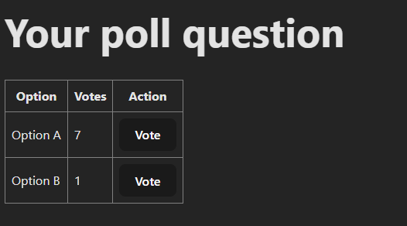

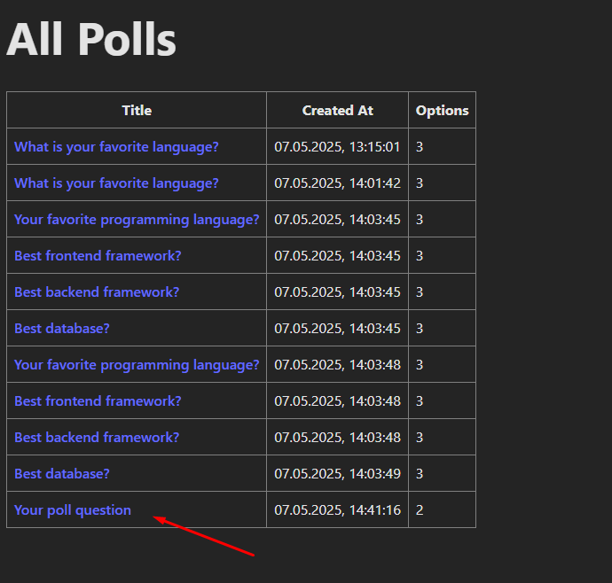

https://github.com/VovaBlyzniuk01/vote-app