Copy Panda rc 5.8 ghz 2.5w:

Summary:
- Rating 2/5
- switch power level don’t work from fc, not always correct work from button
- frequency/channel switch correctly from fc and from button
- measured levels are close to declared levels

OSINT:
- model - vt5804 bat
- https://www.aliexpress.com/i/1005004200851031.html
- https://www.aliexpress.com/item/1005004391674463.html
- https://www.rc-wing.com/pandarc-vtx.html
- https://rcdrone.top/ru/products/pandarc-vt5804
- https://www.youtube.com/watch?v=U8lLyliJzRs
- https://www.youtube.com/watch?v=eyYZdGbk-Bo

Measurements:
Declaration: | Measure: | Comment:
25 mw | 26-34 mw
400 mw |  | Can not select more than 1 try
800 mw | 780 mw
1.5 w |  | Can not select more than 1 try
2.5 w | 2.2-2.4 w

Betaflight Vtx Table:
config - irc trump
vtxtable bands 5
vtxtable channels 8
vtxtable band 1 BAND_A A CUSTOM 5865 5845 5825 5805 5785 5765 5745 5725
vtxtable band 2 BAND_B B CUSTOM 5733 5752 5771 5790 5809 5828 5847 5866
vtxtable band 3 BAND_E E CUSTOM 5705 5685 5665 5665 5885 5905 5905 5905
vtxtable band 4 BAND_F F CUSTOM 5740 5760 5780 5800 5820 5840 5860 5880
vtxtable band 5 BAND_R R CUSTOM 5658 5695 5732 5769 5806 5843 5880 5917
vtxtable powerlevels 5
vtxtable powervalues 25 400 800 1500 2500
vtxtable powerlabels 25 400 800 1W5 2W5

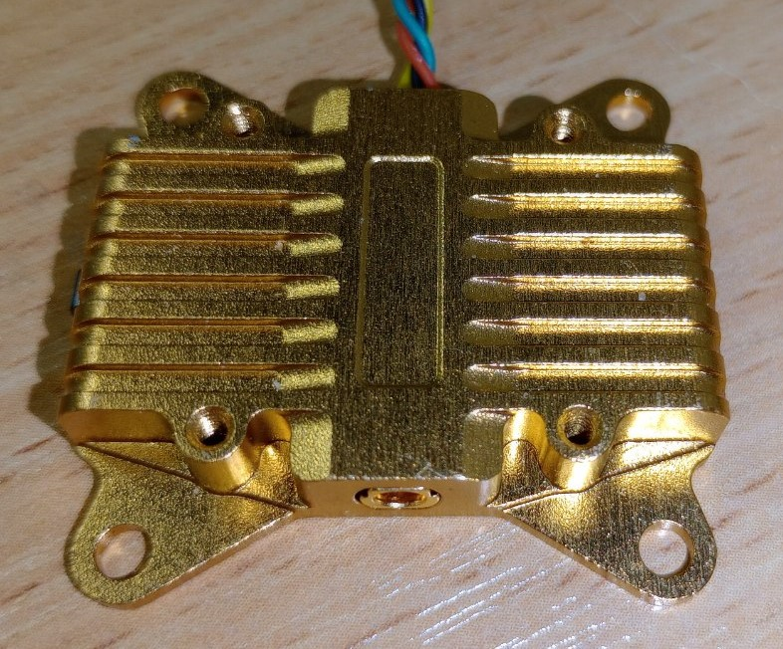
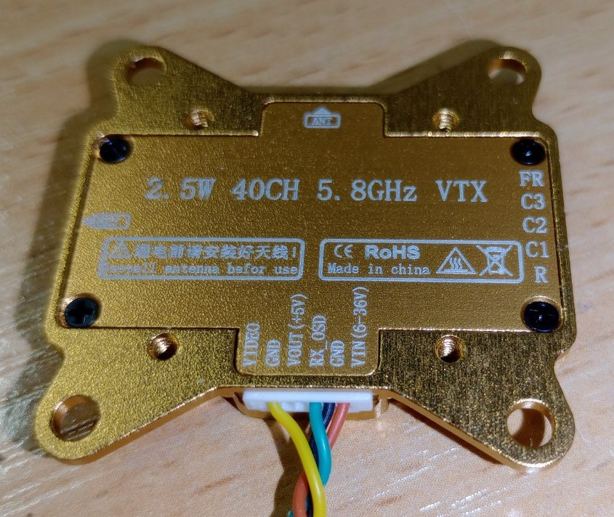
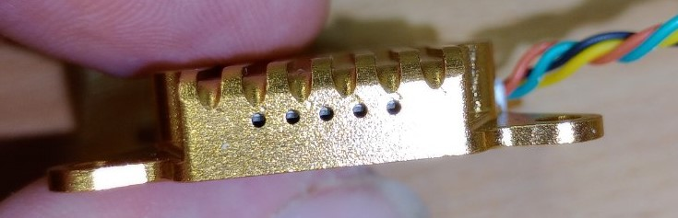
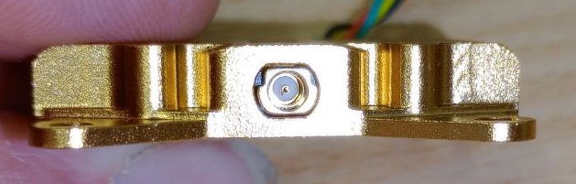
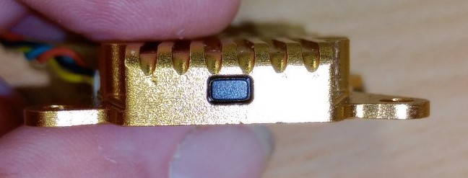

Copy Jaribel/Readytosky 5.8 ghz 3w:

Summary:
- Rating 5/5
- switch power level correctly from fc
- frequency/channel switch correctly from fc and from button
- measured levels are close to declared levels

OSINT:
- Inside RTC6705 chip
- https://www.jaribel.net/ru/products/vtx5g3-3000
- https://manuals.plus/jaribel/yfpv-121221-3w-5-8ghz-fpv-analogue-vtx-manual#axzz8SZ0y2hmB

Measurements:
Declaration: | Measure: | Comment:
25 mw | 28 mw
1 w | 870 mw
2 w | 1720-1950 mw
3 w | 3020 mw

Betaflight Vtx Table:
config - irc trump
vtxtable bands 6
vtxtable channels 8
vtxtable band 1 BAND_A A CUSTOM 5865 5845 5825 5805 5785 5765 5745 5725
vtxtable band 2 BAND_B B CUSTOM 5733 5752 5771 5790 5809 5828 5847 5866
vtxtable band 3 BAND_E E CUSTOM 5705 5685 5665 5645 5885 5905 5925 5945
vtxtable band 4 BAND_F F CUSTOM 5740 5760 5780 5800 5820 5840 5860 5880
vtxtable band 5 BAND_R R CUSTOM 5658 5695 5732 5769 5806 5843 5880 5917
vtxtable band 6 BAND_L L CUSTOM 5362 5399 5436 5473 5510 5547 5584 5621
vtxtable powerlevels 4
vtxtable powervalues 25 1000 2000 3000
vtxtable powerlabels 25 1W 2W 3W

