Part 1: Design and Documentation – Vakioveikkaus Application
1. Interface Design (Wireframe)
The application is designed to be a functional Full Stack tool for generating sports betting rows based on user-defined probabilities.
A) Main View – Generation Screen
This is the primary interface where the user interacts with the generator.
- Header: Titled "Vakioveikkaus".
- Match Input Area: A list of 13 matches with team names and three weight input fields (1, X, 2) for each.
- Row Count Selection: An input field allowing the user to specify the number of rows to generate (range: 1–5000).
- Action Button: A " Ratkaisu " button to process the data.
- Results Area: A display section showing the generated rows in a list format.
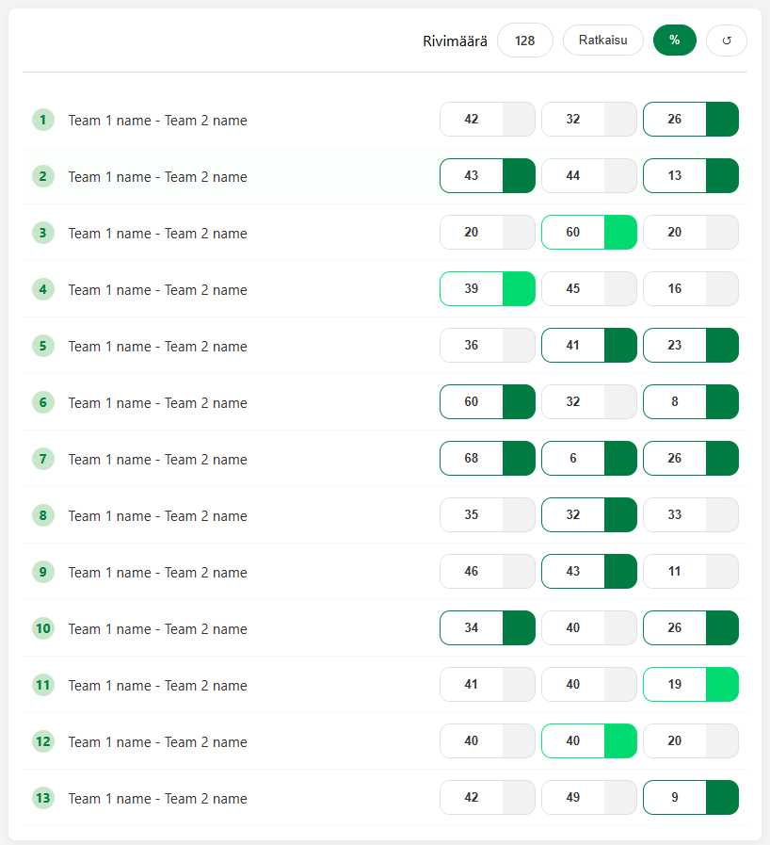 B) History View
This view allows users to browse past results stored in the database.
- Saved Records List: Displays a list of all previously saved generations.
- Metadata: Each entry shows the creation timestamp, the number of rows generated, and a unique identifier (ID).
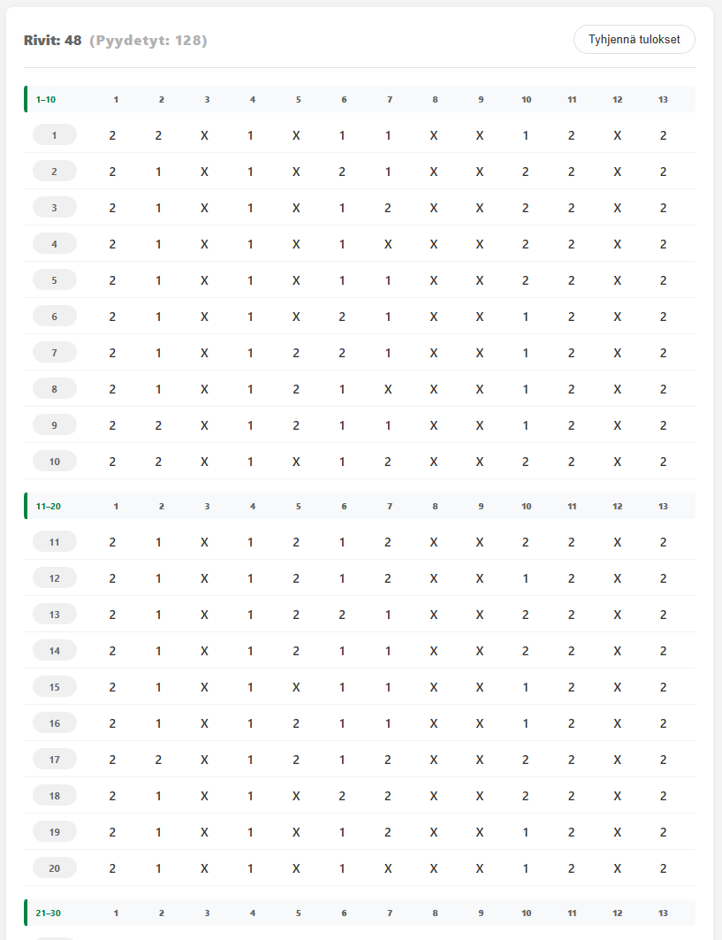
2. User Flow
The application follows a logical step-by-step process for the user:
- Data Entry: The user enters probability weights (1, X, 2) for all 13 matches on the main screen.
- Configuration: The user selects the total number of betting rows they wish to generate.
- Execution: Upon clicking the "Generate" button, the frontend sends the data to the backend.
- Processing & Storage: The backend calculates the rows based on the weights, saves the result to MongoDB Atlas, and sends the rows back to the user.
- Review: The generated rows are instantly displayed on the screen.
- Navigation: The user can switch to the History tab at any time to view older results.

3. Data Design (Backend & Database)
The system architecture ensures seamless data transfer between the client, the server, and the database.
- Frontend to Backend:
  - Sends an object containing the 13 match weight arrays (state and value) and the requested row count.
- Backend to Frontend:
  - Returns the calculated betting rows and a success confirmation.
- Database Storage (MongoDB Atlas):
  - Stores documents containing the generation timestamp, the input weights used, the number of rows, and the actual generated results.
