Resolution Solution
v3000

Contents
Resolution Solution 1
Contents 2
Explanation of terms 3
Variables 4
rs.scale_mode 5
1 – Aspect Scaling 6
2 – Stretch Scaling 9
3 – Pixel Perfect Scaling 10
rs.scale_width [number], rs.scale_height [number] 12
rs.game_width [number], rs.game_height [number] 13
rs.x_offset [number], rs.y_offset [number] 15
rs.game_zone [table] 17
Functions 18
rs.get_game_zone() 19
rs.get_game_size() 20
rs.setMode(width: number, height: number, flags: table) 21
rs.updateMode(width: number, height: number, flags: table) 22
rs.debug_info(x: number [optional], y: number[optional]) 23
rs.resize() 25
rs.resize_callback() 26
rs.push() 27
rs.pop() 28
rs.get_both_scales() 29
rs.is_it_inside() 30
rs.to_game(x: number, y: number) 33
rs.to_window(x: number, y: number) 35
Tips and Tricks 37
Changelog 40
v1000, 7 January 2021 41
v1001, 6 February 2022 42
v1002, 8 February 2022 43
v1003, 12 February 2022 44
v1004, 19 May 2022 45
v1005, 19 May 2022 46
v1006, 20 May 2022 47
v2000, 27 December 2022 48
v2001, 31 December 2022 50
v3000, 30 August 2023 52

Explanation of terms
- Game size / resolution / game content / virtual size - the size of the game that was intended by the software developer (you).
- Window - the game is rendered to a window. The window can be resized by the user to be larger or smaller than the intended size of the game. Some platforms use different terms, but it is the object the game is rendered to.
- rs table - the Resolution Solution table that is exposed by this library. Many settings and values can be accessed via rs functions but they can also be set directly in the rs table. This manual uses "rs table" meaning the table provided by this library.
Example:
rs.scale_mode = 2
- Aspect / aspect ratio - means the size of the game compared to the size of the window as a ratio. Example: a game of 800 x 600 that is rendered in a window that is 1600 x 1200 has an aspect ratio 2:1.

Variables

rs.scale_mode
- Type: number
  - Possible values:
    - Aspect Scaling
    - Stretch Scaling
    - Pixel Perfect Scaling
- Default value: 1
A setting that tells the library how it should scale the game to the window.
To change this setting, use the rs.conf() function.

For advanced users:
If you manually change this setting (rs.scale_mode) directly from the table then you need to call rs.resize() immediately after that to update the library.
Example:
rs.scale_mode = 2
rs.resize()

1 – Aspect Scaling
Aspect scaling will ensure rs.scale_width and rs.scale_height have the same value so images look proportional and not skewed.
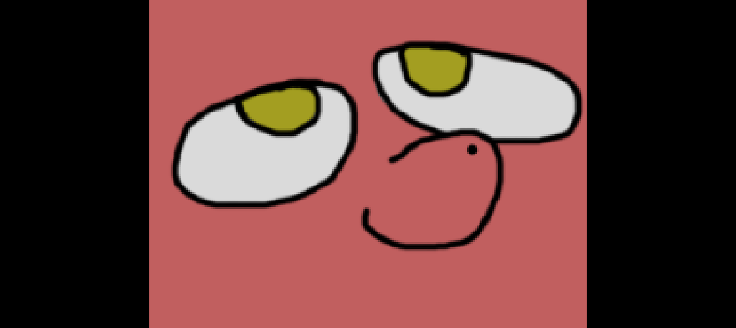
If the window is wider than the game width then the library will draw bars on the left and right side of the window.
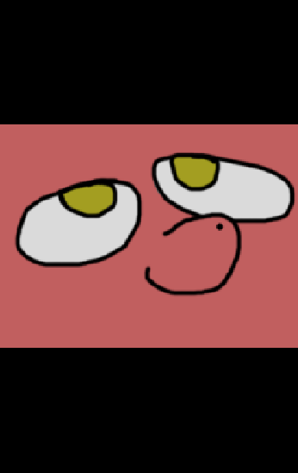
If the window is taller than the game height then the black bars will be drawn on the top and bottom.
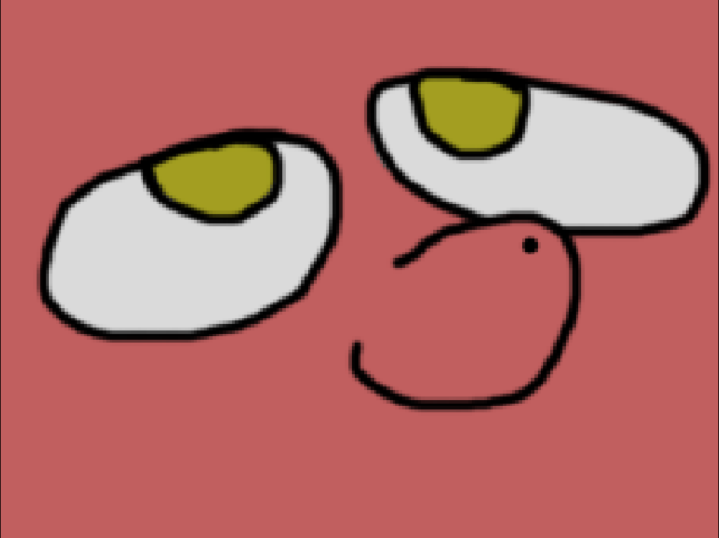
If game aspect and window aspect same, then there will be no visual black bars.
This mode might be best when graphical assets need to remain proportional. Assets that include vector, hand-drawn, 3D etc might look best with this setting. Pixel art might look best with setting 3.

2 – Stretch Scaling
Game content will be scaled to fill the entire window even if it skews the game content.
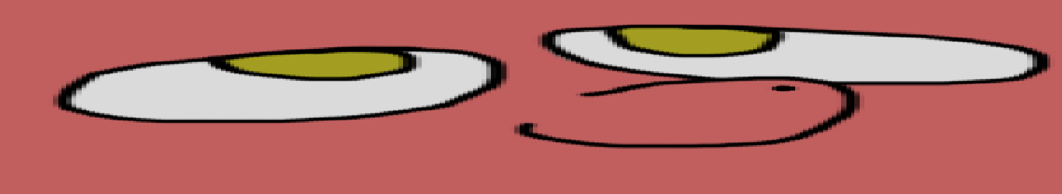
The game might look funny when the window is larger than the game.
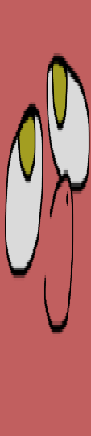
The game might look funny when the window is larger than the game.
Aspect scaling will never display black bars might give strange results.

3 – Pixel Perfect Scaling
As was mentioned before, Pixel Perfect scaling is perfectly suited for games with pixel-art.
It will make sure, that calculations result in number scaling value (1, 2, 3, …) with minimal value being 1. It will floor down scale value to achieve this. So, if scale value turns out to be 1.7, it will be floored to 1, or floored to 2 if scale is 2.3. It will guaranty, that your game content will stays as crisp as possible, and there will be no pixel bleeding.
The downside is, however, that this mode will produce 4 black bars on 4 sides of window, game and window aspect doesn't result in integer value:
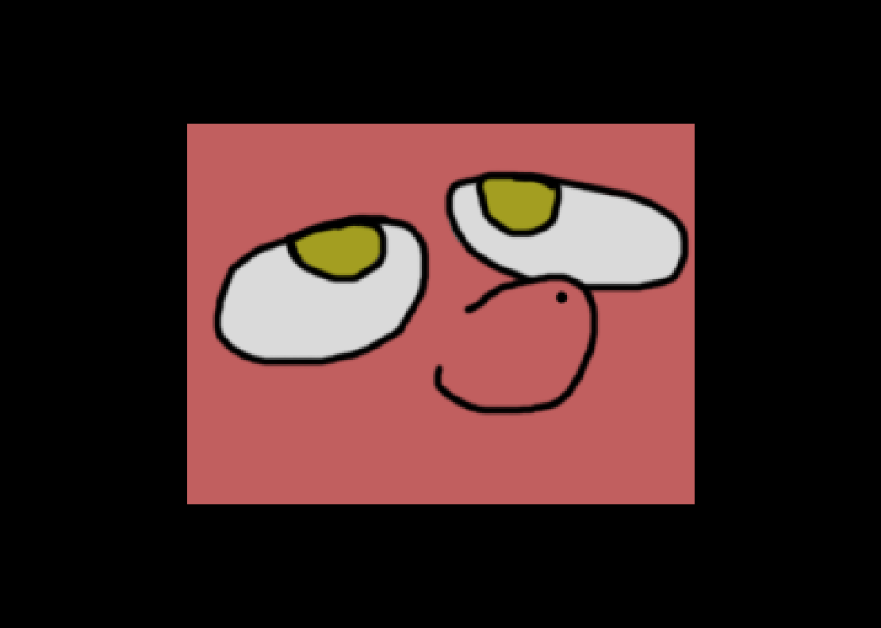
Game size is 640x480, while window size is 1111x792, which resulted in scale value being 1 and 4 black bars. If window was at least 1280x960, scale value would have been 2.
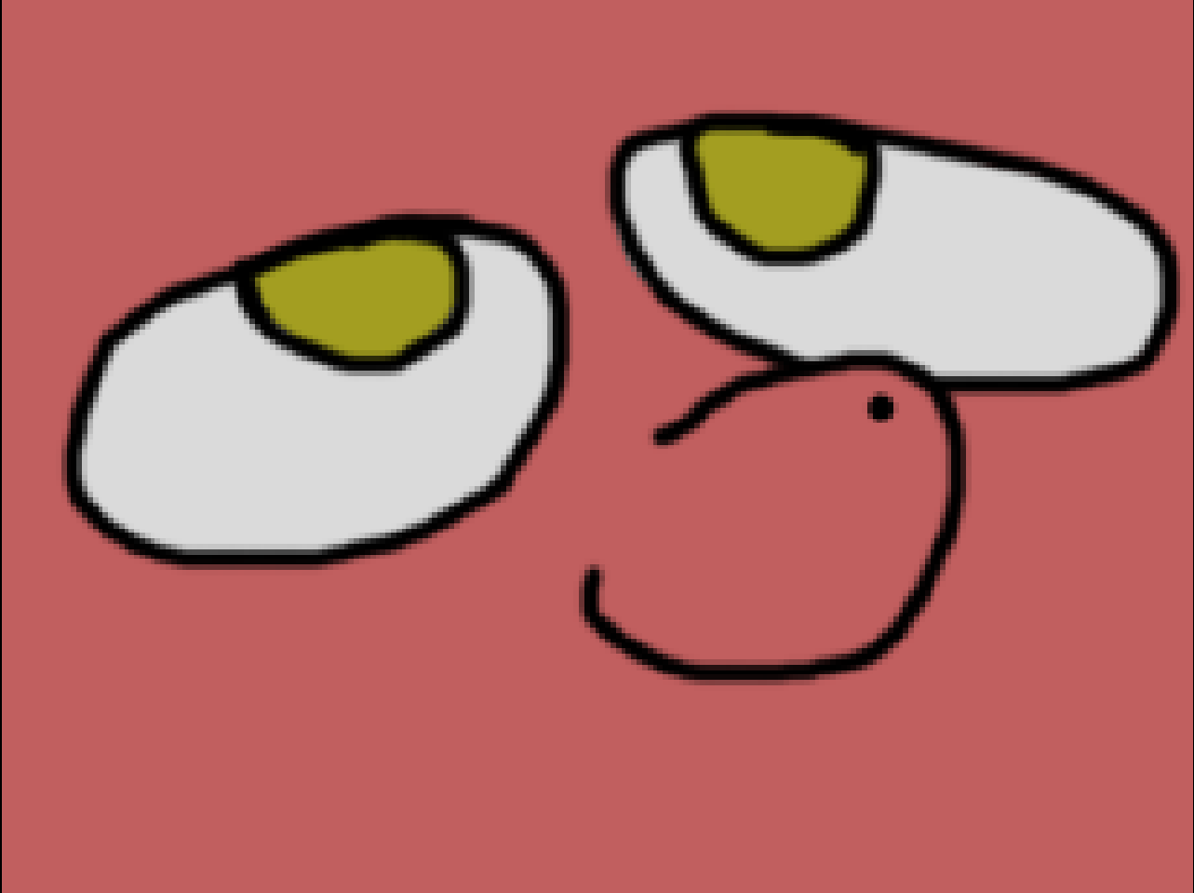
1280x960 window, 640x480 game produced scale 2.

rs.scale_width [number], rs.scale_height [number]
- rs.scale_width
  - Type: number.
- rs.scale_height
  - Type: number.
- Default values: will be calculated on first rs.resize() call.
This 2 values is result of calculations between virtual/game size and window size to fit game content on window no matter which size it has (with exception with 3rd scale mode – Pixel Perfect – where if window smaller then game width and height then parts of game content will be simple not visible). This values will be calculated differently, depending on scale mode that you use.
In mode 1 and 3, rs.scale_width and rs.scale_height have same value, because there scaling same for width and height. In mode 2, width and height scaling is 2 independent values.
Changing this value manually will break library calculations, since this value intended to be updated via rs.resize() or built-in functions that relies on rs.resize() because this is read-only value that you can use in your own calculations if they somehow relies on scaling data.
You can use rs.get_both_scales() to get both rs.scale_width and rs.scale_height at same time.

rs.game_width [number], rs.game_height [number]
- rs.game_width
  - Type: number.
  - Default: 800
- rs.game_height
  - Type: number.
  - Default: 600
This is width and height values, that library will scale game to. They represent “resolution” of your game – amount of content/information that can be visible on screen.
You can get both rs.game_width and rs.game_height in single function call via rs.get_game_size()
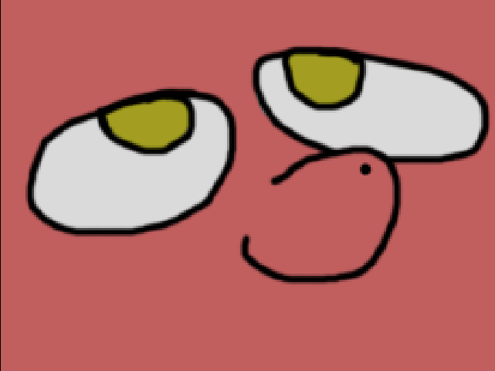
Game with 640x480 resolution/game size. Image has same size, so it 100% fits game resolution.
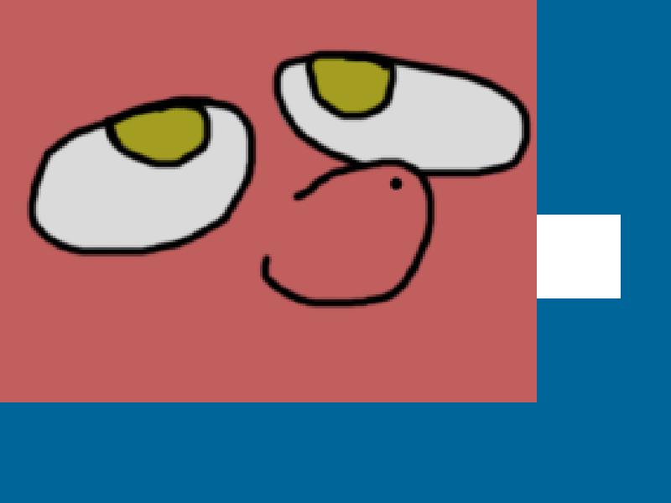
Now game is 800x600, but image still 640x480. It doesn't fit game screen anymore and now you can see white rectangle that was outside of 640x480 boundaries.
As you can see, while this library takes care about scaling your game, you still need to design and implement yourself different resolutions (If you wants/can implement this, of course). For example, that if someone would play game in 800x600 they should be able to see important parts of level (such as enemies, bosses, items, etc) same way as someone who would play with 1920x1080, or, at least, provide some ways to tell player that on that part of level that player can’t see on 640x480 resolutions is something interesting (for example, place NPC that would tell player “hey, did you know that there something interesting lies? Go ahead and check!”).

rs.x_offset [number], rs.y_offset [number]
  - rs.x_offset
    - Type: number.
  - rs.y_offset
    - Type: number.
- Default values: will be calculated on first rs.resize() call.
This variables represent offset values that library generates to insert game inside window according to scaling mode. In scaling mode 2 there will be no offsets since game will fill entire window.
Visualization:
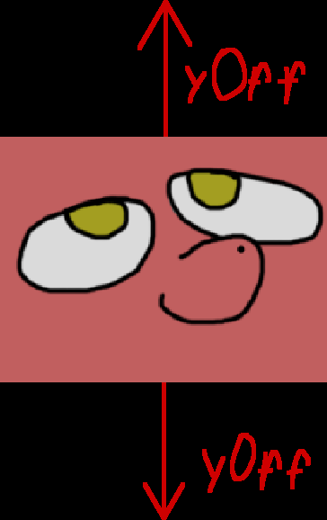
When window taller then game.
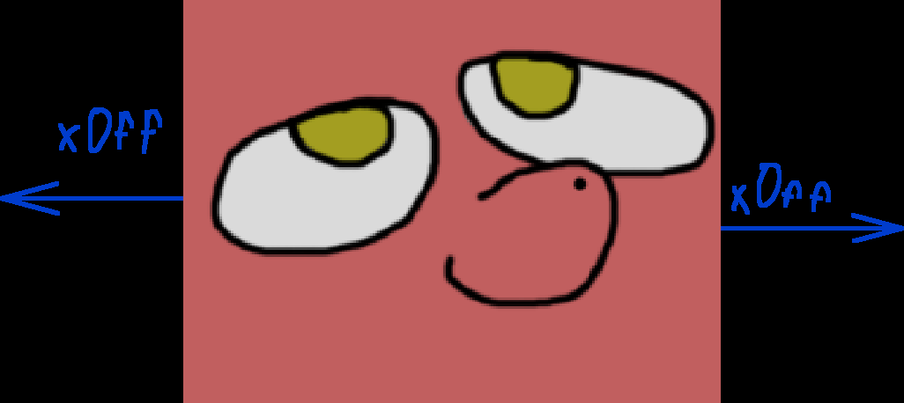
When window wider then game.
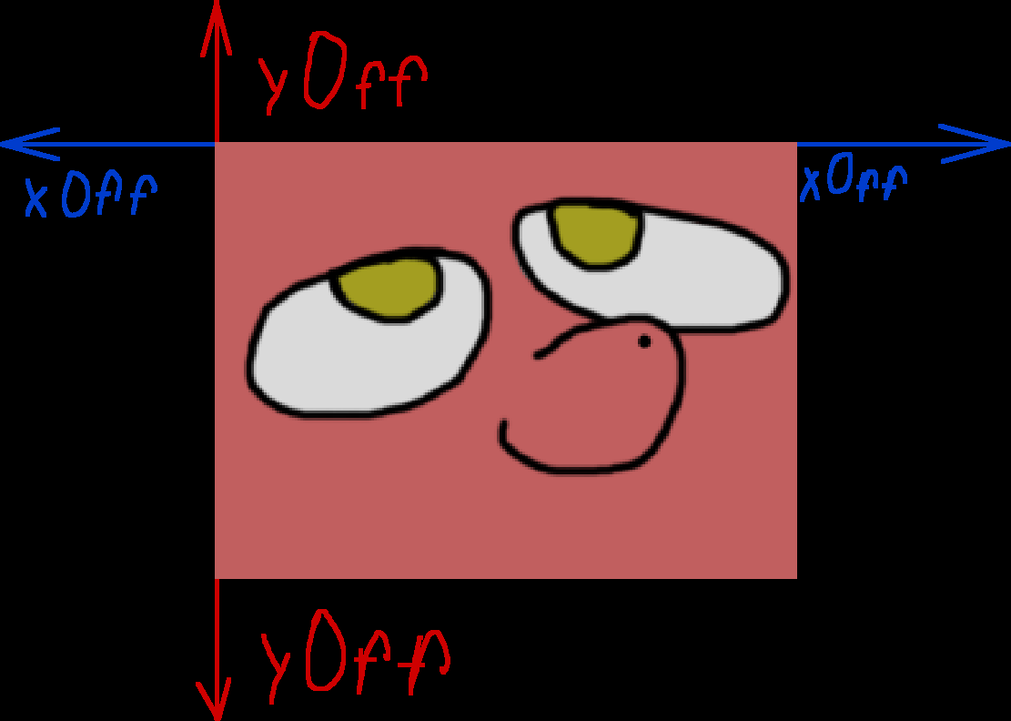
In scale mode 3 you would get both horizontal and vertical offsets.

rs.game_zone [table]
- Type: table.
  - Table contains:
    - x — X coordinate of top-left corner of game zone.
      - Type: number.
    - y — Y coordinate of top-left corner of game zone.
      - Type: number.
    - w — width of game zone.
      - Type: number.
    - h — height of game zone.
      - Type: number.
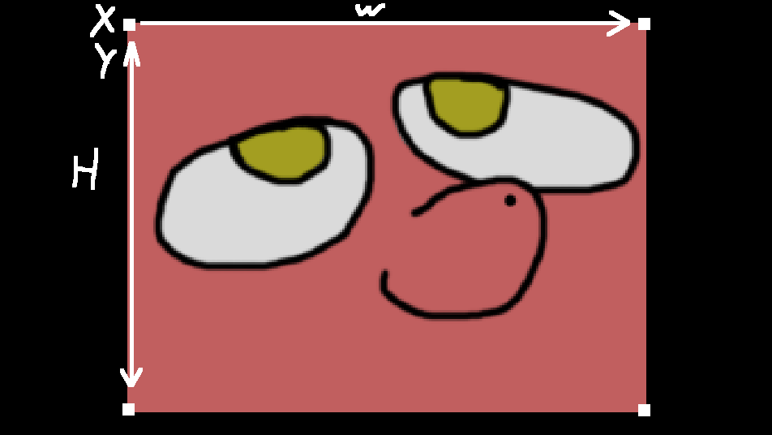
X and Y is top-left corner.
W – Width.
H – Height.
This table contains coordinates for game zone – zone inside black bars, what you can see on screen.

Functions

rs.get_game_zone()
- Arguments: none.
- Returns:
  - x
    - Type: number.
    - X coordinate of top-left point of game zone.
  - y
    - Type: number.
    - Y coordinate of top-left point of game zone.
  - width
    - Type: number.
    - Width of game zone.
  - height
    - Type: number.
    - Height of game zone.
Shortcut function, that would return data of game zone. If you need to get individual values, get them directly from: rs.game_zone.x, rs.game_zone.y, rs.game_zone.w, rs.game_zone.h.
For more info look for rs.game_zone.
Example:
local x, y, w, h = rs.get_game_zone()

rs.get_game_size()
- Arguments: none.
- Returns:
  - rs.game_width
    - Type: number.
  - rs.game_height
    - Type: number.
Shortcut function, that would return both rs.game_width and rs.game_height. For more info look for rs.game_width and rs.game_height.
Example:
-- Basic usage.
local game_width, game_height = rs.get_game_size()

rs.setMode(width: number, height: number, flags: table)
- Arguments:
  - width
    - Type: number.
  - height
    - Type: number.
  - flags
    - Type: table.
- Returns: nothing.
This function is wrapper for love.window.setMode() that you should use with this library.
Wiki page for for love.window.setMode(): https://love2d.org/wiki/love.window.setMode

For advanced users:
-- This wrapper function equivalent of doing this:
love.window.setMode(width, height, flags)
rs.resize()

Example:
-- Basic usage.
rs = require("resolution_solution")
rs.conf({
game_width = 800,
game_height = 600,
scale_mode = 3})
-- We want to create game with 800x600 resolution
-- But we also want to change window size to be same as game.
-- To achieve this, we can do...
rs.setMode(rs.get_game_size(), select(3, love.window.getMode()))
-- Done, now we initialized game with 800x600 game size and resized window to be same as game width and height.

rs.updateMode(width: number, height: number, flags: table)
- Arguments:
  - width
    - Type: number.
  - height
    - Type: number.
  - flags
    - Type: table.
- Returns: nothing.
This function is wrapper for love.window.updateMode() that you should use with this library.
Wiki page for for love.window.updateMode(): https://love2d.org/wiki/love.window.updateMode

For advanced users:
-- This wrapper function equivalent of doing this:
love.window.updateMode(width, height, flags)
rs.resize()

Example:
-- Basic usage.
rs = require("resolution_solution")
rs.conf({
game_width = 800,
game_height = 600,
scale_mode = 3})
-- We want to create game with 800x600 resolution
-- But we also want to change window size to be same as game.
-- To achieve this, we can do...
rs.updateMode(rs.get_game_size())
-- Done, now we initialized game with 800x600 game size and resized window to be same as game width and height.

rs.debug_info(x: number [optional], y: number[optional])
- Arguments:
  - x
    - type: number.
    - If you pass nothing or nil, then it will same as if you pass 0.
  - y
    - type: number.
    - If you pass nothing or nil, then it will same as if you pass 0.
- Returns: nothing.
Basis debug function, that would show info about some states of library. Can be placed somewhere on screen. Calling rs.debug_info() without arguments is equivalent of calling rs.debug_info(0, 0), which would place debug window in top-left corner of window.
If you need more advanced debugging, you better to write own solution or use another debugging library / tool.
List of information that function shows:
  - Library name
  - Library version
  - rs.game_width
  - rs.game_height
  - rs.scale_width
  - rs.scale_height
  - rs.scale_mode
  - rs.x_offset
  - rs.y_offset
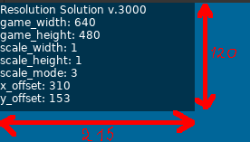
Currently, size of debug window is: width 215, height 120.
Examples:
-- Example drawing this debug window on top-right corner in-between rs.push() and rs.pop()
local rs = require("resolution_solution")
rs.conf({
game_width = 640,
game_height = 480,
scale_mode = 1
})
love.graphics.setBackgroundColor(0.3, 0.5, 1)
rs.setMode(rs.game_width, rs.game_height, {resizable = true})

local game_canvas = love.graphics.newCanvas(rs.get_game_size())

love.resize = function()
rs.resize()
end

love.draw = function()
love.graphics.setCanvas(game_canvas)
love.graphics.clear(0, 0, 0, 1)
love.graphics.setColor(1, 1, 1, 1)
love.graphics.setCanvas()

rs.push()
love.graphics.draw(game_canvas)
rs.debug_info(rs.game_width - 215)
rs.pop()
end

rs.resize()
- Arguments: none.
- Returns: nothing.
Function that update library. In normal circumstances, you need to place it inside love.resize() w, h) function, pass it’s arguments and never touch again.
Example:
local rs = require("resolution_solution")
rs.conf({
game_width = 640,
game_height = 480,
scale_mode = 1
})
love.graphics.setBackgroundColor(0.3, 0.5, 1)
rs.setMode(rs.game_width, rs.game_height, {resizable = true})

local game_canvas = love.graphics.newCanvas(rs.get_game_size())

love.resize = function()
rs.resize()
end

love.draw = function()
love.graphics.setCanvas(game_canvas)
love.graphics.clear(0, 0, 0, 1)
love.graphics.setColor(1, 1, 1, 1)
love.graphics.setCanvas()

rs.push()
love.graphics.draw(game_canvas)
rs.pop()
end

rs.resize_callback()
- Arguments: none.
- Returns: nothing.
Simple function, that will be called every time, when rs.resize() is called. Note, that rs.resize_callback() will be called after rs.resize() would finish updating library.
This function can be useful, if you need to hook into library and, for example, re-scale UI. To do so, you need to replace rs.resize_callback() and fill it with something that you need.
Note: once you setup this function, you might want to immediately call itself to calculate data that depended on it.

Example:
local rs = require("resolution_solution")
rs.conf({
game_width = 640,
game_height = 480,
scale_mode = 1
})
love.graphics.setBackgroundColor(0.3, 0.5, 1)
rs.setMode(rs.game_width, rs.game_height, {resizable = true})

local game_canvas = love.graphics.newCanvas(rs.get_game_size())

love.resize = function()
rs.resize()
end

rs.resize_callback = function()
print("Library was resized!")
end

love.draw = function()
love.graphics.setCanvas(game_canvas)
love.graphics.clear(0, 0, 0, 1)
love.graphics.setColor(1, 1, 1, 1)
love.graphics.setCanvas()

rs.push()
love.graphics.draw(game_canvas)
rs.pop()
end

rs.push()
- Arguments: none.
- Returns: nothing.
Function that would actually start scaling your game. Don’t forget to check rs.pop().
Example:
-- Basic usage
local rs = require("resolution_solution")
rs.conf({
game_width = 640,
game_height = 480,
scale_mode = 1
})
love.graphics.setBackgroundColor(0.3, 0.5, 1)
rs.setMode(rs.game_width, rs.game_height, {resizable = true})

local game_canvas = love.graphics.newCanvas(rs.get_game_size())

love.resize = function()
rs.resize()
end

love.draw = function()
love.graphics.setCanvas(game_canvas)
love.graphics.clear(0, 0, 0, 1)
love.graphics.setColor(1, 1, 1, 1)
love.graphics.setCanvas()

rs.push()
love.graphics.draw(game_canvas)
rs.pop()
end

rs.pop()
- Arguments: none.
- Returns: nothing.
Function that closes rs.push(). For more info look for rs.push().
Example:
local rs = require("resolution_solution")
rs.conf({
game_width = 640,
game_height = 480,
scale_mode = 1
})
love.graphics.setBackgroundColor(0.3, 0.5, 1)
rs.setMode(rs.game_width, rs.game_height, {resizable = true})

local game_canvas = love.graphics.newCanvas(rs.get_game_size())

love.resize = function()
rs.resize()
end

love.draw = function()
love.graphics.setCanvas(game_canvas)
love.graphics.clear(0, 0, 0, 1)
love.graphics.setColor(1, 1, 1, 1)
love.graphics.setCanvas()

rs.push()
love.graphics.draw(game_canvas)
rs.pop()
end

rs.get_both_scales()
- Arguments: none.
- Returns:
  - rs.scale_width
    - Type: number.
  - rs.scale_height
    - Type: number.
Shortcut function, that would return both rs.scale_width and rs.scale_height.
Example:
-- Basic usage.
local x_scale, y_scale = rs.get_both_scales()

rs.is_it_inside()
- Arguments: none.
- Returns:
  - is mouse inside game zone
    - Type: boolean.
    - Returns true if cursor inside game zone.
    - Returns false if cursor outside of game zone.
Function to determine if given coordinates inside game zone (for more info about look for rs.game_zone). You might need it, if you develop game with support of mouse/touchscreen, because you, usually, don’t want to trigger buttons (or any other similar element that you can interact with via cursor) if they behind black bars.
Here quick visualization:
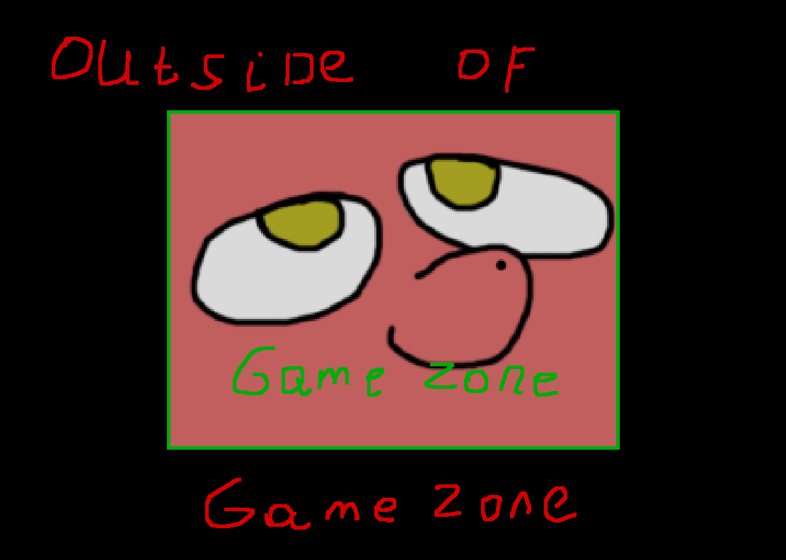
Quick reminder what considered “game zone” and what “outside of game zone”.
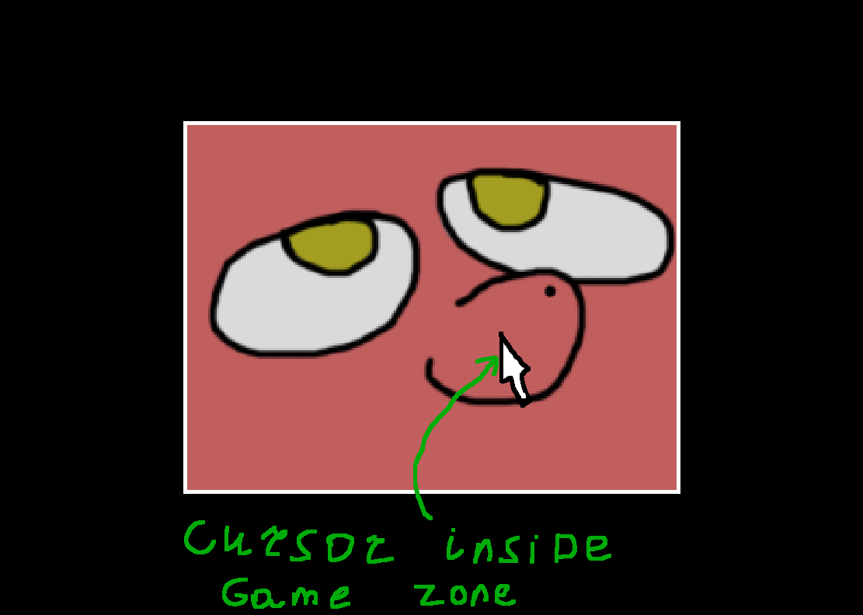
Cursor inside game zone, so rs.is_it_inside(love.mouse.getPosition()) will return true.
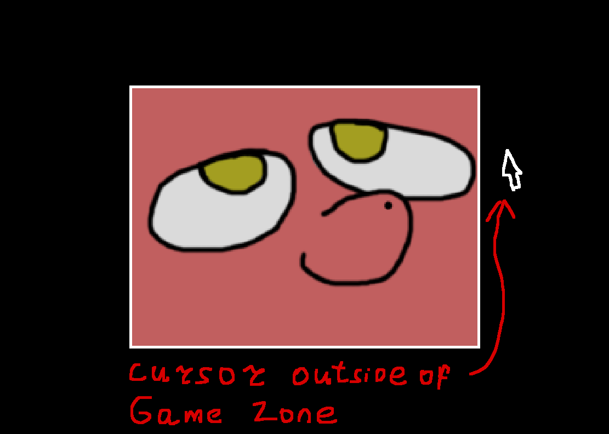
Cursor outside of game zone, so rs.is_it_inside(love.mouse.getPosition()) will return false.

This especially useful, if you develop game with scrolling/camera, like Real-Time Strategies, because you might move camera in that way, that hit-box of units will be behind where black bars and you don’t want game to pick this unit, since user cannot see them!
When scale mode == 2 (Stretch Scaling), then this function will always return true, because there no black bars at all.
Example:
-- Basic usage.
local rs = require("resolution_solution")
rs.conf({
game_width = 640,
game_height = 480,
scale_mode = 1
})
love.graphics.setBackgroundColor(0.3, 0.5, 1)
rs.setMode(rs.game_width, rs.game_height, {resizable = true})

local game_canvas = love.graphics.newCanvas(rs.get_game_size())

local is_inside = false

love.load = function()
image = love.graphics.newImage("image.png")
end

love.resize = function()
rs.resize()
end

love.update = function()
is_inside = rs.is_it_inside(love.mouse.getPosition())
end

love.draw = function()
love.graphics.setCanvas(game_canvas)
love.graphics.clear(0, 0, 0, 1)

if is_inside then
love.graphics.setColor(0, 1, 0, 1)
love.graphics.print("Cursor inside game zone.", rs.game_width / 2, rs.game_height / 2)
else
love.graphics.setColor(1, 0, 0, 1)
love.graphics.print("Cursor outside game zone.", rs.game_width / 2, rs.game_height / 2)
end

love.graphics.setColor(1, 1, 1, 1)
love.graphics.setCanvas()

rs.push()
love.graphics.draw(game_canvas)
rs.pop()
end

rs.to_game(x: number, y: number)
Arguments:
  - x
    - Type: number.
  - y
    - Type: number.
Returns:
  - scaled to game X
- Type: number.
  - Scaled to game Y
    - Type: number.
Function to translate coordinates from window to game game zone. This can be used to translate cursor coordinates so you can check collision of object inside game zone.
If you pass arguments like this: rs.to_game(x) then function would return only scaled x value.
scaled_X = rs.to_game(x)
If you pass like this rs.to_game(nil, y) then function would return only scaled y.
scaled_y = rs.to_game(nil, y)
If you pass both arguments rs.to_game(x, y) then function would return both x and y.
scaled_x, scaled_y = rs.to_game(x, y)
Example:
local rs = require("resolution_solution")
rs.conf({
game_width = 640,
game_height = 480,
scale_mode = 1
})
love.graphics.setBackgroundColor(0.3, 0.5, 1)
rs.setMode(rs.game_width, rs.game_height, {resizable = true})

local game_canvas = love.graphics.newCanvas(rs.get_game_size())

local is_touching = false
local rectangle = {x = 200, y = 200, w = 100, h = 100}

love.resize = function()
rs.resize()
end

love.update = function()
-- Get cursor position.
local mx, my = love.mouse.getPosition()

-- Translate it to game.
mx, my = rs.to_game(mx, my)
if mx >= rectangle.x and -- left
my >= rectangle.y and -- top
mx <= rectangle.x + rectangle.w and -- right
my <= rectangle.y + rectangle.h then -- bottom
is_touching = true
else
is_touching = false
end
end

love.draw = function()
love.graphics.setCanvas(game_canvas)
love.graphics.clear(0, 0, 0, 1)
love.graphics.setColor(1, 1, 1, 1)

if is_touching then
-- Green color, means that we touch rectangle.
love.graphics.setColor(0, 1, 0, 1)
else
-- Red color, means that we don't touch rectangle.
love.graphics.setColor(1, 0, 0, 1)
end

love.graphics.rectangle("line", rectangle.x, rectangle.y, rectangle.w, rectangle.h)

love.graphics.setCanvas()

rs.push()
love.graphics.draw(game_canvas)
rs.pop()
end

rs.to_window(x: number, y: number)
Arguments:
- x
    - Type: number.
- y
    - Type: number.
Returns:
- scaled from game to window X
- Type: number.
- Scaled from game to window Y
    - Type: number.
Function similar to rs.to_game() but reversed: it translated coordinates from game to window. For example, if you want to teleport cursor on object that inside game zone.
If you pass arguments like this: rs.to_window(x) then function would return only scaled x value.
x = rs.to_window(scaled_x)
If you pass like this rs.to_window(nil, y) then function would return only scaled y.
y = rs.to_window(nil, scaled_y)
If you pass both arguments rs.to_window(x, y) then function would return both x and y.
x, y = rs.to_window(scaled_x, scaled_y)
Example:
-- Basic example.
-- Press left button of mouse to teleport cursor to center or rectangle
-- that you can see in center of window.
-- Note: might not work if you use Linux with Wayland.
local rs = require("resolution_solution")
rs.conf({
game_width = 640,
game_height = 480,
scale_mode = 1
})
love.graphics.setBackgroundColor(0.3, 0.5, 1)
rs.setMode(rs.game_width, rs.game_height, {resizable = true})

local game_canvas = love.graphics.newCanvas(rs.get_game_size())

love.resize = function()
rs.resize()
end

love.mousepressed = function(x, y, button)
if button == 1 then
love.mouse.setPosition(
rs.toScreen(
(rs.game_width / 2), -- Translate X.
(rs.game_height / 2) -- Translate y.
)
)
end
end

love.draw = function()
love.graphics.setCanvas(game_canvas)
love.graphics.clear(0, 0, 0, 1)
love.graphics.setColor(1, 1, 1, 1)
-- Place 100x100 rectangle in center of game zone.
love.graphics.rectangle("line", (rs.game_width / 2) - 50, (rs.game_height / 2) - 50, 100, 100)
love.graphics.rectangle("line", (rs.game_width / 2) - 4, (rs.game_height / 2) - 4, 4, 4)
love.graphics.setCanvas()

rs.push()
love.graphics.draw(game_canvas)
rs.pop()
end

Tips and Tricks
This is collection of code snippets and example of useful thing that you could do using this library.
- How to ditch using canvas and use love.graphics.setScissor() instead for hiding content behind bars:
local rs = require("resolution_solution")
rs.conf({
game_width = 640,
game_height = 480,
scale_mode = 1
})
love.graphics.setBackgroundColor(0.3, 0.5, 1)
rs.setMode(rs.game_width, rs.game_height, {resizable = true})

love.resize = function()
rs.resize()
end

love.draw = function()
rs.push()
local old_x, old_y, old_w, old_h = love.graphics.getScissor()
love.graphics.setScissor(rs.get_game_zone())
love.graphics.setColor(0, 0.3, 1)
love.graphics.rectangle("fill", 0, 0, rs.game_width, rs.game_height)
love.graphics.setScissor(old_x, old_y, old_w, old_h)
rs.pop()
end

- How to get resolution of screen on which window with game placed. Just keep in mind, that there people who uses their system with several monitors.
So for example, if user have 2 monitors: 1 is 1366x768; 2 is 1920x1080. If you would try this:
width, height = love.window.getDesktopDimensions(1)
You would make annoying (to user) mistake, because user might place game window on 2nd monitor, so game would get 1366x768 instead of 1920x1080 that user might expected.
So, instead do this:
width, height = love.window.getDesktopDimensions(
select(3, love.window.getMode()).display)
This function would get index of screen on which game window and placed and pass it, so now game will correctly get 1920x1080 if it placed on 2nd monitor and 1366x768 if on 1st.

- How to scale UI outside of rs.push() and rs.pop() for crispy text and other elements.
local rs = require("resolution_solution")
rs.conf({
game_width = 640,
game_height = 480,
scale_mode = 1
})
love.graphics.setBackgroundColor(0, 0, 0)
rs.setMode(rs.game_width, rs.game_height, {resizable = true})
love.graphics.setDefaultFilter("nearest", "nearest")
love.resize = function()
rs.resize()
end

local rectangle2 = {}
local font

rs.resize_callback = function()
rectangle2 = {
x = rs.game_zone.x + rs.game_zone.w / 2,
y = rs.game_zone.y + rs.game_zone.h / 2,
w = rs.game_zone.w * 0.25,
h = rs.game_zone.h * 0.25,
}
-- Note: this scaling example not going to work with Stretch Scaling (2), so for that mode you need to come up with something better.
font = love.graphics.newFont(math.min(rs.game_zone.w * 0.04, rs.game_zone.h * 0.04))
end
rs.resize_callback()

love.draw = function()
rs.push()
local old_x, old_y, old_w, old_h = love.graphics.getScissor()
love.graphics.setScissor(rs.get_game_zone())
love.graphics.setColor(0, 0.3, 1)
love.graphics.rectangle("fill", 0, 0, rs.game_width, rs.game_height)
love.graphics.setScissor(old_x, old_y, old_w, old_h)
rs.pop()

local old_font = love.graphics.getFont()
love.graphics.setColor(1, 1, 1)
love.graphics.rectangle("line", rectangle2.x, rectangle2.y, rectangle2.w, rectangle2.h)
love.graphics.setFont(font)
love.graphics.print("Hello!", rectangle2.x, rectangle2.y)
love.graphics.setFont(old_font)
end

-- Change scale mode via keyboard.
love.keypressed = function(key, scancode, isrepeat)
if key == "f1" then
rs.conf({scale_mode = 1})
elseif key == "f2" then
rs.conf({scale_mode = 2})
elseif key == "f3" then
rs.conf({scale_mode = 3})
end
end

- Whatever method you use to hide game content according to game size, canvas or scissors, them simply changing color for background, that you saw I used several times in this manual:
love.graphics.setBackgroundColor(1, 0.5, 0.5)
It also possible to draw something else before rs.push() so it will be behind everything.
Local funny_image = love.graphics.newImage("funny_image.png")

love.draw = function()
-- You may also want to scale this image to fit entire window:
love.graphics.pop()
love.graphics.origin()
love.graphics.setScale(love.graphics.getWidth() / funny_image:getWidth(), love.graphics.getHeight() / funny_image:getHeight())
love.graphics.draw(funny_image)
love.graphics.pop()

rs.push()
-- canvas or scissors.
-- Draw something here.
rs.pop()
end

- When you going to work with Pixel Perfect scaling, you might notice that when game window has non even sizes (like 801x600) you would have pixel bleeding, because due to calculations, rs.x_offset and rs.y_offset would become float rather then int. The best course of actions here would be ask user to play in fullscreen (because all monitors have even resolutions); don’t allow window resizing by user and present to them list of supported window sizes that they can use instead; just leave it as it; You could try this:
force_even_window = function()
-- local window_width, window_height = love.graphics.getWidth(), love.graphics.getHeight()
-- local is_width_even = (window_width % 2 == 0) -- false == width is not even
-- local is_height_even = (window_height % 2 == 0) -- false == height is not even

-- if not is_width_even then
-- window_width = window_width + 1
-- end

-- if not is_height_even then
-- window_height = window_height + 1
-- end

-- if not is_width_even or not is_height_even then
-- love.window.updateMode(window_width, window_height)
-- end

-- rs.resize()
--end
The question here is when to run this function. Calling it during love.resize() or love.update() is out of window, since only way to change window size in love is love.window.set/updateMode() and this functions will re-create window every time when you call them
- sss

Changelog

v1000, 7 January 2021
Initial release! Yay!

v1001, 6 February 2022
New:
- Added comments for "Simple demo".
- Added more comments for functions and variables in library.
Changed / Fixed:
- Now, scaling.stop() will remember color that was set before it and return it back after.
- Fixed typos in "Simple demo".

v1002, 8 February 2022
Changed / Fixed:
- Fixed (probably) edge cases in rs.isMouseInside() function, so now it should correctly deal with non integer offsets provided by scaling.xOff and scaling.yOff.
- Now rs.isMouseInside() return always true if scale mode is == 2, since there is no black bars in that scaling method so no need to wast CPU time on that.
- Updated rs.isMouseInside() comments.
- Rewritten "Simple demo", now it uses modified demo from github page.
- Fixed typos, rewritten/rephrased comments.
- Added note in rs.toGame/rs.toScreen about rounding/mismatching.
- Added note about rs.isMouseInside().

v1003, 12 February 2022
New:
- Added library license text in rs._LICENSE_TEXT.
- Added auto-completion API for Zerobrane Studio!
Changed / Fixed:
- Updated comments.

v1004, 19 May 2022
Renamed:
- rs.widthScale -> rs.scaleWidth.
- rs.heightScale -> rs.scaleHeight.

v1005, 19 May 2022
New:
- rs.gameZone table, which contains x, y, w, h coordinates of scaled area.
You might need it when you want to draw UI, which shouldn't be scaled by library regardless of current scaling mode (stretching or with black bars), because to draw UI you need to know where starts/ends scaled area on window. And it might help for camera libraries, which uses love.graphics.setScissors().

v1006, 20 May 2022
New:
- rs.drawBlackBars() added.
So now you can call it to draw black bar outside of rs.start() and rs.stop(). Some libraries, especially that use love's scissors functionality might broke black bars rendering;
Or camera (or any other library that relies graphics transformations) libraries might mess with coordinate translating. Which might end up in broken graphics and frustration.
Also, this function uses same rules as rs.stop(), meaning rs.drawBars == false will result in rs.drawBlackBars() will be not rendered.
- Now rs.stop() will draw black bars via rs.drawBlackBars() function.

v2000, 27 December 2022
Big rewrite! Check source file for all detailed changes. Some functionality in this version is not compatible with old versions.
Source file, at almost top, now include some tips and "tricks", check them out.
New:
- Pixel Perfect scaling - rs.setScaleMode(3) to check it out!
- rs.init(options) - before, to change some options in library, you could update value directly from rs.* table or use provided built-in functions. Now, considering new "insides" of library, changing options directly as rs.scaleMode == 1 will do nothing, because library will be updated only on rs.resize() or via newly (and old one) provided functions, including rs.init().
You should call rs.init() at least once, even if you don't need to update anything in options, otherwise until first rs.resize(), you will see black screen.
You can pass argument as table with options, or pass nothing to just update.
- rs.setScaleMode() - allow you to change scale mode via number. Pass 1, 2, 3 to change.
- rs.debug - boolean, which controls if rs.debugFunc() will be rendered or not.
- rs.debugFunc() - function that will show some data that useful for debug. Call it somewhere in love.draw() as rs.debugFunc().
- rs.switchDebug() - switch rs.debug, from true to false and vice-versa.
Removed:
- rs.windowChanged() - because now there no need in this callback.
- rs.gameChanged() - also not really useful anymore.
- rs.gameAspect - it was not really useful anyway.
- rs.windowAspect - also not useful.
- rs.update() - explained below.
Changed / Fixed:
- Before, there was only 2 bars: left/right or top/bottom and they was available only at rs.scaleMode == 1. With introduced 3rd scale method, Pixel Perfect, that has bars at top/bottom/left/right at same time, their functionality changed. You can still access them as: rs.x1, rs.y1, rs.w1, rs.h1 (from 1 to 4, rs.x1, rs.x2, rs.x3...), but order changed:
  - top bar
  - left bar
  - for right bar
  - for bottom bar
- Apparently, rs.gameZone table was never updated, because I forgot to do so in rs.update... Whops!
- Now all functions, that expects arguments, have error messages to point out if you passed something wrong. Yay!
- rs.resize - now library update loop was designed around love.resize() function, instead of love.update(), like other scaling libs do. So less wasted frame time, yay! Don't forget to pass w and h from love.resize(w, h) to library as rs.resize(w, h). For comparability sake, it should be possible to put rs.resize at love.update and just pass rs.resize(love.graphics.getWidth(), love.graphics.getHeight()). It was not tested properly, but i believe there shouldn't be any problem with it, except maybe performance.
- rs.switchScaleMode() - before until 3rd scaling method, there was only 2 methods and this function acted more like "boolean". Now, you can pass 1 or -1 to choose how you want to switch methods: 1 -> 2 -> 3 -> 1... or 3 -> 2 -> 1 -> 1. If you pass nothing, function will act as you passed 1.
- Demo was rewritten.
- From now on, i will include minified version of library, with removed comments and minified code, that will make filesize lesser. https://mothereff.in/lua-minifier.
Renamed:
- rs.drawBars -> rs.bars.
- rs.drawBlackBars -> rs.drawBars.
- rs.switchDrawBars -> rs.switchBars.

v2001, 31 December 2022
Small update, that add some QoL features, and hack for Pixel Perfect Scaling. Check source code (specifically rs.pixelPerfectOffsetsHack and rs.resize()) and this update log for more info.
Happy new year!
New:
- rs.nearestFilter(filter, anisotropy) - this function is easier to use wrapper for love.graphics.setDefaultFilter(). It expects 2 optional arguments:
    - true/false or nil. true/nil results in nearest filtering, while false is linear.
    - Anisotropy. It can be number or nil. If number, function will simply use it to slap into love.graphics.setDefaultFilter(), but if nil, then library will simply get anisotropy value from love.graphics.getDefaultFilter() and will use it instead. Current love uses 1 as default.
If this function was never run, library will never touch or edit love.graphics.setDefaultFilter().
- rs.pixelPerfectOffsetsHack = false/true - very experimental feature, that aim to fix pixel bleeding in perfect scaling mode when window size is not even. It result in always "clean" pixels, but comes with side effects such as:
    - rs.windowWidth and rs.windowHeight will be wrong by 1 if window is non even. The workaround is to use love.graphics.getWidth() and love.graphics.getheight() instead.
    - On non even window size, offset from left and top will place game content on 1 pixel left/upper. But if you never ever draw anything inside rs.unscaleStart() and rs.unscaleStop() and outside of rs.start() and rs.stop(), then you should probably fine using this hack.
- rs.switchPixelHack() - turn on/off mentioned hack.
- rs.setMode() - wrapper around love.window.setMode(). You should use this functions instead, since using love.window.setMode() might don't trigger love.resize() and therefore rs.resize() and as result scaling calculations will be wrong.
Changed / Fixed:
- Updated demo to include all new functions and values.
- Updated rs.debugFunc() to include all new values and functions.

v3000, 30 August 2023
Upgrades, people, upgrades!

