Resolution Solution - v3002

Contents
Resolution Solution - v3002 1
Contents 2
Explanation of terms 4
Variables 5
rs.scale_mode 6
1 – Aspect Scaling 7
2 – Stretch Scaling 10
3 – Pixel Perfect Scaling 11
rs.scale_width [number], rs.scale_height [number] 13
rs.game_width [number], rs.game_height [number] 14
rs.x_offset [number], rs.y_offset [number] 16
rs.game_zone [table] 18
Functions 19
rs.conf(options: table [optional]) 20
rs.get_game_zone() 21
rs.get_game_size() 22
rs.setMode(width: number, height: number, flags: table) 23
rs.updateMode(width: number, height: number, flags: table) 24
rs.debug_info(x: number [optional], y: number[optional]) 25
rs.resize(width: number [optional], height: number [optional]) 28
rs.resize_callback() 30
rs.push() 31
rs.pop() 32
rs.get_both_scales() 33
rs.is_it_inside() 34
rs.to_game(x: number, y: number) 37
rs.to_window(x: number, y: number) 39
Tips and Tricks 41
How to get resolution of screen on which window with game placed 42
Non-even window size 43
Default filter 44
Calculations around game size 45
Changelog 46
v1000, 7 January 2021 47
v1001, 6 February 2022 48
v1002, 8 February 2022 49
v1003, 12 February 2022 50
v1004, 19 May 2022 51
v1005, 19 May 2022 52
v1006, 20 May 2022 53
v2000, 27 December 2022 54
v2001, 31 December 2022 56
v3000, 19 November 2023 58
v3001, 3 December 2023 60
v3002, 20 May 2024 61

Explanation of terms
- Game size / resolution / game content / virtual size - the size of the game that was intended by the software developer (you).
- Window - the game is rendered to a window. The window can be resized by the user to be larger or smaller than the intended size of the game. Some platforms use different terms, but it is the object the game is rendered to.
- rs table - the Resolution Solution table that is exposed by this library. Many settings and values can be accessed via rs functions but they can also be set directly in the rs table. This manual uses "rs table" meaning the table provided by this library.
Example:
rs.scale_mode = 2
- Aspect / aspect ratio - means the size of the game compared to the size of the window as a ratio. Example: a game of 800 x 600 that is rendered in a window that is 1600 x 1200 has an aspect ratio 2:1.

Variables

rs.scale_mode
- Type: number
  - Possible values:
    - Aspect Scaling
    - Stretch Scaling
    - Pixel Perfect Scaling
- Default value: 1
A setting that tells the library how it should scale the game to the window.
To change this setting, use the rs.conf() function.

For advanced users:
If you manually change this setting (rs.scale_mode) directly from the table then you need to call rs.resize() immediately after that to update the library.
Example:
rs.scale_mode = 2
rs.resize()

1 – Aspect Scaling
Aspect scaling will ensure rs.scale_width and rs.scale_height have the same value so images look proportional and not skewed.
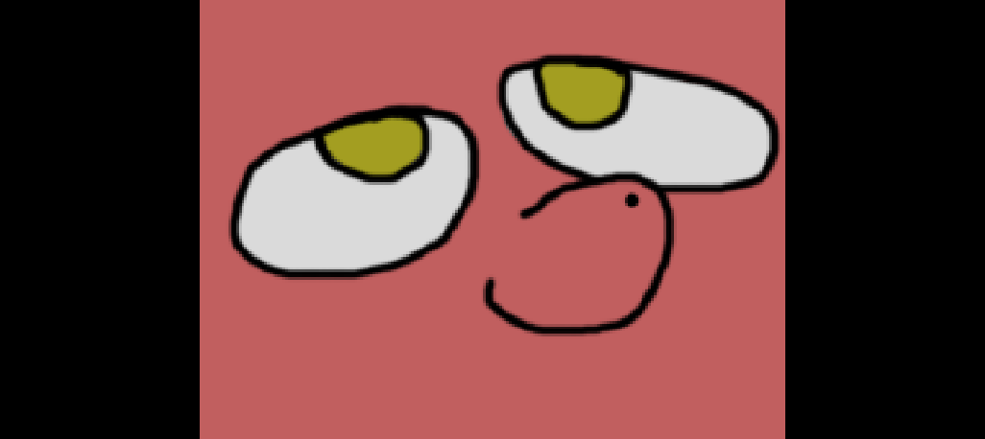
If the window is wider than the game width then the library will draw bars on the left and right side of the window.
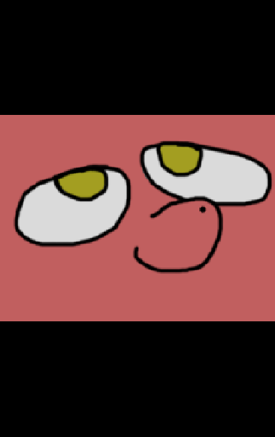
If the window is taller than the game height then the black bars will be drawn on the top and bottom.
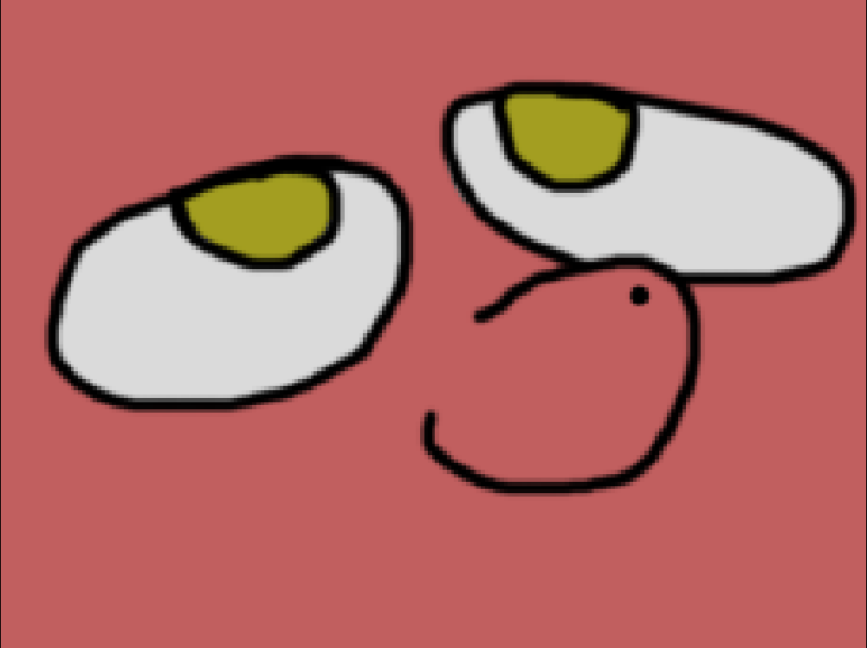
If game aspect and window aspect same, then there will be no visual black bars.
This mode might be best when graphical assets need to remain proportional. Assets that include vector, hand-drawn, 3D etc might look best with this setting. Pixel art might look best with setting 3.

2 – Stretch Scaling
Game content will be scaled to fill the entire window even if it skews the game content.
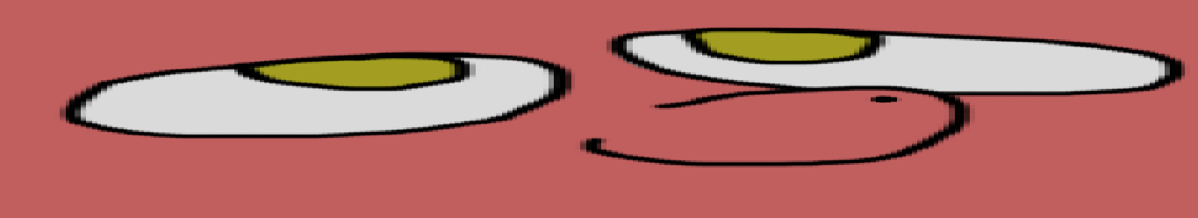
The game might look funny when the window is larger than the game.

The game might look funny when the window is larger than the game.
Stretch scaling might give strange results.

3 – Pixel Perfect Scaling
Pixel Perfect scaling is intended for games with pixel art. It will result in whole-number scaling (1, 2, 3 ... etc) with the lowest value being 1. The scale value will round down to the lowest value (e.g. 1.7 becomes 1.0). Your game content will stay as crisp as possible and there will be no pixel bleeding.
This mode will produce 4 black bars on all sides of the window.
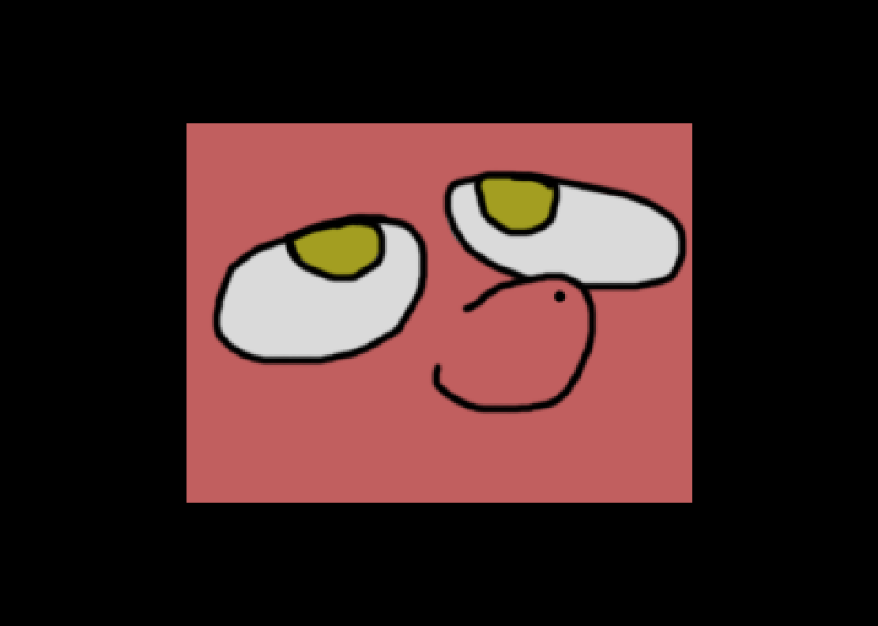
Game size is 640 x 480 while the window is 1111 x 792. Pixel Perfect scaling produces scaling == 1 with 4 black bars. If the window was 1280 x 960 then the scale would be 2.
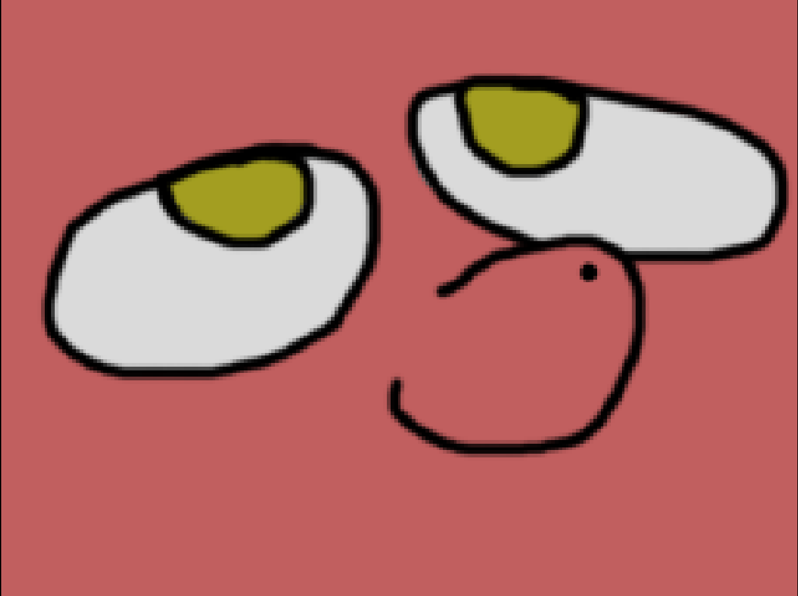
1280x960 window, 640x480 game produced scale 2.

rs.scale_width [number], rs.scale_height [number]
- rs.scale_width
  - Type: number.
- rs.scale_height
  - Type: number.
- Default values: will be calculated when rs.resize() is first called.
- This values is read-only, meaning you shouldn’t change them.
These two values depend on the game size and window size and are influenced by the scale mode specified.
In mode 1 and 3, rs.scale_width and rs.scale_height will have the same value because that scaling uses the same width and height. Mode 2 might result in a different width and height.
Changing this value manually will break the automated calculations provided by the library during rs.resize().
rs.get_both_scales() will provided the width and height scales in a single call.

rs.game_width [number], rs.game_height [number]
- rs.game_width
  - Type: number.
  - Default: 800
- rs.game_height
  - Type: number.
  - Default: 600
Specifies the width and height values your game is designed for. rs.get_game_size() will provided the width and height in a single call.
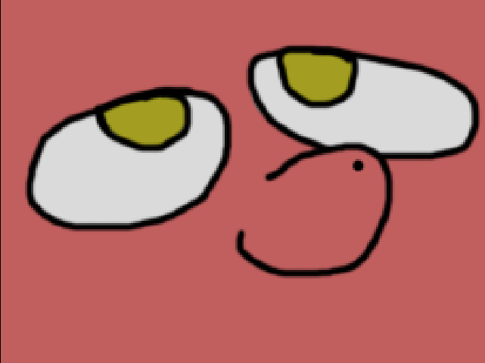
Game with 640x480 resolution/game size. Image has same size, so it 100% fits game resolution.
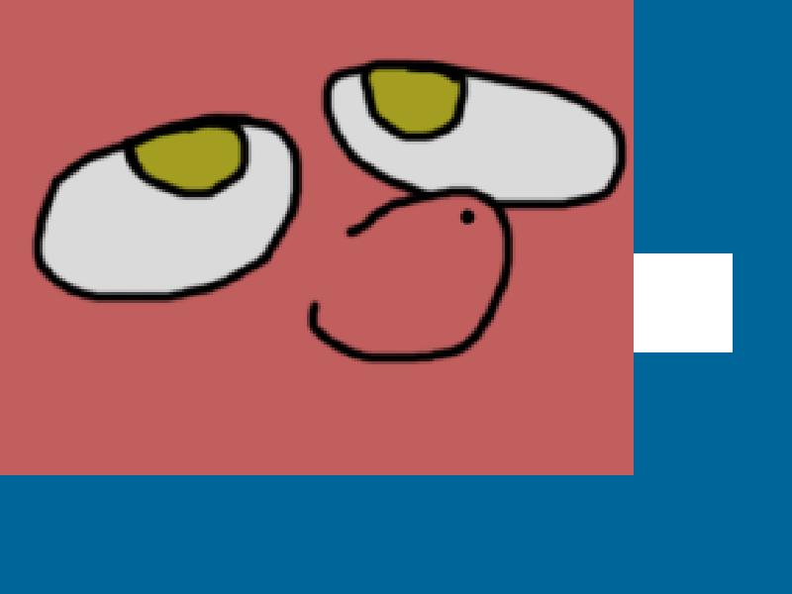
Now game is 800x600, but image still 640x480. It doesn't fit game screen anymore and now you can see white rectangle that was outside of 640x480 boundaries.
You need to know if your game world will exist outside the window and make that clear to the player. If something exists outside the window, you need to think about how the player will know that.

rs.x_offset [number], rs.y_offset [number]
  - rs.x_offset
    - Type: number.
  - rs.y_offset
    - Type: number.
- Default values:will be calculated when rs.resize() is first called.
These variables represent offset values that the library generates to position the game inside the window in accordance with scaling mode. Scale mode 2 will create no offset because the game fills the whole window.
Visualization:
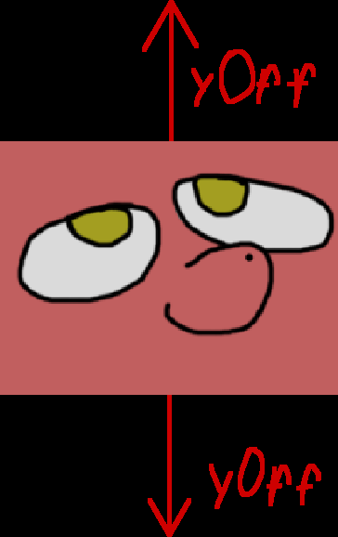
When window taller then game.
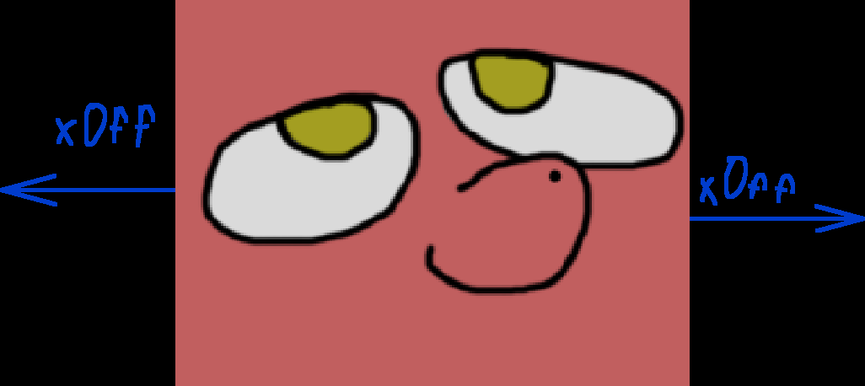
When window wider then game.
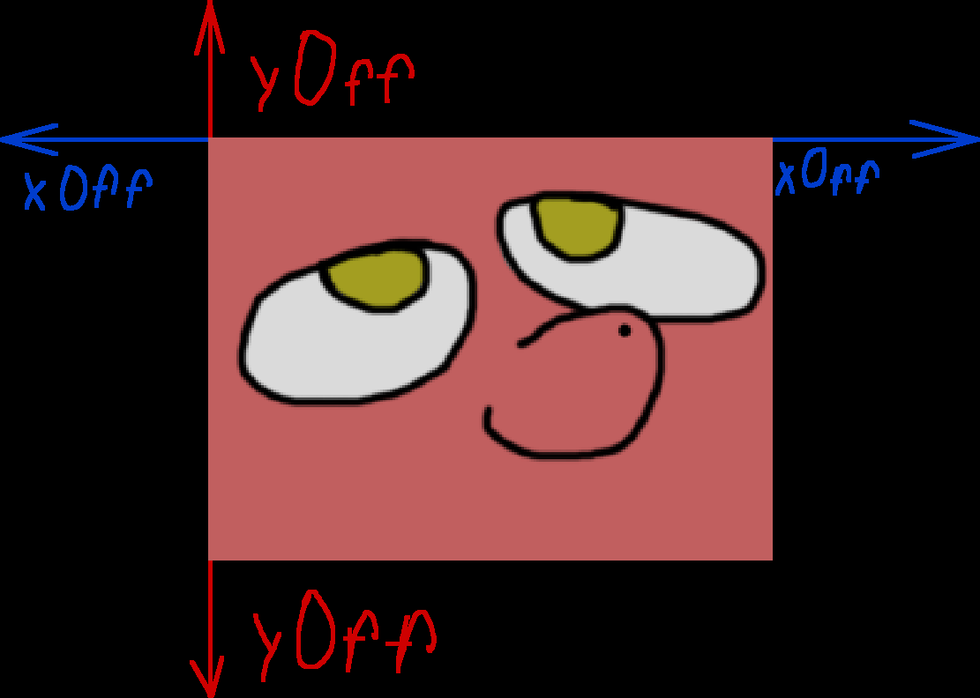
In scale mode 3 you would get both horizontal and vertical offsets.

rs.game_zone [table]
- Type: table.
  - Table contains:
    - x — X coordinate of top-left corner of game zone.
      - Type: number.
    - y — Y coordinate of top-left corner of game zone.
      - Type: number.
    - w — width of game zone.
      - Type: number.
    - h — height of game zone.
      - Type: number.
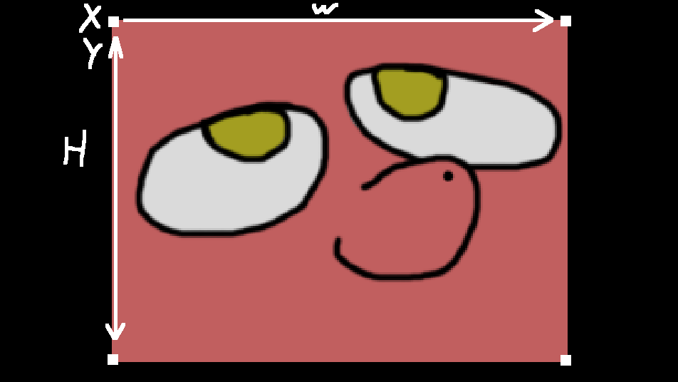
X and Y is top-left corner.
W – Width.
H – Height.
This table contains the coordinates for the game that is inside the black bars. In other words, the coordinates for what you can see on the screen.

Functions

rs.conf(options: table [optional])
- Arguments:
  - options
    - type: table.
- Returns: none.
Function to quickly (re)init, (re)configure library. Optional argument can be table with fields:
- game_width: number – game virtual width, should be 0 or bigger, otherwise function will error.
- game_height: number – game virtual height, should be 0 or more, otherwise function will error.
- scale_mode: number – scaling more, should be 1, 2 or 3, otherwise function will error.
Function won’t do anything with field that wasn’t provided. For example, if you won’t provide game_width, function will simple ignore it and game width will be never changed.
Before finishing, this function will call rs.resize() function to update library state, even if nothing was changed.
Example:
rs.conf({
game_width = 640,
game_height = 480,
scale_mode = 3
})

rs.get_game_zone()
- Arguments: none.
- Returns:
  - x
    - Type: number.
    - X coordinate of top-left point of game zone.
  - y
    - Type: number.
    - Y coordinate of top-left point of game zone.
  - width
    - Type: number.
    - Width of game zone.
  - height
    - Type: number.
    - Height of game zone.
This provides an alternate way to return game zone data. Individual values can be retrieved using rs.game_zone.x, rs.game_zone.y, rs.game_zone.w, rs.game_zone.h
Also see rs.game_zone.
Example:
local x, y, w, h = rs.get_game_zone()

rs.get_game_size()
- Arguments: none.
- Returns:
  - rs.game_width
    - Type: number.
  - rs.game_height
    - Type: number.
A shortcut function that will return rs.game_width and rs.game_height. For more information, see rs.game_width and rs.game_height.
Example:
-- Basic usage.
local game_width, game_height = rs.get_game_size()

rs.setMode(width: number, height: number, flags: table)
- Arguments:
  - width
    - Type: number.
  - height
    - Type: number.
  - flags
    - Type: table.
- Returns: nothing.
This function is a wrapper for love.window.setMode() that should be used with this library. See the Love2d wiki page for information about love.window.setMode(): https://love2d.org/wiki/love.window.setMode

For advanced users:
-- This wrapper function equivalent of doing this:
love.window.setMode(width, height, flags)
rs.resize()

Example:
-- Basic usage.
rs = require("resolution_solution")
rs.conf({game_width = 800, game_height = 600, scale_mode = 3})
rs.setMode(rs.get_game_size(), select(3, love.window.getMode()))
-- Done, now we initialized game with 800x600 game size and resized window to be same as game width and height.

rs.updateMode(width: number, height: number, flags: table)
- Arguments:
  - width
    - Type: number.
  - height
    - Type: number.
  - flags
    - Type: table.
- Returns: nothing.
This function is a wrapper for love.window.updateMode() that should be used with this library. See the Love2d wiki page for information about love.window.updateMode(): https://love2d.org/wiki/love.window.updateMode

For advanced users:
-- This wrapper function equivalent of doing this:
love.window.updateMode(width, height, flags)
rs.resize()

Example:
-- Basic usage.
rs = require("resolution_solution")
rs.conf({
game_width = 800,
game_height = 600,
scale_mode = 3})
-- We want to create game with 800x600 resolution
-- But we also want to change window size to be same as game.
-- To achieve this, we can do...
rs.updateMode(rs.get_game_size())
-- Done, now we initialized game with 800x600 game size and resized window to be same as game width and height.

rs.debug_info(x: number [optional], y: number[optional])
- Arguments:
  - x
    - type: number.
    - If you pass nothing or nil, then it will same as if you pass 0.
  - y
    - type: number.
    - If you pass nothing or nil, then it will same as if you pass 0.
- Returns: nothing.
This is a function to help you debug. It shows information about the library states. You can display these states on the screen to help you troubleshoot. Calling rs.debug_info() without arguments is the same as calling rs.debug_info(0,0) which draws the debug window in the top left corner of the window.
Information displayed:
  - Library name
  - Library version
  - rs.game_width
  - rs.game_height
  - rs.scale_width
  - rs.scale_height
  - rs.scale_mode
  - rs.x_offset
  - rs.y_offset
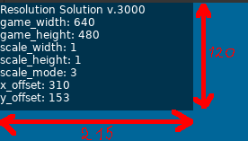
Currently, size of debug window is: width 215, height 120.
Examples:
-- Example drawing this debug window on top-right corner in-between rs.push() and rs.pop()
local rs = require("resolution_solution")
rs.conf({
game_width = 640,
game_height = 480,
scale_mode = 1
})
love.graphics.setBackgroundColor(0.3, 0.5, 1)
rs.setMode(rs.game_width, rs.game_height, {resizable = true})

local game_canvas = love.graphics.newCanvas(rs.get_game_size())

love.resize = function()
rs.resize()
end

love.draw = function()
love.graphics.setCanvas(game_canvas)
love.graphics.clear(0, 0, 0, 1)
love.graphics.setColor(1, 1, 1, 1)
love.graphics.setCanvas()

rs.push()
love.graphics.draw(game_canvas)
rs.debug_info(rs.game_width - 215)
rs.pop()
end

rs.resize(width: number [optional], height: number [optional])
- Arguments:
  - width
    - type: number.
    - If you pass nothing or nil, then library will get size from love.graphics.getWidth().
  - height
    - type: number.
    - If you pass nothing or nil, then library will get size from love.graphics.getHeight()
- Returns: nothing.
A function that forces the library to update. It was designed to be called inside love.resize() function. You can optionally pass width and height arguments to it, or pass nothing and library will get window size from love.
Situation where you might want to pass you own arguments to it, is when, for example, you working on pixel-art game. By default with scale_mode == 3 (so, pixel perfect mode), if game window will be sized non-evenly (for example, 641x481), you will notice that graphics become non-crisp because offsets (x_offset, y_offset) won’t be integer (for example, 25.5). Library doesn’t give any definitive answer for this, so you might want to come up with your own solution (if you want to deal with this at all), like flooring window size to nearest even number and pass it as argument to rs.resize()
Example:
local rs = require("resolution_solution")
rs.conf({
game_width = 640,
game_height = 480,
scale_mode = 1
})
love.graphics.setBackgroundColor(0.3, 0.5, 1)
rs.setMode(rs.game_width, rs.game_height, {resizable = true})

local game_canvas = love.graphics.newCanvas(rs.get_game_size())

love.resize = function()
rs.resize()
end

love.draw = function()
love.graphics.setCanvas(game_canvas)
love.graphics.clear(0, 0, 0, 1)
love.graphics.setColor(1, 1, 1, 1)
love.graphics.setCanvas()

rs.push()
love.graphics.draw(game_canvas)
rs.pop()
end

rs.resize_callback()
- Arguments: none.
- Returns: nothing.
A function that is invoked every time rs.resize() is called. This function is useful if you need to hook into the library. For example, to rescale the UI. To do so, you can write your own rs.resize_callback() and insert your own code inside the function.
Note: rs.resize_callback() is called after rs.resize() is finished updating the library.
Example:
local rs = require("resolution_solution")
rs.conf({
game_width = 640,
game_height = 480,
scale_mode = 1
})
love.graphics.setBackgroundColor(0.3, 0.5, 1)
rs.setMode(rs.game_width, rs.game_height, {resizable = true})

local game_canvas = love.graphics.newCanvas(rs.get_game_size())

love.resize = function()
rs.resize()
end

rs.resize_callback = function()
print("Library was resized!")
end

love.draw = function()
love.graphics.setCanvas(game_canvas)
love.graphics.clear(0, 0, 0, 1)
love.graphics.setColor(1, 1, 1, 1)
love.graphics.setCanvas()

rs.push()
love.graphics.draw(game_canvas)
rs.pop()
end

rs.push()
- Arguments: none.
- Returns: nothing.
A function that scales your game. Also see rs.pop().
Example:
-- Basic usage
local rs = require("resolution_solution")
rs.conf({
game_width = 640,
game_height = 480,
scale_mode = 1
})
love.graphics.setBackgroundColor(0.3, 0.5, 1)
rs.setMode(rs.game_width, rs.game_height, {resizable = true})

local game_canvas = love.graphics.newCanvas(rs.get_game_size())

love.resize = function()
rs.resize()
end

love.draw = function()
love.graphics.setCanvas(game_canvas)
love.graphics.clear(0, 0, 0, 1)
love.graphics.setColor(1, 1, 1, 1)
love.graphics.setCanvas()

rs.push()
love.graphics.draw(game_canvas)
rs.pop()
end

rs.pop()
- Arguments: none.
- Returns: nothing.
A function that closes rs.push(). Also see rs.push()
Example:
local rs = require("resolution_solution")
rs.conf({
game_width = 640,
game_height = 480,
scale_mode = 1
})
love.graphics.setBackgroundColor(0.3, 0.5, 1)
rs.setMode(rs.game_width, rs.game_height, {resizable = true})

local game_canvas = love.graphics.newCanvas(rs.get_game_size())

love.resize = function()
rs.resize()
end

love.draw = function()
love.graphics.setCanvas(game_canvas)
love.graphics.clear(0, 0, 0, 1)
love.graphics.setColor(1, 1, 1, 1)
love.graphics.setCanvas()

rs.push()
love.graphics.draw(game_canvas)
rs.pop()
end

rs.get_both_scales()
- Arguments: none.
- Returns:
  - rs.scale_width
    - Type: number.
  - rs.scale_height
    - Type: number.
A shortcut function that returns rs.scale_width and rs.scale_height.
Example:
-- Basic usage.
local x_scale, y_scale = rs.get_both_scales()

rs.is_it_inside()
- Arguments: none.
- Returns:
  - is mouse inside game zone
    - Type: boolean.
    - Returns true if cursor inside game zone.
    - Returns false if cursor outside of game zone.
A function to determine if given coordinates are inside the game zone. This is useful if you develop games with mouse or touchscreen support that has controls on the screen and outside the game zone.
Here quick visualization:
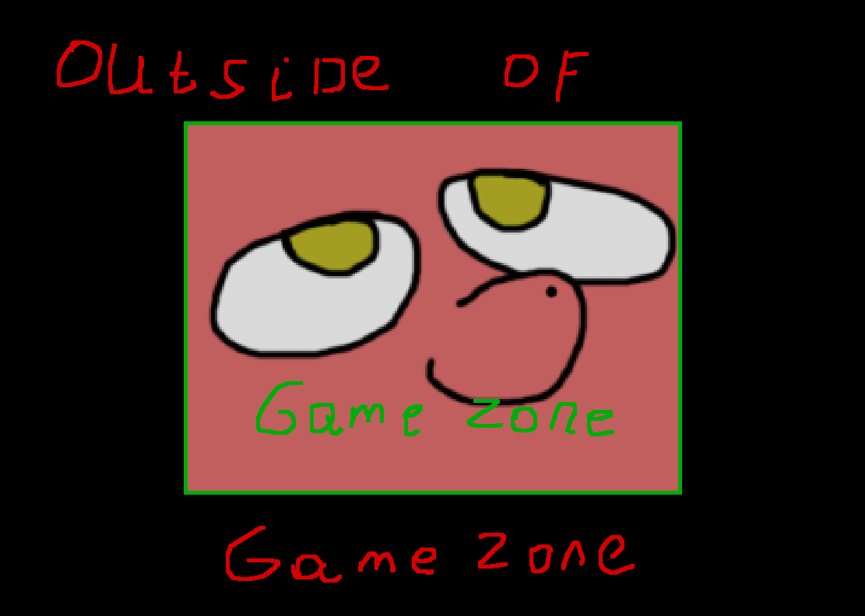
Quick reminder what considered “game zone” and what “outside of game zone”.
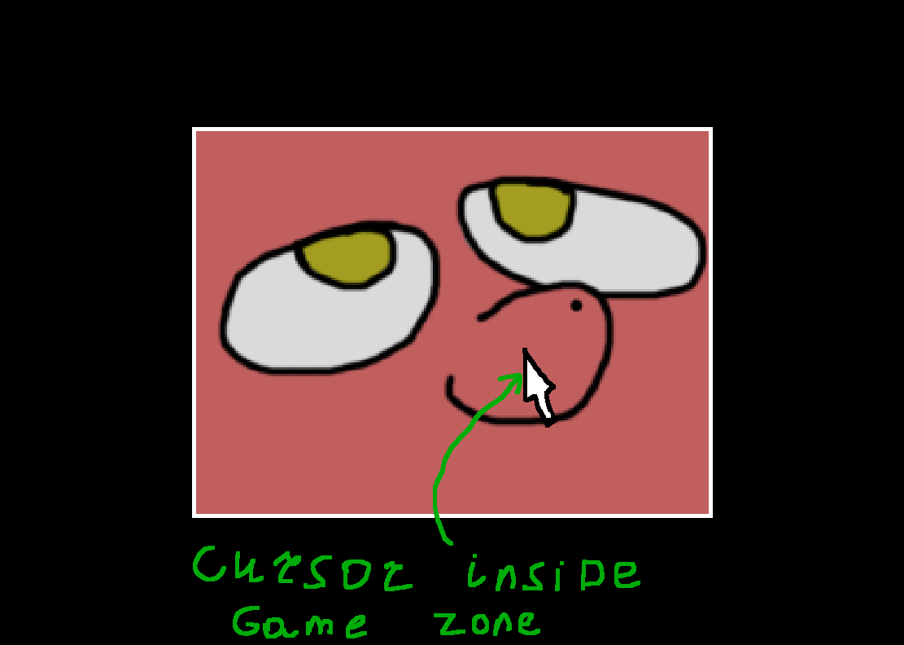
Cursor inside game zone, so rs.is_it_inside(love.mouse.getPosition()) will return true.
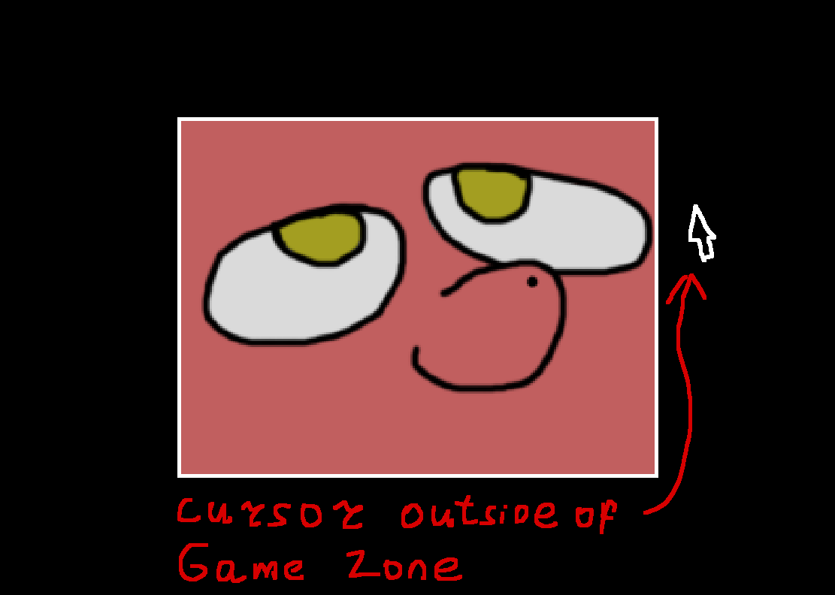
Cursor outside of game zone, so rs.is_it_inside(love.mouse.getPosition()) will return false.

This is especially useful if you develop games with scrolling worlds or camera movements. Click the black bars should manipulate controls and not objects in the game world. When scale mode == 2, the function will always return true because there won't be any black bars.
Example:
-- Basic usage.
local rs = require("resolution_solution")
rs.conf({
game_width = 640,
game_height = 480,
scale_mode = 1
})
love.graphics.setBackgroundColor(0.3, 0.5, 1)
rs.setMode(rs.game_width, rs.game_height, {resizable = true})

local game_canvas = love.graphics.newCanvas(rs.get_game_size())

local is_inside = false

love.load = function()
image = love.graphics.newImage("image.png")
end

love.resize = function()
rs.resize()
end

love.update = function()
is_inside = rs.is_it_inside(love.mouse.getPosition())
end

love.draw = function()
love.graphics.setCanvas(game_canvas)
love.graphics.clear(0, 0, 0, 1)

if is_inside then
love.graphics.setColor(0, 1, 0, 1)
love.graphics.print("Cursor inside game zone.", rs.game_width / 2, rs.game_height / 2)
else
love.graphics.setColor(1, 0, 0, 1)
love.graphics.print("Cursor outside game zone.", rs.game_width / 2, rs.game_height / 2)
end

love.graphics.setColor(1, 1, 1, 1)
love.graphics.setCanvas()

rs.push()
love.graphics.draw(game_canvas)
rs.pop()
end

rs.to_game(x: number, y: number)
Arguments:
  - x
    - Type: number.
  - y
    - Type: number.
Returns:
  - scaled to game X
- Type: number.
  - Scaled to game Y
    - Type: number.
A function to translate coordinates from the window to the game zone. This can be used to translate cursor coordinates so you can check collisions with objects inside the game zone.
If you pass only one argument e.g. rs.to_game(x) then the function will return the scaled x value.
scaled_X = rs.to_game(x)
if you pass the 2nd argument e.g. rs.to_game(nil, y) then the function will return the scaled y value.
scaled_y = rs.to_game(nil, y)
rs.to_game(x, y) will return both values.
scaled_x, scaled_y = rs.to_game(x, y)
Example:
local rs = require("resolution_solution")
rs.conf({
game_width = 640,
game_height = 480,
scale_mode = 1
})
love.graphics.setBackgroundColor(0.3, 0.5, 1)
rs.setMode(rs.game_width, rs.game_height, {resizable = true})

local game_canvas = love.graphics.newCanvas(rs.get_game_size())

local is_touching = false
local rectangle = {x = 200, y = 200, w = 100, h = 100}

love.resize = function()
rs.resize()
end

love.update = function()
-- Get cursor position.
local mx, my = love.mouse.getPosition()

-- Translate it to game.
mx, my = rs.to_game(mx, my)
if mx >= rectangle.x and -- left
my >= rectangle.y and -- top
mx <= rectangle.x + rectangle.w and -- right
my <= rectangle.y + rectangle.h then -- bottom
is_touching = true
else
is_touching = false
end
end

love.draw = function()
love.graphics.setCanvas(game_canvas)
love.graphics.clear(0, 0, 0, 1)
love.graphics.setColor(1, 1, 1, 1)

if is_touching then
-- Green color, means that we touch rectangle.
love.graphics.setColor(0, 1, 0, 1)
else
-- Red color, means that we don't touch rectangle.
love.graphics.setColor(1, 0, 0, 1)
end

love.graphics.rectangle("line", rectangle.x, rectangle.y, rectangle.w, rectangle.h)

love.graphics.setCanvas()

rs.push()
love.graphics.draw(game_canvas)
rs.pop()
end

rs.to_window(x: number, y: number)
Arguments:
- x
    - Type: number.
- y
    - Type: number.
Returns:
- scaled from game to window X
- Type: number.
- Scaled from game to window Y
    - Type: number.
A function similar to rs.to_game but reversed. It translates coordinates from the game world to the window. For example, when you want to move the cursor to an object inside the game zone.
If you pass only one argument e.g. rs.to_window(x) then the function will return the scaled x value.
x = rs.to_window(scaled_x)
if you pass the 2nd argument e.g. rs.to_window(nil, y) then the function will return the scaled y value.
y = rs.to_window(nil, scaled_y)
rs.to_window(x, y) will return both values.
x, y = rs.to_window(scaled_x, scaled_y)
Example:
-- Basic example.
-- Press left button of mouse to teleport cursor to center or rectangle
-- that you can see in center of window.
-- Note: might not work if you use Linux with Wayland.
local rs = require("resolution_solution")
rs.conf({
game_width = 640,
game_height = 480,
scale_mode = 1
})
love.graphics.setBackgroundColor(0.3, 0.5, 1)
rs.setMode(rs.game_width, rs.game_height, {resizable = true})

local game_canvas = love.graphics.newCanvas(rs.get_game_size())

love.resize = function()
rs.resize()
end

love.mousepressed = function(x, y, button)
if button == 1 then
love.mouse.setPosition(
rs.toScreen(
(rs.game_width / 2), -- Translate X.
(rs.game_height / 2) -- Translate y.
)
)
end
end

love.draw = function()
love.graphics.setCanvas(game_canvas)
love.graphics.clear(0, 0, 0, 1)
love.graphics.setColor(1, 1, 1, 1)
-- Place 100x100 rectangle in center of game zone.
love.graphics.rectangle("line", (rs.game_width / 2) - 50, (rs.game_height / 2) - 50, 100, 100)
love.graphics.rectangle("line", (rs.game_width / 2) - 4, (rs.game_height / 2) - 4, 4, 4)
love.graphics.setCanvas()

rs.push()
love.graphics.draw(game_canvas)
rs.pop()
end

Tips and Tricks
This is a collection of code snippets and examples of useful things that you can do with this library. For more complex examples, go to Resolution Solution repository, examples folder.

How to get resolution of screen on which window with game placed
Just keep in mind, that there people who uses their system with several monitors.
So for example, if user have 2 monitors: 1 is 1366x768; 2 is 1920x1080. If you would try this:
width, height = love.window.getDesktopDimensions(1)
You would make annoying (to user) mistake, because user might place game window on 2nd monitor, so game would get 1366x768 instead of 1920x1080 that user might expected.
So, instead do this:
width, height = love.window.getDesktopDimensions(
select(3, love.window.getMode()).display)
This function would get index of screen on which game window and placed and pass it, so now game will correctly get 1920x1080 if it placed on 2nd monitor and 1366x768 if on 1st.

Non-even window size
When you going to work with Pixel Perfect scaling, you might notice that when game window has non even sizes (like 801x600) you would have pixel bleeding, because due to calculations, rs.x_offset and rs.y_offset would become floats rather then ints. The best course of actions here would be:
  - Ask user to play in fullscreen (because all monitors have even resolutions) for best experience.
  - Don’t allow window resizing by user and present to them list of supported window sizes that they can use instead.
  - Just leave it as it.
  - You could try this:
love.resize = function(w, h)
rs.resize(w - (w % 2), h - (h % 2))
end
This function will floor virtual width and height to nearest biggest even numbers. For example, if width is 801 then function will change it to 800. But beware, that this will offset game by 1 pixel if window size is non even, so you should account for that in your code.

Default filter
For pixel-art it is also love.graphics.setDefaultFilter("nearest", "nearest") is must-have. For Stretch Scaling and Aspect Scaling love.graphics.setDefaultFilter("linear", "linear") suits better, but it’s up to you to decide.

Calculations around game size
If you use this library, all calculations should be based around rs.game_width and rs.game_height for everything that should be subject of scaling, rather then window size.

Changelog

v1000, 7 January 2021
Initial release! Yay!

v1001, 6 February 2022
New:
- Added comments for "Simple demo".
- Added more comments for functions and variables in library.
Changed / Fixed:
- Now, scaling.stop() will remember color that was set before it and return it back after.
- Fixed typos in "Simple demo".

v1002, 8 February 2022
Changed / Fixed:
- Fixed (probably) edge cases in rs.isMouseInside() function, so now it should correctly deal with non integer offsets provided by scaling.xOff and scaling.yOff.
- Now rs.isMouseInside() return always true if scale mode is == 2, since there is no black bars in that scaling method so no need to wast CPU time on that.
- Updated rs.isMouseInside() comments.
- Rewritten "Simple demo", now it uses modified demo from github page.
- Fixed typos, rewritten/rephrased comments.
- Added note in rs.toGame/rs.toScreen about rounding/mismatching.
- Added note about rs.isMouseInside().

v1003, 12 February 2022
New:
- Added library license text in rs._LICENSE_TEXT.
- Added auto-completion API for Zerobrane Studio!
Changed / Fixed:
- Updated comments.

v1004, 19 May 2022
Renamed:
- rs.widthScale -> rs.scaleWidth.
- rs.heightScale -> rs.scaleHeight.

v1005, 19 May 2022
New:
- rs.gameZone table, which contains x, y, w, h coordinates of scaled area.
You might need it when you want to draw UI, which shouldn't be scaled by library regardless of current scaling mode (stretching or with black bars), because to draw UI you need to know where starts/ends scaled area on window. And it might help for camera libraries, which uses love.graphics.setScissors().

v1006, 20 May 2022
New:
- rs.drawBlackBars() added.
So now you can call it to draw black bar outside of rs.start() and rs.stop(). Some libraries, especially that use love's scissors functionality might broke black bars rendering;
Or camera (or any other library that relies graphics transformations) libraries might mess with coordinate translating. Which might end up in broken graphics and frustration.
Also, this function uses same rules as rs.stop(), meaning rs.drawBars == false will result in rs.drawBlackBars() will be not rendered.
- Now rs.stop() will draw black bars via rs.drawBlackBars() function.

v2000, 27 December 2022
Big rewrite! Check source file for all detailed changes. Some functionality in this version is not compatible with old versions.
Source file, at almost top, now include some tips and "tricks", check them out.
New:
- Pixel Perfect scaling - rs.setScaleMode(3) to check it out!
- rs.init(options) - before, to change some options in library, you could update value directly from rs.* table or use provided built-in functions. Now, considering new "insides" of library, changing options directly as rs.scaleMode == 1 will do nothing, because library will be updated only on rs.resize() or via newly (and old one) provided functions, including rs.init().
You should call rs.init() at least once, even if you don't need to update anything in options, otherwise until first rs.resize(), you will see black screen.
You can pass argument as table with options, or pass nothing to just update.
- rs.setScaleMode() - allow you to change scale mode via number. Pass 1, 2, 3 to change.
- rs.debug - boolean, which controls if rs.debugFunc() will be rendered or not.
- rs.debugFunc() - function that will show some data that useful for debug. Call it somewhere in love.draw() as rs.debugFunc().
- rs.switchDebug() - switch rs.debug, from true to false and vice-versa.
Removed:
- rs.windowChanged() - because now there no need in this callback.
- rs.gameChanged() - also not really useful anymore.
- rs.gameAspect - it was not really useful anyway.
- rs.windowAspect - also not useful.
- rs.update() - explained below.
Changed / Fixed:
- Before, there was only 2 bars: left/right or top/bottom and they was available only at rs.scaleMode == 1. With introduced 3rd scale method, Pixel Perfect, that has bars at top/bottom/left/right at same time, their functionality changed. You can still access them as: rs.x1, rs.y1, rs.w1, rs.h1 (from 1 to 4, rs.x1, rs.x2, rs.x3...), but order changed:
  - top bar
  - left bar
  - for right bar
  - for bottom bar
- Apparently, rs.gameZone table was never updated, because I forgot to do so in rs.update... Whops!
- Now all functions, that expects arguments, have error messages to point out if you passed something wrong. Yay!
- rs.resize - now library update loop was designed around love.resize() function, instead of love.update(), like other scaling libs do. So less wasted frame time, yay! Don't forget to pass w and h from love.resize(w, h) to library as rs.resize(w, h). For comparability sake, it should be possible to put rs.resize at love.update and just pass rs.resize(love.graphics.getWidth(), love.graphics.getHeight()). It was not tested properly, but i believe there shouldn't be any problem with it, except maybe performance.
- rs.switchScaleMode() - before until 3rd scaling method, there was only 2 methods and this function acted more like "boolean". Now, you can pass 1 or -1 to choose how you want to switch methods: 1 -> 2 -> 3 -> 1... or 3 -> 2 -> 1 -> 1. If you pass nothing, function will act as you passed 1.
- Demo was rewritten.
- From now on, i will include minified version of library, with removed comments and minified code, that will make filesize lesser. https://mothereff.in/lua-minifier.
Renamed:
- rs.drawBars -> rs.bars.
- rs.drawBlackBars -> rs.drawBars.
- rs.switchDrawBars -> rs.switchBars.

v2001, 31 December 2022
Small update, that add some QoL features, and hack for Pixel Perfect Scaling. Check source code (specifically rs.pixelPerfectOffsetsHack and rs.resize()) and this update log for more info.
Happy new year!
New:
- rs.nearestFilter(filter, anisotropy) - this function is easier to use wrapper for love.graphics.setDefaultFilter(). It expects 2 optional arguments:
    - true/false or nil. true/nil results in nearest filtering, while false is linear.
    - Anisotropy. It can be number or nil. If number, function will simply use it to slap into love.graphics.setDefaultFilter(), but if nil, then library will simply get anisotropy value from love.graphics.getDefaultFilter() and will use it instead. Current love uses 1 as default.
If this function was never run, library will never touch or edit love.graphics.setDefaultFilter().
- rs.pixelPerfectOffsetsHack = false/true - very experimental feature, that aim to fix pixel bleeding in perfect scaling mode when window size is not even. It result in always "clean" pixels, but comes with side effects such as:
    - rs.windowWidth and rs.windowHeight will be wrong by 1 if window is non even. The workaround is to use love.graphics.getWidth() and love.graphics.getheight() instead.
    - On non even window size, offset from left and top will place game content on 1 pixel left/upper. But if you never ever draw anything inside rs.unscaleStart() and rs.unscaleStop() and outside of rs.start() and rs.stop(), then you should probably fine using this hack.
- rs.switchPixelHack() - turn on/off mentioned hack.
- rs.setMode() - wrapper around love.window.setMode(). You should use this functions instead, since using love.window.setMode() might don't trigger love.resize() and therefore rs.resize() and as result scaling calculations will be wrong.
Changed / Fixed:
- Updated demo to include all new functions and values.
- Updated rs.debugFunc() to include all new values and functions.

v3000, 19 November 2023
Yet another big library rewrite.
This version is not compatibility with v2001, so major rewriting required.

Main idea behind this rewrite was quite simple: library was doing too much of unnecessary stuff, resulting in bloated library, tons not very useful features that I need to maintain, and I was in general not very satisfied with what library become.
Before, library was focusing too much on “black bars” concept. In fact, around 50% of all functions were only about them. So, now, library become lightweight and focused on SCALING, then anything else. Now library proposes you to implement scaling using canvas, scissors or good old black bars. You not forced to only choose one method and monkeypatch your way through. Now everything should be easy for everyone.
So.. what now?
Library moves to maintenance-only mode, so no new features or rewrites in not planned. Only bug fixes (if users will raise them, of course), version bumping and updating library to new love version, more examples in repository.

Thanks everyone, who uses this library!
New:
- Added complete documentation, as PDF file, which includes examples, screenshots, explanations of some concepts, tips and tricks, and more.
(+ source .odt file)
- Added folder with examples in repository.
Changed / Fixed:
- Most functions or values were removed or reworked.
- Reworked readme in repository.
Renamed:
- All functions and variables now use snake_case.
Removed:
- Most functions or values were removed or reworked.
- Since ZeroBrane API was unmaintained for some time, it was fully removed from repository.
- I don’t provide minified version of library anymore, so it was removed from repository.

v3001, 3 December 2023
Bump to love 11.5, no new features or fixes, mostly changes for internals, like updated comments, shake_case for internals in debug_info function. This even resulted in smaller library size!

Compatible with v3000 without any additional code changes (unless you relied on _DOCUMENTATION variable, for some reason).
New:
- _DOCUMENTATION now has link to documentation pdf file that I forget to add during v3000 update.
Changed:
- Internal variables in debug_info now used snake_case that I forget to update during v3000 update.
- Updated README, mostly better wording and links.

v3002, 20 May 2024
Mostly fixing typos in library code (like error messages) and some updates to documentation.
Documentation:
- Turns out I forget to document rs.conf() function. Welp. That sucks.
- Updated styling and some information (maybe later I need to rewrite it...)
Changed:
- Better error messages.
- Now rs.resize() accepts optional width and height arguments, like most scaling libraries do. You can use it to monkeypatch something (for example, for pixel perfect scaling). If you won’t provide one of this variables, then library will simple get it itself from love.graphics.getWidth() and love.graphics.getHeight(); If you updating from previous version, no changes to code necessary.
Changed:
- Fixed outdated error text in rs.debug_info() function.

