Chapter IV

RESULTS AND DISCUSSION
This chapter discusses and presents the research findings in relation to the objectives specified by the researcher at the beginning of the entire research study. This section also analyzes if the study met its objectives and satisfied the needs of the client. It also covers the analysis of the data obtained from testing and and evaluation of the developed system.
Generally, the study aims to gather data, develop, test and assess a web-based system that would as a platform for managing appointments and schedules in an effective and convenient way, as well as to establish a process for gathering, managing, and storing all data and information from its clients. This chapter presents result of the research methodology the researchers pursued to attain the the specified objectives.

Research Objective No. 1: To design and develop an appointment and scheduling management system with SMS Notification as a platform for managing appointments and schedules in an effective and convenient way, as well as to establish a process for gathering, managing, and storing all data and information from its clients.

The Design
To achieved the first objective of the research study the researcher had gone to fact finding techniques and data gathering methods in order to understand the problems within the process of managing of appointments with the Mayor’s Office. The researcher has used research instruments such as Survey Questionnaire, Technology Acceptance Model with ISO standard, Test-case scenario.
The researchers did a preliminary investigation to gather information and identify the study's target population. The researchers conducted a preliminary interview with the Municipal Technical Staff, Mam Rexerizza R. Boongaling, and Mayor's Private Secretary II, Mam Claries A. Exconde, on June 1, 2022, at 10:00 a.m., about the current problems they are dealing within the management of appointments in the Mayor's Office, which specifically concern their clients. The researchers asked a series of questions, including follow-up questions regarding the step-by-step procedure of managing the municipal mayor's appointments and schedule.
During the interview the researcher were able to identify the problems in the process of handling in the appointment management system that supports the Mayor’s Office where in 1.) Overlapping schedules due to sudden/urgent appointment. 2.) Unexpected change of schedules. 3.) Adjustment in schedule due to unforeseen/walk-in clients. 4.) Late notice of change schedule.This encouraged the researcher to propose a solution that would improve the present procedure of managing the mayor's schedule. The researchers do brainstorming after the interview.
The researchers planned the system's flow after collecting the necessary data and information. An analysis is performed to determine the most pertinent business logic and database models. During this stage of the project's development, technical requirements are specified. For the analysis stage, the researchers construct the program using various diagrams such as process flow diagrams, use case diagrams, system context diagrams, data flow diagrams, and so on. Observations, interviews, library research, and internet research were all employed as research methods.

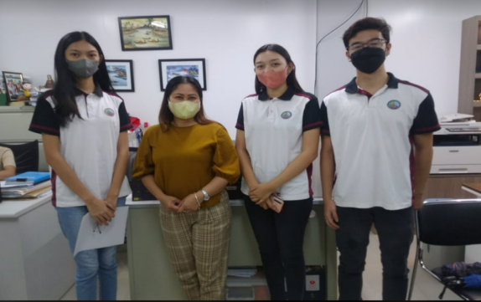
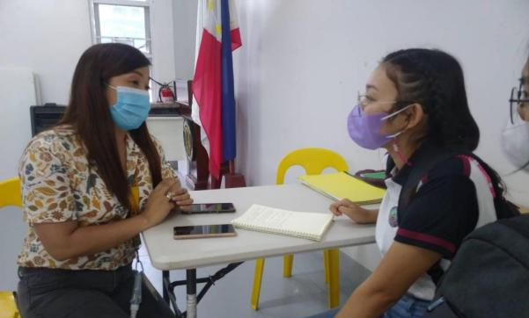

Figure Documentation for Data Gathering Process. This figure shows the picture taken at the locale of the study and how researchers conducted a preliminary investigation for the data gathering.

The Development
Afterward, the researchers created the systems; Appointment and Scheduling Management System with SMS Notification for Mayor’s office of Sta. Cruz, Laguna. The researchers built the systems using the Rapid Application Development, a software methodology. After the development process, the researchers always conferred with their system expert, Mr. Gerald Villaran.
Rapid Application Development has different phases, which the researcher followed to complete the development of their system. In the first phase, requirement planning, the researchers were able to determine the existing status of the departments and their workflows, as well as suggest what prospective modifications may be made to assist the stated office. Following that, the researchers developed a strategic project proposal titled "Appointment and Scheduling Management System with SMS Notification for the Mayor's Office in Sta. Laguna, Cruz." The second phase is user design. The researchers and developers began creating the program in accordance with the project idea. When building the application, the researchers had very specific criteria for its performance and accessibility. Because the program will be used by the government, it must be user-friendly and stress cooperation. The researchers collaborate with their clients and end-users to get feedback on the interface and functionality, as well as to improve the system in general. The third phase is development and testing. After carefully planning the system, the researchers built the application's functionalities and then added some other features. During this phase, the researchers begin collaborating to develop a web-based system based on the data they have collected. In this stage, coding, testing, debugging, and other principles are used. Lastly, implementation, the system was tested to determine its capabilities and limits at the end of the rapid application development process. The web-based system is ready for usage, with the ability to receive feedback and criticism while in use. At this time, all requirements and adjustments in the system development process have been satisfied.
The researchers visited the Mayor’s Office of Sta. Cruz, Laguna after the Appointment and Scheduling Management System with SMS Notification for Mayor’s Office of Sta. Cruz, Laguna, was develop. They demonstrated the developed systems to Mam Claries A. Exconde, the Mayor's private secretary II, and expressed thanks for the chance to examine and utilize the developed system, understanding how useful it would be to their job.
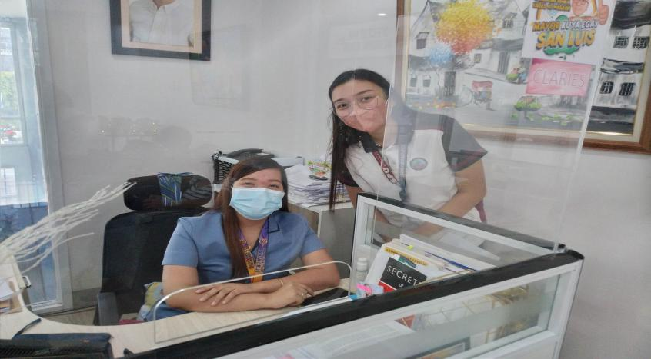

Figure Presentation of the developed web system to the mayor’s private secretary

System Interface
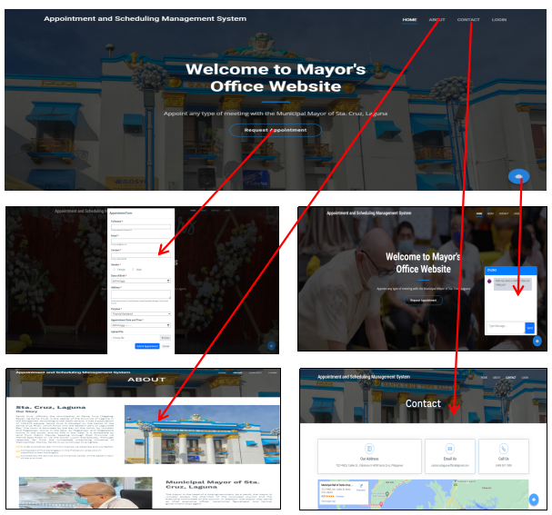
- Client Homepage

Figure Client Interface. The figure above shows the functionalities and processes of the client on the system.

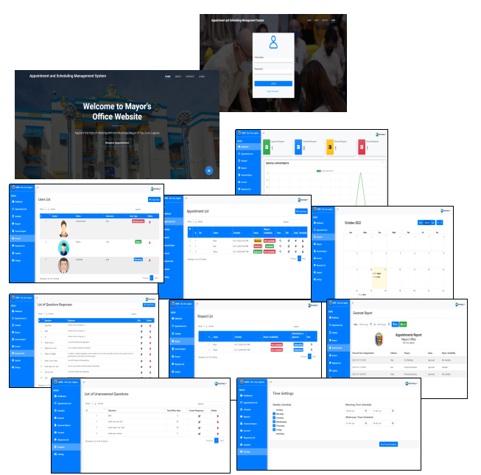
- Mayor’s Secretary Account

Figure Mayor’s secretary interface. The figure above shows the functionalities and processes of the secretary account on the system.

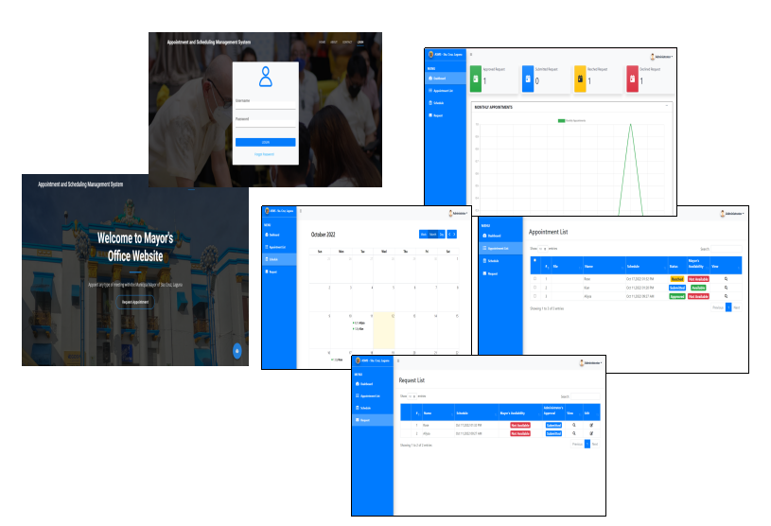
- Administrator Staff Account
Figure Administrator staff interface. The figure above shows the functionalities and processes of the secretary account on the system.

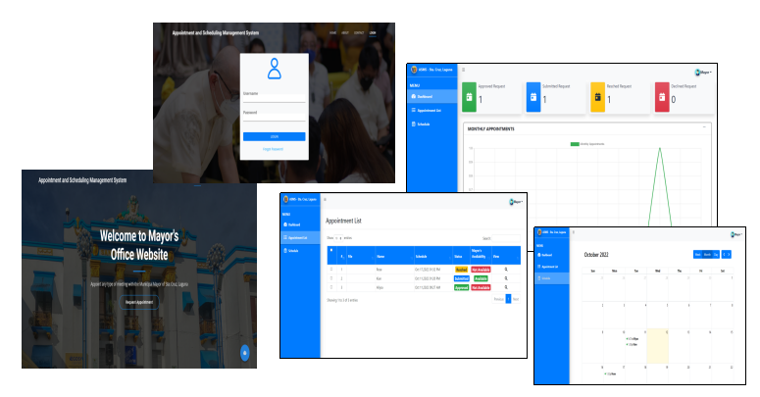
- Mayor Account

Figure Mayor interface. The figure above shows the functionalities and processes of the secretary account on the system.

Research Objective No. 2: To test the functionalities of the developed system based on the developed system's features.
2.1 Client Information
2.2 Adding New Appointments to the System
2.3 Viewing the Appointment Information in Calendar
2.4 Sending SMS Notification
2.5 Generate Report
2.6 Manage the Date and Time of Appointment
2.7 Chatbot for inquiries
To test the functionality of the developed system, the researchers utilized black-box testing. Black Box Testing is a software testing approach in which software applications' functionalities are tested without knowledge of internal code structure, implementation details, or internal paths. This allows you to see how the system reacts to expected and unexpected user activities, as well as its response time, usability concerns, and reliability issues.
The questionnaire contains the functionality of the developed system, and the tester is not allowed to see the code. The researcher creates a set of questions that represent the system's functionality and features. The researchers demonstrated their system to IT experts through Google Meet and face-to-face to verify the functioning and features of the built system and assess whether the functionalities are necessary by the Mayor's Office for appointment management.
After creating a system testing questionnaire, the researchers consult their thesis adviser for validation. The researchers carried out systems testing, and the IT experts tested its features and functions.
The researcher presented their developed system for the respondents to test and got their comments and suggestions on the use of the developed system to determine its effectiveness and efficiency. In terms of user-friendliness, the developed system is acceptable with activities that simplify their current procedure.
The researchers demonstrated the system face-to-face at the Management Information Systems Office (MISO) on November 14, 2022 (9:30–10:30) with selected IT specialists, Mr. John Derel M. Tuazon, Mr. Reinald M. De Luna, Mr. Errylson Delgado, Mr. Renz Alfred Litan, and Mr. Eugenne Ba D. Sumague. On November 21, 2022 (2:00–3:00 p.m.), the researcher also demonstrated the system face-to-face at ACTS Computer College with Mr. Jerome Aguilar. The tester tests the system in order to get the responses from the testing questionnaire. The second test was presented via online demonstration on Google Meet with selected IT specialist. Mr. Rjay H. Mesina, Mr. Jayson Palileo, Mr. Ariel Jr. Tobias and Mr. Kim Sacluti test the system’s features and functions in order to get the responses from the testing questionnaire.
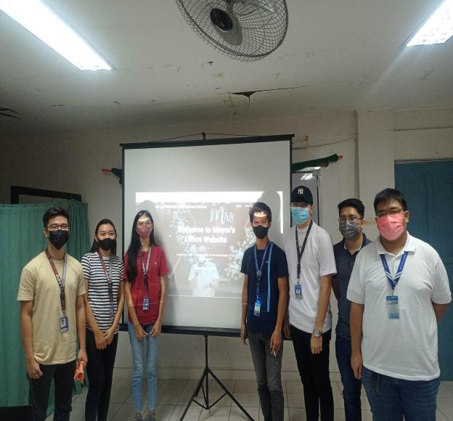
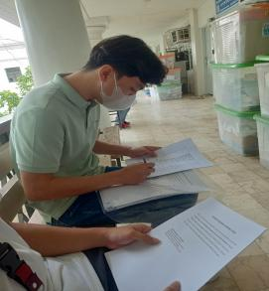
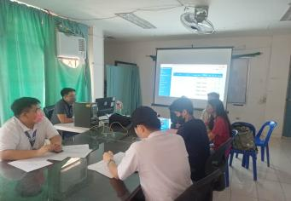
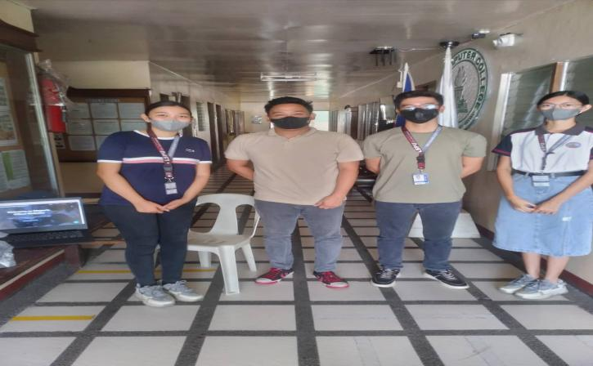

The 10 IT Experts who took part in our testing have provided the following suggestions that the researchers have met and provided feedback, all of which indicate that they are pleased with the system overall.
Feedback of IT Experts for the Black Box Testing
System Evaluators | Name | Feedback
1 | Mr. Rjay H.  Mesina | The developed system is completely functional. The date for the report printed should be included.
2 | Mr. Jayson H.  Palileo | Maximize plugins. The developed system is completely functional.
3 | Mr. Jerome C.  Aguilar | Improve the background color of topnav in homepage. The developed system is completely functional.
4 | Mr. Ariel Jr.  Tobias | The developed system is completely functional and has passed preliminary black box testing.
5 | Mr. John Derel  M. Tuazon | The developed system is completely functional and has passed preliminary black box testing.
6 | Mr. Reinald M.  De Luna | Add the purpose to the table. The developed system is completely functional.
7 | Mr. Errylson  Delgado | There should be a suggested question in the chatbot. The developed system has passed preliminary black box testing.
8 | Mr. Renz Alfred  Litan | Indicate in the alert that the customer must wait for a text message for confirmation. The developed system is completely functional.
9 | Mr. Eugenne Ba D. Sumague | Add the reason of the appointment and contact information for the office if they want to cancel or have any scheduling concerns to the SMS notification. The developed system is completely functional.
10 | Mr. Kim Sacluti | The developed system is completely functional and has passed preliminary black box testing.
Table shows the comments, suggestions, and feedback of the 10 IT experts who have tested the developed system.
During the system testing, the constructed systems were in perfect working order, and the IT experts concluded that the system was capable of performing its intended tasks.
Test case scenario for the client user to request for an appointment
Indicator | No. of Testers | Passed  (Frequency) | Failed  (Frequency) | Percentage
- Click Home | 10 | 10 | 0 | 100%
- Click About | 10 | 10 | 0 | 100%
- Click Contact | 10 | 10 | 0 | 100%
- Click Request Appointment | 10 | 10 | 0 | 100%
- Click Submit | 10 | 10 | 0 | 100%
- SMS Notification | 10 | 10 | 0 | 100%
- Click Chatbot | 10 | 10 | 0 | 100%
The table shows the findings of the IT professionals' black-box testing. The developed system passed all of the IT experts' tests. The results of the ten actual tests performed on the developed system are summarized in the table above. It displays the performance of the tested designed system. The input-output design logic of the created system was divided into seven operations. The first, second, and third processes all have a perfect 10 out of 10 "passed" frequency, which is equivalent to a 100% pass rate. Request Appointment; the fourth step, Submit; the fifth process, SMS Notification; the sixth process, and the eighth process, Chatbot, all got a perfect 10 out of 10 with a 100% passing rate.

Test case scenario for the mayor’s secretary for managing the appointments
Indicator | No. of Testers | Passed  (Frequency) | Failed  (Frequency) | Percentage
- Click Login | 10 | 10 | 0 | 100%
- Click Forgot Password
- Click Notification | 10 | 10 | 0 | 100%
- Click Dashboard | 10 | 10 | 0 | 100%
- Click Appointment List | 10 | 10 | 0 | 100%
- Click Create New | 10 | 10 | 0 | 100%
- Click Search | 10 | 10 | 0 | 100%
- Click View | 10 | 10 | 0 | 100%
- Click Edit | 10 | 10 | 0 | 100%
- Click Send | 10 | 10 | 0 | 100%
- Click File | 10 | 10 | 0 | 100%
- Click Download | 10 | 10 | 0 | 100%
- Click Checkbox | 10 | 10 | 0 | 100%
- Click Schedule | 10 | 10 | 0 | 100%
- Click Request | 10 | 10 | 0 | 100%
- Click Generate Report | 10 | 10 | 0 | 100%
- Click Date | 10 | 10 | 0 | 100%
- Click Filter | 10 | 10 | 0 | 100%
- Click Print | 10 | 10 | 0 | 100%
- Click Refresh | 10 | 10 | 0 | 100%
- Click Account | 10 | 10 | 0 | 100%
- Click Responses List | 10 | 10 | 0 | 100%
- Click Inquiries | 10 | 10 | 0 | 100%
- Click Delete | 10 | 10 | 0 | 100%
- Click Settings | 10 | 10 | 0 | 100%
- Click Set Time Schedule | 10 | 10 | 0 | 100%
- Click My Account | 10 | 10 | 0 | 100%
- Click Logout | 10 | 10 | 0 | 100%
The table shows the findings of the IT professionals' black-box testing. The developed system passed all of the IT experts' tests. The results of the ten actual tests performed on the developed system are summarized in the table above. It displays the performance of the tested designed system. The input-output design logic of the created system was divided into twenty-eight operations. The overall processes all have a perfect 10 out of 10 "passed" frequency, which is equivalent to a 100% pass rate. Overall, the system passed the final testing according to the tester's assessment test using the black box testing. It also demonstrates that the suggested system is highly well-functioning and error-free.
Test case scenario for the administrator staff for managing the appointments
Indicator | No. of Testers | Passed  (Frequency) | Failed  (Frequency) | Percentage
- Click Login | 10 | 10 | 0 | 100%
- Click Forgot Password | 10 | 10 | 0 | 100%
- Click Dashboard | 10 | 10 | 0 | 100%
- Click Appointment List | 10 | 10 | 0 | 100%
- Click Search | 10 | 10 | 0 | 100%
- Click View | 10 | 10 | 0 | 100%
- Click Request | 10 | 10 | 0 | 100%
- Click Approval | 10 | 10 | 0 | 100%
- Click My Account | 10 | 10 | 0 | 100%
- Click Logout | 10 | 10 | 0 | 100%

The table displays the results of the black-box testing performed by IT specialists. All of the IT specialists' tests were passed by the developed system. The table above summarizes the results of the ten actual tests performed on the designed system. It indicates the performance of the system that has been evaluated and created. The developed system's input-output design logic was separated into ten operations. The overall procedures all have a perfect "passed" frequency of 10 out of 10, which is comparable to a 100% pass rate. Overall, the system passed the final testing utilizing black box testing, according to the tester's judgment. It also shows that the proposed system is extremely functional and error-free.

Test case scenario for the mayor for managing the appointments
Indicator | No. of Testers | Passed  (Frequency) | Failed  (Frequency) | Percentage
- Click Login | 10 | 10 | 0 | 100%
- Click Forgot Password | 10 | 10 | 0 | 100%
- Click Dashboard | 10 | 10 | 0 | 100%
- Click Appointment List | 10 | 10 | 0 | 100%
- Click Search | 10 | 10 | 0 | 100%
- Click View | 10 | 10 | 0 | 100%
- Click Approval | 10 | 10 | 0 | 100%
- Click My Account | 10 | 10 | 0 | 100%
- Click Logout | 10 | 10 | 0 | 100%

The table displays the results of the black-box testing performed by IT specialists. All of the IT specialists' tests were passed by the developed system. The table above summarizes the results of the ten actual tests performed on the designed system. It indicates the performance of the system that has been evaluated and created. The developed system's input-output design logic was separated into nine operations. The overall procedures all have a perfect "passed" frequency of 10 out of 10, which is comparable to a 100% pass rate. Overall, the system passed the final testing utilizing black box testing, according to the tester's judgment. It also shows that the proposed system is extremely functional and error-free.

Research Objective No. 3: To evaluate the usability of the Mayor’s Office of Sta. Cruz Laguna Website in terms of satisfaction and evaluation by users.
3.1 Quality Factors
3.2 Perceived Ease of Use
3.3 Perceived Usefulness
3.4 Attitude Towards Using
3.5 Behavioral Intention to Use
3.6 Experience
The researcher did a test with the Mayor's Office of Sta. Cruz, Laguna, and other municipalities use the Technology Acceptance Model, which incorporates quality criteria, perceived ease of use, perceived usefulness, attitude toward using, behavioral intention to use, and experience. The Technology Acceptance Model (TAM) and ISO/ISEC 25010:2011 collaborated on the questionnaire; the researcher utilized TAM as a category and ISO/ISEC 25010:2011 as criteria.

Results for Quality Factors. Technology Acceptance Model in terms of Quality Factor

Indicator | Mean | Standard Deviation | Verbal Interpretation
- APPROPRIATENESS.
- SUITABILITY.
- USER INTERFACE AESTHETICS.
Total Average:

Results for Perceive Ease of Use. Technology Acceptance Model in terms of Perceive Ease of Use

Indicator | Mean | Standard Deviation | Verbal Interpretation
- EFFICIENCY.
- EFFECTIVENESS.
- LEARNABILITY.
Total Average:

Results for Perceive Usefulness. Technology Acceptance Model in terms of Perceive Usefulness
Indicator | Mean | Standard Deviation | Verbal Interpretation
- ACCESIBILITY.
- FUNCTIONALITY.
- OPERABILITY.
Total Average:

Results for Attitude Towards Using. Technology Acceptance Model in terms of Attitude Towards Using

Indicator | Mean | Standard Deviation | Verbal Interpretation
- The developed system will help the users to save time and effort in terms of appointment and scheduling in Mayor’s office.
- The system will be helpful to make appointments , manage appointments and schedule for the Mayor’s Office
- The developed system is reliable in delivering the needs of the user.
Total Average:

Results for Behavioral Intention to Use. Technology Acceptance Model in terms of Behavioral Intention to Use

Indicator | Mean | Standard Deviation | Verbal Interpretation
- I am willing to use the web application to make appointments
- I believe it is recommendable to use the application continuously in the future.
- I am satisfied that the overall functions of the system are clear and understandable
Total Average:

Results for Experience. Technology Acceptance Model in terms of Experience
Indicator | Mean | Standard Deviation | Verbal Interpretation
- The functions of the developed system are working with ease
- The developed system is effective, convenient and easy to use.
- While using the developed system I didn’t encounter any failure or error on its system.
Total Average:

Chapter V

SUMMARY, CONCLUSION AND RECOMMENDATION
This chapter presents the last part of the research that includes the summary and conclusion of the entire study. Also it includes all the recommendations that the system needs for further improvements in the futures

SUMMARY

CONCLUSION
Based on the results of the study the following conclusion were drawn:
1.
2. The system helped the clients of mayor’s office to make appointments.
3. The system helped the mayor’s secretary and admin staff to manage mayor’s appointment.
4. The system attained the main objective and the concept of the entire system.

RECOMMENDATION
The following were recommended
- The researcher may improve the system by adding features in order to lessen the time and effort of the clients to go to mayor’s office
2.
3.

