Object name: Bowl (artificial)

Description:

The object has the shape of a paraboloid with a flat bottom on which it can stand. It has rotational symmetry around the vertical y-axis, and its bottom is narrower than its top. The bottom and the sides are smooth surfaces, and the top is open. It can contain items inside, and items can only be inserted and taken out of it through the open space on the top.

States:

The object is usually in one of the following states:

* It stands on a flat surface, such as a table, with its bottom surface facing downward and is opening facing upward. In this state, items can be put inside and taken outside of the bowl. It can be either full or empty.
* The user holds the object, either by holding its sides with one or both hands (if it is full), holding its top edge, or lifting it by supporting its bottom surface. (Cannot be caught)
* It can be flipped upside down, either to remove its contents or to cover a smaller item, in which case it also stands on a flat surface, such as a table, with its opening facing downward and its bottom surface facing upward.

Components: surface, interior

Actions: If I grab the **side surface** or the **bottom surface** and push upwards, the entire bowl and its contents (if any) will shift upwards.

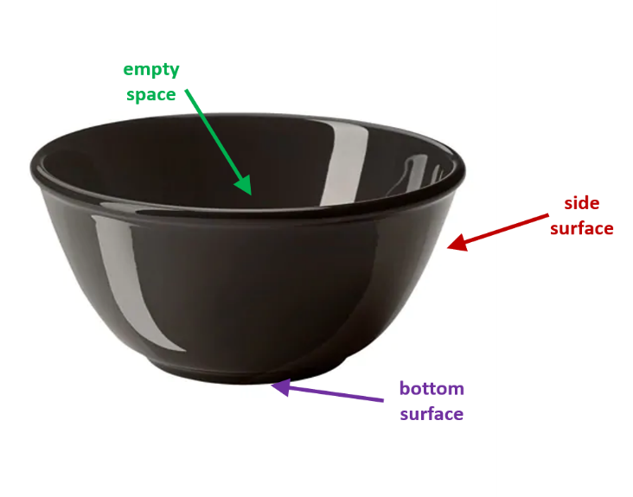If the bowl is full and I rotate it around a horizontal axis, its contents will fall out.