**Dyno Simulation**

The purpose of this project is to simulate different stages of a dyno and chart them on the graph. The different results are not an actual representation of an actual dyno.

**Getting Started**

This documentation will show the tests ran in this application. An executable file will be issued in a new version.

## Running the software

When the application is loaded, a stock dyno will be run automatically.

**Note: Let each dyno instance run completely before running a new dyno**

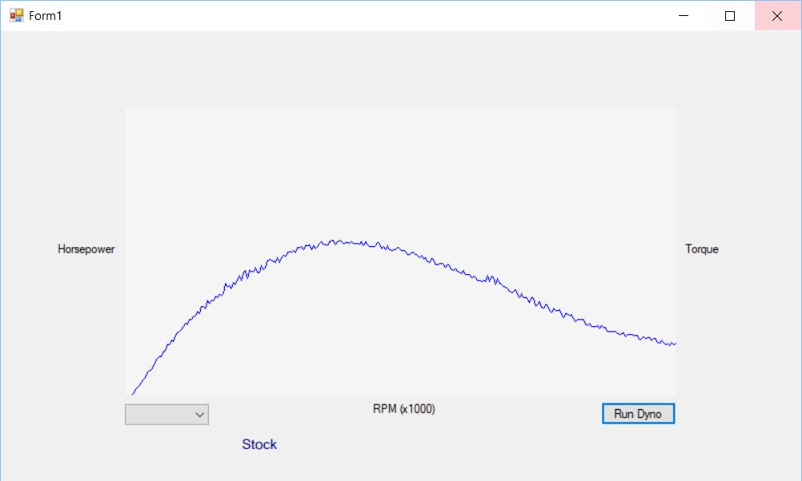

Stage 1 graph after being run.

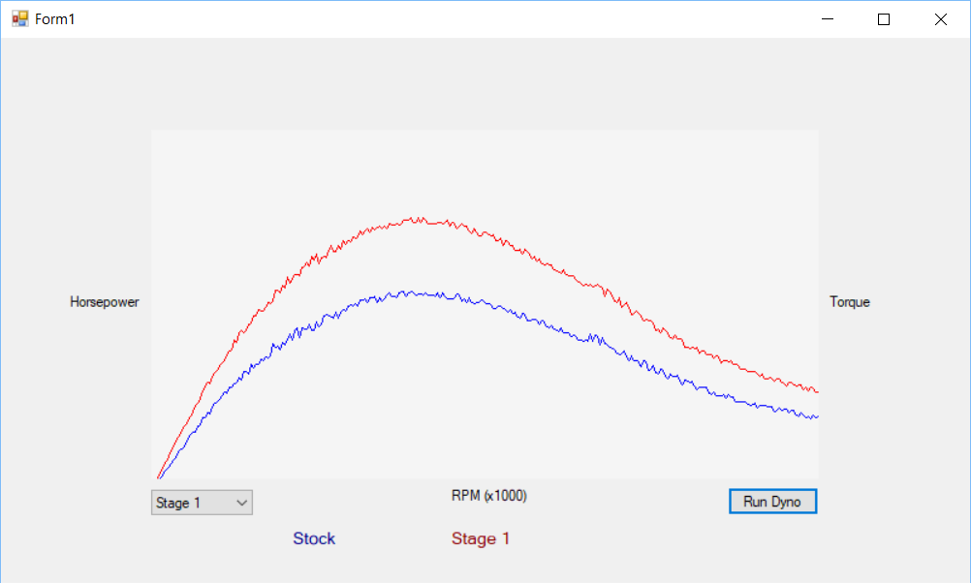

Stage 2 graph after being run.

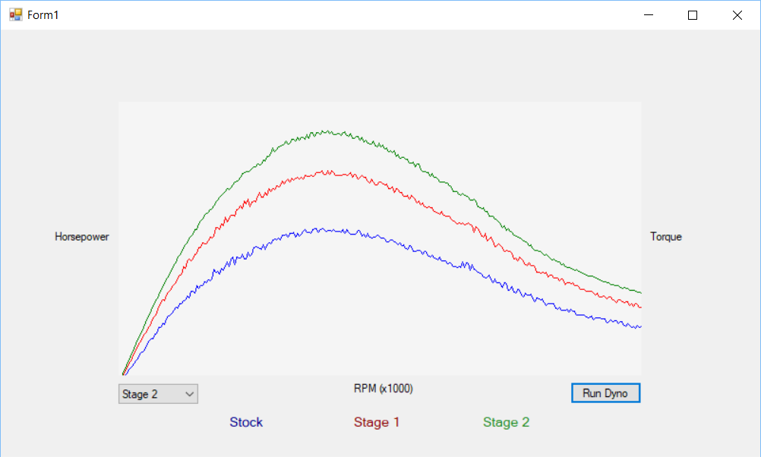

**Built With**

* Visual Studio 2017

**Authors**

* **Vernon Williams** - [Voxenn](https://github.com/Voxenn)

**Acknowledgments**

* Cobb U
* Microsoft
* edX