National University of Singapore
[Course Code] — Smart Industries and Digital Transformation

Open Source 3D Bin Packing Solution
Interim Report

Group Members:
Chai Jie Shen (A0211396H)
Voycevestern Peh (A0329847L)
Rajaram Jayaraman (A0228124M)

Date: [Submission Date]

1. Introduction

1.1 Project Scope
This project develops an open source 3D bin packing solution for iHub Solutions. Given an order's items, a configurable carton catalogue, and a set of packing rules, the solver recommends which carton or cartons to use, where each item is placed, and in what orientation — while minimising the number of cartons used and respecting weight, buffer, and fill constraints.
The scope deliberately excludes reproducing iHub's historical packing decisions exactly. iHub supplied 2,000 masked historical order records as a development benchmark, but the project's own documentation is explicit that "the goal is not to reproduce every historical output exactly... the goal is to build a practical heuristic solver that is fast, explainable and measurable." The historical data is a reference point for plausibility, not a ground truth the solver is graded against line by line.
In scope: a Python package exposing a single solve_order() entry point; support for a configurable box catalogue (not hard-coded to one set of cartons); orientation handling including VerticalRotation=0 (upright-only) items; enforcement of per-carton weight limits, a configurable dimensional buffer, and a fill-percentage cap above a configurable item-count threshold; multi-carton allocation when one carton is insufficient; and an independent validator that checks every recommendation before it is returned.
Out of scope for this phase: a production web API or service layer (the team's own roadmap explicitly defers a FastAPI layer until after the core engine is stable); a provably optimal (exact) solver, given that 3D bin packing is strongly NP-hard (Martello et al., 2000); and reproducing iHub's exact historical carton choices where a different valid choice is equally or more efficient.

1.2 Company Overview
iHub Solutions Pte Ltd is a Singapore-headquartered third-party logistics (3PL) and warehousing provider, founded in 2000 by Managing Director Koh San Joo (Enterprise Singapore, n.d.; iHub Solutions, n.d.-a). The company holds the "Singapore Quality Class with Innovation Niche" certification from Enterprise Singapore and operates warehouses across four markets — Singapore, Malaysia, Hong Kong, and Thailand — offering smart warehousing, contract logistics, last-mile delivery, and e-commerce fulfilment services to clients in fashion, healthcare, and e-commerce (iHub Solutions, n.d.-b; LinkedIn, n.d.). The company employs an estimated 51–200 staff and is registered in Singapore under UEN 200006937C (Tracxn, n.d.).
iHub Solutions markets itself explicitly around digital transformation: its own website describes fully digitalised logistics processes, a proprietary Virtual Logistics System and Cloud Transport System for real-time event tracking across the fulfilment chain, and active exploration of artificial intelligence and machine learning for route optimisation and other logistics applications (iHub Solutions, n.d.-c). This capstone sits squarely within that stated direction: the 3D bin packing problem it addresses — recommending which carton(s) to use and where items go inside them — is one concrete, well-scoped piece of the "smarter logistics" positioning iHub already promotes to its own customers.
The relevance to iHub is direct rather than incidental. As described in Section 2, iHub's current B2C fulfilment operations rely on a third-party proprietary API for carton selection, creating both a technical dependency (the API cannot be customised for iHub's own evolving constraints, such as vertical-rotation handling or fill-percentage rules) and an economic one (pay-per-use pricing that scales linearly with order volume, even though iHub already operates its own warehouse infrastructure capable of hosting the computation at a lower marginal cost). A self-hosted, explainable 3D bin packing solution addresses both constraints at once, and is consistent with the digital-transformation trajectory iHub has already publicly committed to.

2. Project Formulation
iHub Solutions supplied a reference dataset of 2,000 masked historical order request-and-response pairs, each describing a set of items (dimensions, weight, quantity, and whether the item must remain upright) and the carton(s) that were historically selected to pack them. The dataset uses a fixed catalogue of named carton types (Box2 through Box9), with packing governed by a small set of configurable rules: a per-axis dimensional buffer (0 mm length, 0 mm width, 6 mm height in the supplied configuration), a maximum carton weight (20 kg), and a fill-percentage cap (70%) that only applies once an order exceeds a configured item-count threshold (6 items).
The core problem is a variant of the three-dimensional bin-packing problem (3D-BPP): given a set of rectangular items and a set of rectangular bins (cartons) of known sizes, assign every item to a bin and a non-overlapping position within that bin, using the fewest bins possible, while respecting weight and orientation constraints. 3D-BPP is strongly NP-hard (Martello et al., 2000), which rules out an exact solution at the scale and latency the business requires; the project therefore formulates the problem as a heuristic search rather than an exact optimisation.
The problem was formulated around three explicit requirements, agreed before implementation began:
- Correctness over resemblance to history — a packing is accepted if it is geometrically feasible (no overlap, in-bounds, correct orientation, within weight and fill limits), independent of whether it matches iHub's historical choice for that order.
- Explainability — every recommendation must report which carton(s) were used, which items went where, in what orientation, the packed weight, the utilisation percentage, and the status (packed, partially packed, or failed), not just a final carton count.
- Measurability — runtime must be tracked per order (median, 95th-percentile, and maximum) so that solver changes can be evaluated on both packing quality and latency, not quality alone.
These requirements, together with the dataset's own fields, define the solver's public contract: it accepts order data, a box catalogue, and a configuration object, and returns an explainable packing result or a clear statement of which items could not be packed.

3. Project Schedule
The team adopted a workstream-based split rather than a strict phase-based handoff: each of the three members owns a vertical slice of the problem end-to-end, reducing the number of cross-team blocking dependencies. Workstream A owns data, benchmarking, and evaluation; Workstream B owns the core packing algorithm; Workstream C owns the engine interface, configuration, and integration. All three agreed a shared input/output schema and definition of a valid pack in a joint Sprint 0 session before work diverged.
Week | Milestone | Workstream A (Data/Eval) | Workstream B (Core Engine) | Workstream C (Interface)
1 | Kickoff & Sprint 0 | Dataset spec, initial EDA | Survey algorithm approaches | Repo scaffold, interface skeleton
2 | Foundations | Extend EDA | Orientation logic, heuristic v1 | Config loader
3 | First working slice | Evaluation harness v1 | Single-box packing | Output-schema formatter v1
4 | — | Fill-rule checks, edge cases | Multi-box allocation | Wire single-box path, unit tests v1
5 | — | Edge/failure case generation | Carton-count minimisation + tiebreak | Integrate multi-box path
6 | Integration checkpoint 1 | Runtime harness | Fix integration issues | Run B's engine through C's interface
7 | Full benchmark run | Compile benchmark results | Address failure patterns | Polish explainability, usage docs
8 | Mid-report presentation | Joint: finalise mid-report, deliver presentation
Table 1. Fifteen-week schedule, Weeks 1–8 (interim-report horizon).
Weeks 9–15 (not reproduced in full here) cover post-feedback refinement, hardening, documentation finalisation, report writing, and the final presentation, with Week 15 as the project close. The two integration checkpoints (Weeks 6 and 8) are the points at which the schedule is designed to be compressed first if any workstream slips, rather than compressing the final milestone weeks.

4. Literature Review and Industry Background

4.1 Academic Literature on Three-Dimensional Bin Packing
The three-dimensional bin-packing problem has a well-established operations research literature. Martello et al. (2000) formalised the problem, proved it strongly NP-hard, and proposed an exact branch-and-bound algorithm alongside approximation heuristics, establishing the baseline complexity result this project's heuristic approach is designed around: an exact solution is not practical at production scale, so a fast, explainable heuristic is the appropriate engineering choice.
Lodi et al. (2002) extended this with heuristic algorithms specifically aimed at practical runtime, comparing constructive and improvement-based approaches for the 3D case and showing that well-designed constructive heuristics can approach near-optimal solutions far faster than exact methods — directly motivating this project's own choice of a constructive, non-exact placement strategy.
The project's core geometric mechanism is the extreme-point (EP) placement rule introduced by Crainic, Perboli, and Tadei (2008). Rather than exhaustively searching all empty space inside a partially filled carton, the EP rule tracks a small set of candidate "corner" points exposed by already-placed items — specifically, the three points exposed to the right of, behind, and above each newly placed item — and tries subsequent items only at those points. Crainic et al. (2008) show this rule is independent of the specific packing problem and generalises cleanly to additional constraints such as fixed item positions, which is why it was selected as the shared geometric engine for both the First Fit and Best Fit strategies compared in this project rather than designing two unrelated placement mechanisms.
Within this literature, First Fit and Best Fit are standard bin-selection policies layered on top of a placement mechanism: First Fit selects the first (often smallest) bin that accommodates an item or an order, while Best Fit selects the bin that is left with the least residual capacity. A relevant and non-obvious finding from the author's own independent implementation work (Section 5) is that, under a formulation where only bins proven to hold the entire remaining item set are ranked, First Fit and Best Fit are mathematically equivalent — the smallest feasible bin and the fullest feasible bin are the same bin, because the packed volume is identical across all feasible candidates. This is consistent with the literature's treatment of First Fit and Best Fit as closely related greedy policies (Lodi et al., 2002) but sharpens it into a provable equivalence for that specific "rank only complete fits" formulation.
The team's shared repository has since moved beyond this formulation. As of Pull Request #11 (6 October 2026), the weaker First Fit mode was removed entirely, the former Best heuristic was promoted to production Fast, and a new, exact-assisted Best mode was added using a bounded CP-SAT solver — a constraint-programming technique capable of proving optimality within a time budget rather than only approximating it. This moves the shared implementation from the purely heuristic territory of Lodi et al. (2002) toward the exact branch-and-bound tradition of Martello et al. (2000), but bounded by a runtime budget (5,000 ms by default, per Pull Request #40) so that an unprovable case falls back to the Fast result rather than blocking indefinitely. This is discussed further in Section 5.3.

4.2 Industry Background: 3D Bin Packing in Warehouse Logistics
In industry, the 3D bin packing problem this project addresses is a well-recognised and commercially significant one. Industry analysis reports that a shipping box can routinely contain 50% to 90% empty space when carton selection is not optimised, and that automated box-selection optimisation can reduce freight costs by 10% to 25% depending on order complexity and shipping zone (Logistics Viewpoints, 2025; PackChain, n.d.). The Packaging Machinery Manufacturers Institute is cited as reporting that standardising and automating box selection can cut packaging costs by 12% to 18% (as cited in Logistics Viewpoints, 2025).
Commercial 3D bin packing platforms (e.g., Shipium, ShipBob, PackNet Cube, MagicLogic) converge on the same core technique this project implements: given accurate item dimensions, weight, and a box catalogue, evaluate feasible box combinations and select the one minimising wasted volume, often integrated directly into a warehouse management system so the decision is made before picking begins (3DBinPacking, 2025; PackChain, n.d.). This validates the practical relevance of the capstone's chosen problem: it is not an academic exercise but a directly commercialisable capability, with documented case studies reporting double-digit percentage reductions in shipping cost and void-fill material after implementation (3DBinPacking, 2025).
For iHub Solutions specifically, this is not a hypothetical industry trend but a direct operational cost. As a 3PL serving e-commerce, fashion, and healthcare clients across four markets (Section 1.2), every percentage point of wasted carton volume compounds across iHub's own order volume and is ultimately passed through to the clients whose fulfilment iHub manages. A 3D bin packing capability iHub owns and can tune — rather than one rented at a per-call price from a third party — also fits directly into the Virtual Logistics System and AI/ML-driven optimisation iHub already advertises to its customers (iHub Solutions, n.d.-c), making this capstone a plausible candidate for direct integration rather than a purely academic exercise.

5. Data Gathering, Methodology and Analysis

5.1 Dataset
The supplied dataset contains 2,000 masked real iHub order request-and-response pairs in a single JSON array. Each record pairs an input (order items, box catalogue, and packing parameters) with iHub's historical output (the carton(s) selected and their reported utilisation) and a recorded end-to-end latency in milliseconds. Item and order identifiers are masked; no personally identifiable information is present. All 2,000 historical records report a successful pack with no unpacked items — the dataset's own documentation flags this as a limitation the team must compensate for by designing its own edge and failure cases, since the supplied data cannot demonstrate how the solver should behave when a pack is infeasible.
The initial exploratory data analysis (Week 1) established several findings that directly shaped later design decisions. Order complexity, carton usage frequency, and utilisation were profiled across the full 2,000 records. Most significantly, the EDA found that the historical data does not consistently enforce the stated 70% fill-rule threshold — some historical orders are packed above 70% utilisation despite qualifying for the cap. This finding directly supports treating the historical dataset as a benchmark rather than as ground truth: a solver that strictly enforces the documented business rule will, by design, sometimes disagree with history on both carton count and carton choice without being wrong.

5.2 Methodology
The packing engine implements extreme-point placement (Crainic et al., 2008) in the following sequence for each order:
- Expand each order line's Quantity field into individual physical units.
- Filter out any unit that cannot fit any catalogue box in any permitted orientation, flagging it as unpacked with a stated reason.
- For each candidate box, attempt placement using extreme-point candidate positions, trying four item orderings (by volume, longest dimension, largest face, and upright-first) combined with four placement policies, stopping at the first combination that places every remaining item.
- Select a box via a bin-selection rule — First Fit (smallest box that holds everything) or Best Fit (box left fullest) — among boxes proven to hold the complete remaining set.
- When no single box holds everything, branch on the most promising boxes and recurse on the leftover items, keeping whichever full plan uses the fewest cartons, then the least total carton volume.
- Independently validate the final result: check bounds, overlap, support, upright-orientation compliance, weight limits, and the fill-percentage rule, before returning it.
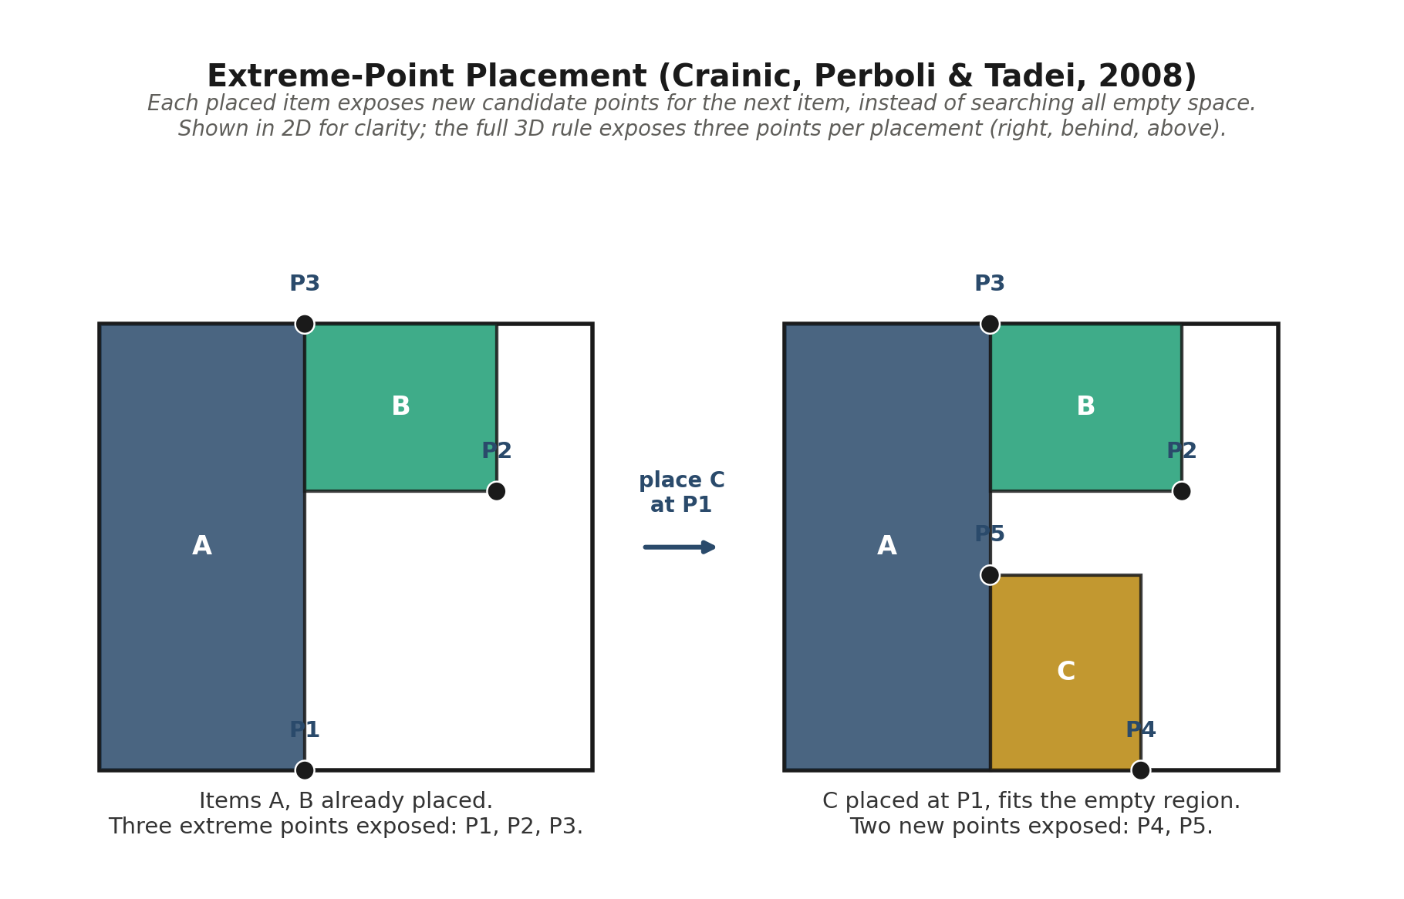
Figure 1. Extreme-point placement: each placed item exposes new candidate points for the next item.
This methodology was implemented twice in parallel for comparison. The author independently built two standalone Python modules (packer_first_fit.py and packer_best_fit.py) sharing the same placement engine and differing only in a simple bin-selection rule (smallest feasible box vs. fullest feasible box). The team's shared GitHub repository took a different path: an initial pluggable package (src/bin_packing_3d, Pull Request #10) originally mirrored the same First Fit / Best Fit split, but was substantially revised in Pull Request #11 (6 October 2026) to remove First Fit, promote the former Best heuristic to production Fast, and add a genuinely exact-assisted Best mode using a bounded CP-SAT solver. The two codebases are therefore no longer architectural parallels of each other, but this is treated as a useful rather than a problematic divergence: the author's simpler First-Fit-vs-Best-Fit comparison (Section 5.3) demonstrates why a naive "rank only complete fits" formulation cannot differentiate the two strategies, which is precisely the limitation the shared repository's CP-SAT approach was built to overcome.

5.3 Analysis and Results
The author's standalone engine was run against the full 2,000-order dataset for both the First Fit and Best Fit variants. All 2,000 orders packed successfully with zero feasibility violations under the independent validator in both runs. Table 2 summarises the comparison against the historical benchmark.
Metric | First Fit | Best Fit | Historical
Orders packed / 2,000 | 2,000 | 2,000 | 2,000
Feasibility violations | 0 | 0 | n/a
Total cartons used | 2,214 | 2,214 | 2,134
Same carton count as historical | 1,916 orders (95.8%) | 1,916 orders (95.8%) | —
Same carton mix as historical | 85.7% of orders | 85.7% of orders | —
Average utilisation | 47.0% | 47.0% | 47.7%
Runtime — median | 3.35 ms | 3.31 ms | 187.25 ms
Runtime — 95th percentile | 61.55 ms | 63.07 ms | 442.34 ms
Runtime — maximum | 1,026 ms | 1,001 ms | 2,615 ms
Table 2. Full-dataset (2,000-order) results, author's standalone engine vs. historical benchmark.
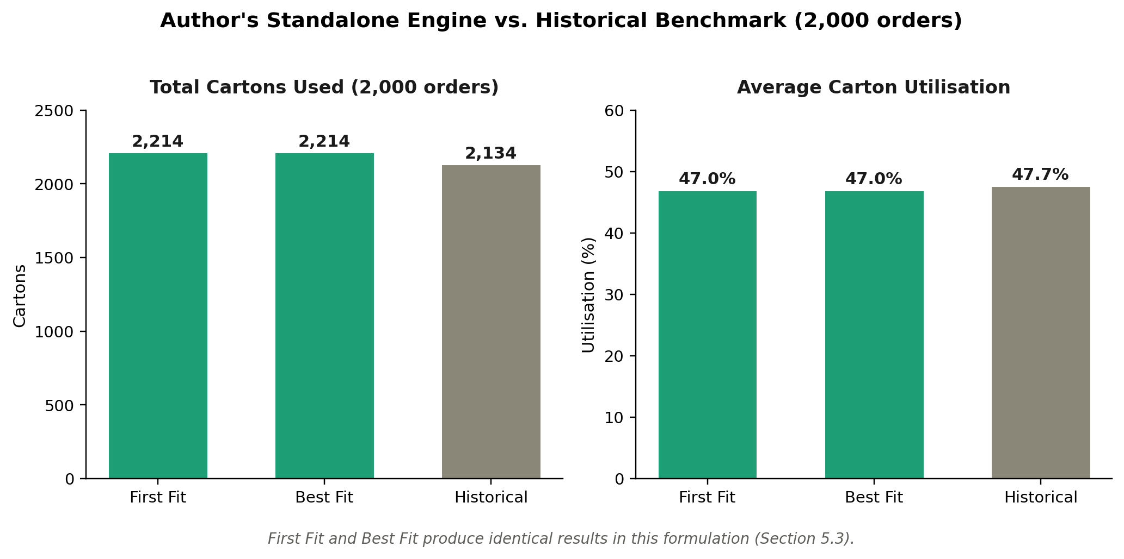
Figure 2. Total cartons used and average utilisation, First Fit vs. Best Fit vs. Historical (2,000 orders).
A notable methodological finding emerged from this analysis: First Fit and Best Fit produced byte-for-byte identical results on every one of the 2,000 orders. Tracing this to the selection logic shows it is not a coincidence but a mathematical consequence of the formulation used: both strategies only rank boxes already proven to hold the entire remaining item set, and for any such box the packed volume is fixed (it is the whole remaining order), so the smallest box by volume and the fullest box by utilisation are necessarily the same box. The two strategies only have the opportunity to diverge in how partial (multi-carton) candidates are ranked during the recursive search, and the current implementation applies an identical fixed ranking rule there regardless of the configured strategy. This is reported as a genuine interim finding rather than a defect: it identifies precisely where a future Best Fit implementation would need to diverge from First Fit to produce different packing behaviour. As Section 5.4 describes, the team's shared repository has since resolved this exact gap by replacing the heuristic split with a CP-SAT exact-assisted Best mode.
The engine's result was also stress-tested for a property not directly required by the brief but material to deployment confidence: independence from input item order. Across 20 randomised shuffles of each of the 29 sample orders tested, the engine produced identical carton counts, carton choices, and unpacked counts in every trial (0 of 29 orders showed any sensitivity to input ordering). This is expected by construction — the placement search re-sorts units internally by four fixed orderings regardless of the order items arrive in — but it is valuable to confirm empirically rather than assume, since a solver whose output depended on an incidental upstream ordering would be unsuitable for production use.

5.4 Update: Shared Repository Benchmark (as of 10 October 2026)
The position described above has changed materially since the author's standalone run. The shared GitHub repository has since run its own full 2,000-order benchmark and reports a result its simpler sibling (Section 5.3) could not produce: a genuine, non-trivial divergence between Fast and its new exact-assisted Best mode. Per Pull Request #11 (6 October 2026), on the development benchmark Best improved on Fast's result on 404 of 2,000 orders and was worse on none; restricted to the 1,817 historical iHub references that obey the dataset's own fill-percentage cap, Best matched or beat the historical carton choice on every case (better on 67, equal on 1,750, worse on 0). Best's median latency was reported as lower than the recorded historical latency, though its 95th-percentile latency was higher, attributed to cases that consumed the full bounded proof-search budget before returning. Pull Request #40 (9 October 2026) subsequently set the production default runtime budget to 5,000 ms and added explicit result provenance (whether a Best result came from a proven exact calculation or a fallback to the Fast result), directly closing the runtime-enforcement gap raised in this report's prior revision.
Two caveats are carried forward from the repository's own documentation rather than omitted. First, the repository owner's own PR description states plainly: "The 2,000 orders informed development, so this is not an independent holdout; a frozen, blinded holdout is still required before claiming generalization" (Pull Request #11) — the 404-order improvement figure describes fit to the development set, not generalisation to unseen orders, and should be reported to stakeholders with that distinction intact. Second, a later correction (Pull Request #49, 10 October 2026) explicitly states that "the notebook's incorrect largest-carton tiebreaker is removed" from this same benchmark-comparison logic. Because this report's access to the repository is read-only and the live README could not be freshly re-rendered at the time of writing (an automated fetch returned a stale cached copy pre-dating Pull Request #11), the 404/67/0 figures above should be treated as the most recently confirmed figures from Pull Request #11 rather than as re-verified against Pull Request #49's correction. The team should re-confirm these headline numbers directly from the current README before they are repeated in the final report.

6. Interim Findings and Recommendation

6.1 Interim Findings
- The core packing engine is functionally complete and independently validated. Both the author's standalone implementation and the team's shared GitHub package implement orientation handling, weight limits, the configurable buffer, the fill-percentage rule, single-carton placement, and multi-carton allocation, with zero feasibility violations found across a full 2,000-order run of the standalone engine.
- First Fit and Best Fit are mathematically equivalent in a naive "rank only complete fits" formulation — and the team's own shared repository independently reached the same conclusion. The author's standalone engine found this empirically (identical results on all 2,000 orders) and confirmed it analytically. The shared repository's own engineering history corroborates it from the opposite direction: it replaced that formulation entirely (Pull Request #11) with a CP-SAT exact-assisted Best mode specifically because the simpler heuristic split could not reliably differentiate from Fast.
- The shared repository's new exact-assisted Best mode is a genuine, measured improvement over Fast. Per Pull Request #11, Best improved on Fast's carton plan for 404 of 2,000 development orders and was worse on none; against the subset of historical references that obey the dataset's own fill cap, Best matched or beat history on all 1,817 comparable orders. This is the strongest evidence to date that the project's optimisation objective (fewer cartons, then less total carton volume) is being met in practice, not just in design.
- A realistic efficiency gap exists against the historical benchmark for the simpler, author-built engine. The standalone First-Fit/Best-Fit engine uses 2,214 cartons against history's 2,134 (3.7% more) and matches history's exact carton mix on 85.7% of orders. Given that the EDA confirmed history does not strictly follow its own fill-rule, some of this gap reflects the solver correctly enforcing a rule history does not consistently honour, not solver inefficiency.
- The engine is substantially faster than the historical system. Median runtime of ~3.3 ms against history's ~187 ms for the standalone engine, and a reported lower median latency than history for the shared repository's Best mode, suggest the project's speed objective is comfortably met; the shared repository's 95th-percentile latency is higher than its own median because some orders consume the full bounded proof-search budget, which is an expected and now-documented trade-off rather than an anomaly.
- Project management is ahead of the published schedule on the core-engine workstream, and the two gaps flagged in the prior revision of this report are now closed. Against the 15-week schedule, work corresponding to Weeks 1–7 (through "address failure patterns from full run") now has merged evidence in the shared repository as of Week 4–5 of the published schedule. The runtime-budget enforcement gap is closed (Pull Request #40, 5,000 ms default with explicit fallback provenance) and the full 2,000-order benchmark has been run (Pull Request #11, refined in Pull Request #49). The new open item is independent validation: the repository owner's own words are that "a frozen, blinded holdout is still required before claiming generalization," and the most recent benchmark correction (Pull Request #49) has not yet been independently re-verified by this report's author.

6.2 Recommendation
Three recommendations follow directly from the findings above and are proposed for the remainder of the project:
- Re-verify the current headline benchmark numbers directly from the live repository before they are repeated in the final report. Pull Request #49 (10 October 2026) explicitly corrected "an incorrect largest-carton tiebreaker" in the same benchmark-comparison logic that produced the 404-orders-improved figure in Pull Request #11. This report cites the Pull Request #11 figures because they are the most recently confirmed in writing, but the team should pull the current README/benchmark CSV directly (this report's automated access returned a stale cached page) and confirm whether the headline numbers moved after the correction.
- Obtain a frozen, blinded holdout before claiming the Best mode generalises. This is not the author's judgement but the repository owner's own stated caveat in Pull Request #11: the 2,000-order benchmark "informed development, so this is not an independent holdout." The team's own edge/failure cases (Section 7) are a natural source of held-out orders the solver has not been tuned against.
- Treat the standalone engine's historical 85.7%/3.7% gap as a starting point for targeted improvement, not a pass/fail bar, and report it alongside the shared repository's stronger CP-SAT-based results. Given the EDA's own finding that history does not strictly enforce its documented fill rule, the team should report carton-count and utilisation gaps alongside an explicit accounting of how many historical orders violate the 70% rule the new solver correctly enforces, so reviewers can distinguish genuine solver inefficiency from principled rule compliance. The shared repository's Best mode (zero historical losses on fill-cap-compliant orders) should be the headline figure; the author's simpler engine is better framed as a methodological baseline.

7. Further Work Needed
Several items from the previous revision of this report (runtime-budget enforcement, the full-dataset benchmark, and differentiating Best from Fast) are now resolved in the shared repository per Pull Requests #11 and #40 (Section 5.4). The following items are confirmed open, drawn directly from the repository's own stated follow-up work and from gaps identified during this update:
- Obtain an independent, blinded holdout benchmark. The repository owner's own words: the 2,000-order benchmark "informed development, so this is not an independent holdout; a frozen, blinded holdout is still required before claiming generalization" (Pull Request #11). This is now the single most important open validation gap.
- Re-verify the headline benchmark figures after the Pull Request #49 tiebreaker correction. Confirm whether the 404-orders-improved, 0-orders-worse figures from Pull Request #11 changed after the "incorrect largest-carton tiebreaker" fix merged four days later; this report could not re-render the live README to confirm directly (Section 5.4).
- Design and execute the team's own edge and failure cases. Since all 2,000 supplied historical records pack successfully, the unpacked-item and partial-pack code paths remain untested against genuinely infeasible input; oversized items, over-weight orders, and infeasible combinations must be authored by the team, and would also serve as candidate material for the blinded holdout above.
- Finalise the evaluation scorecard and results write-up. Owned by Workstream A per the team's work-split; the full-dataset benchmark that this depended on is now available, so this is unblocked.
- Confirm Workstream C's integration and test-suite ownership is stable against the now-revised Fast/Best architecture. The interface layer was originally wired against the First Fit/Best Fit split retired in Pull Request #11; confirm the explainable-output formatter and config layer were updated consistently with the new Fast/Best API rather than left referencing the retired terminology.
- Decide whether the author's standalone engine remains part of the team's deliverable. Now that the shared repository has a materially stronger Best mode (CP-SAT-based, proven improvements on real orders), the team should explicitly decide whether the standalone First-Fit/Best-Fit scripts are retained as a documented baseline/teaching artefact or retired in favour of a single shared engine for the final report.

8. Project Management
The team is tracked against the 15-week schedule (Section 3) using a shared Gantt chart with per-task status (Not Started, In Progress, Completed) and supporting evidence notes, cross-checked against the shared GitHub repository's pull-request history. As of Week 4 (the current reporting point), status is as follows:
Workstream | Task | Status | Evidence
A | Evaluation harness v1 | Completed | Standalone scripts; shared-repo benchmark_comparison.py (PR #49) centralises eligibility/ranking/outcomes
A | Runtime harness + full 2,000-order run | Completed | PR #11, #40: full 2,000-order Fast/Best/historical run with runtime provenance
B | Algorithm selection + rotation logic | Completed | PR #6, #7
B | Single-box 3D packing | Completed | PR #8, #9, #10
B | Multi-box allocation + carton-count minimisation | Completed | PR #11: CP-SAT Best mode optimises carton count, then volume; improved Fast on 404/2,000 orders
B | Fix failure patterns from full run | In Progress | Full run complete (PR #11); independent blinded holdout still required (PR #11's own stated caveat)
B | Runtime optimisation | Completed | PR #40: 5,000 ms default budget enforced, with explicit proof/fallback provenance
C | Repo scaffold + config loader | Completed | PR #7
C | Output formatter + single-box wiring | Completed | PR #10
C | Multi-box integration + test suite | In Progress | 81 tests passing (PR #11); confirm formatter updated for retired First Fit terminology
Table 3. Gantt status as of Week 5, cross-checked against GitHub pull requests #6–#49 (most recent: 10 October 2026).
The core-engine workstream (B) is now substantially ahead of its published schedule: work scheduled through Week 9 (runtime optimisation) has merged evidence in the shared repository, against a published schedule that places this reporting point in Week 4–5. The team's focus should now shift entirely from "build" to "validate": the repository owner's own documentation identifies the lack of an independent, blinded holdout as the primary remaining risk, not any missing engine capability.
Risk register: the two items most likely to affect the Week 6 and Week 8 integration checkpoints are now (1) the unverified effect of the 10 October tiebreaker correction (Pull Request #49) on the headline benchmark numbers cited in Section 5.4 and Section 6.1, which should be confirmed directly from the live repository before the mid-report, and (2) the absence of a frozen, blinded holdout, without which the team cannot yet claim the Best mode's gains generalise beyond the development set it was tuned against. Both are recommended to close before the Week 8 mid-report (Section 6.2).

References
3DBinPacking. (2025, June 16). Cartonization software: Optimizing packaging for cost and efficiency. https://www.3dbinpacking.com/en/blog/cartonization-software-how-it-works/
Crainic, T. G., Perboli, G., & Tadei, R. (2008). Extreme point-based heuristics for three-dimensional bin packing. INFORMS Journal on Computing, 20(3), 368–384. https://doi.org/10.1287/ijoc.1070.0250
Enterprise Singapore. (n.d.). iHub Solutions: For local logistics SME, going digital is logical. Retrieved October 2026, from https://www.enterprisesg.gov.sg/resources/inspiring-stories/ihub-solutions
iHub Solutions. (n.d.-a). About us [LinkedIn company page]. Retrieved October 2026, from https://sg.linkedin.com/company/ihub-solutions
iHub Solutions. (n.d.-b). 3PL fulfilment in Singapore. Retrieved October 2026, from https://ihubsolutions.com/blog/3pl-fulfilment-singapore
iHub Solutions. (n.d.-c). Redefining logistics with AI and ML. Retrieved October 2026, from https://ihubsolutions.com/ai-machine-learning
Logistics Viewpoints. (2025, October 30). High impact ways to optimize your shipping operations: Empower your team, exceed expectations, and transform challenges into opportunities. https://logisticsviewpoints.com/2025/10/30/high-impact-ways-to-optimize-your-shipping-operations-empower-your-team-exceed-expectations-and-transform-challenges-into-opportunities/
Lodi, A., Martello, S., & Vigo, D. (2002). Heuristic algorithms for the three-dimensional bin packing problem. European Journal of Operational Research, 141(2), 410–420. https://doi.org/10.1016/S0377-2217(02)00134-0
Martello, S., Pisinger, D., & Vigo, D. (2000). The three-dimensional bin packing problem. Operations Research, 48(2), 256–267. https://doi.org/10.1287/opre.48.2.256.12386
PackChain. (n.d.). Cartonization software. Retrieved October 2026, from https://packchain.io/cartonization-software/
Tracxn. (n.d.). iHub Solutions: Company profile. Retrieved October 2026, from https://tracxn.com/d/companies/ihub-solutions/__aaCZi1l-GdXjZ4q9aeGUWtYazoIriUNaEaMdHLD1aPk
Voycepeh. (2026). ihubsolutions-capstone-project [Source code repository]. GitHub. https://github.com/Voycepeh/ihubsolutions-capstone-project

Appendices

Appendix A: Data Source
Primary dataset: data_sample_v1.json, 2,000 masked iHub order request/response records, supplied by iHub Solutions and held under data/raw/ in the team's shared repository. Units: millimetres for dimensions, kilograms for weight. Carton catalogue: 6 fixed types in the supplied sample (Box2, Box4, Box5, Box6, Box8, Box9); MVP Plan.md references a 7th (Box3) not present in the sampled catalogue, an open discrepancy carried over from Week 1. Note: as of Pull Request #25 (9 October 2026), the former docs/dataset-specification.md was removed and consolidated into data/raw/README.md and CHANGELOG.md as the authoritative v1/v2 dataset reference — Pull Request #49 subsequently refers to a "2,000-order v2 benchmark," indicating the reference dataset has itself been revised since this report's original data-gathering pass. The exact nature of the v1→v2 change was not independently confirmed for this report and should be checked against the current CHANGELOG.md before the final report is written.

Appendix B: Solver Architecture — Author's Standalone Engine
Figure B1 illustrates the control flow of the author's standalone extreme-point packing engine (pack_order()), described in prose in Section 5.2: expand quantities, filter impossible items, attempt single-box placement across every catalogue box, and branch into a recursive multi-box search when no single box succeeds, before compiling the final explainable result.
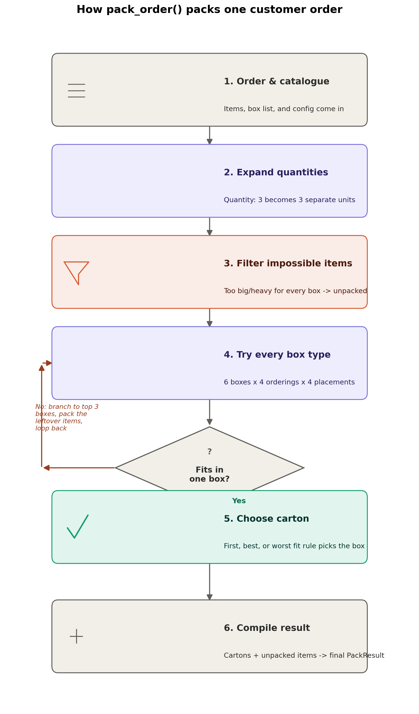
Figure B1. Control flow of the author's standalone pack_order() engine.
The shared repository's own README.md documents a closely related but independently authored flowchart for its engine: order, catalogue and rules enter a pre-check (quantity, volume, weight), impossible boxes are filtered (weight, fill, buffer, item dimensions), the smallest suitable box is attempted first, 3D placement tests XYZ positions and orientations, and — since Pull Request #11 (Section 5.4) — an unsuccessful single-box attempt now proceeds to the CP-SAT-based multi-box and exact-assisted Best search rather than the simpler repacking step this diagram predates.

Appendix C: Evaluation Harness Output Columns
order_id, item_count, status (PACKED/PARTIAL/FAILED), cartons_ours, cartons_hist, boxes_ours, boxes_hist, carton_volume_ours_L, carton_volume_hist_L, avg_util_ours, avg_util_hist, unpacked, runtime_ms, latency_hist_ms, violations. Produced by the author's standalone evaluation harness for every order in a run.

Appendix D: Project Management — Workstream Status Visual
Figure D1 shows the Gantt-style status view maintained alongside the project's spreadsheet Gantt chart, tracking Workstream B (Core Packing Engine) against the published 15-week schedule (Section 3) as of the point this visual was produced. It predates the Section 5.4 update and is retained here as supporting evidence of how workstream status has been tracked throughout the project, complementing Table 3.
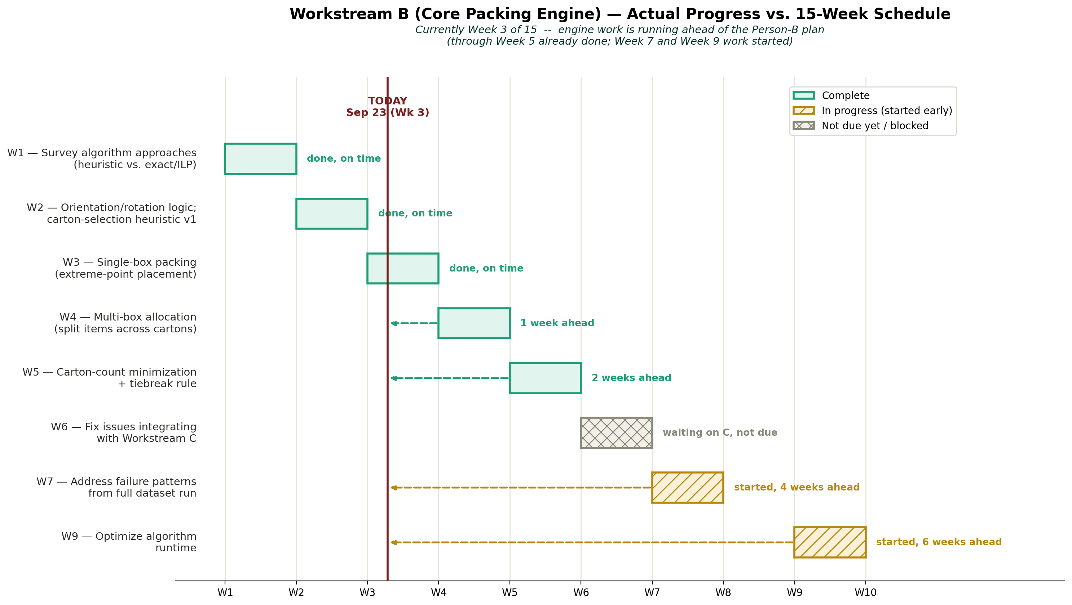
Figure D1. Workstream B status vs. the published 15-week schedule.

