Keychain
Bow Keychain:-
56 chain
6 HDC, 6slst, 12 hdc, 6 slst, 12 hdc, 6 slst, 6hdc , turn
repeat 4 rounds

https://youtu.be/J5BA1nYeb2Q?si=Zk_DybF8Vp8-zUKc
Star keychain:
R1 : - MR 5sc
R2 :- inc * 5 (10)
R3 :- (sc. Inc)*5 (15)
R4 :- (2 sc, inc )*5 (20)
R5 :- (hdc, dc, hdc, dc) slst ni next 3 sts
[sc,hdc,dc,hdc,sc], slst in next 3sts * 4
make 2 and then sew both star facing wrong sides together
fill stuffing , continue sewing
make eyes and smile with thread and sew….

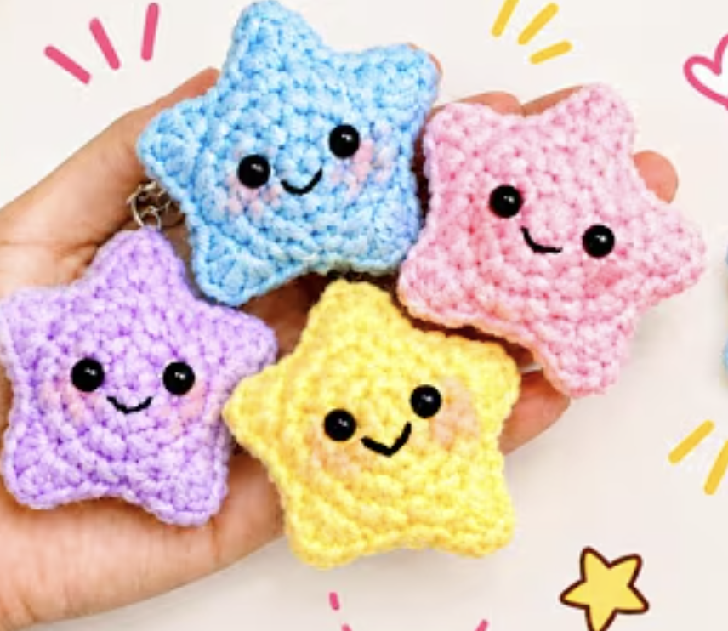
https://youtu.be/jY7pYmuqEeQ?si=DAc__gqUF1DsoUE_

