**Micro-Service Deployment Step and Guide**

**Pre-Request :**

* Install Java 11/17
* Install Maven 3.9.6 Or latest
* Install Docker-Hub(Docker-Desktop)
* Install Jenkins
* Creating Micro-service with induvial Repository

**Reference : https://www.youtube.com/watch?v=PKcGy9oPVXg**

**Dockization**

**Step 1:** Go to Service folder and Build the service with Command

**mvn clean intall -DskipTests**

**Step 2:** Check Jar file in target folder and Create Docker file with Configuration

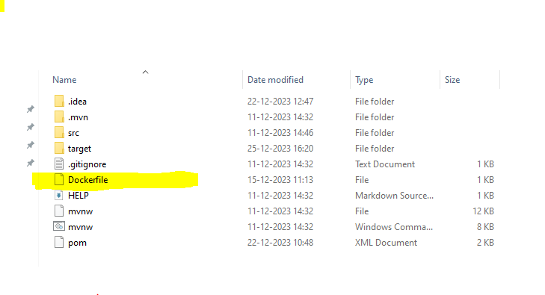

**Step 3:** Open CMD/Terminal write and run the command for to create the image for that services as per docker configuration. With this command you can give as per your convenient image name.

**docker build -t <Name of Image> .**

**Step 4 :** Create a Docker-compose file in that we declare our database and all service container and configuration. And after that run that particular file with this command.

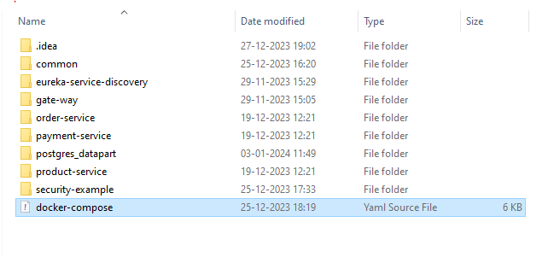

**docker compose -f docker-compose.yaml up -d**

**Note : (.)** dot means that you said to the docker to find the configuration file in this folder/directive

Now,

**Implement CI-CD pipeline With Jenkins**

**Step 1:** After installJenkins **(**<https://www.jenkins.io/download/#downloading-jenkins>**)** install all plugins that we need to configure

**Like :** (It’s a basic plugin configuration to implement ci-cd pipeline for spring boot maven project)

* Maven plugin
* Pipeline Maven Integration Plugin
* Pipeline implementation for Blue Ocean
* Pipeline SCM API for Blue Ocean
* Pipeline: GitHub
* Git Pipeline for Blue Ocean
* Bitbucket Pipeline for Blue Ocean
* Pipeline Utility Steps
* Docker Pipeline
* Docker plugin
* docker-build-step
* Git plugin
* Git Push Plugin
* GitHub Branch Source Plugin
* GitHub Organization Folder Plugin
* Oracle Java SE Development Kit Installer Plugin
* Pipeline
* Workspace Cleanup Plugin

**Location:** (Goto Manage Jenkis >> Plugins >> Search it and install)

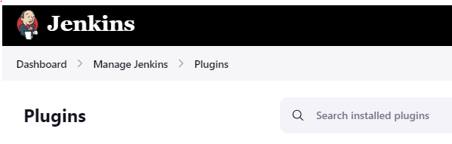

Step 2: Install Tools for spring-boot

(After adding the maven please remember the name which is you given and write that mention name in pipeline where you wanted to use maven )

Like:- Maven, Git (git.exe)

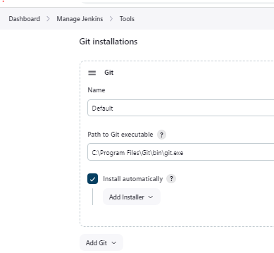 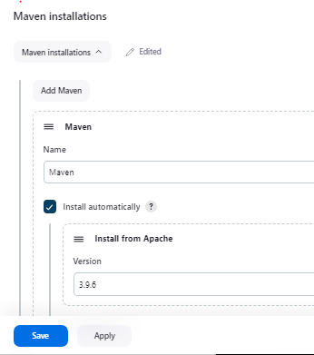

Step 3: Now Create pipeline ->Name - **Shopping-Cart-CI-CD ->** Select Pipeline

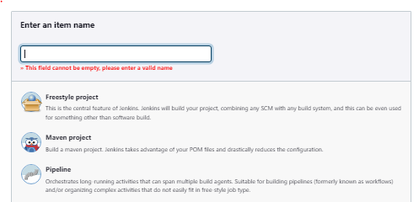

Step 4: Add configuration

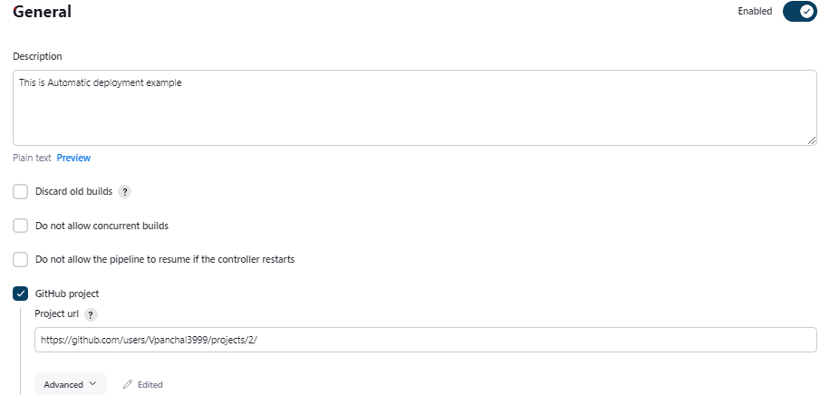

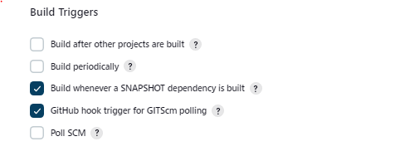

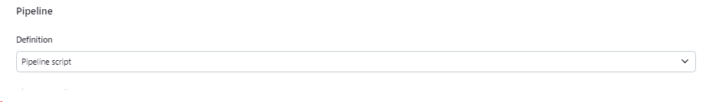

**Note :-**  If you want to create user name and password as secret text or any pipeline syntax please click on Link as show in blow image



Now, write the pipeline syntax to run automatically deployment

**Note :-** For micro-service In Jenkins work space clean up automatically each and every pipeline stage so if you want any operation that depends on particular file or folder at particular stage or step then write that step below/under the that step