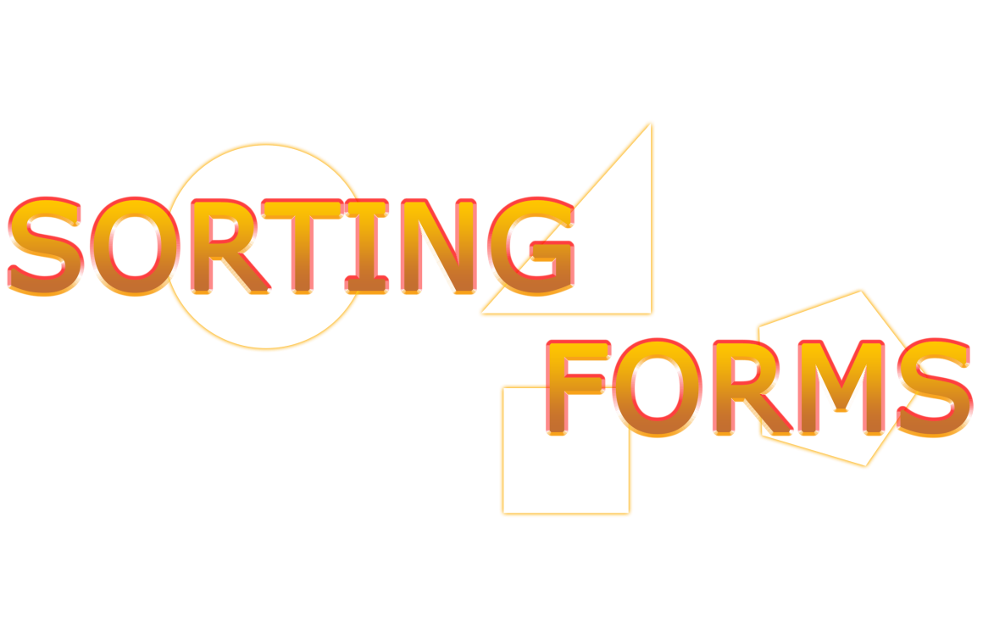

*[Test Purpose]*

Game Objective

*Player can start to play a game of “Sorting Forms”. Each correct answer adds points to the player’s score; every wrong answer deduces points from the score. When the game is over, the player can see his score on a scoreboard that stores the points. if you restart the game and finish a second time, you can see previous scores.*

Game Rules

● The game starts with a 3-second countdown  
● A randomly selected shape is displayed  
● The player decides with a tap on the arrow key left (Triangle and Pentagon) or right (Square and Circle) where the shape belongs  
● after the answer is selected, the next random shape is displayed  
● The player has 4 seconds per shape  
● if time runs out the answer is counted as incorrect  
● when an answer is given(correct or wrong) the next random shape appears  
● correct answers give 100 points  
● wrong answers deduce 200 points  
● The points are displayed as “Score”  
● the player has 60 seconds to correctly sort as many shapes as possible  
● there should be an equal amount of choices. 25% per shape  
● the final score is saved in the high score even after the game is closed Version History

|  |  |  |  |  |  |
| --- | --- | --- | --- | --- | --- |
| Version # | Implemented  By | Revision  Date | Approved  By | Approval  Date | Reason |
| 1.0 | *VJ* | *07/01/2022* | *-* | *-* | *Initial version* |
|  |  |  |  |  |  |
|  |  |  |  |  |  |
|  |  |  |  |  |  |

1. Concept

*Player can start to play a game of “Sorting Forms”. Each correct answer adds points to the player’s score; every wrong answer deduces points from the score. When the game is over, the player can see his score on a scoreboard that stores the points. if you restart the game and finish a second time, you can see previous scores.*

.

*Shapes.*

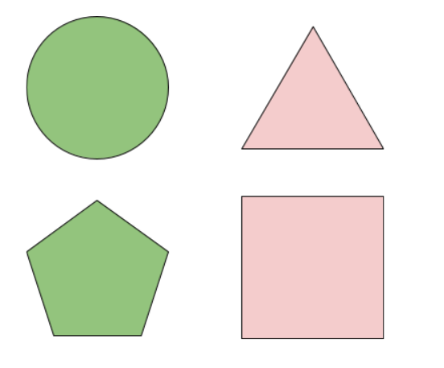

2. Gameplay

2.1. Goals

This is a game where user has to press the correct button mapped to the shapes if a wrong map will cause a loss of score points and a correct map will be a gain of score points

*For example:*

*Correct score: +100*

*Wrong Score: -200*

2.2. User Skills

This Game is a very simple game which allows only a clicking of arrow buttons to map the shapes.

*For example:*

1. Triangle and Pentagon maps to left arrow
2. Square and Circle maps to right arrow

2.3. Game Logic

● The game starts with a 3-second countdown  
● A randomly selected shape is displayed  
● The player decides with a tap on the arrow key left (Triangle and Pentagon) or right (Square and Circle) where the shape belongs  
● after the answer is selected, the next random shape is displayed  
● The player has 4 seconds per shape  
● if time runs out the answer is counted as incorrect  
● when an answer is given(correct or wrong) the next random shape appears  
● correct answers give 100 points  
● wrong answers deduce 200 points  
● The points are displayed as “Score”  
● the player has 60 seconds to correctly sort as many shapes as possible  
● there should be an equal amount of choices. 25% per shape  
● the final score is saved in the high score even after the game is closed

2.4. Visual Concept

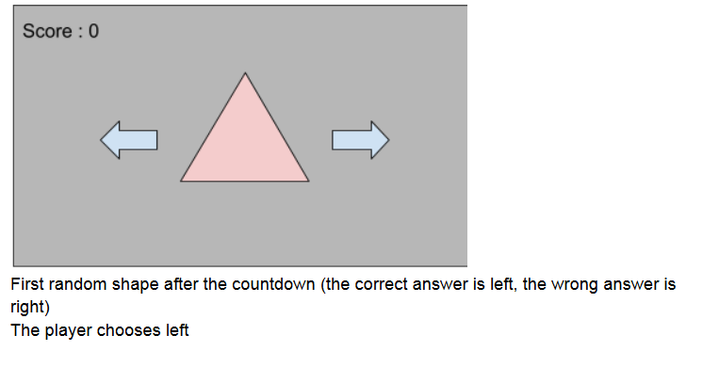

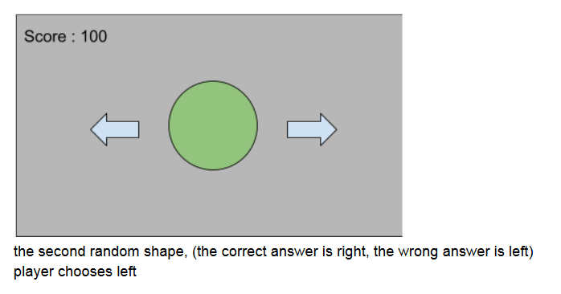

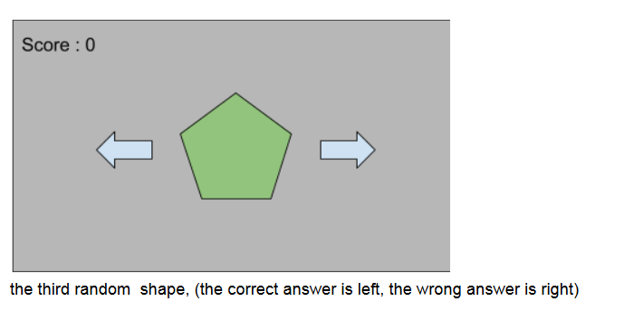

3. Art style

Title Screen:

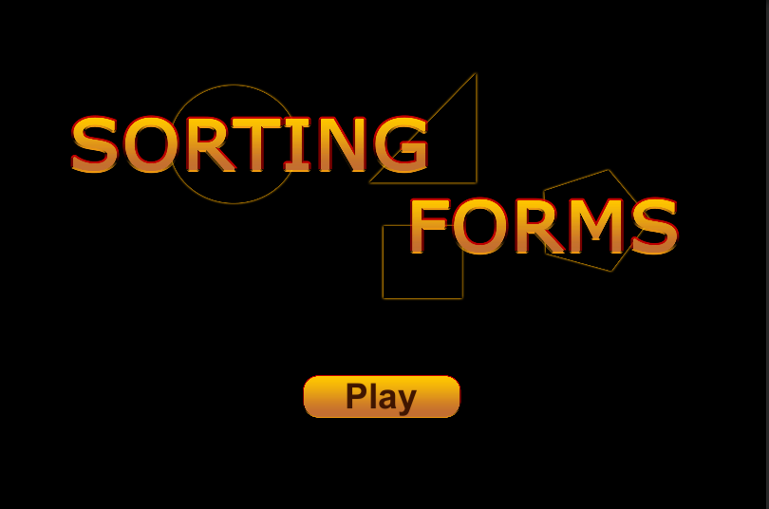

Count Down:

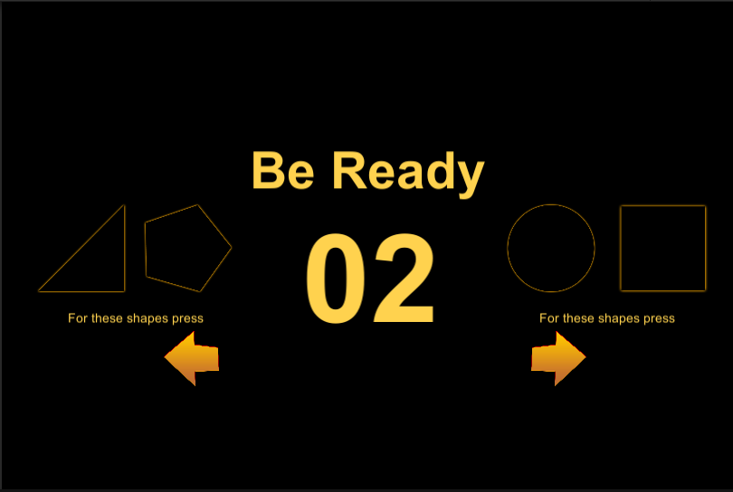

Game UI:

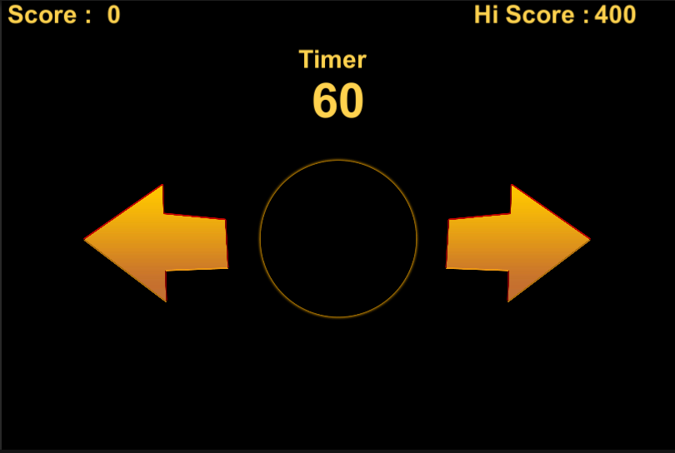

Completion:

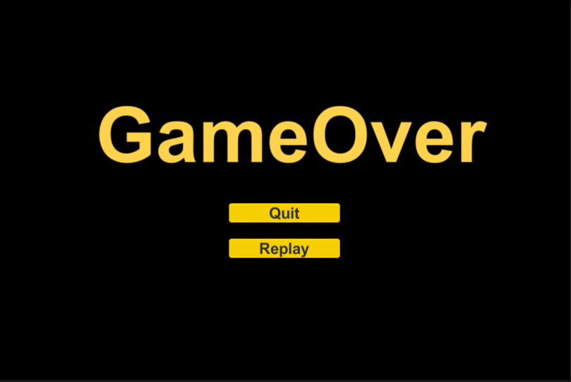

4. Music and Sounds

The Game needs 3 Background music’s,

* Tile Page music
* Gameplay music
* Game Over music

The SFX for the game are,

* Button Click sound
* Correct answer sound
* Wrong answer sound

1. Platforms

Currently the game is developed for windows and android but it can be extended to IOS and WebGL in the future.