Assignment 2: GitHub Collaboration &
Automation
Group Project Report
Our project: Password Checker
Group size | 3 members (based on the project evidence)
Full names / student IDs | Wiame hara _ Mouna Kherraf _ Ihssane El Omari / 165051 _ 160691 _ 159529
Course code & section | CSC332402/03
GitHub usernames | Vpollyon999; kherrafmounai-lab; wiamehara
Repository URL | https://github.com/Vpollyon999/password-checker
GitHub Pages URL | https://vpollyon999.github.io/password-checker/

Project & Role Distribution
For this assignment, we chose the Password Checker theme. We built the project in Python and divided the work into separate features so that each member could develop and test their part on a feature branch. Our project work covered password validation, checking whether a password is commonly used, and calculating a password-strength score. We also worked with pytest, GitHub Actions, pull requests, branch protection and a GitHub Pages project page.
GitHub account | Work shown in our evidence | What we can see in the screenshots
kherrafmounai-lab | Password validation; feature/password-validation | PR #1, “Add password validation and tests,” with the application and test files shown in the changed files.
Vpollyon999 | Common-password detection; feature/common-password | PR #2 adds is_common(); the screenshots show five tests and a local result of 5 passed.
wiamehara | Code review/approval; strength-scoring work is also shown on feature/strength-score. | The evidence includes a review comment and approval, plus a terminal screenshot showing score_password tests and a push.

Branches, Commits & Contributions
We did not develop the features directly on main. Instead, our screenshots show separate branches for password validation, common-password detection and strength scoring. On the common-password branch, we added the is_common() function and then added tests for it. On the strength-scoring branch, the terminal evidence shows the commit “Add score_password with boundary and invalid-input tests,” followed by a push to the remote branch. The password-validation pull request also shows multiple commits and the related application and test files.
This branch-based approach let us keep each feature separate while preparing it for review and merging. Before submitting, we should ensure that the contribution list and commit history in the final repository match the work described here.

Pull Requests & Code Review
We used pull requests to propose our changes to main. PR #1 was titled “Add password validation and tests,” and PR #2 was titled “Add common-password check (is_common) and tests.” The screenshots show that review was part of the process: one review comment suggested using a named constant for the minimum password length, and another raised the need to check how common-password detection handles uppercase letters and surrounding spaces. These comments helped us think about maintainability and edge cases, not only whether the code ran.
Our evidence also shows an approval by wiamehara and a pull request that was blocked while an approving review was still required. The screenshots available to us do not clearly show the entire required “Request changes → fix on the same branch → re-review” cycle. If we completed that cycle, we should include the relevant screenshot and describe the actual correction; otherwise, we should finish that requirement before submission.

Merge Conflict
The assignment required us to create a controlled conflict in the shared Project status line in README.md by changing the same line differently on two branches. We then needed to merge the first change, update the second branch with the latest origin/main, resolve the conflict, commit the resolution and complete the pull request. The screenshots provided for this report do not clearly show the conflicting “Current” and “Incoming” text or the final resolved line.

Unit Tests
We used pytest to test the project’s functions. The common-password work includes five tests, and our terminal screenshot shows the result “5 passed.” The strength-scoring terminal evidence shows a test file and the result “2 passed.” The password-validation pull request also includes a test file. The tests are intended to check the behavior of the individual features rather than only whether the program starts.
For common-password detection, the function checks that the input is a string and compares a stripped, lower-case version of the password against the common-password list. The strength-scoring commit message says that boundary and invalid-input tests were added. We should run the full test suite after all branches have been merged and enter the exact final test count here. The separate screenshot results should not be presented as the final combined test count.

Continuous Integration
We added a GitHub Actions workflow at .github/workflows/tests.yml. The visible workflow is named “Password Checker Tests” and uses actions/setup-python@v5 with Python 3.12. It is intended to run pytest when we push changes or open/update a pull request, so the tests can be checked automatically rather than relying only on a local run.

Ruleset & Protected main
We configured a ruleset named “Protect main” for the main branch. The screenshot shows the ruleset targeting main and an empty bypass list. Our goal was to prevent changes from being merged without review and passing the automated test check, while also preventing force pushes and branch deletion. The pull-request evidence shows that GitHub can block a merge while a required approval is missing.

Continuous Deployment: GitHub Pages
We published a static project page using GitHub Pages at https://vpollyon999.github.io/password-checker/. The screenshot shows the “Password Checker” title, a short description, and information about password-length validation, pytest and GitHub Actions. The page also includes instructions for installing dependencies and running the tests.
The assignment asks us to make one final visible change through a branch and pull request, merge it into main, and check that the live page updates. Our screenshot proves that the page is available, but it does not clearly prove that a final post-merge change was observed. The page also says that team members and contributions will be listed, so we should replace that placeholder with our actual team details and verify the updated live page.

Contribution Summary
Based on the screenshots, kherrafmounai-lab worked on password validation and authored PR #1. Vpollyon999 worked on the common-password check, authored PR #2 and contributed five visible tests for that feature. The evidence for wiamehara includes a meaningful review comment and approval, as well as strength-scoring work and a local test run on feature/strength-score. We should check the final commit and pull-request history with all members so that each person’s feature branch, authored pull requests, reviewed pull requests and tests are reported accurately.

Fair Use of AI
We used AI assistance to help organize and explain parts of our project/report. We checked suggestions against our actual code, tests, GitHub workflow and assignment instructions rather than accepting them automatically. We remain responsible for understanding the code and tests attributed to us, the Git commands we used, the workflow configuration and the review decisions.

Sources & Reflection
For this report, we used the Assignment 2 instructions, our Password Checker GitHub repository, the pull-request and review pages, the GitHub Actions run details, our local pytest terminal output, and our published GitHub Pages site.

Appendix: Screenshots from Our Work
These screenshots provide evidence from our repository settings, pull requests, code review, local tests, GitHub Actions and published project page.
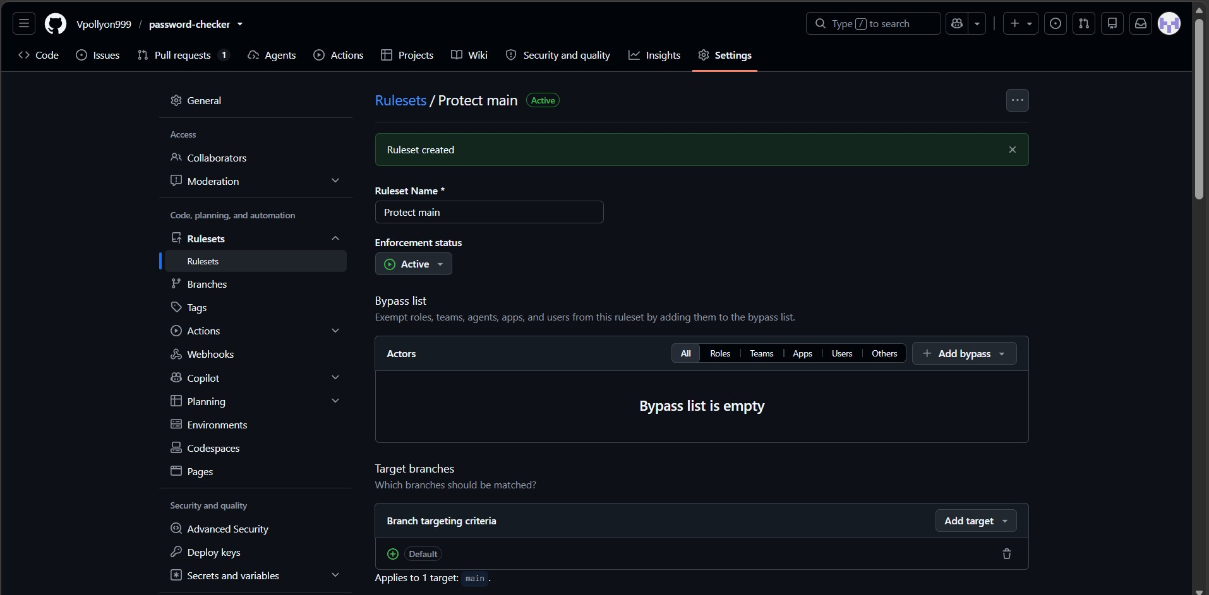
Figure 1. Our “Protect main” ruleset targeting the main branch.
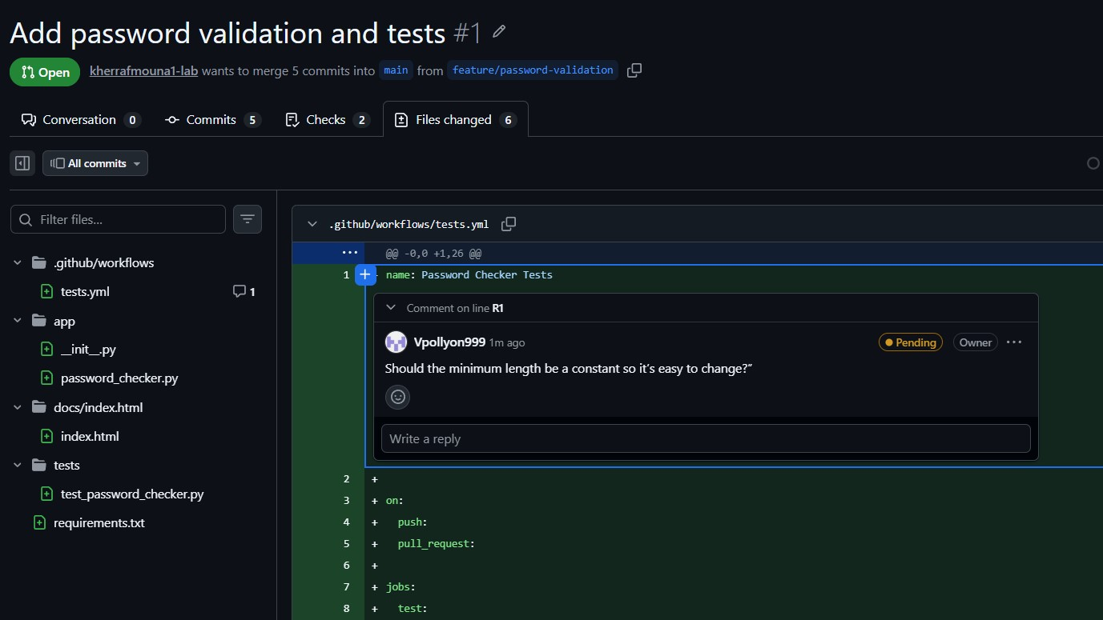
Figure 2. Our password-validation pull request and changed files.
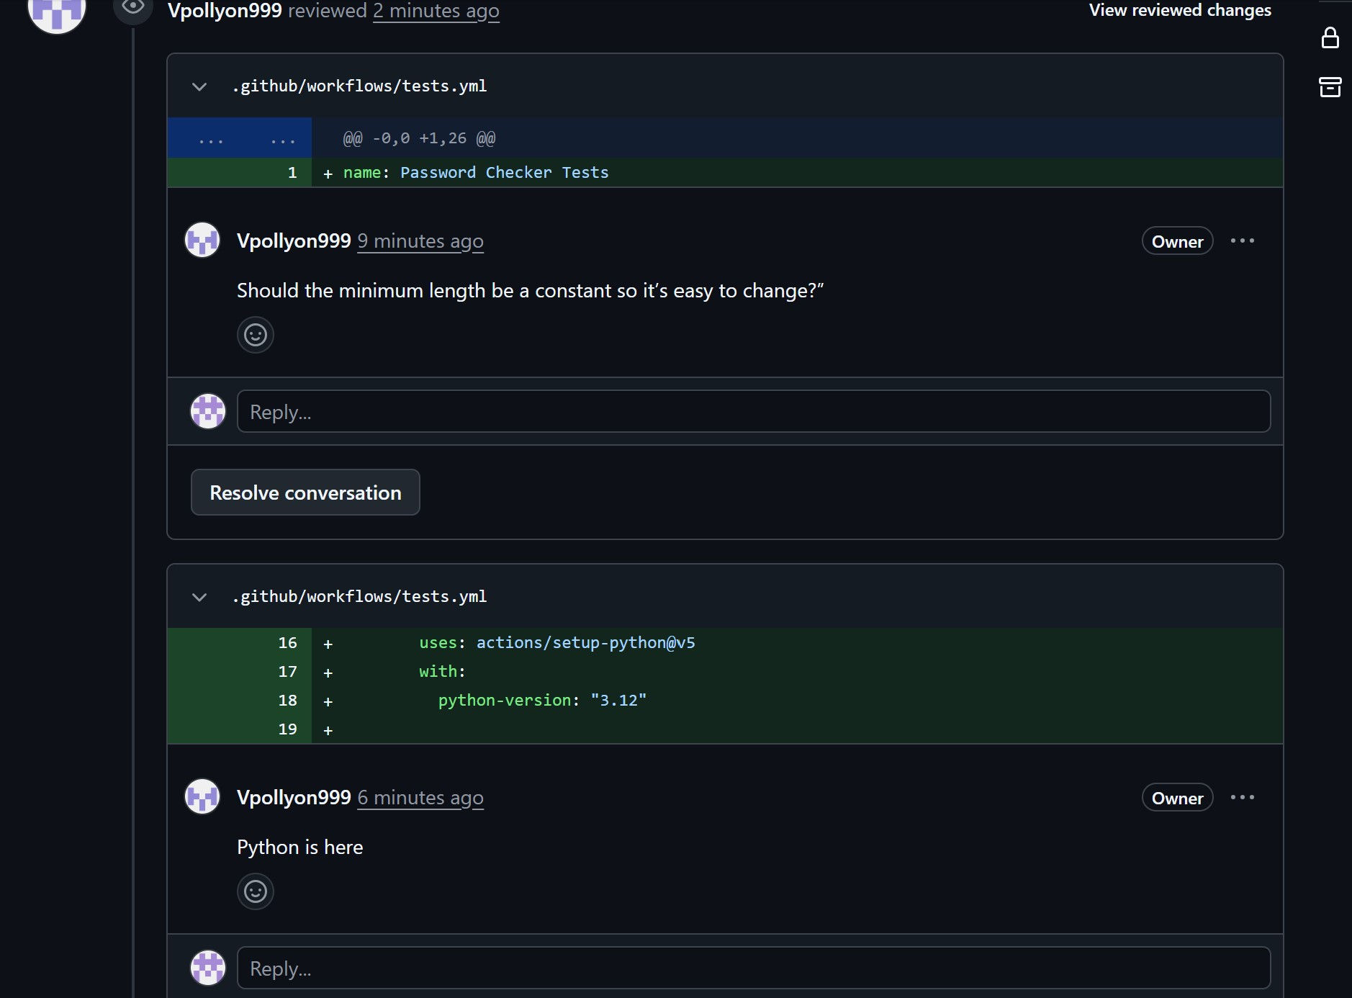
Figure 3. A review comment on the minimum password-length setting.
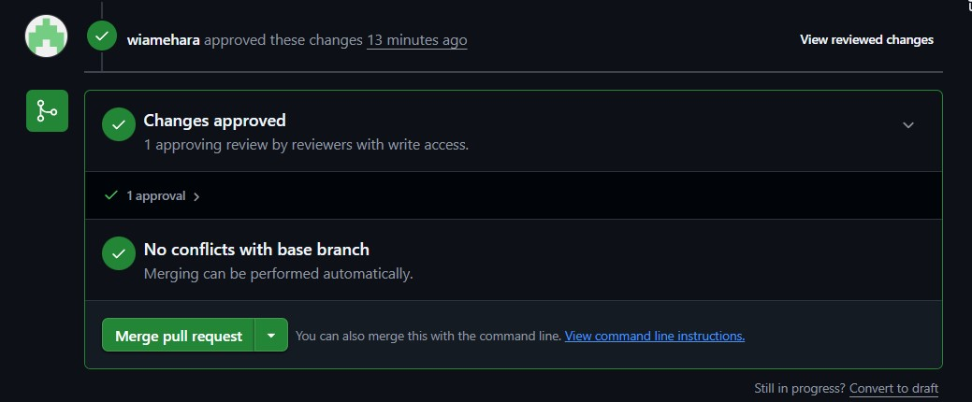
Figure 4. Approval recorded on a pull request.
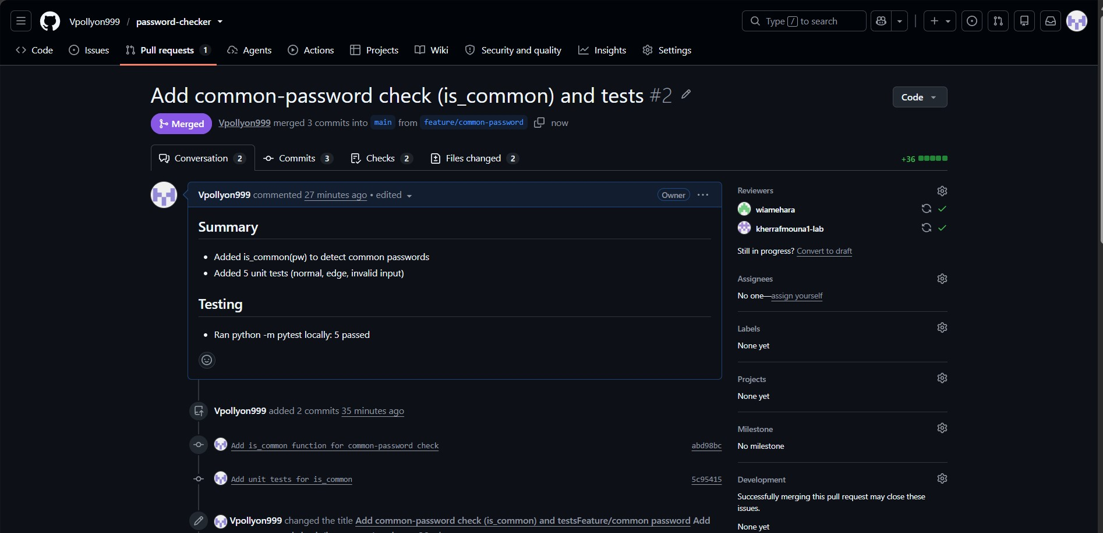
Figure 5. Our common-password pull request and visible test result.
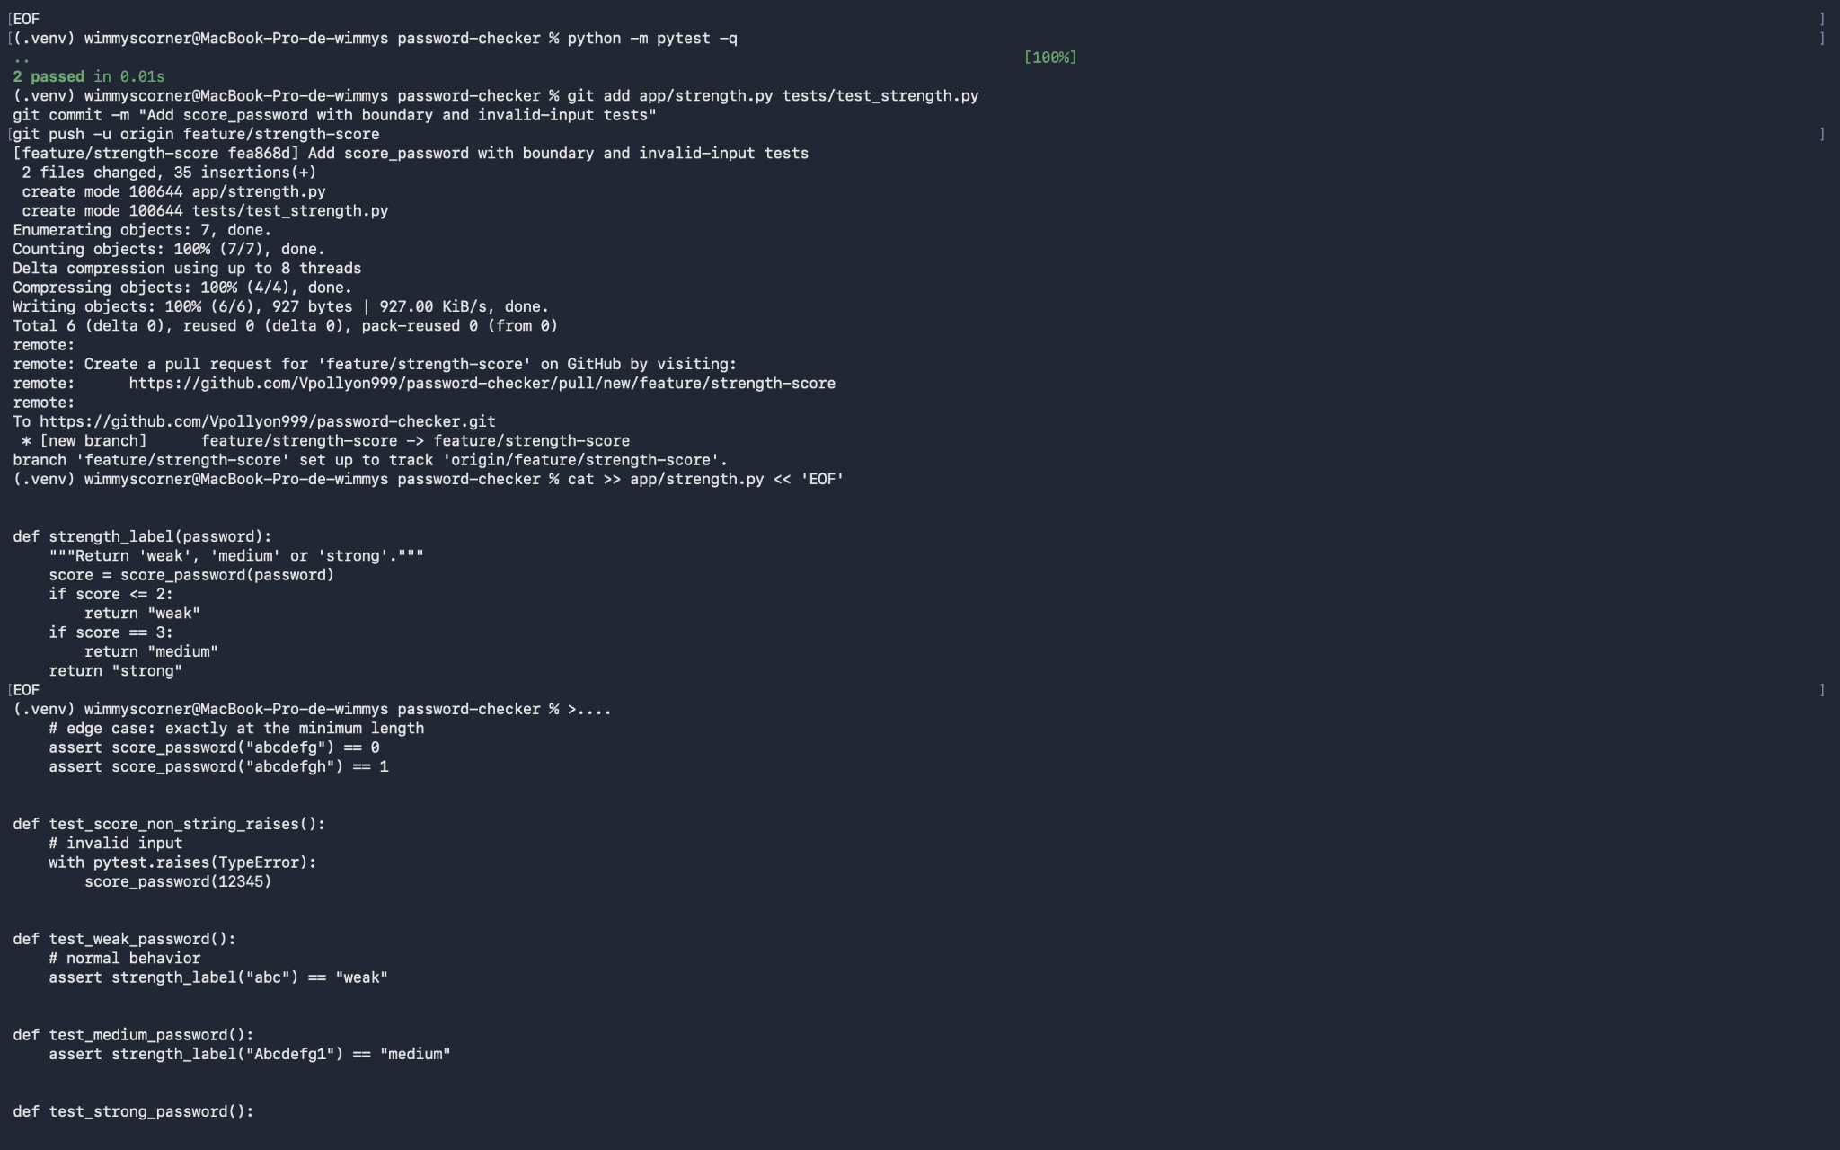
Figure 6. Local test output and the strength-scoring commit/push.
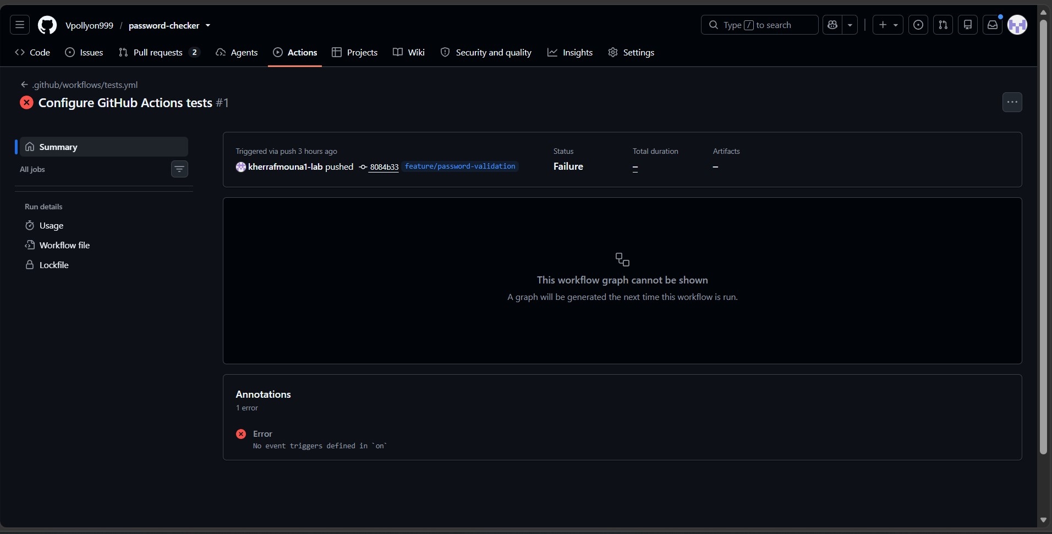
Figure 7. The initial failed GitHub Actions run and its trigger error.
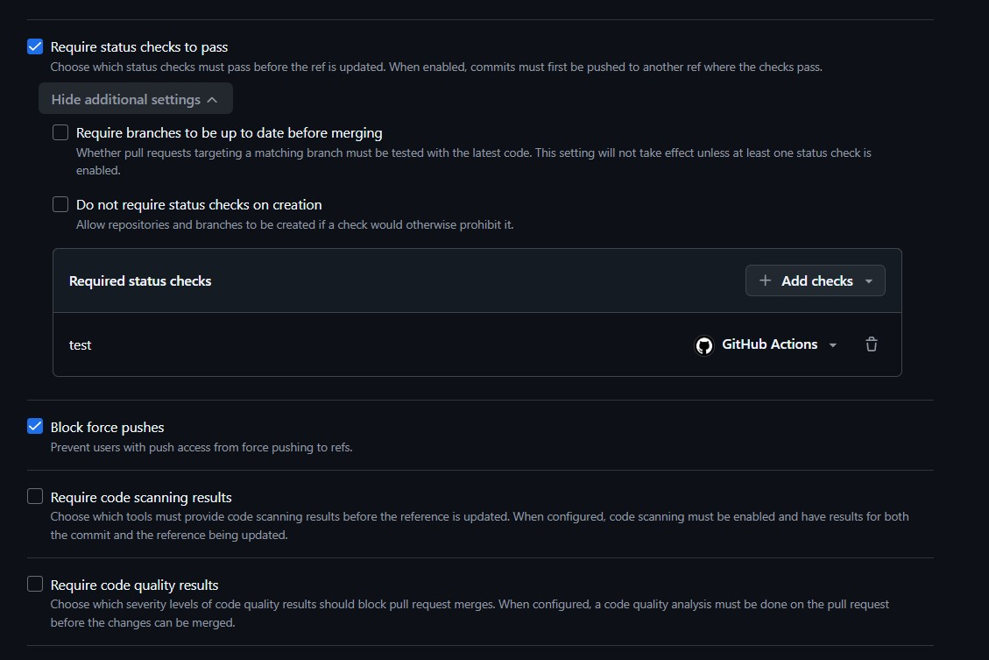
Figure 8. Our repository ruleset/status-check settings.
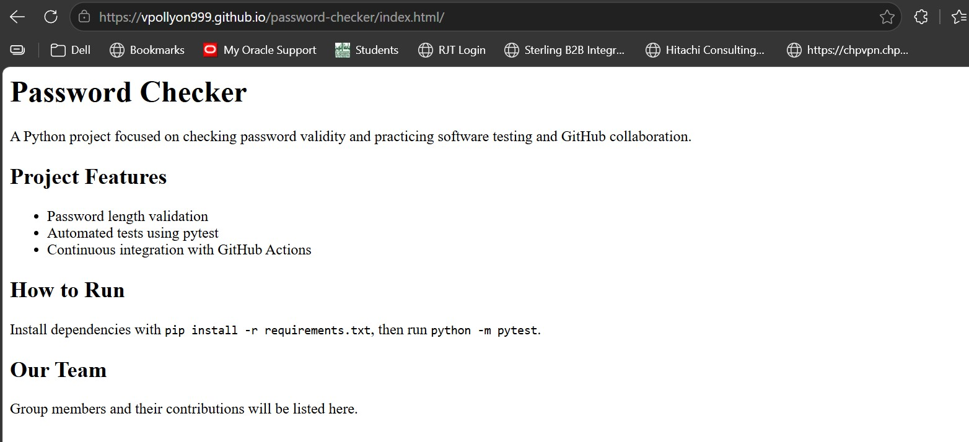
Figure 9. Our published Password Checker project page.

