FROM SCRAPED JSON
TO HISTORICAL FOOTBALL INSIGHT
A first-principles field guide to modelling, change detection, and reliable data pipelines

A book-style working document for a local-first football competition analytics system.
Scope: the source is a website that exposes cumulative team statistics in JSON. The goal is to preserve how each team’s reported profile evolves as a competition progresses, without scraping expensive detail unnecessarily or losing evidence when a run fails.

Prepared 9 October 2026
Design principle: understand the observation before choosing the tool.

Contents
How to read this guide
1. Our domain and problem statement
2. Questions to ask before building a data pipeline
3. Data-engineering fundamentals for this project
4. Decisions we made, and how to reason from first principles
5. A practical design for the first working version
6. Failure scenarios and what a trustworthy pipeline does
7. A build checklist
8. Recommended sources and further reading
Appendix A. Example data contracts and table sketches
Appendix B. A compact glossary
The diagrams are conceptual rather than vendor-specific. They show responsibility boundaries and data meaning, not an exact deployment topology.

How to read this guide
This document follows a learning sequence. It begins with the real-world thing being measured, then asks what must be true for a historical analysis to be trustworthy. Only after that does it choose file formats, tables, scheduling, and libraries.
The central habit is to move from the question to the evidence. A pipeline is not just code that copies fields. It is a repeatable process that makes a defensible claim about what a source reported, when it reported it, how complete that report was, and whether the stored version can be trusted.
Three layers of reasoning
Domain truth: what does a row mean in football terms? Data truth: what was actually captured and validated? Tooling: which component runs each step? If these questions are answered in the reverse order, a neat stack can still preserve the wrong thing.

1. Our domain and problem statement

1.1 The thing we are trying to observe
The domain is a football competition evolving over time. At each useful observation point, the source reports a table of teams and a set of cumulative statistics for those teams. We want to retain these successive reported states so we can compare the same team with itself across the competition, compare teams at the same stage, and later study whether a team’s statistical profile changed as results accumulated.
This is different from collecting only a final league table. A final table answers “where did each team finish?” A historical sequence can answer “when did the team begin creating more chances?”, “did defensive numbers deteriorate over the middle of the season?”, or “did a team’s style shift after a run of fixtures?” Those questions require observations from multiple points in time, not just the last value.
The intended product is a historical analytical dataset. The scraper is only the collection mechanism. The data model must support questions that do not yet exist, while avoiding a design so abstract that the first usable dataset becomes difficult to build.

1.2 What the source returns
The source response is mostly flattened. It includes metadata, plus three large sections for each team. At present, one row of JSON can represent the team’s overall competition statistics, so the fact that it contains several sections does not automatically require three separate fact tables.
Source section | What it contains | Representative flattened fields
Competition Team Statistics | Table-like totals and team performance measures; includes Summary, Defensive and xG groups, often split by home and away. | goals_away; points; xG; other summary/defensive measures
Competition Situational Statistics | Event counts grouped by situation or event type; views may include Overall/Home/Away and For/Against. | overall_home_openplay; overall_home_against_openplay
Competition Positional Statistics | Measures grouped by pitch side, shot direction, shot zone or action zone; may also be split by location and For/Against. | overall_home_leftSide; overall_home_against_middleOfThePitch

The exact field dictionary should be documented separately as the source contract. This guide uses representative names to explain the model; it does not assume that every listed field exists in every source version.

1.3 The core problem statement
Problem statement
Capture accepted versions of each team’s cumulative competition statistics as the source changes after fixtures; preserve the original evidence; detect likely updates cheaply; validate detailed data before publication; and make the historical series queryable without confusing one observation with another.

A correct result is not “the latest JSON was saved”. A correct result is a series of traceable observations. Each accepted observation must answer: which competition and season did it refer to, which teams were included, which source state was seen, when was it observed, what was the raw evidence, and did every required section pass validation?

1.4 What future analysis needs from the data
- Compare a team’s cumulative points, goals, xG, and other measures at different points in the competition.
- Compare team profiles at approximately equivalent stages, rather than only at the end.
- Inspect home/away splits and situational or positional breakdowns without mixing them with a different snapshot.
- Detect the change between two captured states and investigate when a change first appears in the source.
- Rebuild a corrected analytical table from preserved raw captures if parsing logic or the source-field mapping changes.
- Explain missing or unexpected data: distinguish “the team had zero” from “the source did not provide a value” and from “the capture failed”.

1.5 A crucial limit: observations are not match events
The source reports cumulative state. If the system captures after match windows, each observation may incorporate one match, several matches, or corrections made by the provider. The stored history therefore says what was observed at each accepted point. It does not automatically say what happened in each individual match.
Differences between cumulative integer totals can sometimes estimate the combined activity since the prior accepted snapshot. But if two fixtures occurred between snapshots, the difference cannot attribute that change to either fixture by itself. Ratios, percentages, rankings and model-derived ratings cannot generally be differenced as if they were additive counts. If match-by-match attribution becomes a requirement, collect a match-level source as a separate data process.
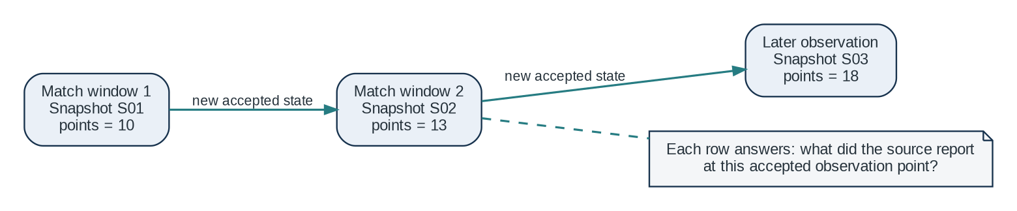
Figure 1. A sequence of accepted states preserves observed history; it does not manufacture a match-by-match record.

2. Questions to ask before building a data pipeline
These questions are more valuable than starting with “Which orchestrator should I use?” They expose the assumptions that a reliable implementation must encode. Not all answers need to be perfect on day one, but unknowns should be named rather than silently guessed.

2.1 Domain and analytical questions
1. What is the real-world object? Here, it is a team’s reported statistical state within one competition and season at an accepted observation point.
2. What decisions or analyses should this history enable? Define a few concrete examples before deciding table shapes.
3. Does every metric describe the same team, competition, season and observation point? If not, it may belong at a different grain.
4. Which measures are counts, which are cumulative totals, which are ratios or percentages, and which are rankings? These behave differently under aggregation and differencing.
5. What does a missing value mean in this source? Is it unavailable, not applicable, temporarily missing, or genuinely zero?
6. Are the provider’s definitions stable? For example, an xG model or category definition may change; a value can change because the method changed, not because football performance changed.

2.2 Identity and grain questions
1. What exactly does one source row represent? Write the sentence before choosing primary keys.
2. What identifies a team across observations? Prefer a stable source team ID over a display name that can change or be localized.
3. What identifies a competition and season? Do not infer a season from a calendar year if the competition has a non-calendar season.
4. Can two valid observations occur on the same date? If yes, date alone cannot identify a snapshot.
5. Is one capture an observation of the whole competition or an independent observation for each team? The current design should prefer a shared competition snapshot if all teams are fetched as one coherent update.
6. Can one response contain partial pages, split requests or only some teams? If yes, define a completeness rule before accepting it.

2.3 Time and source-behaviour questions
1. When is a fixture expected to finish, and how long after that does the source usually update?
2. Can several fixtures finish close together? How do we combine overlapping check windows to avoid repeated expensive work?
3. What observable signal changes when the provider publishes a new state: table values, a last-updated field, a revision ID, ETag, or something else?
4. What exactly does the provider guarantee about update order? Does a changed table mean detailed statistics are ready? Does an unchanged table prove that detailed statistics have not changed? These are different claims.
5. Can values be corrected later, including for an earlier match? If so, historical snapshots must preserve the correction as a newly observed state rather than silently rewriting the earlier capture.
6. What happens when the source is late, rate-limited, unavailable, or returns a partial response? Which step can be retried, and how often?

2.4 Data quality questions
1. How many teams should be present for this competition and season at this point?
2. Are team identifiers unique within a snapshot? Are required metric fields present with expected types?
3. Are the three detailed sections consistent with each other and with the set of teams in the table?
4. Which checks are hard failures versus warnings? An impossible team count is different from a plausible but surprising xG value.
5. How will a schema change be detected? If a field disappears or is renamed, should the pipeline stop, continue with an explicit null, or quarantine the capture?
6. How can a user distinguish real zero from unavailable data or a failed scrape?

2.5 Recovery and state questions
1. What counts as success: HTTP 200, valid JSON, all expected teams, all required sections, or a fully committed snapshot? Success should mean the last item.
2. If detailed scraping fails after the table check, what value is stored as the last successfully processed state?
3. Can retrying the same logical update create duplicate history? If so, what key or uniqueness rule prevents duplicates?
4. Can the process stop between writing files and inserting rows? How will incomplete work be identified and safely retried?
5. Do we retain failed attempts and their raw response? A failed response can explain why an update was rejected.
6. Can the same raw capture be reprocessed with a newer parser without scraping the website again?

2.6 Tool and operating questions
1. Can a local file plus a SQL engine satisfy current analysis needs, or is a server database required now?
2. Do we need an external API at this stage, or only a reproducible dataset and notebooks?
3. Does the orchestration tool provide useful retries, run history, observability and dependency management, or would a simple scheduled script be enough initially?
4. What is the smallest data volume and concurrency the first version needs to handle?
5. Which details should stay in plain Python, and which belong in SQL where transformations are easier to inspect?
First-principles shortcut
Start from failure: imagine the source returns only 17 of 20 teams, the process crashes after saving JSON, or detailed stats fail after the table changed. If the design cannot explain what is stored, what is accepted, and what happens next, the design is not finished.

3. Data-engineering fundamentals for this project
This section explains the concepts needed for the first version, not the full data-engineering universe. Each concept is included because it solves a concrete problem in this pipeline.

3.1 Grain: the most important sentence in a data model
Grain is the exact meaning of one row. In dimensional modelling, it is defined from the real-world measurement event or state before the columns and keys are chosen. Kimball’s guidance is to declare the grain first because every dimension and measure must be consistent with it [1, 2].
Proposed grain for the historical analytical table
One row represents one team’s competition-season statistics at one accepted competition snapshot. The natural analytical key is (snapshot_id, team_id). The snapshot header identifies the competition, season, source state and observation metadata.

This means the points, goals, xG, home/away splits and situational or positional fields can live on the same wide row if all of them describe that same team at the same snapshot. The number of columns does not change the grain. A different grain would be needed for a match event, a shot, a player, or a metric category stored as an individual record.
Candidate row meaning | Could it fit here? | Reason
Team × competition snapshot | Yes; this is the proposed grain. | All cumulative fields refer to the same team and observed source state.
One match performance | No; separate grain. | A match row represents a match/team event, not a cumulative competition state.
One positional category | Not in the same fact row grain. | It would create multiple rows per team and snapshot; model as a child/long table if useful.
One ingestion attempt | No; operational record. | A run can fail or retry without creating a new accepted analytical snapshot.

The grain is not just a database implementation trick. It is what keeps a comparison meaningful. If one row represents a team after Matchday 5 and another after Matchday 7, a chart can legitimately show the later cumulative state. If the rows accidentally mix two seasons, two teams or different source revisions, the chart is mathematically valid but analytically wrong.
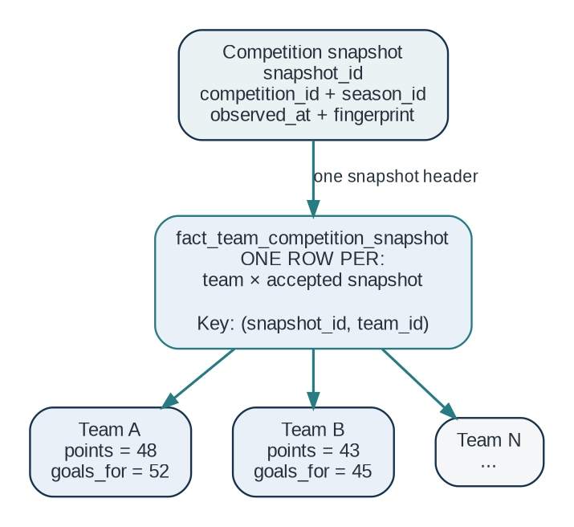
Figure 2. One accepted snapshot is a shared observation point; each team has one row under that snapshot.

3.2 Historical snapshots, periods, and the word “cumulative”
“Cumulative” describes the measures from the source: season-to-date points, goals, shots or xG may accumulate as matches are played. It does not name a separate standard fact-table type. Kimball describes three common types: transaction facts, periodic snapshot facts and accumulating snapshot facts [2].
Term | What it means | Fit for this project
Cumulative measure | A value accumulated over a span: goals to date, points to date, shots to date. | Yes: this describes many source metrics.
Periodic snapshot fact | State summarized at a defined reporting period, such as day, week or month. | Conceptually close if we intentionally define regular reporting periods.
Accumulating snapshot fact | One row progresses through predictable process milestones and is updated as the process advances. | Better for the ingestion run lifecycle, not team history.
Event-driven historical state snapshot | A stored version each time a relevant source state is accepted, even if observation times are irregular. | The most precise description of the current plan.

Our scrape is triggered around fixture completion and source updates. The timestamps may therefore be irregular. It is safer to call the analytical table a historical state-snapshot fact table, using ideas from periodic snapshots, instead of claiming that it is a strict periodic snapshot unless the capture calendar actually has a fixed period.
Do not overwrite the previous team values when a new state arrives. Insert new rows under a new snapshot_id. Then a latest-state view can expose the most recent accepted snapshot while the underlying table retains the historical sequence.

3.3 Observation time versus event time
Time has more than one meaning. A match has an event time. The provider publishes or recalculates the competition table at some source time. Our system observes that state at a capture time. The pipeline commits it at another moment. These timestamps can differ.
Field | Question it answers | Example
fixture_end_expected_at | When did we expect the source to become ready? | 2026-10-09 21:45 local time
source_updated_at | When does the provider say the state was updated? | Provider timestamp, if available
observed_at | When did our check see this payload? | 2026-10-09 22:03 UTC
ingested_at | When did our system persist the raw attempt? | 2026-10-09 16:33 UTC
accepted_at | When was the full dataset validated and published? | 2026-10-09 16:34 UTC

Do not put all of these into a single generic “date” column. They answer different questions. A source may publish late, our scheduler may run late, and a valid raw file may sit in staging before it is accepted. Separating those facts makes latency and historical comparisons explainable.

3.4 Cumulative totals, derived deltas, and corrections
Suppose a team’s cumulative goals for are 12 in snapshot S1 and 17 in S2. If the statistic has the same definition and no correction occurred, the difference of 5 says that five additional goals were included in the later reported total between observations. It does not prove they were scored in one match, because multiple matches or data revisions could lie between the snapshots.
delta_goals_for = current.goals_for - previous.goals_for
The same arithmetic is not meaningful for every metric. A league position is ordinal, not additive. A per-90 rate can change because both its numerator and denominator changed. A percentage may go down even while its underlying count increases. Treat deltas as derived analytical values, not as raw facts.
A provider may correct historical data. For example, a shot classification could be revised, altering a cumulative total after the match has ended. Keeping each accepted state allows you to observe that revision. If the source provides no correction log, you may not know whether the delta came from new matches or a correction; record that as a limitation rather than inventing certainty.

3.5 Raw, staging, and analytical layers
Keep the source payload separate from the tables that analysts query. The raw layer answers “what did we receive?” Staging answers “how do we interpret the received fields as typed columns?” The historical model answers “what are the accepted observations and their keys?” Analysis views answer “what is the latest state, and how did it change?” These are different responsibilities even if the first implementation stores them on one computer.
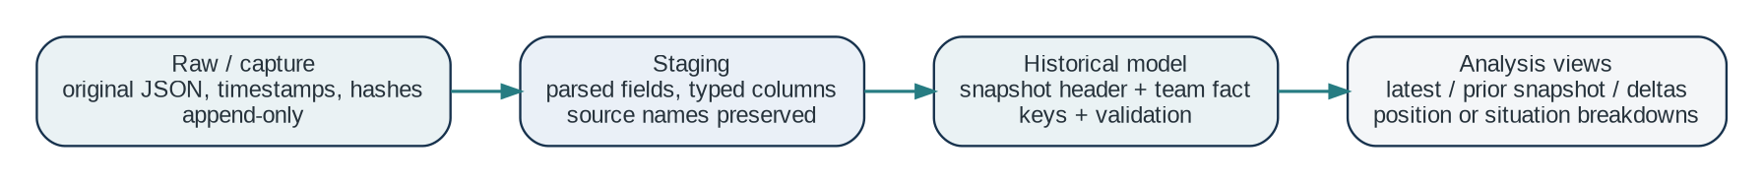
Figure 3. Separate source evidence, parsing, historical modelling and analytical convenience views.
Layer | Purpose | Mutation rule
Raw capture | Original JSON response and metadata needed to trace it. | Append-only; do not silently replace an earlier capture.
Staging | Parsed and typed values, normalized names and source IDs. | Rebuildable from raw captures.
Historical model | Accepted snapshot header and one row per team/snapshot. | Insert a new state; deduplicate retries by a defined logical identity.
Views / marts | Latest snapshot, deltas, trends and chart-friendly shapes. | Recompute from accepted data; do not become the only copy of history.

This is a light-weight layered architecture, not a requirement to adopt a large “lakehouse” platform. The value comes from preserving raw evidence and making transformations repeatable, not from giving every folder a fashionable name.

3.6 JSON and Parquet solve different problems
JSON is a good capture format because it preserves the source’s structure and is widely used for data interchange. DuckDB can read JSON and project its fields into relational columns [6]. JSON is not necessarily the best repeated-analysis format: it is text-oriented and can require parsing each time.
Parquet is a column-oriented analytical file format. Its layout can let query engines read only selected columns and use compression, which is useful once snapshots are being queried repeatedly [7, 8]. It is a useful transformed format, but it should not replace the original JSON evidence. Converting a response into Parquet is a transformation and can drop source-only fields, preserve inferred types incorrectly, or flatten nested meaning.
Format | Use it for | Keep in mind
JSON | Immutable source capture; exact provider response. | Preserve the exact payload and capture metadata.
Parquet | Typed, repeated analytical reads and intermediate datasets. | Generate from raw or staging data; keep schema/version info.
DuckDB tables/views | Local SQL transformations and historical analysis. | Great for local analytical workloads; a database table is not the raw archive.

3.7 Orchestration versus application APIs
An orchestrator decides when work should run, tracks step execution, and coordinates dependencies, retries and run history. Dagster schedules can trigger work at planned times; sensors can react to observed external state [4]. A fixture-driven process with change checks is a natural place for orchestration because the next action depends on a source observation.
FastAPI serves application requests over HTTP. It is useful if another application or front end needs to query the dataset, request a report or trigger a controlled action. It is not the part that should define a team-snapshot grain or decide whether data is complete. A first version can build and query the dataset without exposing an API at all.
Keeping responsibilities separate avoids a common overbuild: adding an API framework because it is familiar even though the present problem is scheduled ingestion and local analytics. Start without FastAPI; add it when there is a real client or service contract to support.

3.8 Change detection, fingerprints, and checkpoints
A fingerprint is a compact digest of a canonical representation of selected source content. The fingerprint is not the data; it is evidence that the representation appears to have changed. To be useful, the input representation must be stable: teams should be sorted by stable IDs, key ordering should not affect the result, and volatile fields such as “scraped at” should not be included. Otherwise identical content could generate different hashes just because the serialization changed.
A checkpoint records how far a process has successfully advanced. The checkpoint must reflect committed work, not merely an observation. If the source state changed but detailed scraping failed, the system must still be able to retry that state. This leads to a crucial distinction between “last seen fingerprint” and “last committed fingerprint”.
Checkpoint rule
Advance the last-committed fingerprint only after the detailed payload has passed validation and the accepted snapshot has been committed. A failed attempt may be recorded, but it must not make an unprocessed source state look completed.

The change-detection gate also depends on a source guarantee. If a changed league table implies that detailed statistics are ready, it can be a useful positive trigger. But skipping detailed scraping on an unchanged table requires a stronger guarantee: every meaningful detail update must necessarily change the table representation used for the fingerprint. Verify that claim before relying on it.

3.9 Idempotency: safe retries without duplicate history
A pipeline is idempotent when repeating the same logical operation does not create a different outcome from running it once. Real ingestion needs retries because networks fail, sources respond late and processes crash. We do not necessarily need to avoid every repeated request; we need retries to be safe.
Separate three identities: (1) run_id, which identifies an execution attempt; (2) raw_capture_id, which identifies an exact source capture; and (3) snapshot_id, which identifies an accepted analytical observation. One accepted snapshot may have several failed capture attempts before it. It should still be published as one coherent analytical state when one attempt succeeds.
A practical approach is to persist each raw attempt under its own identity, validate a candidate state in staging, then enforce a uniqueness rule for accepted states. The correct deduplication key depends on what the source can guarantee. A fingerprint alone is a good retry signal only if the canonicalized table state fully represents all relevant updates. It is not a universal identity for source content.

3.10 Data quality is a contract, not a feeling
Validation turns “the response looks plausible” into explicit, repeatable rules. Common categories include uniqueness, not-null requirements, accepted values, and references to known records. These are also common built-in test patterns in data-transformation tools such as dbt [9]. You do not need dbt for the first version; you need the discipline of writing and running assertions.
Check | Example rule | Failure action
Identity | No duplicate team_id within snapshot_id. | Reject candidate snapshot.
Completeness | Team set matches the expected competition team set, with documented exceptions. | Reject or quarantine.
Schema | Required fields exist and have parseable types. | Reject or route through an explicit schema-change path.
Cross-section consistency | Team statistics, situational statistics and positional statistics cover the same expected teams. | Reject partial candidate.
Plausibility | Played matches, goals and points are within known bounds; nullable fields are handled intentionally. | Hard-fail impossible values; warn on unusual values.
Freshness | Source timestamp or table state is consistent with the trigger window. | Retry or mark source not ready.

“Missing” and “zero” must not be conflated. A value of zero means the source reported no events for that metric. Null or absent means that no value was provided or it could not be interpreted. Use an explicit source-null convention and document it. This prevents downstream modelling from treating a scrape defect as a real football observation.

4. Decisions we made, and how to reason from first principles
The design decisions below are not arbitrary preferences for particular libraries. Each follows from a requirement or a failure mode. In each case, the guiding question is: what is the smallest mechanism that preserves the truth we need?
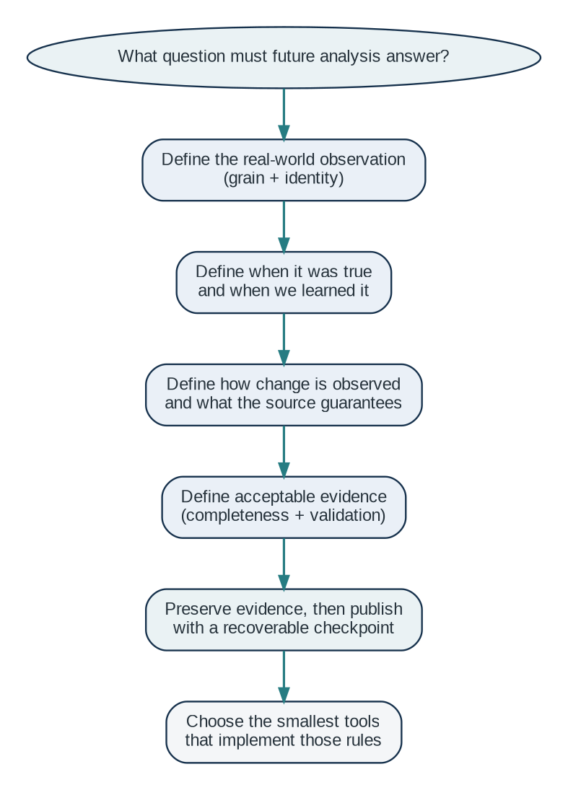
Figure 4. Reason from the analytical claim backwards to the tools that can support it.

4.1 Decision: one wide team row can hold the three source sections
Why: the Team, Situational and Positional sections all refer to the same team’s cumulative state at the same competition snapshot. They are different groups of measures, but not automatically different grains. Keeping them on one row makes an observation easy to retrieve, inspect and validate.
First-principles reasoning: split data when the real-world thing represented by a row changes, when cardinality is genuinely one-to-many, or when separate lifecycle/quality rules justify it. Do not split merely because the source UI uses three tabs or headings.
The wide shape has a cost: fields such as overall_home_openplay and overall_home_against_openplay encode category and view information inside their names. SQL queries for one category are straightforward while there are few stable categories, but schema evolution and generic “top category” analyses can get awkward. Start wide because the source is wide and the grain is coherent; extract category rows later if repeated analytical questions benefit from it.

4.2 Decision: retain raw JSON captures
Why: the provider is external and its interface can change. Raw payloads let us reparse a historic capture when the field mapping is wrong, investigate a failed run, and compare source behaviour without another request to the provider.
First-principles reasoning: the original response is evidence. A transformed table is an interpretation of that evidence. If only the interpretation is stored, a parser bug can destroy the ability to reproduce or audit the result.
Recommended capture metadata: capture_id, run_id, source URL or endpoint name, competition_id, season_id, captured_at in UTC, HTTP status, payload hash, parser/schema version if known, and the path to the payload. Avoid putting secrets or session cookies into logs. Failed payloads can also be useful evidence, but access and retention should be controlled if the response contains sensitive data.
raw/provider=example/competition=comp_123/season=2026-27/
captured_at=2026-10-09T16-33-02Z_run=run_0187.json
The path is a suggested convention, not a mandatory partition scheme. Use stable IDs and a unique capture/run component so a later attempt never silently overwrites an earlier payload.

4.3 Decision: use fixture windows to reduce repeated checks
Why: the fixture list provides a schedule of when a competition might have changed. If two matches are expected to finish close together, checking the table after each individual match can duplicate work while the source publishes them together or shortly apart.
First-principles reasoning: the expensive detailed scrape is only worthwhile when the source has likely advanced. Combine known expected completion times into check windows, wait a configured grace interval after the last expected completion in a window, and check the league table once for that window. If the source is late, retry on a bounded cadence rather than immediately launching overlapping duplicate scrapes.
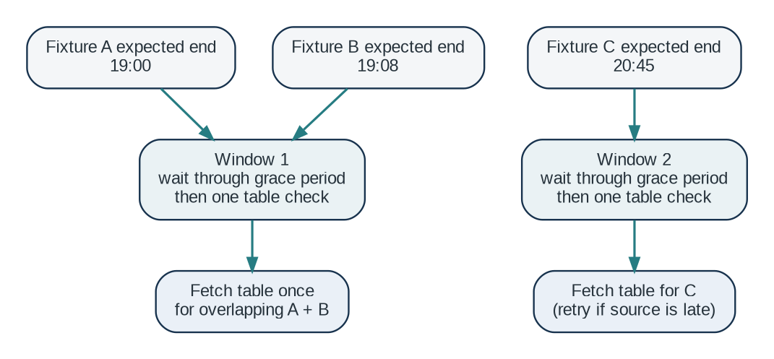
Figure 5. Expected match-end times can be coalesced into source-check windows.
The grace period and retry window are operational parameters, not timeless truths. Measure the actual delay between final whistles and source publication. Keep attempts bounded and leave enough time before the next window to avoid a permanently growing backlog.

4.4 Decision: probe the league table before detailed statistics
Why: one compact league table request may be cheaper than fetching all team details. If a valid update signal exists, it can act as a gate before the more expensive requests.
First-principles reasoning: optimize the number of expensive operations only after defining a trustworthy change signal. A cheap check is valuable when it saves work without creating false negatives. A false positive means we scrape details when they are unchanged (wasted work). A false negative means we miss a real update (lost history), which is usually more damaging for an analytical system.
Logical direction of the source guarantee
“When the table updates, detailed stats are updated” establishes table change → detail readiness. It does not establish detail change → table change. To safely skip detailed scraping when the table hash is unchanged, verify the second implication as well. If you cannot verify it, treat the table check as a positive trigger only and add periodic reconciliation, a detail-level freshness signal, or a conservative scrape policy.

Use stable source team IDs in the fingerprint input where possible. Sort team rows by ID; canonicalize the field ordering; exclude request time, HTML noise and other volatile metadata; include the meaningful table fields. When uncertain, bias toward a few extra fetches rather than a hash rule that can silently discard real observations.

4.5 Decision: one shared snapshot_id for all teams in a competition update
Why: the intended comparisons are often “all teams at this point in the competition”. A shared identifier makes this observation cohort explicit. It also lets validation detect when only some teams were captured.
First-principles reasoning: the source update is one logical observation of the competition state. Each team row is one member of that observation. If the source is requested in several calls, the calls may be operationally separate, but they should only be published together under one accepted snapshot when they represent the same source state and satisfy completeness rules.
Do not use one independent timestamp per team as the only version identity. That makes it harder to prove whether the teams being compared belonged to the same capture cycle. Store observed_at on the snapshot header and, if needed, per-section capture timestamps in raw/run metadata.

4.6 Decision: distinguish a run from a snapshot
Why: scheduled work may be repeated, fail halfway, retry after the source is ready, or be reprocessed with a corrected parser. If run_id and snapshot_id are the same thing, an operational retry can accidentally create a false new version or overwrite the wrong row.
Entity | Represents | Typical status
ingestion_run | One execution attempt of the pipeline. | started, skipped, failed, succeeded
raw_capture | One exact payload received from a request. | captured with status and hash
competition_snapshot | One accepted observed source state for a competition-season. | candidate, accepted, rejected
fact_team_competition_snapshot | One team’s metrics within one accepted snapshot. | published only when snapshot is accepted

4.7 Decision: commit a complete snapshot, not partial rows
Why: an analytics query should not mistake an incomplete scrape for a smaller competition. Imagine 20 expected teams, but only 18 rows were loaded before a network failure. If those 18 rows appear as the latest snapshot, a dashboard can report false league comparisons.
First-principles reasoning: a candidate snapshot is a unit of publication. Store and validate candidate data away from the accepted view. Once every required section passes, publish the header and all team rows together (using a database transaction or an accepted-status/manifest boundary appropriate to the storage system). If validation fails, retain the evidence and mark the candidate rejected; keep the previous accepted snapshot visible.

4.8 Decision: advance the checkpoint only after acceptance
Why: the checkpoint tells future runs what has been processed. If a changed table is recorded as “processed” before detailed statistics are validated and committed, the next run might skip the very update that failed.
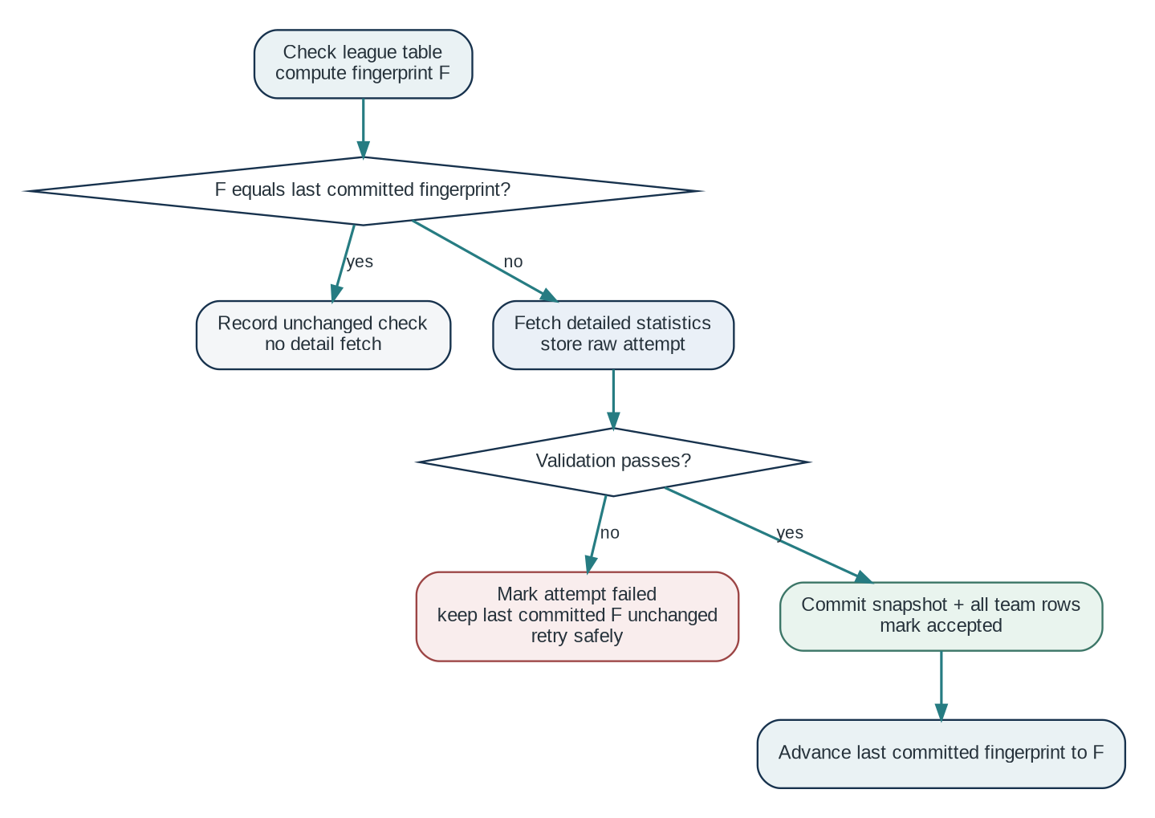
Figure 6. The committed checkpoint advances only after a complete, validated snapshot is accepted.
Store both what was observed and what was successfully committed. A simple operational ledger can include last_seen_fingerprint and last_committed_fingerprint, but the comparison used to decide whether a state needs processing should be against the committed state. Failed attempts should remain retryable.

4.9 Decision: DuckDB first, Parquet when useful, FastAPI later
Why DuckDB: the workload begins as local ingestion and analytical SQL over historical rows. DuckDB can query Parquet directly and can read/write Parquet files [5, 7]. This lets the first version work with a local database and files rather than introducing a client/server database before concurrency or serving requirements demand it.
Why Parquet: it makes repeated column-focused analytical scans more efficient and provides a portable data file. But avoid converting everything preemptively. Keep raw JSON as evidence; create Parquet or DuckDB tables when it simplifies repeated work and schema control.
Why Dagster: orchestration has real needs here—fixture-derived check windows, conditional work, retries, status history and explicit dependencies. A Dagster schedule or sensor can trigger the flow, while ordinary Python functions handle fixture grouping, canonicalization, scraping and validation [4].
Why not FastAPI yet: there is no stated current need for an external service. The data pipeline and queryable dataset can exist first. Add an API once there is a concrete consumer and a stable response contract to design around.

4.10 Decision summary
Decision | Underlying reason | Constraint to preserve
Wide row for the 3 metric groups | Same team × snapshot grain. | Do not mix metrics from different observation points.
Append-only raw JSON | Source evidence must survive parser and schema changes. | Unique capture path and traceable metadata.
Fixture-driven windows | Reduce duplicate polling after near-simultaneous matches. | Handle late source publication with bounded retries.
League table as gate | Cheaper update probe than full detail scraping. | Prove the no-change implication or reconcile independently.
Shared snapshot_id | Compare all teams from one accepted competition state. | Reject incomplete team/section coverage.
Run and snapshot IDs differ | Execution attempts are not analytical observations. | Retries must not duplicate accepted history.
Validate then publish atomically | Prevent partial states from appearing current. | Latest view reads accepted snapshots only.
DuckDB + optional Parquet; Dagster | Fit local analytical SQL and conditional orchestration. | Add API/server database only when justified.

5. A practical design for the first working version
This section converts the decisions into a concrete flow. It is a reference design, not a demand to build every table and mechanism on the first day. The minimum viable version should keep the data semantics correct even if some operational capabilities begin simply.
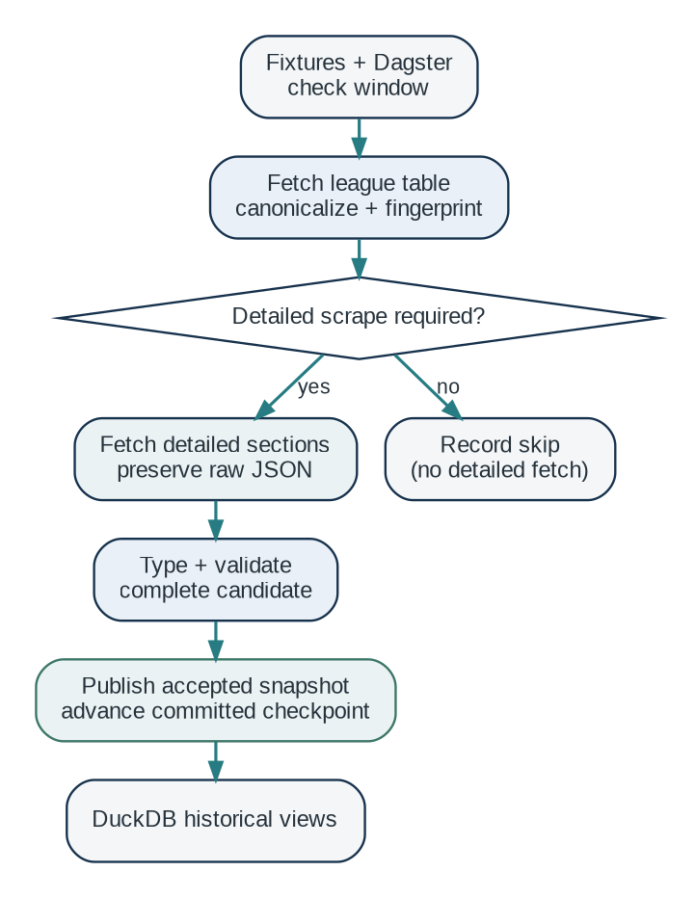
Figure 7. End-to-end flow: cheap probe, detailed capture, validation, publication and analysis.

5.1 End-to-end run
1. Read the fixture list and build check windows for each competition. Group overlapping expected end times; apply an evidence-based grace period.
2. Start a Dagster run for a due window. Record run_id, competition, season, trigger window and start time.
3. Fetch the league table and save the probe payload with its capture metadata, even if the data appears unchanged.
4. Canonicalize the table, compute a fingerprint and compare it with the last committed state using a change-detection rule whose guarantees are documented.
5. If there is no safe reason to process the details, record a skip. If a likely new state exists, fetch the team, situational and positional sections.
6. Persist each detailed response as a raw capture before transforming it. Raw files should be unique and immutable.
7. Parse into typed staging records. Map team IDs, competition and season IDs, metric fields, source nulls and units consistently.
8. Validate the candidate: expected teams, duplicate IDs, required sections, schema, types, cross-section consistency and plausible values.
9. Create a logical snapshot_id and publish the snapshot header plus all team rows as one accepted unit.
10. Advance the last-committed fingerprint only after publication succeeds. Record final status and metrics for the run.

5.2 Sketch of the operational metadata
A lean first implementation needs enough metadata to answer “what ran, what did it see, and what was accepted?” It does not need a sprawling control database. The following are conceptual columns; choose exact types and constraints when implementing.
Table | Useful columns | Why it exists
ingestion_run | run_id, competition_id, season_id, trigger_window, started_at, finished_at, status, error_summary | Trace and retry operational attempts.
raw_capture | capture_id, run_id, section_name, captured_at, payload_path, payload_hash, http_status | Trace each exact response.
competition_snapshot | snapshot_id, competition_id, season_id, observed_at, source_fingerprint, accepted_at, status | Define one logical observed state and its acceptance.
fact_team_competition_snapshot | snapshot_id, team_id, rank, points, goals_for, goals_against, xG fields, source metrics... | Historical analytical values at team × snapshot grain.
pipeline_checkpoint | competition_id, season_id, last_seen_fingerprint, last_committed_fingerprint, updated_at | Control safe incremental processing.

5.3 Identity and keys
Use the source’s stable team identifier where available. Team names are labels, not reliable identity keys: naming, punctuation, translations or sponsorship can change. A team dimension can keep a stable team_id and a display name current at first. If historical names are analytically meaningful, preserve the name in each raw capture or maintain a time-aware name history later.
The snapshot header should own competition_id and season_id so the same team_id can appear in multiple competitions, seasons and snapshots without ambiguity. Within the fact table, enforce uniqueness of (snapshot_id, team_id). If team metrics later need to be split into multiple tables, keep the shared snapshot identity and declare each table’s new grain explicitly.

5.4 A raw capture manifest
A small JSON or database record next to the raw payload can make captures self-describing. For example:
{
"capture_id": "cap_0187_team_stats",
"run_id": "run_0187",
"competition_id": "comp_123",
"season_id": "2026-27",
"section": "team_statistics",
"captured_at": "2026-10-09T16:33:02Z",
"payload_sha256": "<computed digest>",
"http_status": 200,
"schema_version": "provider-shape-v1"
}
The hash is calculated from the exact saved bytes for audit and integrity checking. The change-detection fingerprint is different: it is calculated from the canonicalized subset of the league table used to decide whether detailed work is needed. Do not reuse these terms interchangeably.

5.5 Candidate and accepted data
The easiest implementation can hold candidate rows in temporary tables or a staging schema, validate them, then insert the accepted snapshot in a single database transaction. If storage is file-first, write all candidate files into a uniquely named run directory and create an explicit manifest that says when the group is accepted. The latest-state query must consult only accepted data.
Do not delete a failed candidate just because it was not accepted. Store failure status and enough metadata to inspect it. You may choose to remove extremely large or sensitive payloads under a retention policy, but the default for this learning project should be traceability, not invisible cleanup.

5.6 First analytical views
Build views from the accepted snapshot table instead of duplicating data for every question. Useful starting views are:
- latest_team_competition_state: all teams from the latest accepted snapshot per competition and season.
- team_snapshot_history: a team’s full sequence of accepted values ordered by observed_at.
- team_snapshot_delta: selected additive cumulative counts compared with the preceding accepted snapshot, with caveats documented.
- snapshot_completeness: expected versus captured teams and sections for each accepted or rejected candidate.
- source_freshness: expected fixture-window end, first observed update, and accepted time.
A latest-state view is a convenience, not the history itself. If a dashboard only sees latest_state, keep the underlying historical rows accessible so a later analysis can recover the trajectory.

5.7 A basic SQL-shaped model
CREATE TABLE competition_snapshot (
snapshot_id VARCHAR PRIMARY KEY,
competition_id VARCHAR NOT NULL,
season_id VARCHAR NOT NULL,
observed_at TIMESTAMP NOT NULL,
source_fingerprint VARCHAR NOT NULL,
accepted_at TIMESTAMP NOT NULL,
status VARCHAR NOT NULL
);

CREATE TABLE fact_team_competition_snapshot (
snapshot_id VARCHAR NOT NULL,
team_id VARCHAR NOT NULL,
points INTEGER,
goals_for INTEGER,
goals_against INTEGER,
-- other metrics from the same source state
PRIMARY KEY (snapshot_id, team_id)
);
This is a shape sketch, not a final production schema. The example deliberately leaves most provider fields out. In a real schema, define numeric types and nullability from the field dictionary; use decimal types if the source’s precision requires it; include all necessary dimensions or keys; and do not assume that a string type is correct just because the JSON encoded a number as text.

6. Failure scenarios and what a trustworthy pipeline does
A design is easier to evaluate when tested against awkward cases. The pipeline should make a clear choice for each situation and leave evidence that explains the result.
Scenario | Unsafe behaviour | Trustworthy behaviour
Table changes; detail scrape fails. | Store new fingerprint as processed, so later checks skip the update. | Record failed attempt; keep last committed fingerprint unchanged; retry.
Only 18 of 20 expected teams appear. | Publish 18 rows and let this become “latest”. | Reject candidate; preserve raw captures; previous accepted snapshot remains latest.
Two fixtures overlap in expected end time. | Launch redundant detail scrapes that race to write rows. | Coalesce checks into one window, with a single logical candidate and safe retry.
Provider adds a new field or changes a type. | Silently discard it or infer a different type each run. | Flag schema drift; preserve raw payload; apply explicit mapping/version update.
JSON key order changes but values do not. | Hash raw serialized bytes and scrape everything again. | Canonicalize the table before computing the change-detection fingerprint.
Same run retries after partial insert. | Duplicate accepted rows or overwrite a prior snapshot. | Use run IDs, unique keys, a publication transaction and committed checkpoint semantics.
Table unchanged but detail data changed. | Skip details forever because table hash is unchanged. | Only skip if the source guarantee supports that inference; otherwise reconcile or use another signal.
Two observations occur on the same day. | Use the date as the snapshot key, causing collision or overwrite. | Generate a logical snapshot_id; keep observed_at for temporal ordering.
Provider corrects old cumulative statistics. | Mutate prior history in place and lose what was previously reported. | Capture a new accepted state; preserve raw evidence and document revision ambiguity.
A metric is absent in the payload. | Replace with zero, turning missing data into a false performance claim. | Represent absence/null explicitly; fail if a required field vanished without an approved rule.

6.1 What should be considered a hard failure?
A hard failure means the candidate must not become an accepted snapshot. Examples include duplicate team keys, a missing required section, an unparseable required field, or a team set that is incomplete without an explained exception. A warning means the data is structurally valid but surprising—for example, an extreme statistical value that may be possible or may signal a source definition change.
Avoid making data-quality rules so strict that ordinary source revisions become impossible to ingest. Equally, do not weaken validation merely to make runs green. Define each rule from the intended analytical meaning: what would be the consequence if this value were wrong but still published?

6.2 Freshness and late updates
A scheduled task can run successfully while the source has not updated yet. “The scraper returned valid JSON” is not proof that it has captured the expected post-match state. Keep the trigger window, observed source values, source timestamps if available, and attempt number. Retry within a bounded policy. If the source remains unchanged beyond the expected interval, report a source-late outcome rather than inventing a successful snapshot.
Where possible, separate run outcome from data outcome. For example, a run can be operationally successful because it checked the source and found no accepted update; that is different from a detailed scrape failing validation. Distinct statuses make operational dashboards meaningful.

6.3 Idempotency in plain language
Suppose the same state is fetched twice because a run timed out after storing raw JSON but before updating the database. The second attempt may be necessary. The design should allow two raw captures if there were two requests, while ensuring that only one accepted logical snapshot is published for the same source state under the chosen deduplication rule. Raw attempts and accepted analytical states have different lifecycle rules.

6.4 What “replayable” really means
Replayable does not simply mean “we can run the script again.” It means that a known raw capture can be transformed again using a recorded parser/schema version, and that the result can be compared with the earlier accepted output. Replaying a current website request is not the same as replaying a historic input: the site may have changed. Preserve the payload if reproducibility matters.

7. A build checklist
Use this checklist as the implementation gate. It is intentionally focused on correctness before optimization.

7.1 Domain contract
☐ Write the row-grain sentence in the schema README.
☐ Define competition_id, season_id, team_id and snapshot_id.
☐ List the source fields for Team, Situational and Positional sections, including types and units.
☐ Document which metrics are cumulative counts, ratios, percentages, rankings or provider-derived scores.
☐ Document missing-value meaning and known changes in provider definitions.
☐ State clearly whether the intended history is event-driven snapshots or a fixed reporting cadence.

7.2 Source behaviour and trigger logic
☐ Measure how long after fixture completion the source usually becomes current.
☐ Coalesce overlapping fixture-end windows and avoid competing runs for the same competition state.
☐ Verify both directions of the league-table/detail-stat update relationship before using an unchanged table as proof of no detail update.
☐ Canonicalize the table before hashing; use stable IDs and exclude volatile metadata.
☐ Choose a bounded retry schedule for late source updates.
☐ Keep a fallback reconciliation policy if the cheap signal is imperfect.

7.3 Capture and validation
☐ Store every raw payload with a unique path, UTC timestamp, run ID, source section and payload hash.
☐ Record failed and skipped attempts rather than silently losing their outcomes.
☐ Validate team count, unique IDs, required fields, types, cross-section coverage and critical plausibility rules.
☐ Treat each complete competition snapshot as one publication unit.
☐ Ensure latest-state views return accepted snapshots only.
☐ Test failures by deliberately removing a team, a section and a required field from fixtures.

7.4 Storage and orchestration
☐ Start with DuckDB and local raw files unless a concrete concurrency/serving need requires another database.
☐ Use Dagster for schedules, dependencies, run status and conditional orchestration; keep the domain rules in testable Python/SQL functions.
☐ Advance last_committed_fingerprint only after an accepted snapshot is committed.
☐ Make (snapshot_id, team_id) unique in the analytical fact table.
☐ Add Parquet for repeated analytical reads when it provides a clear benefit; do not discard raw JSON.
☐ Delay FastAPI until there is an actual consumer-facing API requirement.

7.5 The first trustworthy milestone
The first milestone is reached when one real competition can be scraped twice, the second run can correctly identify “no new state” or “new state” under a validated change rule, failed detail capture can be retried without losing the update, and each accepted snapshot contains all expected teams under one snapshot_id. At that point the system has a reliable historical spine. Additional features can be built without changing the meaning of the stored observations.

8. Recommended sources and further reading
These sources were selected for the concepts that underpin the design. Start with the Kimball material for grain and snapshot semantics, then read the official tool documentation once the concepts are clear. The data-modelling guidance is more important than memorizing any particular tool’s API.
[1] Kimball Group — “Grain”
Explains why a row’s meaning must be declared before choosing dimensions and measures. Read this first when designing the fact table.
https://www.kimballgroup.com/data-warehouse-business-intelligence-resources/kimball-techniques/dimensional-modeling-techniques/grain/
[2] Ralph Kimball — “Fact Tables”
Overview of transaction, periodic snapshot and accumulating snapshot fact tables, with a clear explanation of why their grains differ.
https://www.kimballgroup.com/2008/11/fact-tables/
[3] Kimball Group — “Periodic Snapshot Fact Tables” and “Accumulating Snapshot Fact Tables”
Use these together to distinguish a report-period state from a process row updated at milestones. The provider’s cumulative measures do not themselves dictate which fact-table type to use.
https://www.kimballgroup.com/data-warehouse-business-intelligence-resources/kimball-techniques/dimensional-modeling-techniques/periodic-snapshot-fact-table/
Accumulating Snapshot Fact Tables: https://www.kimballgroup.com/data-warehouse-business-intelligence-resources/kimball-techniques/dimensional-modeling-techniques/accumulating-snapshot-fact-table/
[4] Dagster documentation — Schedules and Sensors
Official reference for time-based schedules and state/event-driven sensors. Use it to implement fixture windows and conditional work after the data contract is clear.
https://main.archive.dagster-docs.io/docs/api/dagster/schedules-sensors
[5] DuckDB documentation — Guides
Practical material for local analytical SQL, querying files, and moving from files to tables where helpful.
https://duckdb.org/docs/current/guides/overview
[6] DuckDB documentation — JSON overview
Shows how DuckDB reads JSON and extracts fields. Useful for prototyping the staging layer without treating JSON as the final analytical model.
https://duckdb.org/docs/lts/data/json/overview
[7] DuckDB documentation — Reading and Writing Parquet
Explains direct Parquet scans, writing Parquet and how columnar reads fit analytical workloads.
https://duckdb.org/docs/data/parquet
[8] Apache Parquet — Overview
The format’s own documentation, describing Parquet as an open column-oriented file format designed for efficient storage and retrieval.
https://parquet.apache.org/docs/overview/
[9] dbt documentation — Data tests
A useful catalog of executable data assertions: unique, not-null, accepted-values and relationships. These ideas can be used without adopting dbt itself.
https://docs.getdbt.com/docs/build/data-tests

A recommended reading order
1. Read [1] Grain, then [2] Fact Tables. Write the grain sentence and identify the type of historical observation you actually have.
2. Read [3] on periodic and accumulating snapshots. Recheck whether your collection cadence is a regular reporting period or an event-driven state observation.
3. Read [6] JSON overview and [7] Parquet docs. Build a tiny prototype that reads one real payload, inspects its inferred schema and writes a typed table.
4. Read [4] Dagster schedules and sensors after your run boundaries are explicit. Implement one fixture window with one source probe and a bounded retry.
5. Use [9] as a checklist for validation assertions, even if you implement them as ordinary Python checks or SQL queries.

Appendix A. Example data contracts and table sketches

A.1 The source contract
Write a compact contract before making the parser sophisticated. A first version might contain these sections:
Contract item | Example content
Entity | Competition team statistic state
Source sections | Team statistics; situational statistics; positional statistics
Expected identifiers | competition ID, season ID, stable team ID if provided
Observation semantics | Cumulative values as reported at capture; one logical snapshot per accepted competition update
Required coverage | All expected teams and all three required sections
Metric types | Integer counts, decimal values, rates, percentages and categorical labels documented separately
Null policy | Absent/null values remain distinguishable from zero; required-field absence rejects unless approved
Time policy | UTC timestamps for captured/accepted times; retain source timestamps and fixture window separately
Schema change policy | Unknown field: preserve in raw and report; required field removed/type changed: fail or route explicitly

A.2 A snapshot integrity contract
Candidate is acceptable only if:
- competition_id and season_id are known
- every team record has a stable or explicitly mapped team key
- team_id is unique within the candidate snapshot
- required team-stat, situational and positional data are present
- the expected team set is complete (unless an exception is documented)
- required values parse to their declared types
- nulls follow the metric-specific policy
- candidate is coherent enough to represent one observed source state
- the accepted snapshot key does not duplicate an already-published state
These checks are a starting contract, not universal rules for every competition. Some competitions have withdrawals, points deductions, qualification rounds or provider-specific exceptions. Encode known exceptions explicitly instead of loosening the general rule for all competitions.

A.3 Wide versus long: an example
A wide record is natural when the source publishes a stable, known set of fields:
snapshot_id | team_id | overall_home_openplay | overall_home_against_openplay
S_002 | TEAM_A | 18 | 7
A long record is useful when the categories are dynamic or the analysis asks generic questions across them:
snapshot_id | team_id | view | direction | situation | value
S_002 | TEAM_A | home | for | openplay | 18
S_002 | TEAM_A | home | against | openplay | 7
Neither shape is universally superior. The wide layout is convenient for direct ingestion and fixed schemas. The long layout makes category-driven SQL more generic but requires explicit dimensions such as view, direction and situation, plus a metric value and a defined unit. If you transform wide fields to long rows, verify that a field’s name maps unambiguously to those dimensions and that the original field can be traced.

A.4 Example checkpoint ledger
Field | Meaning
competition_id + season_id | Scope for the checkpoint.
last_seen_fingerprint | Most recent league-table state observed by the probe, whether processed or not.
last_committed_fingerprint | Latest fingerprint whose detailed data is accepted and persisted.
last_probe_at | Time of most recent probe.
last_success_at | Time of last accepted detailed snapshot.
last_outcome | No change, source not ready, accepted, validation failed, fetch failed, etc.
retry_after / attempt_count | Information for bounded retries and recovery.

Appendix B. A compact glossary
Term | Plain-language meaning in this project
Grain | What exactly one row represents.
Fact table | A table of measurements at a defined grain, linked to the context needed to interpret them.
Snapshot | An accepted observation of the competition’s state at a point in time.
Cumulative measure | A season-to-date quantity reported by the provider, such as goals or points.
Periodic snapshot | A fact-table pattern for state summarized at a predefined regular reporting period.
Accumulating snapshot | A fact-table pattern whose row is updated as a process reaches milestones.
Raw capture | An immutable saved response from the external source.
Staging | A typed and parsed representation of raw data, before acceptance as analytical history.
Fingerprint | A digest of canonicalized content used as a change signal; not a replacement for storing the data.
Checkpoint | A record of how far successfully committed processing has advanced.
Idempotency | The property that retrying the same logical work does not create duplicate or inconsistent accepted outcomes.
Orchestration | Scheduling and coordinating tasks, dependencies, retries and run status.
Schema drift | A source field, structure or type changes over time.
Atomic publication | A snapshot becomes visible as accepted all at once, not as partially loaded team rows.

Closing principle
The first system does not need many services. It needs a correct observation model, preserved evidence, a truthful update signal, repeatable validation and a checkpoint that advances only when the data is accepted. Once those rules are clear and tested, choosing libraries becomes a much smaller decision.

